MANNION v. COORS BREWING CO.
____________________________

United States District Court for the Southern District of New York, 2005

377 F. Supp. 2d 444
MEMORANDUM OPINION

LEWIS A. KAPLAN, District Judge.

The parties dispute whether a photograph used in billboard advertisements for Coors Light beer infringes the plaintiff's copyright in a photograph of a basketball star. The defendants almost certainly imitated the plaintiff's photograph. The major question is whether and to what extent what was copied is protected. The case requires the Court to consider the nature of copyright protection in photographs. The matter is before the Court on cross motions for summary judgment.

Facts

Jonathan Mannion is a freelance photographer who specializes in portraits of celebrity athletes and musicians in the rap and rhythm-and-blues worlds. In 1999 he was hired by SLAM, a basketball magazine, to photograph basketball star Kevin Garnett in connection with an article that the magazine planned to publish about him. The article, entitled "Above the Clouds," appeared as the cover story of the December 1999 issue of the magazine. It was accompanied by a number of Mannion's photographs of Garnett, including the one at issue here (the "Garnett Photograph"), which was printed on a two-page spread introducing the article.

The Garnett Photograph, which is reproduced below, is a three-quarter-length portrait of Garnett against a backdrop of clouds with some blue sky shining through. The view is up and across the right side of Garnett's torso, so that he appears to be towering above earth. He wears a white T-shirt, white athletic pants, a black close-fitting cap, and a large amount of platinum, gold, and diamond jewelry ("bling bling" in the vernacular), including several necklaces, a Rolex watch and bracelet on his left wrist, bracelets on his right wrist, rings on one finger of each hand, and earrings. His head is cocked, his eyes are closed, and his heavily-veined hands, nearly all of which are visible, rest over his lower abdomen, with the thumbs hooked on the waistband of the trousers. The light is from the viewer's left, so that Garnett's right shoulder is the brightest area of the photograph and his hands cast slight shadows on his trousers. As reproduced in the magazine, the photograph cuts off much of Garnett's left arm.

In early 2001, defendant Carol H. Williams Advertising ("CHWA") began developing ideas for outdoor billboards that would advertise Coors Light beer to young black men in urban areas. One of CHWA's "comp boards"--a "comp board" is an image created by an advertising company to convey a proposed design--used a manipulated version of the Garnett Photograph and superimposed on it the words "Iced Out" ("ice" being slang for diamonds) and a picture of a can of Coors Light beer (the "Iced Out Comp Board"). CHWA obtained authorization from Mannion's representative to use the Garnett Photograph for this purpose.

The Iced Out Comp Board, reproduced below, used a black-and-white, mirror image of the Garnett Photograph, but with the head cropped out on top and part of the fingers cropped out below. CHWA forwarded its comp boards to, and solicited bids for the photograph for the Coors advertising from, various photographers including Mannion, who submitted a bid but did not receive the assignment.

Coors and CHWA selected for a Coors billboard a photograph (the "Coors Billboard"), reproduced below, that resembles the Iced Out Comp Board. The Coors Billboard depicts, in black-and-white, the torso of a muscular black man, albeit a model other than Garnett, shot against a cloudy backdrop. The pose is similar to that in the Garnett Photograph, and the view also is up and across the left side of the torso. The model in the billboard photograph also wears a white T-shirt and white athletic pants. The model's jewelry is prominently depicted; it includes a necklace of platinum or gold and diamonds, a watch and two bracelets on the right wrist, and more bracelets on the left wrist. The light comes from the viewer's right, so that the left shoulder is the brightest part of the photograph, and the right arm and hand cast slight shadows on the trousers.

Mannion subsequently noticed the Coors Billboard at two locations in the Los Angeles area. He applied for registration of his copyright of the Garnett Photograph in 2003 and brought this action for infringement in February of 2004. The registration was completed in May 2004. The parties each move for summary judgment.

Discussion

A. Summary Judgment Standard

Summary judgment is appropriate if there is no genuine issue of material fact and the moving party is entitled to judgment as a matter of law. The moving party has the burden of demonstrating the absence of a genuine issue of material fact, and the Court must view the facts in the light most favorable to the nonmoving party. "Where cross-motions for summary judgment are filed, a court 'must evaluate each party's motion on its own merits, taking care in each instance to draw all reasonable inferences against the party whose motion is under consideration.'"

B. The Elements of Copyright Infringement

"To prove infringement, a plaintiff with a valid copyright must demonstrate that: (1) the defendant has actually copied the plaintiff's work; and (2) the copying is illegal because a substantial similarity exists between the defendant's work and the protectible elements of plaintiff's." "Actual copying"--which is used as a term of art to mean that "the defendant, in creating its work, used the plaintiff's material as a model, template, or even inspiration"--may be shown by direct evidence, which rarely is available, or by proof of access and probative similarities (as distinguished from "substantial similarity") between the two works.

Mannion concededly owns a valid copyright in the Garnett photograph. Access is undisputed. There is ample evidence from which a trier of fact could find that CHWA actually copied the Garnett Photograph for the Coors Billboard. Thus, the major questions presented by these motions are whether a trier of fact could or must find substantial similarity between protected elements of the Coors Billboard and the Garnett Photograph. If no reasonable trier could find such similarity, the defendants' motion must be granted and the plaintiff's denied. If any reasonable trier would be obliged to find such similarity (along with actual copying), the plaintiff's motion must be granted and the defendants' denied. If a reasonable trier could, but would not be required to, find substantial similarity (and actual copying), both motions must be denied.

C. Determining the Protectible Elements of the Garnett Photograph

The first question must be: in what respects is the Garnett Photograph protectible?

1. Protectible Elements of Photographs

It is well-established that "the sine qua non of copyright is originality" and, accordingly, that "copyright protection may extend only to those components of a work that are original to the author." 'Original' in the copyright context "means only that the work was independently created by the author (as opposed to copied from other works), and that it possesses at least some minimal degree of creativity."

It sometimes is said that "copyright in the photograph conveys no rights over the subject matter conveyed in the photograph." But this is not always true. It of course is correct that the photographer of a building or tree or other pre-existing object has no right to prevent others from photographing the same thing. That is because originality depends upon independent creation, and the photographer did not create that object. By contrast, if a photographer arranges or otherwise creates the subject that his camera captures, he may have the right to prevent others from producing works that depict that subject.

Almost any photograph "may claim the necessary originality to support a copyright." Indeed, ever since the Supreme Court considered an 1882 portrait by the celebrity photographer Napoleon Sarony of the 27-year-old Oscar Wilde, courts have articulated lists of potential components of a photograph's originality. These lists, however, are somewhat unsatisfactory.

First, they do not deal with the issue, alluded to above, that the nature and extent of a photograph's protection differs depending on what makes that photograph original.

Second, courts have not always distinguished between decisions that a photographer makes in creating a photograph and the originality of the final product. Several cases, for example, have included in lists of the potential components of photographic originality "selection of film and camera," "lens and filter selection," and "the kind of camera, the kind of film, [and] the kind of lens." Having considered the matter fully, however, I think this is not sufficiently precise. Decisions about film, camera, and lens, for example, often bear on whether an image is original. But the fact that a photographer made such choices does not alone make the image original. "Sweat of the brow" is not the touchstone of copyright. Protection derives from the features of the work itself, not the effort that goes into it.

This point is illustrated by Bridgeman Art Library, Ltd. v. Corel Corp., in which this Court held that there was no copyright in photographic transparencies that sought to reproduce precisely paintings in the public domain. To be sure, a great deal of effort and expertise may have been poured into the production of the plaintiff's images, including decisions about camera, lens, and film. But the works were "slavish copies." They did not exhibit the originality necessary for copyright.

The Court therefore will examine more closely the nature of originality in a photograph. In so doing, it draws on the helpful discussion in a leading treatise on United Kingdom copyright law, which is similar to our own with respect to the requirement of originality.

A photograph may be original in three respects. They are not mutually exclusive.

a. Rendition

First, "there may be originality which does not depend on creation of the scene or object to be photographed . . . and which resides [instead] in such specialties as angle of shot, light and shade, exposure, effects achieved by means of filters, developing techniques etc." I will refer to this type of originality as originality in the rendition because, to the extent a photograph is original in this way, copyright protects not what is depicted, but rather how it is depicted.

It was originality in the rendition that was at issue in SHL Imaging, Inc. v. Artisan House, Inc. That case concerned photographs of the defendants' mirrored picture frames that the defendants commissioned from the plaintiff. The photographs were to be used by the defendants' sales force for in-person pitches. When the defendants reproduced the photographs in their catalogues and brochures, the court found infringement: "Plaintiff cannot prevent others from photographing the same frames, or using the same lighting techniques and blue sky reflection in the mirrors. What makes plaintiff's photographs original is the totality of the precise lighting selection, angle of the camera, lens and filter selection." Again, what made the photographs original was not the lens and filter selection themselves. It was the effect produced by the lens and filters selected, among other things. In any case, those effects were the basis of the originality of the works at issue in SHL Imaging.

By contrast, in Bridgeman Art Library, the goal was to reproduce exactly other works. The photographs were entirely unoriginal in the rendition, an extremely unusual circumstance. Unless a photograph replicates another work with total or near-total fidelity, it will be at least somewhat original in the rendition.

b. Timing

A photograph may be original in a second respect. "[A] person may create a worthwhile photograph by being at the right place at the right time." I will refer to this type of originality as originality in timing.

One case that concerned originality in timing, among other things, was Pagano v. Chas. Beseler Co., which addressed the copyrightability of a photograph of a scene in front of the New York Public Library at Fifth Avenue and Forty-Second Street:

"The question is not, as defendant suggests, whether the photograph of a public building may properly be copyrighted. Any one may take a photograph of a public building and of the surrounding scene. It undoubtedly requires originality to determine just when to take the photograph, so as to bring out the proper setting for both animate and inanimate objects . . . . The photographer caught the men and women in not merely lifelike, but artistic, positions, and this is especially true of the traffic policeman. . . . There are other features, which need not be discussed in detail, such as the motor cars waiting for the signal to proceed."

A modern work strikingly original in timing might be Catch of the Day, by noted wildlife photographer Thomas Mangelsen, which depicts a salmon that appears to be jumping into the gaping mouth of a brown bear at Brooks Falls in Katmai National Park, Alaska. An older example is Alfred Eisenstaedt's photograph of a sailor kissing a young woman on VJ Day in Times Square, the memorability of which is attributable in significant part to the timing of its creation.

Copyright based on originality in timing is limited by the principle that copyright in a photograph ordinarily confers no rights over the subject matter. Thus, the copyright in Catch of the Day does not protect against subsequent photographs of bears feasting on salmon in the same location. Furthermore, if another photographer were sufficiently skilled and fortunate to capture a salmon at the precise moment that it appeared to enter a hungry bear's mouth--and others have tried, with varying degrees of success--that photographer, even if inspired by Mangelsen, would not necessarily have infringed his work because Mangelsen's copyright does not extend to the natural world he captured.

In practice, originality in timing gives rise to the same type of protection as originality in the rendition. In each case, the image that exhibits the originality, but not the underlying subject, qualifies for copyright protection.

c. Creation of the Subject

The principle that copyright confers no right over the subject matter has an important limitation. A photograph may be original to the extent that the photographer created "the scene or subject to be photographed." This type of originality, which I will refer to as originality in the creation of the subject, played an essential role in Rogers v. Koons and Gross v. Seligman.

In Rogers, the court held that the copyright in the plaintiff's photograph Puppies, which depicted a contrived scene of the photographer's acquaintance, Jim Scanlon, and his wife on a park bench with eight puppies on their laps, protected against the defendants' attempt to replicate precisely, albeit in a three dimensional sculpture, the content of the photograph. Although the Circuit noted that Puppies was original because the artist "made creative judgments concerning technical matters with his camera and the use of natural light"--in other words, because it was original in the rendition--its originality in the creation of the subject was more salient. The same is true of the works at issue in Gross v. Seligman, in which the Circuit held that the copyright in a photograph named Grace of Youth was infringed when the same artist created a photograph named Cherry Ripe using "the same model in the identical pose, with the single exception that the young woman now wears a smile and holds a cherry stem between her teeth."

* * *

To conclude, the nature and extent of protection conferred by the copyright in a photograph will vary depending on the nature of its originality. Insofar as a photograph is original in the rendition or timing, copyright protects the image but does not prevent others from photographing the same object or scene. Thus, the copyright at issue in SHL Imaging does not protect against subsequent photographs of the picture frames because the originality of the plaintiffs' photographs was almost purely in the rendition of those frames, not in their creation or the timing of the scene captured. In Pagano, the timing of the capture of the scene in front of the New York Public Library and its rendition were original, but the copyright in the Pagano photograph does not protect against future attempts to capture a scene in front of the same building, just as a copyright in Catch of the Day would not protect against other photographers capturing images of salmon-eating bears.

By contrast, to the extent that a photograph is original in the creation of the subject, copyright extends also to that subject. Thus, an artist who arranges and then photographs a scene often will have the right to prevent others from duplicating that scene in a photograph or other medium.

2. Originality of the Garnett Photograph

There can be no serious dispute that the Garnett Photograph is an original work. The photograph does not result from slavishly copying another work and therefore is original in the rendition. Mannion's relatively unusual angle and distinctive lighting strengthen that aspect of the photograph's originality. His composition--posing man against sky--evidences originality in the creation of the subject. Furthermore, Mannion instructed Garnett to wear simple and plain clothing and as much jewelry as possible, and "to look 'chilled out.'" His orchestration of the scene contributes additional originality in the creation of the subject.

Of course, there are limits to the photograph's originality and therefore to the protection conferred by the copyright in the Garnett Photograph. For example, Kevin Garnett's face, torso, and hands are not original with Mannion, and Mannion therefore may not prevent others from creating photographic portraits of Garnett. Equally obviously, the existence of a cloudy sky is not original, and Mannion therefore may not prevent others from using a cloudy sky as a backdrop.

The defendants, however, take this line of reasoning too far. They argue that it was Garnett, not Mannion, who selected the specific clothing, jewelry, and pose. In consequence, they maintain, the Garnett Photograph is not original to the extent of Garnett's clothing, jewelry, and pose. They appear to be referring to originality in the creation of the subject.

There are two problems with the defendants' argument. The first is that Mannion indisputably orchestrated the scene, even if he did not plan every detail before he met Garnett, and then made the decision to capture it. The second difficulty is that the originality of the photograph extends beyond the individual clothing, jewelry, and pose viewed in isolation. It is the entire image--depicting man, sky, clothing, and jewelry in a particular arrangement--that is at issue here, not its individual components. The Second Circuit has rejected the proposition that:

"in comparing designs for copyright infringement, we are required to dissect them into their separate components, and compare only those elements which are in themselves copyrightable. . . . If we took this argument to its logical conclusion, we might have to decide that 'there can be no originality in a painting because all colors of paint have been used somewhere in the past.'"

3. The Idea / Expression Difficulty

Notwithstanding the originality of the Garnett Photograph, the defendants argue that the Coors Billboard does not infringe because the two, insofar as they are similar, share only "the generalized idea and concept of a young African American man wearing a white T-shirt and a large amount of jewelry."

It is true that an axiom of copyright law is that copyright does not protect "ideas," only their expression. Furthermore, when "a given idea is inseparably tied to a particular expression" so that "there is a 'merger' of idea and expression," courts may deny protection to the expression in order to avoid conferring a monopoly on the idea to which it inseparably is tied. But the defendants' reliance on these principles is misplaced.

The "idea" (if one wants to call it that) postulated by the defendants does not even come close to accounting for all the similarities between the two works, which extend at least to angle, pose, background, composition, and lighting. It is possible to imagine any number of depictions of a black man wearing a white T-shirt and "bling bling" that look nothing like either of the photographs at issue here.

This alone is sufficient to dispose of the defendants' contention that Mannion's claims must be rejected because he seeks to protect an idea rather than its expression. But the argument reveals an analytical difficulty in the case law about which more ought to be said. One of the main cases upon which the defendants rely is Kaplan v. Stock Market Photo Agency, Inc., in which two remarkably similar photographs of a businessman's shoes and lower legs, taken from the top of a tall building looking down on a street below (the plaintiff's and defendants' photographs are reproduced below), were held to be not substantially similar as a matter of law because all of the similarities flowed only from an unprotected idea rather than from the expression of that idea.

But what is the "idea" of Kaplan's photograph? Is it (1) a businessman contemplating suicide by jumping from a building, (2) a businessman contemplating suicide by jumping from a building, seen from the vantage point of the businessman, with his shoes set against the street far below, or perhaps something more general, such as (3) a sense of desperation produced by urban professional life?

If the "idea" is (1) or, for that matter, (3), then the similarities between the two photographs flow from something much more than that idea, for it have would been possible to convey (1) (and (3)) in any number of ways that bear no obvious similarities to Kaplan's photograph. (Examples are a businessman atop a building seen from below, or the entire figure of the businessman, rather than just his shoes or pants, seen from above.) If, on the other hand, the "idea" is (2), then the two works could be said to owe much of their similarity to a shared idea.

To be sure, the difficulty of distinguishing between idea and expression long has been recognized. Judge Learned Hand famously observed in 1930:

"Upon any work, and especially upon a play, a great number of patterns of increasing generality will fit equally well, as more and more of the incident is left out. The last may perhaps be no more than the most general statement of what the play is about, and at times might consist only of its title; but there is a point in this series of abstractions where they are no longer protected, since otherwise the playwright could prevent the use of his 'ideas,' to which, apart from their expression, his property is never extended. Nobody has ever been able to fix that boundary, and nobody ever can."

Three decades later, Judge Hand's views were essentially the same: "The test for infringement of a copyright is of necessity vague. . . . Obviously, no principle can be stated as to when an imitator has gone beyond copying the 'idea,' and has borrowed its 'expression.' Decisions must therefore inevitably be ad hoc." Since then, the Second Circuit and other authorities repeatedly have echoed these sentiments.

But there is a difference between the sort of difficulty Judge Hand identified in Nichols and Peter Pan Fabrics and the one presented by the Kaplan rationale and the defendants' argument about ideas in this case. The former difficulty is essentially one of line-drawing, and, as Judge Hand taught, is common to most cases in most areas of the law. The latter difficulty, however, is not simply that it is not always clear where to draw the line; it is that the line itself is meaningless because the conceptual categories it purports to delineate are ill-suited to the subject matter.

The idea/expression distinction arose in the context of literary copyright. For the most part, the Supreme Court has not applied it outside that context. The classic Hand formulations reviewed above also were articulated in the context of literary works. And it makes sense to speak of the idea conveyed by a literary work and to distinguish it from its expression. To take a clear example, two different authors each can describe, with very different words, the theory of special relativity. The words will be protected as expression. The theory is a set of unprotected ideas.

In the visual arts, the distinction breaks down. For one thing, it is impossible in most cases to speak of the particular "idea" captured, embodied, or conveyed by a work of art because every observer will have a different interpretation. Furthermore, it is not clear that there is any real distinction between the idea in a work of art and its expression. An artist's idea, among other things, is to depict a particular subject in a particular way. As a demonstration, a number of cases from this Circuit have observed that a photographer's "conception" of his subject is copyrightable. By "conception," the courts must mean originality in the rendition, timing, and creation of the subject--for that is what copyright protects in photography. But the word "conception" is a cousin of "concept," and both are akin to "idea." In other words, those elements of a photograph, or indeed, any work of visual art protected by copyright, could just as easily be labeled "idea" as "expression."

This Court is not the first to question the usefulness of the idea/expression terminology in the context of non-verbal media. Judge Hand pointed out in Peter Pan Fabrics that whereas "in the case of verbal 'works', it is well settled that . . . there can be no copyright in the 'ideas' disclosed but only in their 'expression[,]'" "in the case of designs, which are addressed to the aesthetic sensibilities of the observer, the test is, if possible, even more intangible." Moreover, Judge Newman has written:

"I do not deny that all of these subject matters [computer programs, wooden dolls, advertisements in a telephone directory] required courts to determine whether the first work was copyrightable and whether the second infringed protectable elements. What I question is whether courts should be making those determinations with the same modes of analysis and even the same vocabulary that was appropriate for writings. . . . It is not just a matter of vocabulary. Words convey concepts, and if we use identical phrases from one context to resolve issues in another, we risk failing to notice that the relevant concepts are and ought to be somewhat different."

He then referred to dicta from his own decision in Warner Bros. v. American Broadcasting Companies, explaining: "I was saying . . . [that] one cannot divide a visual work into neat layers of abstraction in precisely the same manner one could with a text." The Third Circuit has made a similar point:

"Troublesome, too, is the fact that the same general principles are applied in claims involving plays, novels, sculpture, maps, directories of information, musical compositions, as well as artistic paintings. Isolating the idea from the expression and determining the extent of copying required for unlawful appropriation necessarily depend to some degree on whether the subject matter is words or symbols written on paper, or paint brushed onto canvas."

For all of these reasons, I think little is gained by attempting to distinguish an unprotectible "idea" from its protectible "expression" in a photograph or other work of visual art. It remains, then, to consider just what courts have been referring to when they have spoken of the "idea" in a photograph.

A good example is Rogers v. Koons, in which the court observed that "it is not . . . the idea of a couple with eight small puppies seated on a bench that is protected, but rather Rogers' expression of this idea-as caught in the placement, in the particular light, and in the expressions of the subjects . . . ." But "a couple with eight small puppies seated on a bench" is not necessarily the idea of Puppies, which just as easily could be "people with dogs on their laps," "the bliss of owning puppies," or even a sheepishly ironic thought such as "Ha ha! This might look cute now, but boy are these puppies going to be a lot of work!"

Rather, "a couple with eight small puppies seated on a bench" is nothing more or less than what "a young African American man wearing a white T-shirt and a large amount of jewelry" is: a description of the subject at a level of generality sufficient to avoid implicating copyright protection for an original photograph. Other copyright cases that have referred to the "idea" of a photograph also used "idea" to mean a general description of the subject or subject matter. The Kaplan decision even used these terms interchangeably: "The subject matter of both photographs is a businessperson contemplating a leap from a tall building onto the city street below. As the photograph's central idea, rather than Kaplan's expression of the idea, this subject matter is unprotectable in and of itself." Thus another photographer may pose a couple with eight puppies on a bench, depict a businessman contemplating a leap from an office building onto a street, or take a picture of a black man in white athletic wear and showy jewelry. In each case, however, there would be infringement (assuming actual copying and ownership of a valid copyright) if the subject and rendition were sufficiently like those in the copyrighted work.

This discussion of course prompts the question: at what point do the similarities between two photographs become sufficiently general that there will be no infringement even though actual copying has occurred? But this question is precisely the same, although phrased in the opposite way, as one that must be addressed in all infringement cases, namely whether two works are substantially similar with respect to their protected elements. It is nonsensical to speak of one photograph being substantially similar to another in the rendition and creation of the subject but somehow not infringing because of a shared idea. Conversely, if the two photographs are not substantially similar in the rendition and creation of the subject, the distinction between idea and expression will be irrelevant because there can be no infringement. The idea/expression distinction in photography, and probably the other visual arts, thus achieves nothing beyond what other, clearer copyright principles already accomplish.

I recognize that those principles sometimes may pose a problem like that Judge Hand identified with distinguishing idea from expression in the literary context. As Judge Hand observed, however, such line-drawing difficulties appear in all areas of the law. The important thing is that the categories at issue be useful and relevant, even if their precise boundaries are sometimes difficult to delineate. In the context of photography, the idea/expression distinction is not useful or relevant.

D. Comparison of the Coors Billboard and the Garnett Photograph

The next step is to determine whether a trier of fact could or must find the Coors Billboard substantially similar to the Garnett Photograph with respect to their protected elements.

Substantial similarity ultimately is a question of fact. "The standard test for substantial similarity between two items is whether an 'ordinary observer, unless he set out to detect the disparities, would be disposed to overlook them, and regard [the] aesthetic appeal as the same.'" The Second Circuit sometimes has applied a "more discerning observer" test when a work contains both protectible and unprotectible elements. The test "requires the court to eliminate the unprotectible elements from its consideration and to ask whether the protectible elements, standing alone, are substantially similar." The Circuit, however, is ambivalent about this test. In several cases dealing with fabric and garment designs, the Circuit has cautioned that:

"a court is not to dissect the works at issue into separate components and compare only the copyrightable elements. . . . To do so would be to take the 'more discerning' test to an extreme, which would result in almost nothing being copyrightable because original works broken down into their composite parts would usually be little more than basic unprotectible elements like letters, colors and symbols."

Dissecting the works into separate components and comparing only the copyrightable elements, however, appears to be exactly what the "more discerning observer" test calls for.

The Circuit indirectly spoke to this tension in the recent case of Tufenkian Import/Export Ventures, Inc. v. Einstein Moomjy, Inc. There the trial court purported to use the more discerning observer test but nonetheless compared the "total-concept-and-feel" of carpet designs. The Circuit observed that the more discerning observer test is "intended to emphasize that substantial similarity must exist between the defendant's allegedly infringing design and the protectible elements in the plaintiff's design." In making its own comparison, the Circuit did not mention the "more discerning observer" test at all, but it did note that:

"the total-concept-and-feel locution functions as a reminder that, while the infringement analysis must begin by dissecting the copyrighted work into its component parts in order to clarify precisely what is not original, infringement analysis is not simply a matter of ascertaining similarity between components viewed in isolation. . . . The court, confronted with an allegedly infringing work, must analyze the two works closely to figure out in what respects, if any, they are similar, and then determine whether these similarities are due to protected aesthetic expressions original to the allegedly infringed work, or whether the similarity is to something in the original that is free for the taking."

In light of these precedents, the Court concludes that it is immaterial whether the ordinary or more discerning observer test is used here because the inquiries would be identical. The cases agree that the relevant comparison is between the protectible elements in the Garnett Photograph and the Coors Billboard, but that those elements are not to be viewed in isolation.

The Garnett Photograph is protectible to the extent of its originality in the rendition and creation of the subject. Key elements of the Garnett Photograph that are in the public domain--such as Kevin Garnett's likeness--are not replicated in the Coors Billboard. Other elements arguably in the public domain--such as the existence of a cloudy sky, Garnett's pose, his white T-shirt, and his specific jewelry--may not be copyrightable in and of themselves, but their existence and arrangement in this photograph indisputably contribute to its originality. Thus the fact that the Garnett Photograph includes certain elements that would not be copyrightable in isolation does not affect the nature of the comparison. The question is whether the aesthetic appeal of the two images is the same.

The two photographs share a similar composition and angle. The lighting is similar, and both use a cloudy sky as backdrop. The subjects are wearing similar clothing and similar jewelry arranged in a similar way. The defendants, in other words, appear to have recreated much of the subject that Mannion had created and then, through imitation of angle and lighting, rendered it in a similar way. The similarities here thus relate to the Garnett Photograph's originality in the rendition and the creation of the subject and therefore to its protected elements.

There of course are differences between the two works. The similarity analysis may take into account some, but not all, of these. It long has been the law that "no plagiarist can excuse the wrong by showing how much of his work he did not pirate." Thus the addition of the words "Iced Out" and a can of Coors Light beer may not enter into the similarity analysis.

Other differences, however, are in the nature of changes rather than additions. One image is black and white and dark, the other is in color and bright. One is the mirror image of the other. One depicts only an unidentified man's torso, the other the top three-fourths of Kevin Garnett's body. The jewelry is not identical. One T-shirt appears to fit more tightly than the other. These changes may enter the analysis because "if the points of dissimilarity not only exceed the points of similarity, but indicate that the remaining points of similarity are, within the context of plaintiff's work, of minimal importance . . . then no infringement results."

The parties have catalogued at length and in depth the similarities and differences between these works. In the last analysis, a reasonable jury could find substantial similarity either present or absent. As in Kisch v. Ammirati & Puris Inc., which presents facts as close to this case as can be imagined, the images are such that infringement cannot be ruled out--or in--as a matter of law.

Conclusion

The defendants' motion for summary judgment dismissing the complaint (docket item 18) is granted to the extent that the complaint seeks relief for violation of the plaintiff's exclusive right to prepare derivative works and otherwise denied. The plaintiff's cross motion for summary judgment is denied.

SO ORDERED.

APPENDIX

The Garnett Photograph

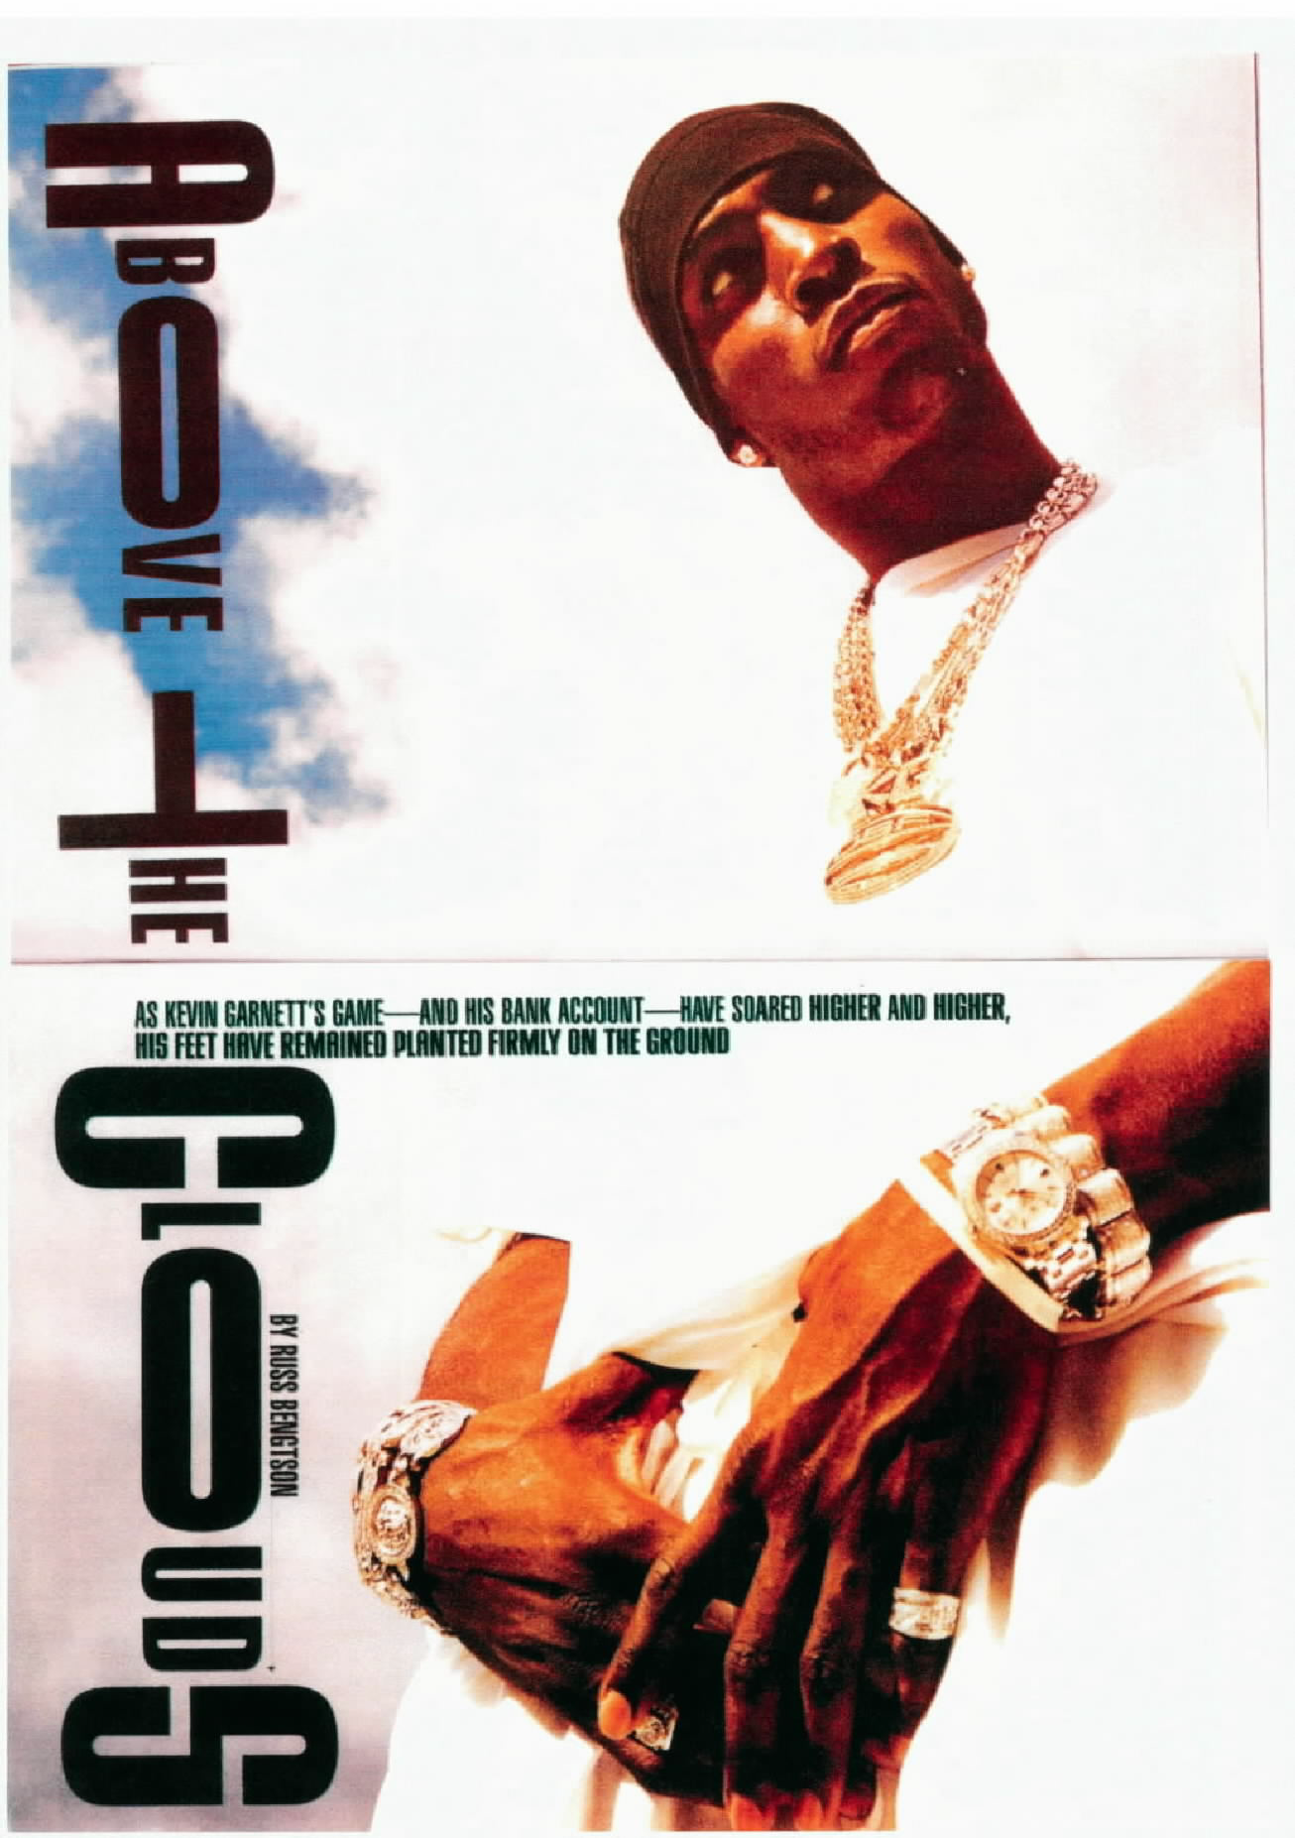
The Iced Out Comp Board

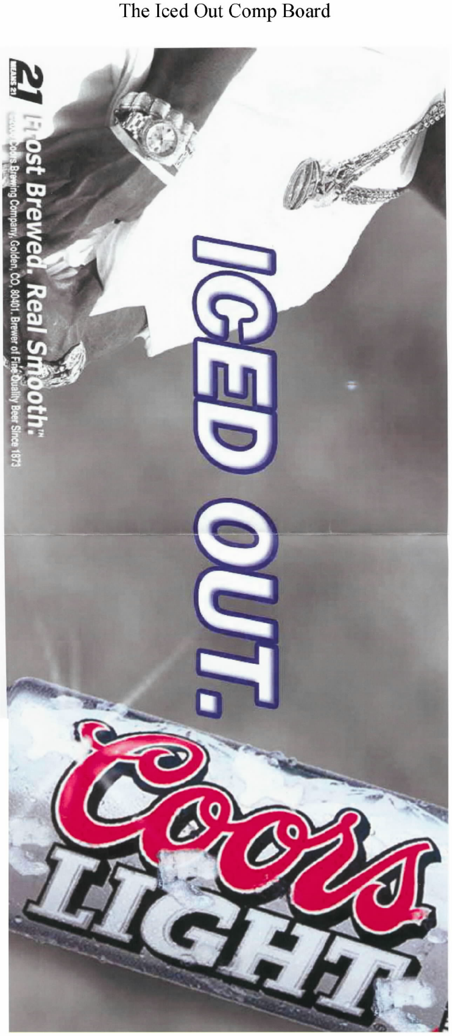

The Coors Billboard

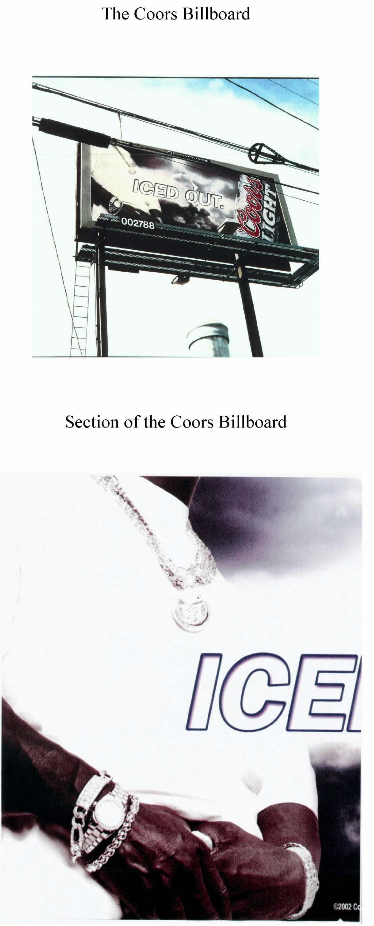

Section of the Coors Billboard

The plaintiff's photograph in Kaplan v. Stock Market Photo Agency, Inc.

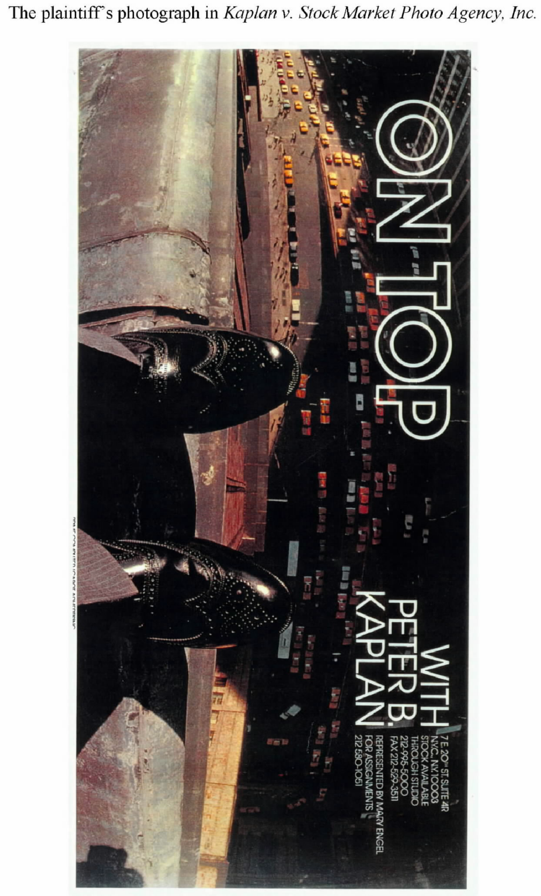

The defendant's photograph in Kaplan

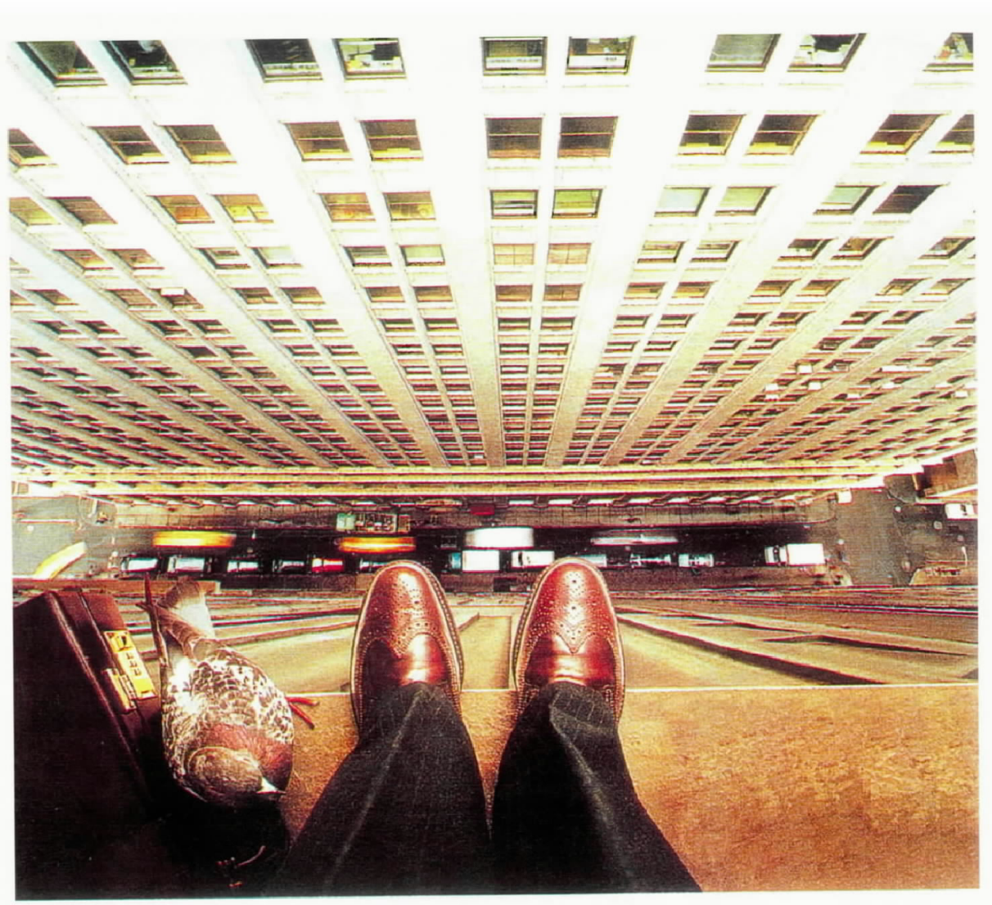

Mannion Decl. P 1.
Id. P 3.
See Pl. Ex. A.
See id.; Def. Ex. A; Am. Cpt. Ex. B.
Published opinions in copyright cases concerning graphical works do not often include reproductions of those works. Two exceptions are Knitwaves, Inc. v. Lollytogs Ltd., 71 F.3d 996, 1014-17 (2d Cir. 1996) and Tufenkian Import/Export Ventures, Inc. v. Einstein Moomjy, Inc., 237 F. Supp. 2d 376, 390-93 (S.D.N.Y. 2002). Such reproductions are helpful in understanding the opinions, even if the images are not ideal because the West reporters print in black and white.
Def. Ex. A; Pl. Ex. A; Am. Cpt. Ex. B; Mannion Decl. PP 4-5, 7-8.
Cook Decl. P 2.
See Mannion Decl. P 12; Cook Decl. P 4; Fournier v. Erickson, 202 F. Supp. 2d 290, 292 (S.D.N.Y. 2002).
See, e.g., AMERICAN HERITAGE DICTIONARY 868 (4th ed. 2000).
See Cook Decl. PP 3, 5; Pl. Ex. B.
See Cook Decl. P 5; Def. Ex. B. The authorization was for "usage in internal corporate merchandising catalog," Def. Ex. B, which Mannion concedes extended to the Iced Out Comp Board. See Pl. Opening Mem. 2; Pl. Reply Mem. 2.
See Pl. Ex. B.
Cook Decl. P 6; Mannion Decl. PP 12, 17-19.
See Def. Ex. C; Am. Cpt. Ex. C.
Cook Decl. P 7.
See Def. Ex. C; Am. Cpt. Ex. C.
Mannion Decl. P 20.
Am. Cpt. Ex. A.
Id.
FED. R. CIV. P. 56(c); Anderson v. Liberty Lobby, Inc., 477 U.S. 242, 248, 91 L. Ed. 2d 202, 106 S. Ct. 2505 (1986); White v. ABCO Eng'g Corp., 221 F.3d 293, 300 (2d Cir. 2000).
Adickes v. S.H. Kress & Co., 398 U.S. 144, 157, 26 L. Ed. 2d 142, 90 S. Ct. 1598 (1970).
United States v. Diebold, Inc., 369 U.S. 654, 655, 8 L. Ed. 2d 176, 82 S. Ct. 993 (1962); Hetchkop v. Woodlawn at Grassmere, Inc., 116 F.3d 28, 33 (2d Cir. 1997).
Hotel Employees & Restaurant Employees Union, Local 100 v. City of New York Dep't of Parks & Recreation, 311 F.3d 534, 543 (2d Cir. 2002) (quoting Heublein, Inc. v. United States, 996 F.2d 1455, 1461 (2d Cir. 1993) (internal quotation marks omitted)); accord Make the Road by Walking, Inc. v. Turner, 378 F.3d 133, 142 (2d Cir. 2004).
Knitwaves, Inc. v. Lollytogs Ltd., 71 F.3d 996, 1002 (2d Cir. 1995) (second emphasis added) (quoting Fisher-Price, Inc. v. Well-Made Toy Mfg. Corp., 25 F.3d 119, 122-23 (2d Cir. 1994)); accord Tufenkian Import/Export Ventures, Inc. v. Einstein Moomjy, Inc., 338 F.3d 127, 131 (2d Cir. 2003) (citing Castle Rock Entm't, Inc. v. Carol Publ'g Group, Inc., 150 F.3d 132, 137-38 (2d Cir. 1998)); Boisson v. Banian, Ltd., 273 F.3d 262, 267-68 (2d Cir. 2001) (citing Feist Pub'lns, Inc. v. Rural Tel. Serv. Co., 499 U.S. 340, 361, 113 L. Ed. 2d 358, 111 S. Ct. 1282 (1991) and Streetwise Maps, Inc. v. Vandam, Inc., 159 F.3d 739, 747 (2d Cir. 1998)); Fournier v. Erickson, 202 F. Supp. 2d 290, 294 (S.DN.Y. 2002).
4 NIMMER ON COPYRIGHT § 13.01[B], at 13-8 ("NIMMER").
E.g., Jorgensen v. Epic/Sony Records, 351 F.3d 46, 51 (2d Cir. 2003); Boisson, 273 F.3d at 267-68 (citing Laureyssens v. Idea Group, Inc., 964 F.2d 131, 140 (2d Cir. 1992)).
See Def. Opening Mem. 7; Def. Supp. Mem. 5.
Contrary to the implication in some of the plaintiff's papers, see Am. Cpt. PP 27-29; Pl. Opening Mem. 6; Pl. Supp. Mem. 6-10; see also Tr. (1/27/05) 8-11, 14-19, 25, 30-32, 34-36 ("Tr."), this case does not require a determination whether the defendants have violated the plaintiff's exclusive right under 17 U.S.C. § 106(2) to prepare derivative works based upon the Garnett Photograph. The image used on the Iced Out Comp Board may have been a derivative work based upon the Garnett Photograph, see 17 U.S.C. § 101 (2005), but CHWA obtained the right to use the Garnett Photograph in connection with the Iced Out Comp Board. The question whether the Coors Billboard is a derivative work based upon the Garnett Photograph is immaterial. "[A] work will be considered a derivative work only if it would be considered an infringing work" absent consent. 1 NIMMER § 3.01, at 3-4. That is, the infringement inquiry logically precedes or at least controls the derivative work inquiry. Finally--again contrary to the plaintiff's suggestion, see Pl. Opening Mem. 9; Pl. Reply Mem. 2-4; Tr. 21-24--also immaterial is the question whether the Coors Billboard may infringe Mannion's copyright if the Coors Billboard is not substantially similar to the Garnett Photograph but is substantially similar to the Garnett Photograph's hypothesized derivative on the Iced Out Comp Board. Mannion has no registered copyright in the image on the Iced Out Comp Board, which precludes a suit for infringement based upon that image. Well-Made Toy Mfg. Corp. v. Goffa Int'l Corp., 354 F.3d 112, 115-117 (2d Cir. 2003); 17 U.S.C. § 411(a) (2005). The only question in this case is whether the Coors Billboard infringes the copyright in the Garnett Photograph. The only material comparison therefore is between those two images. Accordingly, the complaint is dismissed to the extent that it asserts a violation of Mannion's exclusive right to prepare derivative works.
Feist Pub'lns, Inc. v. Rural Tel. Serv. Co., 499 U.S. 340, 345, 113 L. Ed. 2d 358, 111 S. Ct. 1282 (1991).
Id. at 348.
Id. at 345 (citing 1 NIMMER §§ 2.01[A], [B] (1990)).
1 NIMMER § 2.08[E][1], at 2-130.
E.g., Caratzas v. Time Life, Inc., 1992 U.S. Dist. LEXIS 16285, No. 92 Civ. 6346 (PKL), 1992 WL 322033, at *4 (S.D.N.Y. Oct. 23, 1992) (observing, in the context of photographs of historic sites, that "Justice Holmes made it clear almost ninety years ago that actionable copying does not occur where a photographer takes a picture of the subject matter depicted in a copyrighted photograph, so long as the second photographer does not copy original aspects of the copyrighted work, such as lighting or placement of the subject.").
See Rogers v. Koons, 960 F.2d 301 (2d Cir. 1992); Gross v. Seligman, 212 F. 930 (2d Cir. 1914).
1 NIMMER § 2.08[E][1], at 2-129; see also Bridgeman Art Library, Ltd. v. Corel Corp., 36 F. Supp. 2d 191, 196 (S.D.N.Y. 1999).
See Burrow-Giles Lithographic Co. v. Sarony, 111 U.S. 53, 28 L. Ed. 349, 4 S. Ct. 279, 1884 Dec. Comm'r Pat. 186 (1884); SHL Imaging, Inc. v. Artisan House, Inc., 117 F. Supp. 2d 301, 307-08 (S.D.N.Y. 2000) (recounting the history of Burrow-Giles with reference to THE WAKING DREAM: PHOTOGRAPHY'S FIRST CENTURY 339-40 (Met. Museum of Art 1993)). The photograph at issue in Burrow-Giles is reproduced in MELVILLE B. NIMMER ET AL., CASES AND MATERIALS ON COPYRIGHT 11 (6th ed. 2000) ("CASES AND MATERIALS ON COPYRIGHT").
See Burrow-Giles Lithographic Co., 111 U.S. at 60 (originality of Wilde portrait founded upon overall composition, including pose, clothing, background, light, and shade, "suggesting and evoking the desired expression"); Leibovitz v. Paramount Pictures Corp., 137 F.3d 109, 116 (2d Cir. 1998) ("Leibovitz is entitled to protection for such artistic elements as the particular lighting, the resulting skin tone of the subject, and the camera angle that she selected."); Rogers v. Koons, 960 F.2d 301, 307 (2d Cir. 1992) ("Elements of originality in a photograph may include posing the subjects, lighting, angle, selection of film and camera, evoking the desired expression, and almost any other variant involved."); Gross v. Seligman, 212 F. 930, 931 (2d Cir. 1914) ("exercise of artistic talent" reflected in "pose, light, and shade, etc."); SHL Imaging, Inc. v. Artisan House, Inc., 117 F. Supp. 2d 301, 311 (S.D.N.Y. 2000) ("What makes plaintiff's photographs original is the totality of the precise lighting selection, angle of the camera, lens and filter selection."); E. Am. Trio Prods., Inc. v. Tang Elec. Corp., 97 F. Supp. 2d 395, 417 (S.D.N.Y. 2000) ("The necessary originality for a photograph may be founded upon, among other things, the photographer's choice of subject matter, angle of photograph, lighting, determination of the precise time when the photograph is to be taken, the kind of camera, the kind of film, the kind of lens, and the area in which the pictures are taken."); Kisch v. Ammirati & Puris Inc., 657 F. Supp. 380, 382 (S.D.N.Y. 1987) (copyrightable elements of a photograph "include such features as the photographer's selection of lighting, shading, positioning and timing."). Even these lists are not complete. They omit such features as the amount of the image in focus, its graininess, and the level of contrast.
Rogers v. Koons, 960 F.2d 301, 307 (2d Cir. 1992).
SHL Imaging, Inc. v. Artisan House, Inc., 117 F. Supp. 2d 301, 311 (S.D.N.Y. 2000).
E. Am. Trio Prods., Inc. v. Tang Elec. Corp., 97 F. Supp. 2d 395, 417 (S.D.N.Y. 2000) (Kaplan, J.).
Feist, 499 U.S. at 359-60.
36 F. Supp. 2d 191 (S.D.N.Y. 1999).
Id. at 197; Bridgeman Art Library, Ltd. v. Corel Corp., 25 F. Supp. 2d 421, 427 & nn. 41, 47 (S.D.N.Y. 1998).
HON. SIR HUGH LADDIE ET AL., THE MODERN LAW OF COPYRIGHT AND DESIGNS (3d ed. Butterworths 2000) ("LADDIE").
See Copyright, Designs and Patents Act 1988, c. 48, § 1(1)(a); 1 LADDIE § 1.8.
See 1 LADDIE § 4.57, at 229.
Id.
See Caratzas v. Time Life, Inc., 1992 U.S. Dist. LEXIS 16285, No. 92 Civ. 6346 (PKL), 1992 WL 322033, at *4 (S.D.N.Y. Oct. 23, 1992); Leigh v. Warner Bros., 212 F.3d 1210, 1214 (11th Cir. 2000); see also Bleistein v. Donaldson Lithographing Co., 188 U.S. 239, 249, 47 L. Ed. 460, 23 S. Ct. 298, 1903 Dec. Comm'r Pat. 650 (1903) ("It is obvious also that the plaintiff's case is not affected by the fact, if it be one, that the pictures represent actual groups-visible things. They seem from the testimony to have been composed from hints or description, not from sight . . . . But even if they had been drawn from the life, that fact would not deprive them of protection. The opposite proposition would mean that a portrait by Velasquez or Whistler was common property because others might try their hand on the same face. Others are free to copy the original. They are not free to copy the copy."); Franklin Mint Corp. v. Nat'l Wildlife Art Exchange, Inc., 575 F.2d 62, 65 (3d Cir. 1978) (same); F. W. Woolworth Co. v. Contemporary Arts, Inc., 193 F.2d 162, 164 (1st Cir. 1951) ("It is the well established rule that a copyright on a work of art does not protect a subject, but only the treatment of a subject."); BENJAMIN KAPLAN, AN UNHURRIED VIEW OF COPYRIGHT 56 (1967) (observing that, with respect to "works of 'fine art,'" "the manner of execution is usually of more interest than the subject pictured.").
117 F. Supp. 2d 301 (S.D.N.Y. 2000).
Id. at 311.
1 LADDIE § 4.57, at 229.
234 F. 963 (S.D.N.Y. 1916).
Id. at 964.
A digital image of the photograph may be found at http://www.fulcrumgallery.com/print_38089.aspx (last visited July 20, 2005).
A digital image appears at http://www.gallerym.com/work.cfm?ID=69 (last visited July 20, 2005).
See, e.g., http://www.raydoan.com/6140.asp (last visited July 20, 2005); http://www.shusterimages.net/Bears%20at%20Brooks%20Falls.htm (last visited July 20, 2005).
1 LADDIE § 4.57, at 229.
960 F.2d 301 (2d Cir. 1992).
212 F. 930 (2d Cir. 1914).
For a reproduction of the works at issue in Rogers v. Koons, see ROBERT C. OSTERBERG & ERIC C. OSTERBERG, SUBSTANTIAL SIMILARITY IN COPYRIGHT LAW A-24, A-25 (Practising Law Institute 2003).
960 F.2d at 304.
See id. ("When Rogers went to [Jim Scanlon's] home . . . he decided that taking a picture of the puppies alone [as Scanlon originally had requested] would not work successfully, and chose instead to include [the Scanlons] holding them. . . . [Rogers] selected the light, the location, the bench on which the Scanlons are seated and the arrangement of the small dogs.").
The two photographs are reproduced in CASES AND MATERIALS ON COPYRIGHT 211.
212 F. at 930-31. Also part of the court's analysis was the observation that there were "many close identities of . . . light[] and shade." Id.
I recognize that the preceding analysis focuses on a medium--traditional print photography--that is being supplanted in significant degree by digital technology. These advancements may or may not demand a different analytical framework.
Mannion Decl. PP 4-7, 9.
Def. Reply Mem. 10-11. The defendants complain as well that Mannion's declaration does not mention, among other things, the type of film, camera, and filters that he used to produce the Garnett Photograph. Id. at 11. These omissions are irrelevant. As discussed above, originality in the rendition is assessed with respect to the work, not the artist's specific decisions in producing it.
Knitwaves, Inc. v. Lollytogs Ltd., 71 F.3d 996, 1003 (2d Cir. 1995) (citation omitted).
Def. Br. 6.
See 4 NIMMER § 13.03[B][2][a]; 17 U.S.C. § 102(b).
4 NIMMER § 13.03[B][3].
133 F. Supp. 2d 317 (S.D.N.Y. 2001).
The Kaplan decision itself characterized the "idea" as "a businessperson contemplating a leap from a tall building onto the city street below," see id. at 323, but this characterization does not fully account for the disposition of the case. The court agreed with the defendants that: "in order to most accurately express this idea . . ., the photograph must be taken from the 'jumper's' own viewpoint, which would (i) naturally include the sheer side of the building and the traffic below, and (ii) logically restrict the visible area of the businessperson's body to his shoes and a certain portion of his pants legs . . . . Thus, the angle and viewpoint used in both photographs are essential to, commonly associated with, and naturally flow from the photograph's unprotectable subject matter. . . . The most common, and most effective, viewpoint from which the convey the idea of the 'jumper' . . . remains that of the 'jumper' himself." Id. at 326. The Kaplan court's observations about the angle and viewpoint "essential to" and "commonly associated with," that "naturally flow from," "most accurately express," and "most effectively" convey the "idea of a businessperson's contemplation of a leap" are unpersuasive. Thus, the opinion is best read to hold that the "idea" expressed was that of a businessperson contemplating suicide as seen from his own vantage point because only this reading explains the outcome.
Nichols v. Universal Pictures Corp., 45 F.2d 119, 121 (2d Cir. 1930) (citation omitted). This passage is often referred to as the abstractions test, but it is no such thing. Judge Newman has lamented this parlance and the underlying difficulty it elides: "Judge Hand manifestly did not think of his observations as the enunciation of anything that might be called a 'test.' His disclaimer (for himself and everyone else) of the ability to 'fix the boundary' should have been sufficient caution that no 'test' capable of yielding a result was intended." Hon. Jon O. Newman, New Lyrics for an Old Melody: The Idea/Expression Dichotomy in the Computer Age, 17 CARDOZO ARTS & ENT. L.J. 691, 694 (1999).
Peter Pan Fabrics, Inc. v. Martin Weiner Corp., 274 F.2d 487, 489 (2d Cir. 1960).
See, e.g., Attia v. Soc'y of the N.Y. Hosp., 201 F.3d 50, 54 (2d Cir. 1999) (quoting Peter Pan Fabrics); Williams v. Crichton, 84 F.3d 581, 587-588 (2d Cir. 1996) ("The distinction between an idea and its expression is an elusive one."); Durham Indus., Inc. v. Tomy Corp., 630 F.2d 905, 912 (2d Cir. 1980) (quoting Peter Pan Fabrics and characterizing "the idea/expression distinction" as "an imprecise tool"); Reyher v. Children's Television Workshop, 533 F.2d 87, 91 (2d Cir. 1976) (acknowledging that "the demarcation between idea and expression may not be susceptible to overly helpful generalization"); Herbert Rosenthal Jewelry Corp. v. Kalpakian, 446 F.2d 738, 742 (9th Cir. 1971) ("At least in close cases, one may suspect, the classification the court selects may simply state the result reached rather than the reason for it."); Fournier v. Erickson, 202 F. Supp. 2d 290, 295 (S.D.N.Y. 2002) ("the distinction between the concept and the expression of a concept is a difficult one"); see also BENJAMIN KAPLAN, AN UNHURRIED VIEW OF COPYRIGHT 48 (1967) ("We are in a viscid quandary once we admit that 'expression' can consist of anything not close aboard the particular collocation in its sequential order. The job of comparison is not much eased by speaking of patterns, nor is the task of deciding when the monopoly would be too broad for the public convenience made much neater by speaking of ideas and expression. The polarity proposed by Hand is indeed related geneologically to the ancient opposition of idea to form, but the ancestor is not readily recognized in the ambiguous and elusive descendant.").
"While we are as aware as any one that the line, whereever it is drawn, will seem arbitrary, that is no excuse for not drawing it; it is a question such as courts must answer in nearly all cases." Nichols, 45 F.2d at 122.
There appears to be no Supreme Court case explicitly making the distinction any earlier than Holmes v. Hurst, 174 U.S. 82, 43 L. Ed. 904, 19 S. Ct. 606, 1899 Dec. Comm'r Pat. 433 (1899), in which the Court observed that the Copyright Act protects "that arrangement of words which the author has selected to express his ideas." Id. at 86.
One non-literary case in which the Supreme Court referred to the idea/expression distinction was Mazer v. Stein, 347 U.S. 201, 217-18, 98 L. Ed. 630, 74 S. Ct. 460, 1954 Dec. Comm'r Pat. 308 (1954), which is described below in footnote 80.
In cases dealing with toys or products that have both functional and design aspects, courts sometimes use "idea" to refer to a gimmick embodied in the product. See, e.g., Mazer v. Stein, 347 U.S. 201, 217-18, 98 L. Ed. 630, 74 S. Ct. 460, 1954 Dec. Comm'r Pat. 308 (1954) (court, after introducing idea/expression dichotomy, stated that plaintiffs, who had copyrights in statuettes of human figures used as table lamps, "may not exclude others from using statuettes of human figures in table lamps; they may only prevent use of copies of their statuettes as such or as incorporated in some other article."); Herbert Rosenthal Jewelry Corp. v. Kalpakian, 446 F.2d 738, 742 (9th Cir. 1971) (bejeweled gold pin in the shape of a bee was an unprotected "idea"); Herbert Rosenthal Jewelry Corp. v. Honora Jewelry Co., 509 F.2d 64, 65-66 (2d Cir. 1974) (same for turtle pins); Great Importations, Inc. v. Caffco Int'l, Inc., 1997 U.S. Dist. LEXIS 10700, No. 95 Civ. 0514, 1997 WL 414111, at *4 (S.D.N.Y. July 24, 1997) (M.J.) ("To the degree the similarities between the two sculptures herein are simply because they are both three-piece sets of candleholders in the shape of the letters J, O and Y with baby angels and holly, those similarities are non-copyrightable ideas . . . ."). This case does not concern any kind of gimmick, and the Court ventures no opinion about the applicability of the idea/expression dichotomy to any product that embodies a gimmick, including toys or other objects that combine function and design.
See Gross v. Seligman, 212 F. 930, 931 (2d Cir. 1914); Kaplan v. Stock Market Photo Agency, Inc., 133 F. Supp. 2d 317, 323 (S.D.N.Y. 2001); Andersson v. Sony Corp. of Am., 1997 U.S. Dist. LEXIS 5948, No. 96 Civ. 7975 (RO), 1997 WL 226310, at *2 (S.D.N.Y. May 2, 1997); Kisch v. Ammirati & Puris Inc., 657 F. Supp. 380, 382 (S.D.N.Y. 1987); Pagano v. Chas. Beseler Co., 234 F. 963, 964 (S.D.N.Y. 1916).
The terminology can be still more confused. Consider this sentence, in a section of an opinion analyzing what was original, and hence protectible, in a photograph created by a freelancer in accordance with instructions from a defendant: "Defendants conclude that Fournier cannot assert copyright protection, to the extent that he does, over the expression of businessmen in traditional dress on their way to work, an idea which originated with McCann in any event." Fournier v. Erickson, 202 F. Supp. 2d 290, 295 (S.D.N.Y. 2002) (emphases added).
274 F.2d at 489.
Newman, New Lyrics for an Old Melody, supra, at 697.
720 F.2d 231 (2d Cir. 1983). In that case, which considered the question whether the protagonist of the television series The Greatest American Hero infringed the copyright in the Superman character, Judge Newman observed that a tension between two different propositions dealing with the significance of differences between an allegedly infringing work and a copyrighted work "perhaps results from [those propositions'] formulation in the context of literary works and their subsequent application to graphic and three-dimensional works." Id. at 241.
Newman, New Lyrics for an Old Melody, supra, at 698.
Franklin Mint Corp. v. Nat'l Wildlife Art Exchange, Inc., 575 F.2d 62, 65 (3d Cir. 1978); accord Kisch v. Ammirati & Puris Inc., 657 F. Supp. 380, 383 (S.D.N.Y. 1987).
960 F.2d at 308 (first emphasis added).
89 Def. Br. 6. See supra.
See SHL Imaging, Inc. v. Artisan House, Inc., 117 F. Supp. 2d 301, 314 (S.D.N.Y. 2000) ("defendants' instructions were so general as to fall within the realm of unprotectible ideas. Thus, they cannot substantiate a work-for-hire authorship defense." (emphasis added)); Andersson v. Sony Corp., 1997 U.S. Dist. LEXIS 5948, No. 96 Civ. 7975 (RO), 1997 WL 226310, at *3 (S.D.N.Y. May 2, 1997) ("What these two photos may arguably share, the idea of a woman in futuristic garb becoming fascinated with an object held in her hand, is simply not protectible." (emphasis added)); Gentieu v. Tony Stone Images/Chicago, Inc., 255 F. Supp. 2d 838, 849 (N.D. Ill. 2003) ("Gentieu cannot claim a copyright in the idea of photographing naked or diapered babies or in any elements of expression that are intrinsic to that unprotected idea. Clearly the 'poses' at issue in Gentieu's images capture the natural movements and facial expressions of infants . . . . Such poses are implicit in the very idea of a baby photograph and are not proper material for protection under Gentieu's copyrights." (emphases added)). It is interesting to note that United Kingdom law faces a similar terminological problem and that the solution of Laddie and supporting authorities is to conclude that the generality of an "idea" is what determines its protectability: "Confusion is caused in the law of copyright because of the use of the catchphrase 'There is no copyright in ideas but only in the form of their expression'. Unless one understands what this means its utility is non-existent, or it is positively misleading. An artistic work of the imagination presupposes two kinds of ingredients: the conception of one or more ideas, and artistic dexterity and skill in their representation in the chosen medium. It is not the law that copyright protects the second kind of ingredient only. If that were so a debased copy which failed to capture the artist's dexterity and skill would not infringe, which plainly is not the case. Unless an artist is content merely to represent a pre-existent object (eg a building) or scene, it is part of his task as artist to exercise his imagination and in so doing he may create a pattern of ideas for incorporation in his finished work. This idea-pattern may be as much part of his work, and deserving of copyright protection, as the brushstrokes, pencil-lines, etc. The true proposition is that there is no copyright in a general idea, but that an original combination of ideas may [be protected]." 1 LADDIE § 4.43, at 212 (footnote omitted).
133 F. Supp. 2d at 323 (emphases added).
Yurman Design, Inc. v. PAJ, Inc., 262 F.3d 101, 111 (2d Cir. 2001) (quoting Hamil America, Inc. v. GFI, 193 F.3d 92, 100 (2d Cir. 1999) (quoting Peter Pan Fabrics, Inc. v. Martin Weiner Corp., 274 F.2d 487, 489 (2d Cir. 1960)) (internal quotation marks omitted)); accord Boisson v. Banian, Ltd., 273 F.3d 262, 272 (2d Cir. 2001) (quoting Folio Impressions, Inc. v. Byer California, 937 F.2d 759, 765 (2d Cir. 1991)).
Hamil America, Inc., 193 F.3d at 101; accord Knitwaves, Inc. v. Lollytogs Ltd., 71 F.3d 996, 1002 (2d Cir. 1995); Folio Impressions, 937 F.2d at 765-66; see also Boisson, 273 F.3d at 272.
Boisson, 273 F.3d at 272 (citing Knitwaves, 71 F.3d at 1003); accord Hamil America, 193 F.3d at 101.
338 F.3d 127 (2d Cir. 2003).
See 237 F. Supp. 2d 376, 386-88 (S.D.N.Y. 2002).
338 F.3d at 130 (emphasis in original).
Id. at 134-35 (emphasis in original).
Id. at 132-33 (quoting Sheldon v. Metro-Goldwyn Pictures Corp., 81 F.2d 49, 56 (2d Cir. 1936)) (internal quotation marks omitted).
4 NIMMER § 13.03[B][1][a], at 13-63.
657 F. Supp. 380, 384 (S.D.N.Y. 1987).

