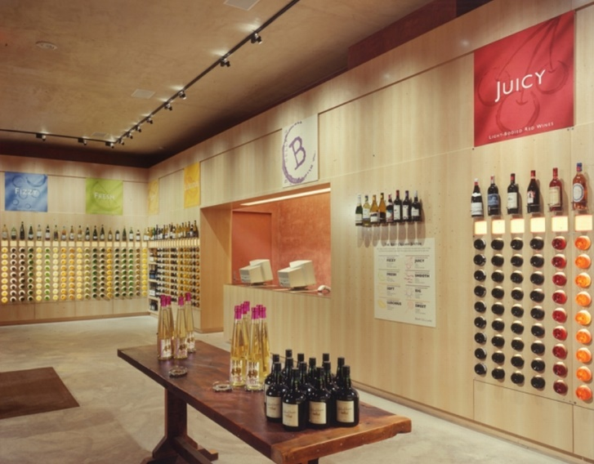

Best Cellars, Inc. v. Wine Made Simple, Inc.
320 F.Supp.2d 60, 69-70 (S.D.N.Y. 2003)
In Best Cellars, the plaintiff, a wine retailer based in New York City, broadly claimed as its trade dress
the total effect of the interior design of its store, which it describes as: (1) eight words differentiating taste categories; (2) eight colors differentiating taste categories; (3) eight computer manipulated images differentiating taste categories; (4) taste categories set above display fixtures by order of weight; (5) single display bottles set on stainless-steel wire pedestals; (6) square 4”x4” cards with verbal descriptions of each wine (“shelf talkers”) with text arranged by template; (7) shelf talkers positioned at eye level, below each display bottle; (8) bottles vertically aligned in rows of nine; (9) storage cabinets located beneath vertically aligned bottled; (10) materials palette consisting of light wood and stainless steel; (11) mixture of vertical racks and open shelving display fixtures; (12) no fixed aisles; (13) bottles down and back-lit; and (14) limited selection (approximately 100) of relatively inexpensive wine.
Id. at 70.
Judge Lynch briefly analyzed whether this constituted product packaging trade dress or product configuration trade dress as follows:
Unlike more traditional trade dress cases that concern product packaging (like water bottles, see Nora Beverages, Inc. v. Perrier Group of America, Inc., 269 F.3d 114 (2d Cir. 2001)) or product designs (like children’s clothing, see Samara Bros., 529 U.S. at 213), this case concerns the interior decor of a retail establishment where customers purchase other products. In this, the case is similar to Two Pesos, which concerned the interior decor of Mexican-themed restaurants. See Two Pesos, 505 U.S. at 764–65 n. 1 (noting that trade dress “may include features such as size, shape, color or color combinations, texture, graphics, or even particular sales techniques” (citations and internal quotation marks omitted)). As the Supreme Court explained, the interior decor category fits awkwardly into the classifications of trade dress law, constituting either product packaging or a “tertium quid” akin to product packaging. Samara Bros., 529 U.S. at 215. Interior decor is thus clearly not product design. Accordingly, it is appropriate to analyze the Best Cellars’ interior decor trade dress under the product packaging standard for inherent distinctiveness . . . .
Id. at 69-70.

From Rockwell Group, http://www.rockwellgroup.com/projects/entry/best-cellars.

