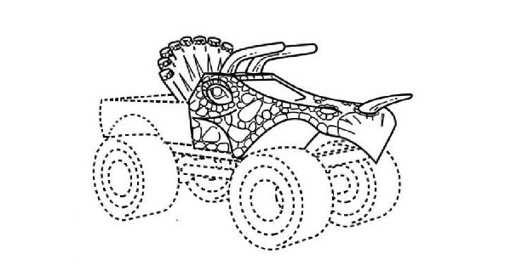

In re Frankish Enterprises Ltd.
113 U.S.P.Q.2d 1964 (TTAB 2015)
In In Re Frankish Enterprises Ltd., the applicant sought to register the above-pictured three-dimensional mark for “[e]ntertainment services, namely, performing and competing in motor sports events in the nature of monster truck exhibitions.” The applicant described the mark as follows: “The mark consists of a truck cab body in the design of a fanciful, prehistoric animal. The matter shown by dotted lines is not part of the mark, but serves only to show the position of the mark.” The TTAB concluded that the mark was capable of inherent distinctiveness:
Applicant does not seek registration of its design for a product, it seeks registration of its “fanciful, prehistoric animal” design for its monster truck exhibition services, and under Two Pesos, trade dress for services may be inherently distinctive. Indeed, Applicant’s service is exhibiting its monster truck in action, such as doing wheelies, jumping over and crushing smaller vehicles and otherwise entertaining fans with the truck’s size, power and sheer awesomeness, which could be performed with or without the “fanciful, prehistoric animal” design on the outside of the truck, just as Taco Cabana’s service of offering Mexican food to restaurant customers could be performed without the particular interior design found to be inherently distinctive in Two Pesos. {T}he “fanciful, prehistoric animal” design is akin to the packaging of what is being sold, in this case Applicant’s monster truck services.
In Re Frankish Enterprises Ltd., 113 U.S.P.Q.2d 1964, 2015 WL 1227728, at *4 (TTAB 2015). (For the Board’s determination of whether in fact the mark was inherently distinctive, see below in Part I.A.2.c).
Having concluded that the mark was capable of inherent distinctiveness as “akin to the packaging of” the applicant’s monster truck services, the TTAB applied the Seabrook factors as follows to find that the mark was inherently distinctive:
Here, the evidence made of record by the Examining Attorney fails to show that Applicant’s “fanciful, prehistoric animal” design is either a common or a basic shape or design. Rather, it is unique among the more than 100 monster trucks depicted in the Examining Attorney’s image search results. To the extent that two of the monster trucks among those results have certain characteristics in common with Applicant’s mark, they are nevertheless readily distinguishable from Applicant’s unique design which includes peculiar horns, scales, a protective shield and other features which neither Swamp Thing nor the “Raptors” monster trucks share. Indeed, Applicant’s monster truck is “unique” and “unusual” in the monster truck field. The Examining Attorney provided scant, if any, evidence that Applicant’s truck is a “mere refinement” of anything, let alone a “commonly-adopted” and “well-known form” in the monster truck field. To the contrary, the totality of the record makes clear that Applicant’s truck stands alone in the quality and quantity of its distinctive traits which set it apart from the other monster trucks about which the Examining Attorney submitted evidence, as the body of Applicant’s truck is cut and molded to convey the body of a dinosaur and adorned with other dinosaur elements, including horns, a protective shield and eyes bordered by scales. These elements are unique and make Applicant’s truck unlike any of those included in the Examining Attorney’s search results.
In Re Frankish Enterprises Ltd., 113 U.S.P.Q.2d 1964, 2015 WL 1227728, at *5 (TTAB 2015).

