In re Lizzo LLC
United States Patent and Trademark Office
Trademark Trial and Appeal Board
Serial Nos. 88466264 and 88466281
Hearing: October 5, 2022 Mailed: February 2, 2023
This Opinion is a Precedent of the TTAB
Before Cataldo, Pologeorgis and Coggins, Administrative Trademark Judges.
Opinion by Cataldo, Administrative Trademark Judge:
Applicant, Lizzo LLC, seeks registration on the Principal Register of 100% THAT BITCH (in standard characters), as a mark identifying the following goods in International Class 25: “Clothing, namely, shirts, jackets, jerseys, beanies, baseball hats, headwear, shorts, tank tops, sweatshirts, long sleeve shirts, hooded sweatshirts, hooded shirts, bandannas, wristbands as clothing, headbands, shoes and sleepwear;” and “Clothing, namely, t-shirts.”
The Trademark Examining Attorney refused registration in each application of 100% THAT BITCH under Trademark Act Sections 1, 2, and 45, 15 U.S.C. §§1051- 1052, and 1127, for failure to function as a mark on the basis that 100% THAT BITCH “is a commonplace expression widely used by a variety of sources to convey an ordinary, familiar, well-recognized sentiment.”
In response to the initial refusal, Applicant explained that it is the trademark holding company of the popular singer and performer known as Lizzo, and that the proposed mark was inspired by a lyric in one of Lizzo’s songs entitled “Truth Hurts.” Applicant claimed that Lizzo adopted and has used the proposed mark in connection with her musical-artist related goods and services, including clothing, and the proposed mark is definitively associated with her.
Unpersuaded by Applicant’s arguments, the Examining Attorney made the refusals final, after which Applicant appealed and requested reconsideration. When the Examining Attorney denied the requests for reconsideration, the appeals were resumed and consolidated. The appeals are fully briefed. Applicant’s counsel and the Examining Attorney appeared for an oral hearing before the Board.
We reverse the refusals to register.
I. Applicable Law
A. Statutory Definition of a Trademark
When a proposed mark fails to meet the statutory definition of a trademark, it is ineligible for registration. Sections 1, 2 and 45 of the Trademark Act provide the statutory basis for refusal to register subject matter that fails to function as a trademark. 15 U.S.C. §§ 1051, 1052 and 1127. Specifically:
Sections 1 and 2 provide for the application and registration on the Principal Register of “trademark[s] by which the goods of the applicant may be distinguished from the goods of others”; and
Section 45 defines a “trademark” in pertinent part, as “any word, name, symbol, or device, or any combination thereof . . . used by a person, or . . . which a person has a bona fide intention to use in commerce … to identify and distinguish his or her goods, including a unique product, from those manufactured or sold by others, and to indicate the source of the goods, even if that source is unknown.”
The Office thus “is statutorily constrained to register matter on the Principal Register if and only if it functions as a mark.” In re Brunetti, 2022 USPQ2d 764, at *9 (TTAB 2022); see also In re Vox Populi Registry, Ltd., 25 F.4th 1348, 2022 USPQ2d 115, at *2 (Fed. Cir. 2022) (“Under the Lanham Act, ‘no service mark by which the services of the applicant may be distinguished from the services of others shall be refused registration on the principal register on account of its nature’ subject to certain exceptions. 15 U.S.C. §§ 1052-53. One of these exceptions is that a service or trademark must function to ‘identify and distinguish the services of one person ... from the services of others and to indicate the source of the services.’ 15 U.S.C. §1127.”) (cleaned up); In re Standard Oil Co., 275 F.2d 945, 125 USPQ 227, 228 (CCPA 1960) (“The Trademark Act is not an act to register words but to register trademarks. Before there can be registrability, there must be a trademark ... .”); see also, e.g., In re The Ride, LLC, 2020 USPQ2d 39644, at *5-6 (TTAB 2020). “Matter that does not operate to indicate the source or origin of the identified goods or services and distinguish them from those of others does not meet the statutory definition of a trademark and may not be registered ... .” In re Greenwood, 2020 USPQ2d 11439, at *2 (TTAB 2020) (quoting In re AC Webconnecting Holding B.V., 2020 USPQ2d 11048, at *2-3 (TTAB 2020)).
B. Failure to Function
“Not every designation adopted with the intention that it perform a trademark function necessarily accomplishes that purpose.” In re Brunetti, 2022 USPQ2d 764, at *10; In re Tex. With Love, LLC, 2020 USPQ2d 11290, at *2-3 (TTAB 2020) (quoting In re Pro-Line Corp., 28USPQ2d 1141, 1142 (TTAB 1993) (“Mere intent that a phrase function as a trademark is not enough in and of itself to make it a trademark.”)); D.C. One Wholesaler, Inc. v. Chien, 120 USPQ2d 1710, 1713 (TTAB 2016) (granting petition to cancel registration on the Supplemental Register where “the marketplace is awash in products that display the term.”); see also Roux Labs., Inc. v. Clairol, Inc., 427 F.2d 823, 166 USPQ 34, 39 (CCPA 1970) (“The mere fact that a combination of words or a slogan [such as HAIR COLOR SO NATURAL ONLY HER HAIRDRESSER KNOWS FOR SURE] is adopted and used by a manufacturer with the intent [that it function as a trademark] does not necessarily mean that the slogan accomplishes that purpose in reality.”); Am. Velcro, Inc. v. Charles Mayer Studios, Inc., 177 USPQ 149, 154 (TTAB 1973).
“An applicant’s proposed mark must, by definition, ‘identify and distinguish his or her goods ... from those manufactured or sold by others and ... indicate the source of the goods, even if that source is unknown.’” Univ. of Ky. v. 40-0, LLC, 2021 USPQ2d 253, at *24 (TTAB 2021) (quoting Trademark Act Section 45, 15 U.S.C. § 1127). “Hence, a proposed trademark is registrable only if it functions as an identifier of the source of the applicant’s goods or services.” Id.; see also In re Bose Corp., 546 F.2d 893, 192 USPQ 213, 215 (CCPA 1976) (“[T]he classic function of a trademark is to point out distinctively the origin of the goods to which it is attached.”).
“In analyzing whether a proposed mark functions as a source identifier,” the Board focuses on “consumer perception,” Vox Populi, 2022 USPQ2d 115, at *2, just as it does in other contexts. See also Univ. of Ky., 2021 USPQ2d 253, at *25 (“The critical inquiry in determining whether a proposed mark functions as a trademark is how the relevant public perceives the term sought to be registered.”) (citing In re Greenwood, 2020 USPQ2d 11439, at *2); cf. U.S. Patent and Trademark Office v. Booking.com B.V., 591 U.S. ___, 2020 USPQ2d 10729, at *5 (2020) (emphasizing “the Lanham Act’s focus on consumer perception” in a case concerning whether a proposed mark is generic).
The Board and its reviewing courts long have held that slogans, phrases or terms that consumers perceive as “merely informational in nature . . . are not registrable.” In re Brunetti, 2022 USPQ2d 764, at *11 (quoting In re Eagle Crest, Inc., 96 USPQ2d 1227, 1229 (TTAB 2010) and citing additional cases). “Matter may be merely informational and fail to function as a trademark if it is a common term or phrase that consumers of the goods or services identified in the application are accustomed to seeing used by various sources to convey ordinary, familiar, or generally understood concepts or sentiments. Such widely used messages will be understood as merely conveying the ordinary concept or sentiment normally associated with them, rather than serving any source-indicating function.” Id. at *12, see also In re Greenwood, 2020 USPQ2d 11439, at *6 (“The more commonly a phrase is used, the less likely that the public will use it to identify only one source and the less likely that it will be recognized by purchasers as a trademark.”).
“‘[W]e look to [any] … evidence of record showing how the designation is actually used in the marketplace’” in evaluating consumer perception. In re Tex. with Love, 2020 USPQ2d 11290, at *2 (quoting In re Eagle Crest, 96 USPQ2d at 1229, and noting at *7 that “widespread use of a term or phrase may be enough to render it incapable of functioning as a trademark, regardless of the type of message.”). “Where the evidence suggests that the ordinary consumer would take the words at their ordinary meaning rather than read into them some special meaning distinguishing the goods and services from similar goods and services of others, then the words fail to function as a mark.” In re Ocean Tech., Inc., 2019 USPQ2d 450686, at *3 (TTAB 2019) (internal punctuation omitted). When “there are no limitations on the channels of trade or classes of consumers of the [goods] identified in the application, the relevant consuming public comprises all potential purchasers of … [such goods].” In re Team Jesus, LLC, 2020 USPQ2d 11489, at *3 (TTAB 2020). Here, the relevant consuming public consists of purchasers of clothing, i.e., the general public.
II. Arguments and Evidence of Record
A. The Examining Attorney’s Arguments and Evidence
The Examining Attorney argues: “the evidence of record indicates that consumers will not view applicant’s mark as a trademark indicating the source of the clothing only sold by applicant, but instead as a message of self-confidence and female empowerment used by many different entities in a variety of settings.”
The Examining Attorney specifies: “In the context of clothing, where the evidence shows that the wording in the mark is commonly used in an informational and ornamental manner on clothing and other retail items produced and sold by others, the mark is likely to be seen for the meaning of its wording and not as a source indicator.”
The Examining Attorney further argues that Lizzo did not originate the term 100% THAT BITCH, but merely popularized it.
Lizzo, herself, stated that the lyrics originated after seeing an internet meme containing the phrase “I just took a DNA Test, turns out I’m 100% that bitch,” which she later adopted and placed into her song “Truth Hurts.” Specifically, Lizzo is quoted that after seeing the meme containing the phrase it made her feel empowered, i.e., the phrase “made [her] feel like 100% that bitch.” By applicant’s own acknowledgment, she adopted these lyrics because of the message of female empowerment, and the party claiming prior use of the full lyric was given a coownership to the copyright of the lyrics. Accordingly, the phrase 100% THAT BITCH, as used by applicant, originated from as a derivation of the popular phrase “that bitch,” which was widely shared throughout social media by internet users.
The Examining Attorney concludes: “evidence that consumers may associate the phrase with the famous singer/song because it was a lyric in the singer’s song does not entitle the applicant as a singer-songwriter to appropriate for itself exclusive use of the phrase.”
Applicant’s specimen of use in application Serial No. 88466281 is reproduced below.
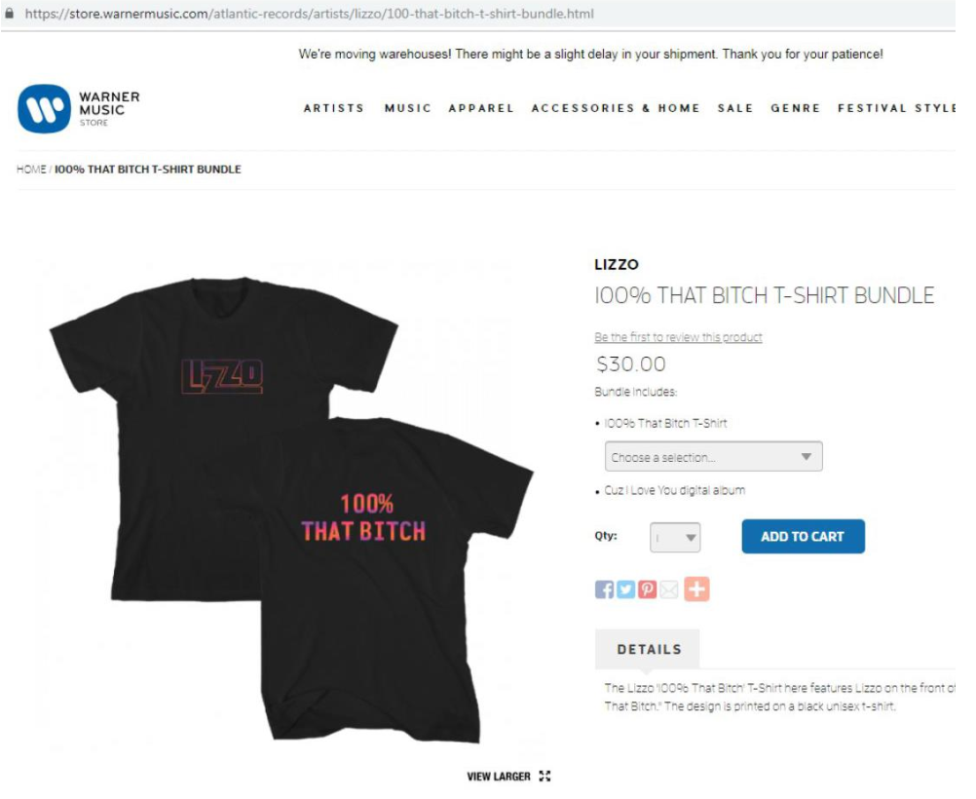

The Examining Attorney introduced into the record a page from the Urban Dictionary (urbandictionary.com) with the following entry for 100% THAT BITCH, explaining the message conveyed by the term:
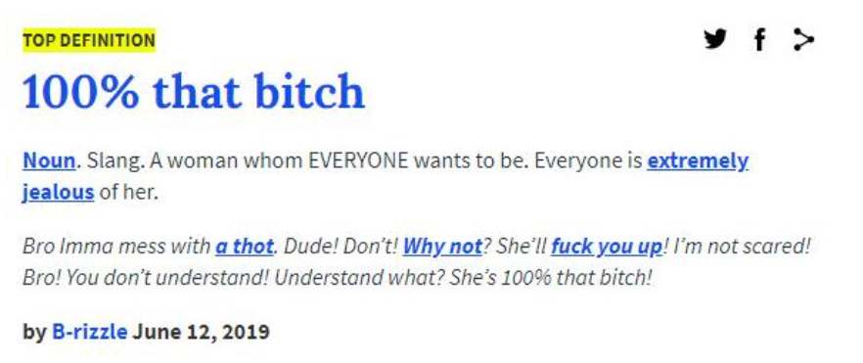
The Urban Dictionary is “a slang dictionary with definitions submitted by visitors to the website,” and although the Board has considered definitions from it in prior cases, we “recognize the inherent problems regarding the reliability of Urban Dictionary because it is a collaborative website that permits anyone to submit or edit a definition.” In re Star Belly Stitcher, Inc., 107 USPQ2d 2059, 2061 n.3 (TTAB 2013). “Urban Dictionary entries suffer from the same potential reliability problem that the Board has confronted with respect to Wikipedia,” id., thus the Board “will consider dictionary definitions taken from Urban Dictionary so long as the non-offering party has an opportunity to rebut that evidence by submitting other definitions that may call into question the accuracy of the particular Urban Dictionary definitions.” Id. The Board also noted that “the better practice with respect to such evidence is to corroborate the information with other reliable sources if available.” Id. In this case, we find the evidence of record as a whole corroborates the Urban Dictionary entry.
The Examining Attorney submitted lyrics from Lizzo’s single “Truth Hurts,” including the line “I just took a DNA test, turns out I’m 100% that bitch.”
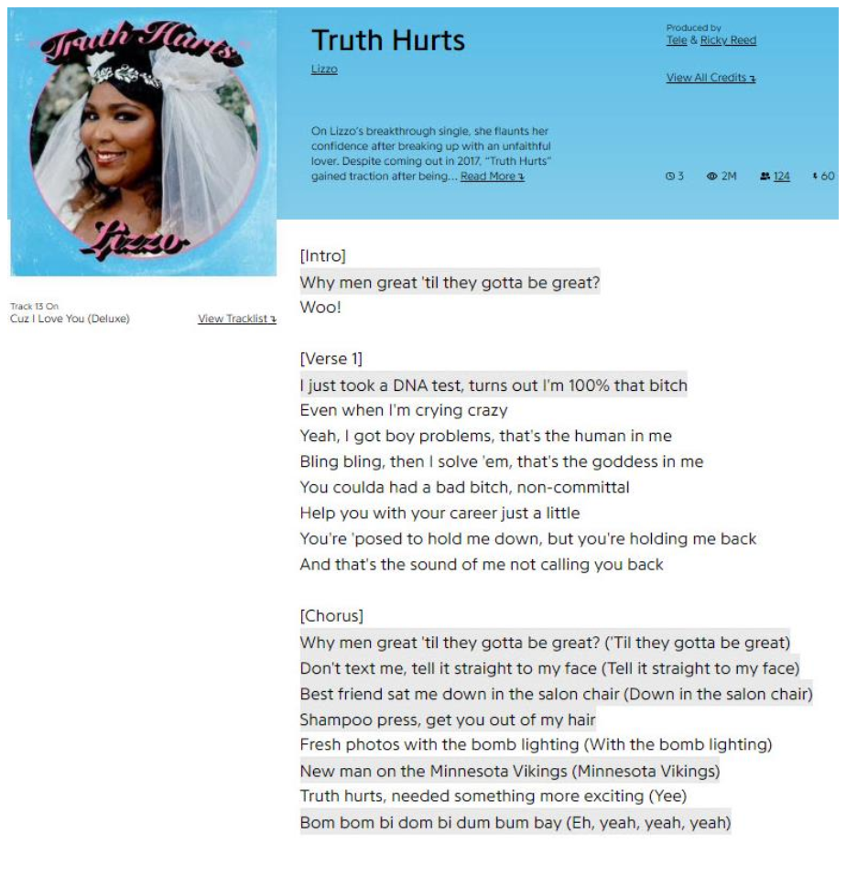
The Examining Attorney further introduced internet articles discussing Lizzo’s admission that she did not originate the expression “I just took a DNA test, turns out I’m 100% that bitch,” but rather adopted it from a 2017 Twitter meme.
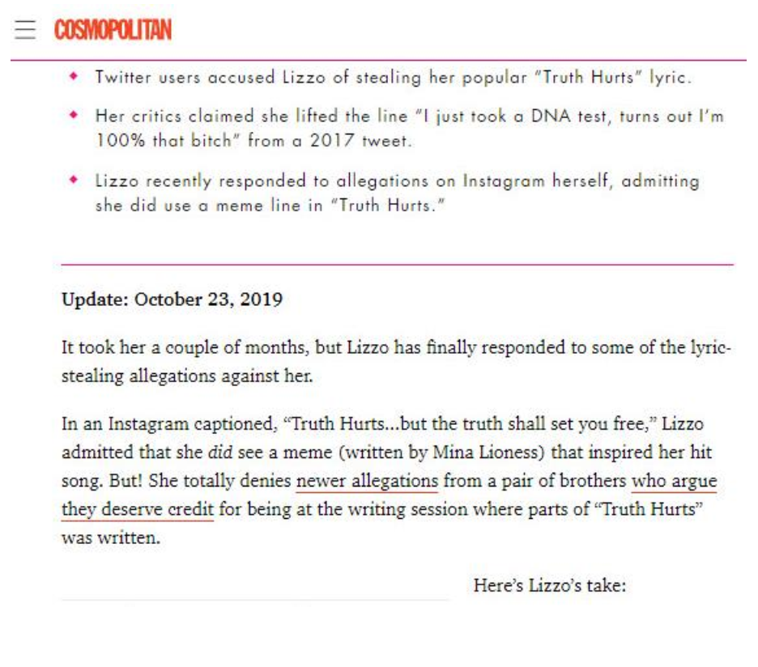
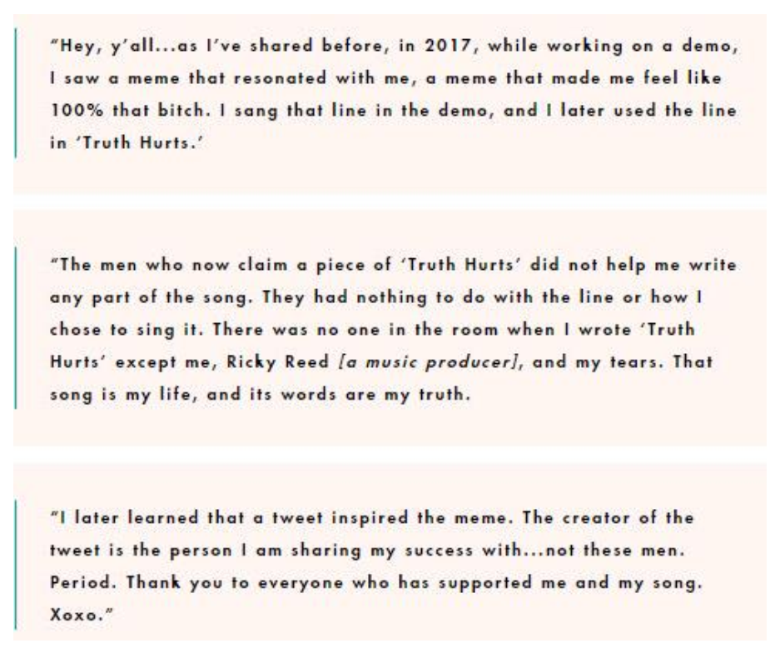
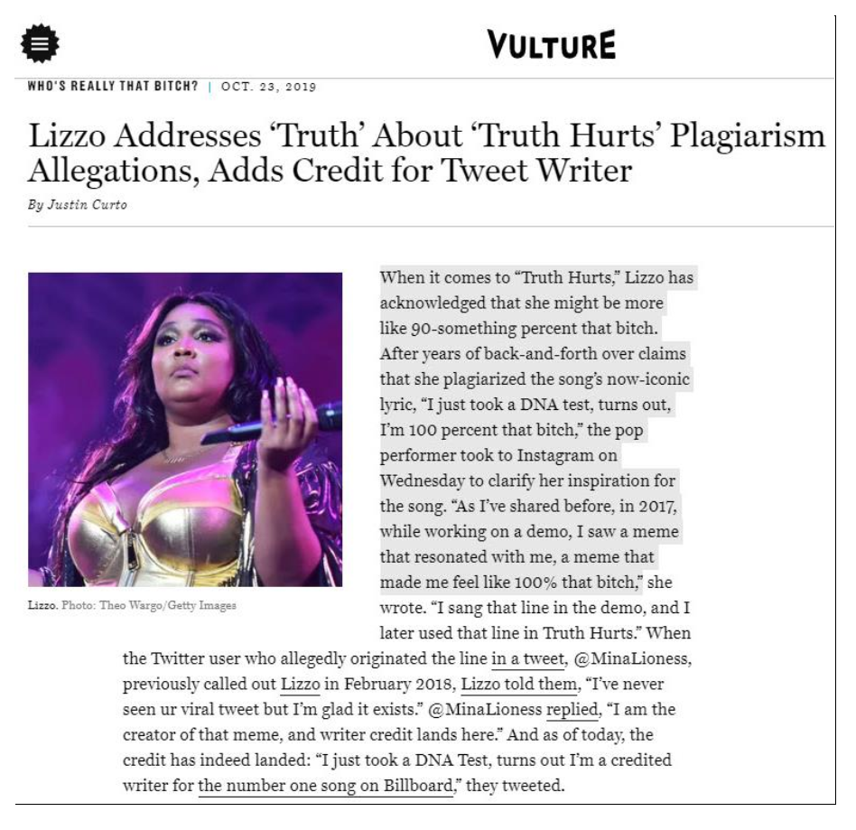
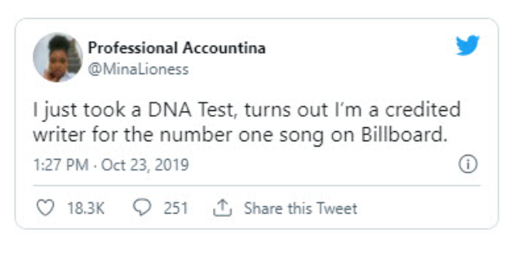
An August 9, 2019 Letter of Protest Memorandum forming part of the application record includes supporting evidence in the form of twelve screenshots from Etsy and other third-party online retail outlets, offering various shirts and hats featuring the wording 100% THAT BITCH alone or in context. A representative sample is reproduced below.
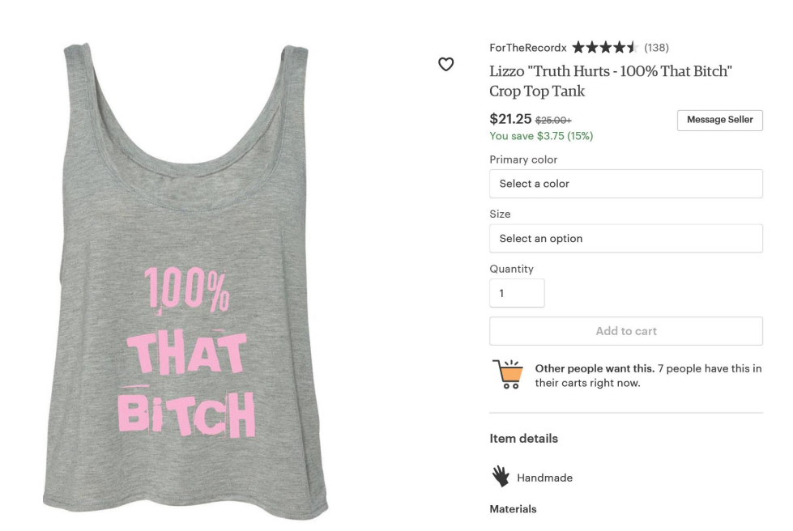
Of the 12 screenshots, one is from Applicant’s website and displays the same photograph as Applicant’s specimen of record, three more specifically reference Lizzo and her song “Truth Hurts,” and four more refer to the song lyric “I just took a DNA test, turns out, I’m 100% that bitch.”
The Examining Attorney also submitted screen shots from third-party commercial web pages showing the wording 100% THAT BITCH appearing, most often in an ornamental manner, on a variety of goods, including various items of clothing, key chains, mugs, stickers, bandanas for dogs, lip balm, wall art, patches, drinking glasses and balloons. The term also appears in connection with third-party entertainment and retail services. Representative samples are reproduced below.
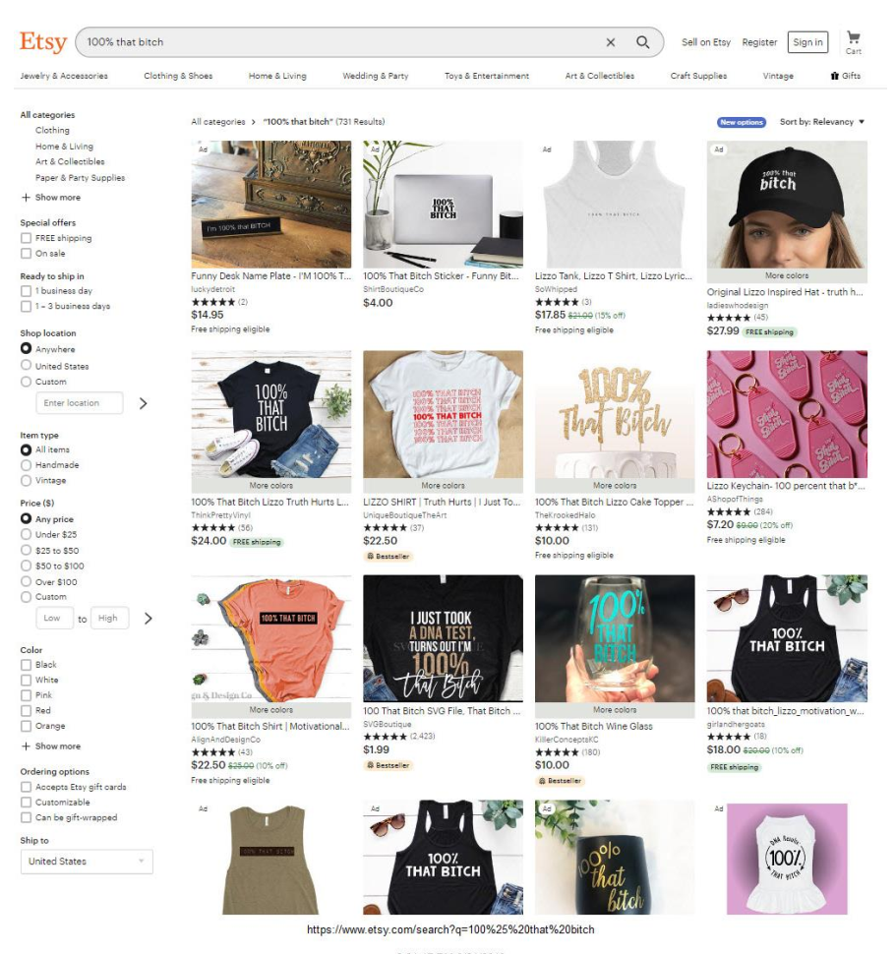
Of the 12 complete listings on the above webpage that include descriptions of the goods, seven of them reference Lizzo, her song “Truth Hurts,” or both. The product descriptions on the bottom row of items is cut off in the evidence as submitted.
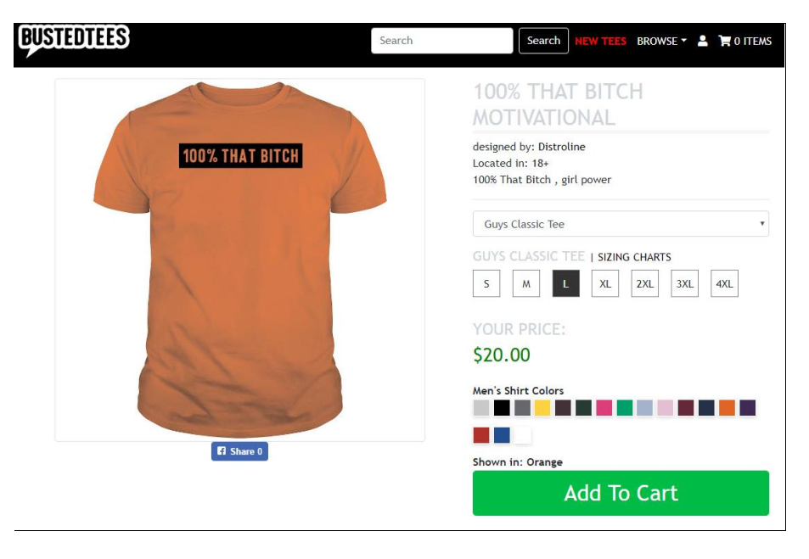
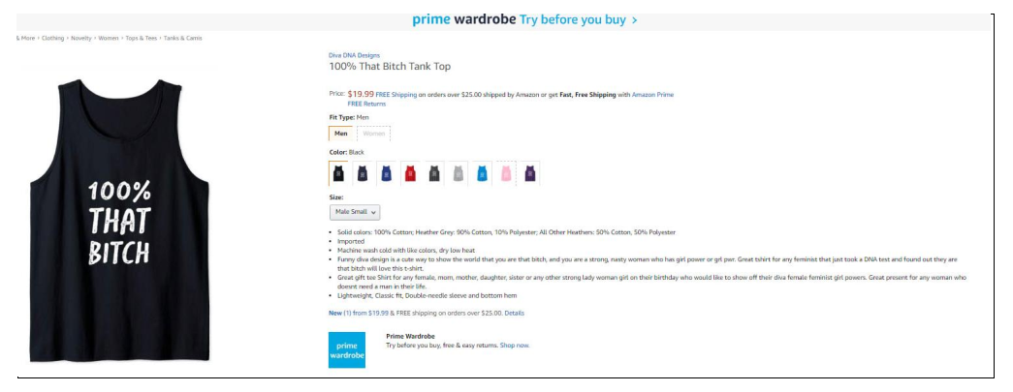
The description of the goods to the right of the above picture includes the following reference to Lizzo’s song “Truth Hurts”: “Great t-shirt for any feminist that just took a DNA test and found out they are that bitch will love this t-shirt.”
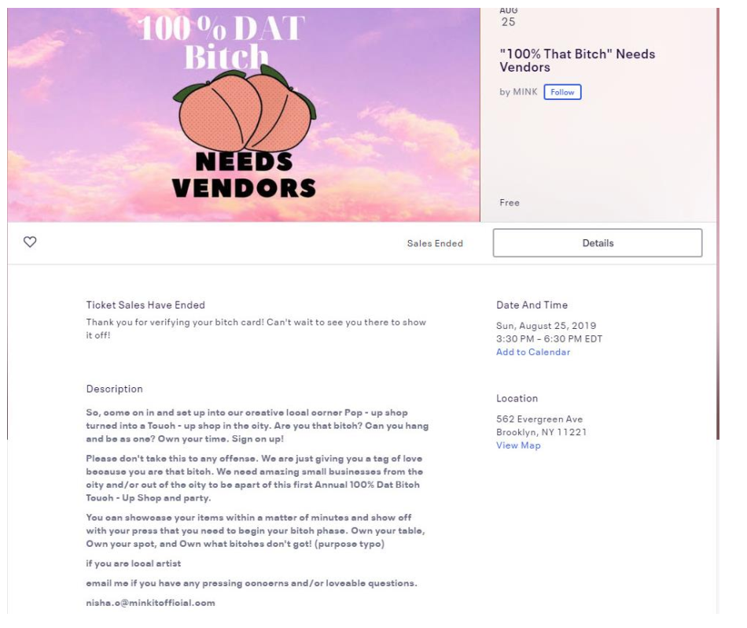
Above is an advertisement for an event showcasing local artists and vendors offering goods and services directed toward women.
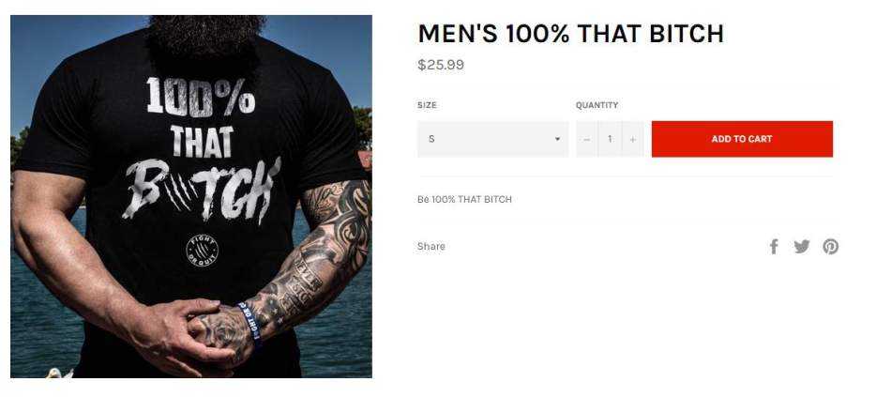
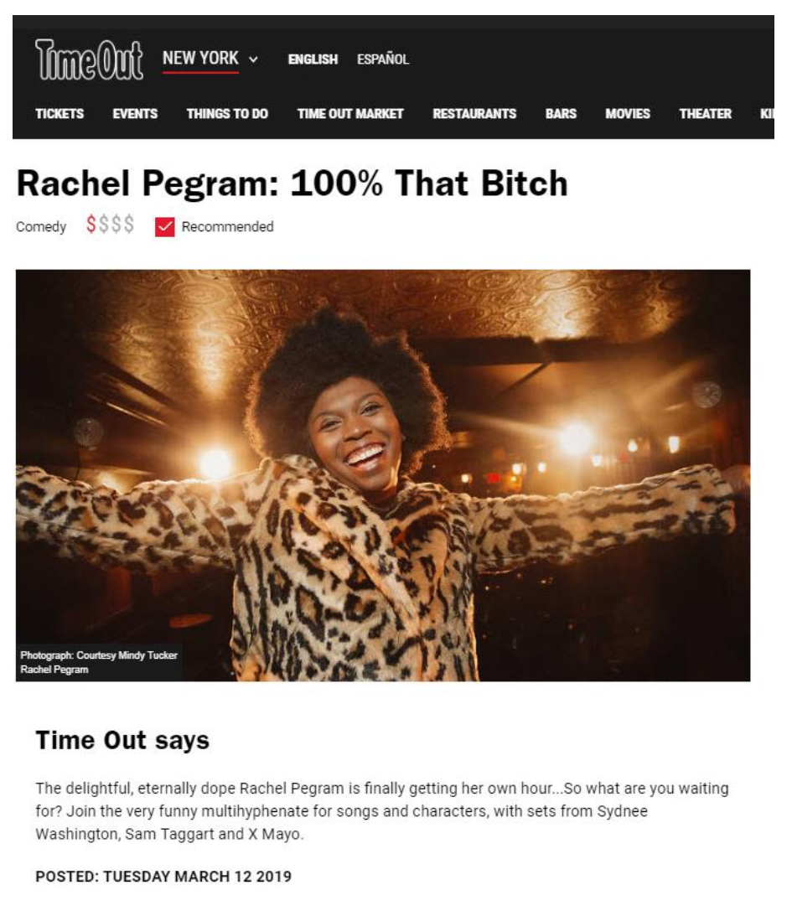

Above is an advertisement for a music and comedy event.
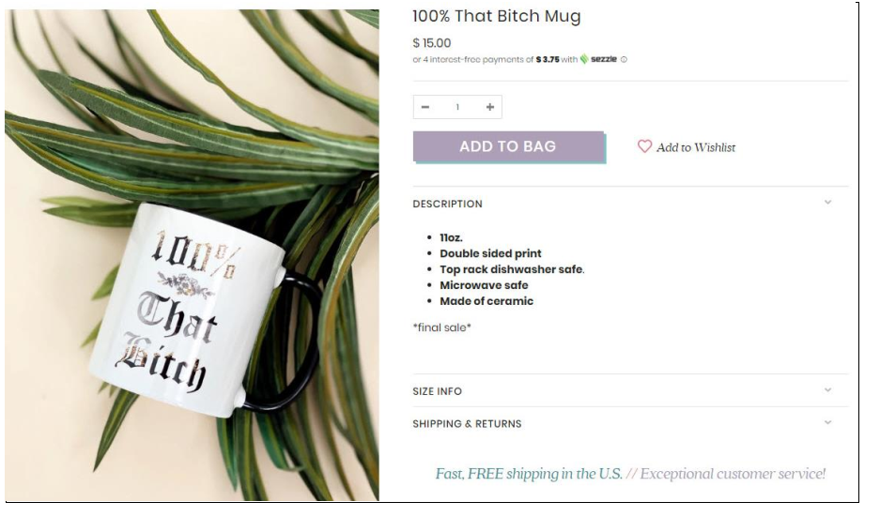

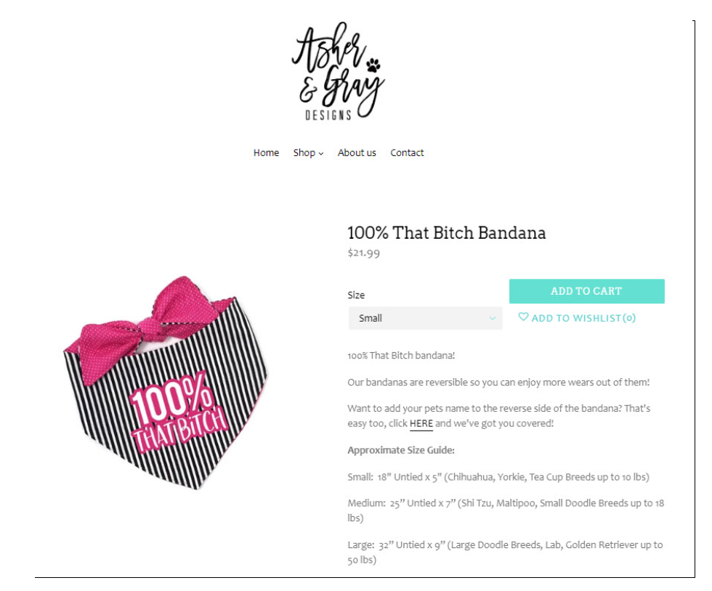
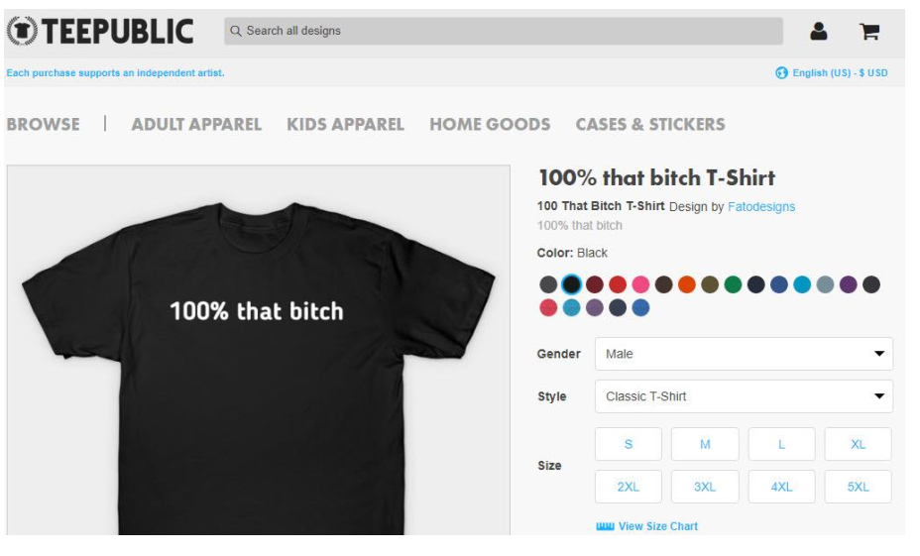

Finally, the Examining Attorney introduced “internet evidence showing additional widespread use of 100% THAT BITCH in an ornamental manner on clothing and related items, further establishing that the mark is likely to be seen for the meaning of its wording and not as a source indicator.” Of the ten screenshots submitted in support, three are from Applicant’s own website, and another one specifically refers to Lizzo’s song “Truth Hurts.”
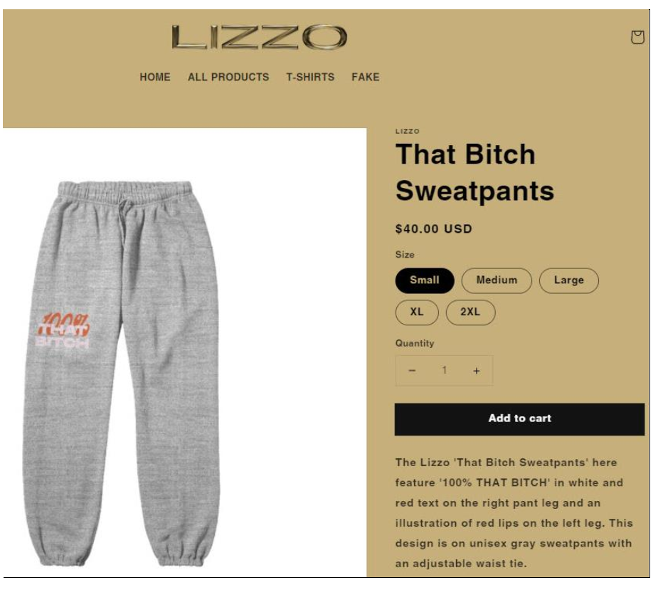
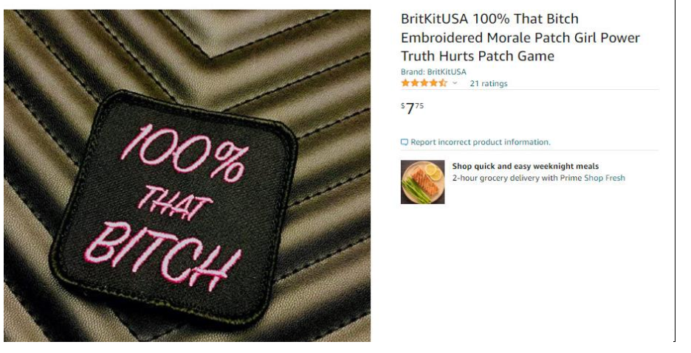
B. Applicant’s Arguments and Evidence
Applicant argues that the refusal of registration is based on evidence that fails to “show a commonplace use of the wording ‘100% That Bitch’ by the public or that the public is exposed to the phrase (other than in relation to Applicant) in a widespread manner that would cause it to fail to be a strong-identifier of Applicant’s … clothing goods.”
To the contrary, the evidence relied upon by the Examining Attorney proves that 100% THAT BITCH functions precisely the way a trademark is supposed to function, namely, it identifies Lizzo as the source of goods, which is the sole reason why those attempting to trade off of Lizzo’s fame, notoriety and good will have elected to use the term in order to sell unauthorized merchandise, that often not only includes the identical mark 100% THAT BITCH, but also often relies upon other unauthorized references to Lizzo (including her name, song titles, etc.)[.] Further, the refusal to register a mark that is so clearly being used by others to create a false association with Lizzo and to trade off of her goodwill in connection with the sale of unauthorized and unlicensed merchandise, is directly at odds with the fundamental principles of the Lanham Act, which exists in order to protect consumers and the owners of source identifying-marks from unauthorized, infringing uses by third parties.
In support of its arguments in favor of registration, Applicant submitted copies of its companion applications Serial Nos. 88466246 and 88466307, also for the mark 100% THAT BITCH (in standard characters) identifying various entertainment services and musical sound recordings, that are not subject to the failure to function refusal.
Applicant also submitted webpages displaying Applicant’s use of 100% THAT BITCH on clothing items. The following example is illustrative.
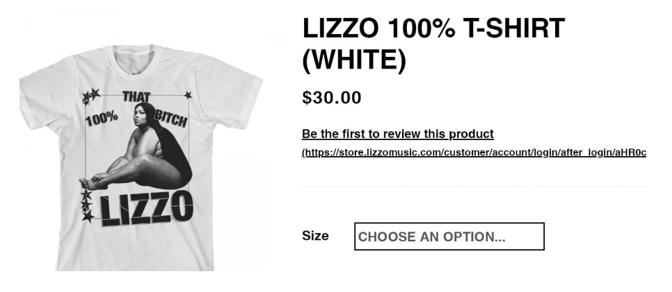
To support its argument that it is “common practice for well-known musical artists to adopt trademarks . . . that were inspired by the titles or lyrics of their songs,” Applicant introduced third-party registrations for marks consisting of lines from popular song lyrics used to identify various goods and services including clothing items. These include (all marks appear in standard characters):
• Reg. No. 5770375 for LOOK WHAT YOU MADE ME DO for goods and
services including clothing;
• Reg. No. 5770429 for …READY FOR IT? for goods and services including
clothing;
• Reg. No. 5944651 for THE OLD TAYLOR CAN’T COME TO THE PHONE
RIGHT NOW for protective covers for mobile phones; and
• Reg. No. 5124573 for CALL ME MAYBE for clothing.
Applicant also introduced articles from Wikipedia discussing the songs from which the marks in the above third-party registrations are taken, the artists performing them, and various aspects of their writing and recording.
Applicant further introduced copies of take-down requests sent by its counsel to Etsy and other online retailers regarding alleged infringing third-party uses of 100% THAT BITCH on merchandise and correspondence from these retailers. Three representative samples are reproduced below.
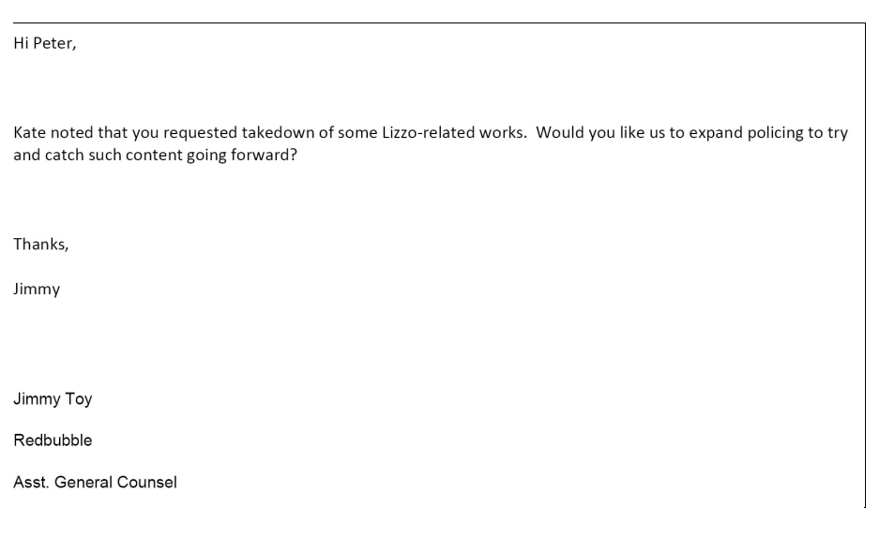
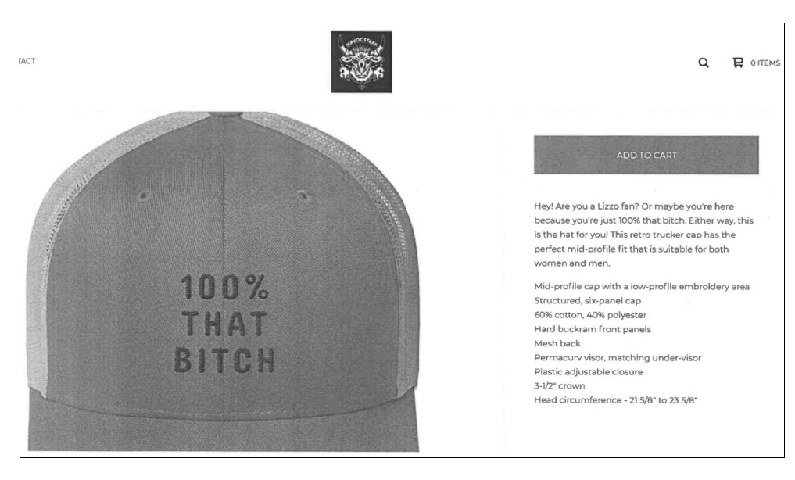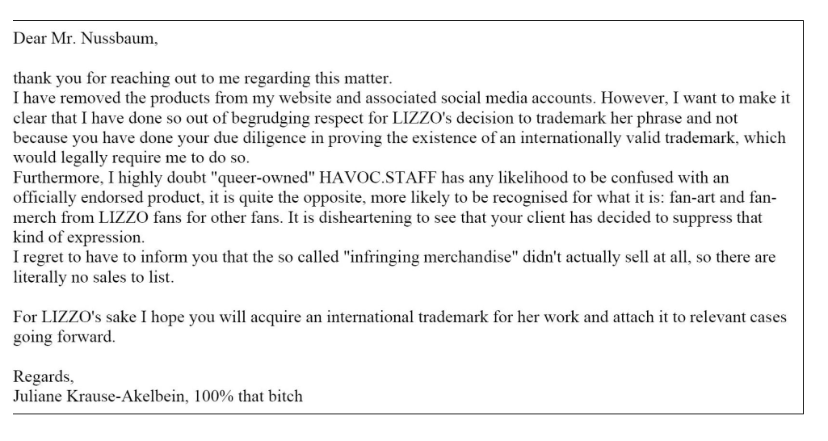
The retailers’ responses to the takedown requests recognize Lizzo as the source of the expression 100% THAT BITCH.

III. Analysis of the Refusal
A. Overview and legal background
As discussed above, proposed marks that are perceived as commonplace expressions fail to function as a mark to indicate source under Trademark Act Sections 1, 2 and 45 and thus are not registrable. See, e.g., D.C. One Wholesaler, 120 USPQ2d at 1716 (I ♥ DC for bags, clothing, plush toys); In re AOP LLC, 107 USPQ2d 1644, 1655 (TTAB 2013) (AOP for wine); In re Eagle Crest, 96 USPQ2d at 1229 (ONCE A MARINE, ALWAYS A MARINE for clothing); In re Aerospace Optics, Inc., 78 USPQ2d 1861, 1864 (TTAB 2006) (SPECTRUM for illuminated pushbutton switches), appeal dismissed, 208 F. App’x 824 (Fed. Cir. 2006); In re Volvo Cars of N. Am. Inc., 46 USPQ2d 1455, 1460-61 (TTAB 1998) (DRIVE SAFELY for automobiles); In re Manco Inc., 24 USPQ2d 1938, 1942 (TTAB 1992) (THINK GREEN and design for weather stripping and paper products); In re Remington Prods., Inc., 3 USPQ2d 1714, 1715 (TTAB 1987) (PROUDLY MADE IN USA for electric shavers); In re Tilcon Warren, Inc., 221 USPQ 86 (TTAB 1984) (WATCH THAT CHILD for construction material); In re Schwauss, 217 USPQ 361, 362 (TTAB 1983) (FRAGILE for labels and bumper stickers); cf. In re Boston Beer Co., 198 F.3d 1370, 53 USPQ2d 1056, 1058 (Fed. Cir. 1999) (“The proposed mark [THE BEST BEER IN AMERICA] is a common, laudatory advertising phrase which is … so highly laudatory and descriptive of the qualities of its product that the slogan does not and could not function as a trademark to distinguish Boston Beer’s goods and serve as an indication of origin.”) (emphasis added).
In each of these cases, the Board or Federal Circuit affirmed the examining attorney’s refusal of registration under Sections 1, 2 and 45 (and Section 3 where the proposed mark identified services) for failure of the designation to function as a mark, on the basis that the proposed mark consisted of merely informational matter or a commonplace expression that would not be perceived by consumers as identifying and distinguishing the source of the enumerated goods or services. See generally TRADEMARK MANUAL OF EXAMINING PROCEDURE (TMEP) § 1202.04 (July 2022) and authorities cited therein.
That is in essence the basis of the Examining Attorney’s refusal here: that 100% THAT BITCH is a common expression that will not be perceived by consumers as a trademark under Sections 1, 2 and 45 of the Trademark Act. The refusal finds its basis under Trademark Act Sections 1, 2 and 45, in the requirement that the matter submitted for registration be a mark – which by definition must identify and distinguish an applicant’s goods. What constitutes such matter may be any word, name, symbol, or device, or any combination thereof; however, it must also be capable of distinguishing source. See 15 U.S.C. §§1051-52, and 1127.
B. Analysis of the evidence and arguments
Applicant filed application Serial No. 88466264 under Section 1(b) based on its intent to use the mark in commerce, and Serial No. 88466281 under Section 1(a) based on its allegation of use of the mark in commerce. Applicant’s specimen of use filed in connection with the latter application and further evidence of Lizzo’s use of 100% THAT BITCH in connection with goods identified in both applications are reproduced above. In addition, evidence in the record shows that others also use the designation in the marketplace, frequently in reference to Lizzo, her music and lyrics, which further informs our determination how consumers would perceive the proposed mark. See In re Eagle Crest, 96 USPQ2d at 1229 (considering specimens and evidence in the record showing how the designation is actually used in the marketplace).
Prominent ornamental use of a proposed mark, as shown in the examples of record, “is probative in determining whether a term or phrase would be perceived in the marketplace as a trademark or as a widely used message.” In re Mayweather Promotions, LLC, 2020 USPQ2d 11298, at *4; In re Hulting, 107 USPQ2d 1175, 1179 (TTAB 2013) (prominent ornamental use tends to be “more consistent with the conveying of an informational message than signifying a brand or an indicator of source.”). See also D.C. One Wholesaler, 120 USPQ2d at 1716 (prominent ornamental display of I ♥ DC “itself is an important component of the product and customers purchase the product precisely because it is ornamented with a display of the term in an informational manner, not associated with a particular source”).
Here, the evidence of record shows 100% THAT BITCH appearing predominantly in an ornamental manner on various goods including clothing, key chains, mugs, stickers, wall art, patches, drinking glasses and balloons as well as entertainment and retail services. Significantly, much of this evidence references Lizzo, her music and song lyrics from the single “Truth Hurts.” The remainder of the evidence displays 100% THAT BITCH used in context in internet articles discussing Lizzo, her song “Truth Hurts,” and the origin of the song lyric comprising the mark at issue. This lessens the weight we otherwise may have accorded the ornamental nature of those uses in showing that the phrase fails to function as a trademark.
We note further that ornamental use by others is only one type of evidence that may be relevant to consumer perception. In re Hulting, 107 USPQ2d at 1178 (citing In re Lululemon Athletica Can. Inc., 105 USPQ2d 1684, 1689 (TTAB 2013)). Also pertinent is the nature of the message conveyed by the proposed mark. While an expression need not convey a specific type of message to be inherently incapable of functioning as a mark, see In re Tex. With Love, 2020 USPQ2d 11290, at *7 (“[W]idespread use of a term or phrase may be enough to render it incapable of functioning as a trademark, regardless of the type of message.”), familiar every day expressions and slogans used to convey social, political, patriotic, religious, and laudatory concepts are more likely to be perceived as imparting information than signifying source. In re Hulting, 107 USPQ2d at 1179 (“[A]s the record reflects, consumers would not view the proposed mark as an indicator of the source of applicant’s goods due to the nature of the political message conveyed.”); In re Eagle Crest, 96 USPQ2d at 1229 (“no dispute that the phrase ONCE A MARINE, ALWAYS A MARINE is an old and familiar Marine expression that should remain free for all to use”); In re Volvo Cars, 46 USPQ2d at 1460 (finding that the commonly used safety admonition DRIVE SAFELY “should remain in the public domain.”); In re Manco, 24 USPQ2d at 1942 (finding THINK GREEN “broadly conveys the ecological concerns of the expanding environmental movement” and this message “would be impressed upon purchasers and prospective customers for applicant’s goods”); In re Remington Prods., 3 USPQ2d at 1715 (PROUDLY MADE IN USA not registrable for electric shavers because it would be perceived as expressing a preference for American-made products rather than as a source identifier); Tilcon Warren, 221 USPQ at 88 (finding WATCH THAT CHILD for construction materials merely informational because it merely expresses a general concern for child safety).
In contrast to the preceding cited cases, the evidence here does not demonstrate that Applicant’s proposed mark is used in general parlance or that it conveys a common social, political, patriotic, religious or other informational message such as DRIVE SAFELY, THINK GREEN or WATCH THAT CHILD. Applicant and the Examining Attorney agree that the proposed mark conveys a feeling of female strength, empowerment and independence. But more importantly, considering the entirety of the record, we find that most consumers would perceive 100% THAT BITCH used on the goods in the application as associated with Lizzo rather than as a commonplace expression.
We have recognized that “widespread use of a term or phrase may be enough to render it incapable of functioning as a trademark, regardless of the type of message.” In re Tex. With Love, 2020 USPQ2d 11290, at *7. Expressions in ubiquitous use are unlikely to be perceived as source identifiers. For example, in D.C. One Wholesaler the Board found that I ♥ DC failed to function as a mark because the market was “awash” in merchandise prominently bearing I ♥ DC as an ornamental feature of the goods sold over a long period of time and by a large number of merchandisers. 120 USPQ2d at 1716. Similarly, in Eagle Crest, a Google search retrieved nearly three million hits for the slogan ONCE A MARINE ALWAYS A MARINE. 96 USPQ2d at 1229. And in Volvo Cars, the applied-for-phrase DRIVE SAFELY was “uttered on a daily basis, almost automatically with no thought, to others as they drive off in an automobile.” 46 USPQ2d at 1460-61.
By contrast, the evidence in these appeals establishes that in 2017, the musical artist Lizzo encountered “I just took a DNA test, turns out I’m 100% that bitch” as a Twitter meme from the same year. The message in the meme resonated with her, and she used the meme as a lyric in her 2017 song “Truth Hurts,” which went on to become a Billboard Number 1 hit single. Lizzo did not originate the expression she encountered as a Twitter meme, and subsequently granted a writing credit for her song “Truth Hurts” to its originator. See Hole In 1 Drinks, Inc. v. Lajtay, 2020 USPQ2d 10020, at *9 (TTAB 2020) (“[T]rademark rights are not gained by creating a mark, but through use of the mark.”). Nonetheless, lyrics from songs are more likely to be attributed to the artists who sing, rap or otherwise utter them, rather than the songwriters, who may be different individuals receiving varying degrees of writing credit. The evidence of record here indicates that Lizzo and her hit song “Truth Hurts” popularized the lyric and elevated 100% THAT BITCH from what may have been a lesser known phrase (the evidence of record only points to use of that phrase from the 2017 meme onward) to more memorable status.
All of the evidence of record regarding third-party use of 100% THAT BITCH is from 2017 or later. The Urban Dictionary entry for the term is dated June 12, 2019. Thus, the evidence is contemporaneous with or subsequent to the release of Lizzo’s hit single “Truth Hurts.” There is no evidence of use of the term 100% THAT BITCH prior to 2017, so we have no indication that the proposed mark already was “widely used, over a long period of time and by a large number of merchandisers” before Lizzo popularized it. See D.C. One Wholesaler, Inc., 120 USPQ2d at 1716. And, as noted above, much of the evidence of third-party use specifically seeks to associate the goods emblazoned with 100% THAT BITCH with Lizzo, her music and the lyrics from “Truth Hurts.” In addition, evidence of record indicates that third-party retailers responding to takedown notices from Applicant’s counsel recognize that 100% THAT BITCH is associated with Lizzo and her music.
C. Ultimate determination
As noted earlier, the Examining Attorney asserted that the evidence here shows that “consumers may associate the phrase with the famous singer/song because it was a lyric in the singer’s song,” but that “does not entitle the applicant as a singer-songwriter to appropriate for itself exclusive use of the phrase.” We find the totality of the evidence of record does more than that. It undercuts a finding that 100% THAT BITCH is a commonplace expression, so widely used by third parties that consumers would not perceive it as indicating the source of the goods identified thereby. Specifically, the evidence here does not show that consumers recognize 100% THAT BITCH merely as a lyric in one of Lizzo’s popular songs. Rather, we find that the evidence of record shows that consumers encountering 100% THAT BITCH on the specific types of clothing identified in the application―even when offered by third parties―associate the term with Lizzo and her music. We acknowledge that to some degree consumers and potential consumers have been exposed to use of the proposed mark 100% THAT BITCH in a non-source-identifying (i.e., ornamental) manner on the same and similar goods to those of Applicant. We find, however, that that circumstance is outweighed by references in most of those uses to Lizzo and/or her music.
We emphasize that on this record we find much less persuasive Applicant’s evidence of the registration by the USPTO of different expressions using different wording (e.g., LOOK WHAT YOU MADE ME DO) by other musical artists. The registrability of different lyrics and slogans identified by Applicant, based on the evidentiary records in those applications, has little bearing on the question of whether 100% THAT BITCH is registrable for the goods identified here. See In re Nett Designs, Inc., 236 F.3d 1339, 57 USPQ2d 1564, 1566 (Fed. Cir. 2001) (“Even if some prior registrations had some characteristics similar to Nett Designs’ application, the PTO’s allowance of such prior registrations does not bind the Board or this court.”); Curtice-Burns, Inc. v. Nw. Sanitation Prods., Inc., 530 F.2d 1396, 189 USPQ 138, 141 (CCPA 1976) (“[A]s we shall evidently have to continue saying ad nauseam: ‘… prior decisions on other marks for other goods are of very little help one way or the other in cases of this type. Each case must be decided on its own facts and the differences are often subtle ones.’”) (citation omitted); In re USA Warriors Ice Hockey Program, Inc., 122 USPQ2d 1790, 1793 n.10 (TTAB 2017) (prior decisions and actions of other trademark examining attorneys in registering other marks have little evidentiary value and the Trademark Trial and Appeal Board is not bound by prior decisions involving different records); see also In re Datapipe, Inc., 111 USPQ2d 1330, 1336 (TTAB 2014). Indeed, where an applicant cites registrations where the factual record is unknown, those references “have no precedential value.” In re HarrisIntertype Corp., 518 F.2d 629, 632 (CCPA 1975). At best, this evidence merely reflects that there is no per se legal rule against phrases that are song lyrics serving as trademarks in some circumstances.
II. Conclusion
The record as a whole does not establish that the proposed mark is a common expression in such widespread use that it fails to function as a mark for the goods identified in this application.
Decision: The refusals to register are reversed.

Application Serial No. 88466264 was filed on June 10, 2019, based on Applicant’s assertion of a bona fide intention to use the mark in commerce under Section 1(b) of the Trademark Act, 15 U.S.C. § 1051(b).
Application Serial No. 88466281 was filed on June 10, 2019, based on Applicant’s assertion of May 17, 2018, as a date of first use of the mark anywhere and in commerce under Section 1(a) of the Trademark Act, 15 U.S.C. § 1051(a).
Examining Attorney’s brief, 10 TTABVUE 3.
April 8, 2020 Response to Office Action at TSDR 7-11 in Serial No. 88466264.
In an order issued on July 27, 2022 (9 TTABVUE), the Board granted the Examining Attorney’s motion to consolidate these appeals for purposes of briefing (8 TTABVUE).
Similarly, Trademark Act Section 3, 15 U.S.C. § 1053, applies to service marks and provides that service marks shall be registrable in the same manner as trademarks.
Because the evidentiary records in these appeals are essentially identical, we refer in this decision to the evidence in application Serial No. 88466264 unless otherwise noted.
10 TTABVUE 4.
10 TTABVUE 4. (Internal citations omitted.)
10 TTABVUE 8. (Emphasis supplied by Examining Attorney; internal citations omitted.)
10 TTABVUE 9.
We note this specimen shows the proposed mark used in a merely ornamental manner on the identified goods. However, the Examining Attorney found the mark also used as a trademark on an acceptable website display associated with the goods. Thus, whether the specimen merely shows the mark in an ornamental manner is not at issue in this case.
October 30, 2019 first Office Action at 14.
August 11, 2021 final Office Action at 18.
Id. at 19-23.
October 30, 2019 first Office Action at 4-13; August 11, 2021 final Office Action at 5-17; April 5, 2022 Denial of Request for Reconsideration at 3-12.
April 5, 2022 Denial of Request for Reconsideration at 2; screenshots at 3-13.
6 TTABVUE 2.
6 TTABVUE 2-3.
November 24, 2020 Response to second Office Action at 21-24.
Id. at 26-29.
6 TTABVUE 8.
November 24, 2020 Response to second Office Action at 31-38.
Id. at 39-108. These registrations are owned by the holding companies for Taylor Swift and Carly Rae Jepsen. The Board gives guarded consideration to evidence taken from Wikipedia, bearing in mind the limitations inherent in this reference work, so long as the non-offering party has an opportunity to rebut the evidence by submitting other evidence that may call its accuracy into question. See In re IP Carrier Consulting Grp., 84 USPQ2d 1028, 1032 (TTAB 2007); In re Jimmy Moore LLC, 119 USPQ2d 1764, 1768 (TTAB 2016). In the case before us, the Wikipedia evidence was submitted with the Examining Attorney’s initial Office action, and Applicant had an opportunity to rebut it.
Id. at 110-309.
August 11, 2021 final Office Action at 19-23.
Id.
Id.
Id. at 110-309. The third parties seeking to associate their use of the phrase 100% THAT BITCH with Lizzo suggests that, for purposes of this failure to function refusal, the phrase currently is associated with Lizzo. We observe, nonetheless, that proliferation of unauthorized thirdparty use risks the mark’s loss of strength as an exclusive source indicator, or even abandonment. See, e.g., Nobelle.com, LLC v. Qwest Commc’ns Int’l, Inc., 66 USPQ2d 1300, 1306-07 (TTAB 2003).
10 TTABVUE 9.

