In re SnoWizard, Inc.
129 U.S.P.Q.2d 1001 (TTAB 2018)
The applicant sought to register the mark shown below for goods it identified as consisting of a “Concession trailer for snowball vendors to operate a viable snowball business.” Id. at 1001. The applicant described the mark as follows: “The mark consists of a three-dimensional configuration of a snowcapped roof with the word “SNOBALLS”, a snowball and associated beverage container positioned on top of a concession trailer for snowball vendors. The matter shown in broken or dotted lines is not part of the mark and serves only to show the position or placement of the mark.” Id. at 1001-02.
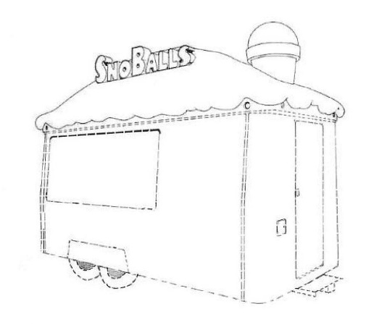
The applicant presented the photograph shown below as its specimen of use:

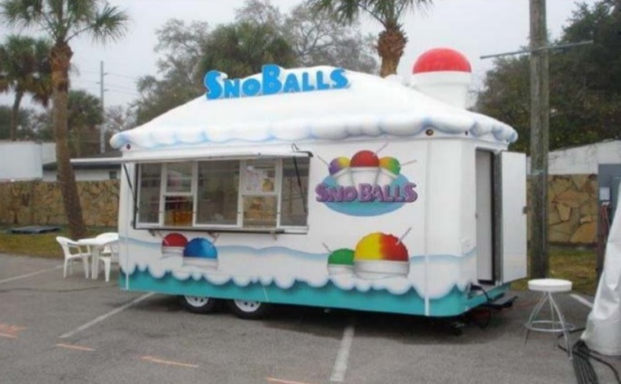

The TTAB found: “Clearly, the product at issue in this case is the concession trailer; that is the product offered for sale, purchased by, and used by snowball vendors. It is not a container for flavored shaved ice or snowballs sold to consumers, as suggested by Applicant. Accordingly, Applicant’s applied-for mark is properly characterized as a product design. Specifically, it is the design of the roof of a concession trailer. It therefore requires a showing of acquired distinctiveness in order to be registered on the Principal Register.” Id. at 1003. (Reviewing, among other things, voluminous photographic evidence of similar concession trailers, the TTAB went on to find no secondary meaning. See id. at 1004-08)

