Innovation Ventures, LLC v. N.V.E., Inc.
694 F.3d 723, 729-730 (6th Cir. 2012)
{Plaintiff Innovation Ventures, LLC, d/b/a Living Essentials (“LE”), produced a beverage under the mark 5-hour energy. Defendant NVE began to produce a similar beverage under the mark 6 hour power. Plaintiff sued and defendant claimed that plaintiff’s mark was merely descriptive. The parties’ cross-moved for summary judgment.}

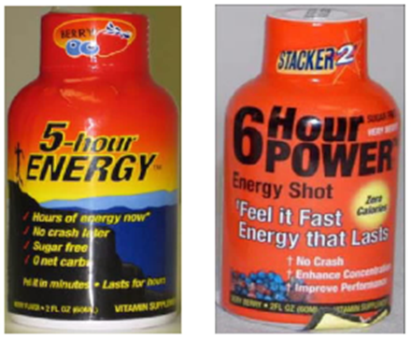

Boggs, Circuit Judge
. . . .
NVE claims that the term “5–hour ENERGY” is not a distinctive mark, but is a descriptive mark.1 A descriptive mark, by itself, is not protectable. However, “[a] merely descriptive term . . . can, by acquiring a secondary meaning, i.e., becoming distinctive of the applicant’s goods . . . , become a valid trademark.” Induct–O–Matic Corp. v. Inductotherm Corp., 747 F.2d 358, 362 (6th Cir. 1984). LE counters that the “5–hour ENERGY” mark is not descriptive, but rather is distinctive, due to the mark’s suggestiveness. Such a mark “suggests rather than describes an ingredient or characteristic of the goods and requires the observer or listener to use imagination and perception to determine the nature of the goods.” Id. at 362.
The “5–hour ENERGY” mark could be characterized as merely descriptive, in the sense that it simply describes a product that will give someone five hours of energy. But that is not the end of such an inquiry. The first question one would ask is how would the energy be transferred? Through food? Through drink? Through injections? Through pills? Through exercise? Also, one would ask what kind of energy is the mark referring to? Food energy (measured in Calories)? Electrical energy? Nuclear energy? With some thought, one could arrive at the conclusion that the mark refers to an energy shot. But it is not as straightforward as NVE suggests. Such cognitive inferences are indicative of “suggestive” rather than descriptive marks.
The nature of the “5–hour ENERGY” mark “shares a closer kinship with those marks previously designated as suggestive than those labeled merely descriptive because of the degree of inferential reasoning necessary for a consumer to discern” that the “5–hour ENERGY” mark relates to an energy shot. Tumblebus v. Cranmer, 399 F.3d 754, 763 (6th Cir. 2005). The connection between “5–hour” and “ENERGY” is “not so obvious that a consumer seeing [5–hour ENERGY] in isolation would know that the term refers to” an energy shot rather than, for example, a battery for electronics, an exercise program, a backup generator, or a snack for endurance sports. Ibid. Connecting the mark “5–hour ENERGY” with the energy-shot product requires “imagination and perception to determine the nature of the goods.” Induct–O–Matic, 747 F.2d at 362.
“The line between merely descriptive and suggestive marks is admittedly hazy and can be difficult to discern.” Tumblebus, 399 F.3d at 763. However, we disagree with NVE’s contention that the mark is not distinctive and thus not protectable. The “5–hour ENERGY” mark is “suggestive.”
{The Sixth Circuit found other fact issues and remanded.}

1 We note that, in contrast with its position in this case, in other litigation NVE has asserted that its own mark, “6 Hour POWER,” is an “inherently distinctive” mark. See Complaint at ¶ 12, N.V.E., Inc. v. N2G Distrib., Inc. & Alpha Performance Labs, No. 2:08–cv–01824 (D.N.J. Apr. 14, 2008) (“The 6 HOUR POWER mark distinguishes NVE as the source of these products, is inherently distinctive, and has also become distinctive through the acquisition of secondary meaning.” (emphasis added)).

