International Stamp Art v. U.S. Postal Service
456 F.3d 1270 (11th Cir. 2006)
In International Stamp Art, ISA produced cards, posters, and prints depicting postage stamps enclosed in a flat-edged perforated border design meant to invoke classic postage stamps. In 1996, it managed to get a trademark registration for this design:
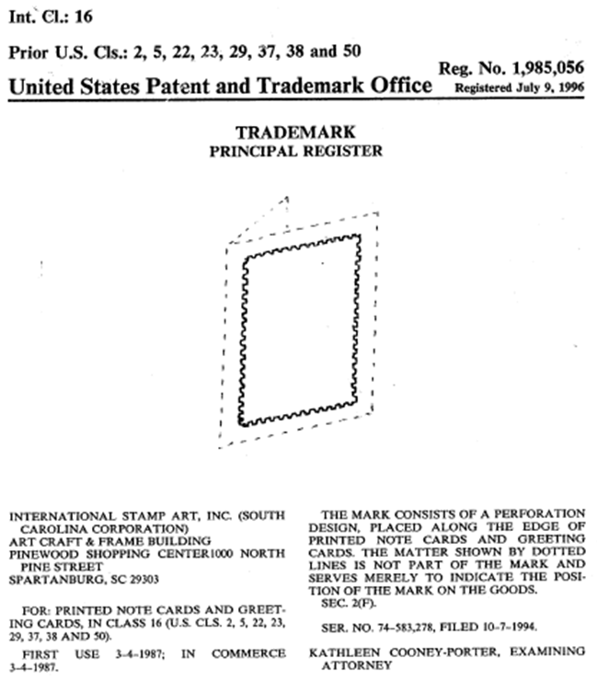
USPS licensed ISA among others to create merchandise incorporating USPS’s images. “Stamp images were transmitted to licensees in the form of transparencies, each marked as copyright protected and depicting the entire stamp including any perforated edges.” Id. at 1272. USPS eventually began to produce its own line of stamp art cards, some of which incorporated the flat-edged perforated border design. ISA sued for trademark infringement. USPS claimed descriptive fair use.
Affirming the district court’s grant of summary judgment, the Eleventh Circuit found descriptive fair use. The court devoted the bulk of its analysis to the third step, whether USPS’s use was in good faith, i.e., “whether the alleged infringer intended to trade on the good will of the trademark owner by creating confusion as to the source of the goods or services.” Id. at 1275. The court noted that “the overwhelming majority of stamps the Postal Service produces include perforated edges and have long done so,” id.; that USPS “prominently places its own familiar Eagle trademark on the backs of its stamp art products thereby identifying them as Postal Service products,” id.; and that “ISA has not identified any evidence that the Postal Service sought to mislead or confuse consumers into thinking that the source of the cards it produced was actually International Stamp Art,” id.
ISA claimed that USPS had a “non-infringing, commercially viable alternative” in the form of “cards depicting the art upon which its stamp designs was based, rather than the stamps themselves.” Id. at 1276. The Eleventh Circuit recognized that “[f]ailure to employ a non-infringing, commercially viable alternative can raise a genuine issue of material fact,” id., but was ultimately unpersuaded: “This, however, is not an alternative manner of depicting the stamps, but rather a choice not to depict stamps.” Id.

