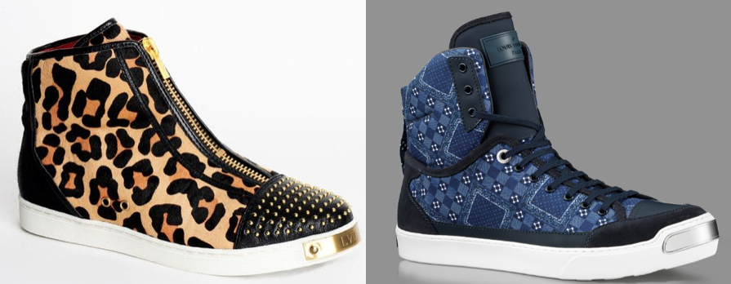

LVL XIII Brands, Inc. v. Louis Vuitton Malletier S.A.
209 F. Supp. 3d 612, 626 (S.D.N.Y. 2016)
In LVL XIII Brands, the plaintiff produced “‘luxury’ men’s sneakers” featuring “a rectangular metal toe plate with a ‘LVL XIII inscription’ secured to the front outsole of the sneaker by metal screws.” Id. at 628. (See the above image on the left). The defendant produced luxury sneakers also featuring a metal toe plate (above, right). The parties filed cross-motions for summary judgment. The district court analyzed whether the plaintiff’s toe plate design was product packaging or product configuration:
This is not a close case. Even a cursory examination of the TP {metal toe plate} discloses that it does not qualify as a trademark or product packaging. . . . {P}roduct packaging is generally limited to “the appearance of labels, wrappers, boxes, envelopes, and other containers used in packaging a product as well as displays and other materials used in presenting the product to prospective purchasers.” Restatement (Third) of Unfair Competition § 16 cmt.a (1995).
Tellingly, LVL XIII has not offered any admissible evidence to support its claim that the TP falls within either of these categories. And the record evidence is decidedly to the contrary.
First, the “packag[ing]” described in LVL XIII’s business plan consists solely of “distinctive branded shoe boxes” and “black cotton dust bags”—it does not include the TP.
Second, in declining to register {LVL XIII’s trademark} Application, the PTO stated that “the rectangular shape of the shoe toe plate . . . is a configuration of a feature of the shoe design,” which “can never be inherently distinctive as a matter of law.” Although the PTO’s determination is not dispositive, the Court is to “accord weight” to it. Genesee Brewing Co. v. Stroh Brewing Co., 124 F.3d 137, 148 n. 11 (2d Cir. 1997). Such deference is particularly appropriate where, as here, the PTO’s determination is consistent with the registrant’s own characterization of the claimed mark: As noted, the ‘102 Application sought registration for a “shoe toe design” (emphasis added); see In re Slokevage, 441 F.3d at 959 (“Slokevage’s reference in her application to the trade dress as a ‘cut-away flap design’ supported a determination that the configuration constitutes product design.”). And LVL XIII used dotted lines to identify unclaimed portions of the mark, a procedure required only for “trade dress marks.” See U.S. Patent & Trademark Office, Trademark Manual of Examining Procedures (“TMEP”) § 1202.02(c)(i) (Apr. 2016 ed.).
Despite this evidence, LVL XIII argues that the TP is an inherently distinctive trademark because its uniform size and placement on LVL XIII’s line of sneakers renders it “arbitrary” and “fanciful,” and thus apt to be an automatic indicator of source. That argument is not persuasive. . . . Despite LVL XIII’s efforts to shoehorn the TP into the trademark category, it does not fit. Rather, like the configuration in Slokevage, the TP serves a primarily aesthetic function: making LVL XIII’s sneakers appear more enticing. Accordingly, the TP can be classified only as a product design feature which is not inherently distinctive. To prevail on its Lanham Act claims, LVL XIII must therefore show that the TP acquired secondary meaning.
LVL XIII Brands, Inc. v. Louis Vuitton Malletier S.A., 209 F. Supp. 3d 612, 652–54 (S.D.N.Y. 2016) (footnotes and some citations omitted). The Second Circuit subsequently affirmed. LVL XIII Brands, Inc. v. Louis Vuitton Malletier SA, 720 F. App’x 24 (2d Cir. 2017).

http://www.thefashionlaw.com/home/louis-vuitton-lvl-xiii-head-back-to-court-over-sneaker-top-plates?rq=LVL%20XIII.

