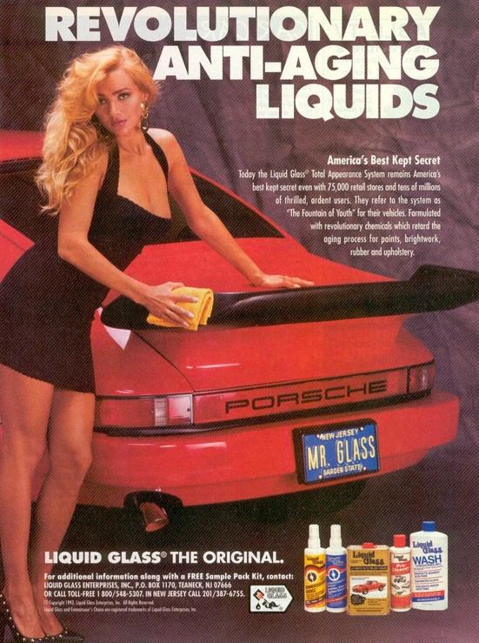

Liquid Glass Enterprises, Inc. v. Dr. Ing. h.c.F. Porsche AG
8 F. Supp. 2d 398 (D.N.J. 1998)
In Liquid Glass Enterprises, Inc. v. Dr. Ing. h.c.F. Porsche AG, the declaratory plaintiff Liquid Glass ran numerous advertisements incorporating Porsche automobiles. The court focused on two. The first was “an ad appearing in the May 1997 issue of a national car magazine, Motor Trend, which portrays a provocatively-dressed woman applying Liquid Glass car polish to a Porsche 911 with the trademark ‘PORSCHE’ prominently displayed on the car.” Id. at 399. The second was a ten-minute video for use at trade shows that
opens with a Porsche 911 (with the Porsche crest plainly visible) accelerating down a highway. Immediately following, the video cuts to a woman who is undressing and taking a shower. Thereafter, the video cuts alternately between a car (not a Porsche) being washed and polished and a woman showering, putting on her makeup and getting dressed. The video then illustrates Liquid Glass’s uses on numerous expensive cars and ends with a shot of the Porsche 911 speeding down the road.
Id. at 400.
Applying New Kids, the court found no nominative fair use and ultimately granted the declaratory defendant’s preliminary injunction motion. As to the first factor, “Liquid Glass has asserted no reason why the Porsche trademark or trade dress is necessary in its promotion of Liquid Glass products.” Id. at 402. As to the second factor, “[n]either does Liquid Glass use only so much of Porsche’s trademarks and trade dress as is reasonably necessary. See, e.g., Volkswagenwerk Aktiengesellschaft v. Church, 411 F.2d 350, 352 (9th Cir. 1969) (repair shop can only use the word ‘Volkswagen’ but cannot use the distinctive lettering or the encircled ‘VW’ emblem)”. Id. at 402-403. As to the third New Kids factor, the court then proceeded through the Third Circuit’s Scott Paper multifactor test for consumer confusion to find that “Liquid Glass’s advertisements could mislead the public into believing that Porsche endorsed Liquid Glass’s products or at least approved of their use on Porsche automobiles.” Id. at 403. The court also found dilution by blurring.

