Christian Louboutin S.A. v. Yves Saint Laurent America Holding, Inc.
696 F.3d 206, 218-228 (2d Cir. 2012)
{Since 1992, designer Christian Louboutin has painted the outsoles of his high-heeled women’s shoes with a high-gloss red lacquer, specifically, Pantone 18-1663 TPX Chinese Red. In 2008, based on the secondary meaning he built up in the design, Plaintiff Christian Louboutin S.A. (“Louboutin”) registered the red lacquered outsole as a trademark (see the registration certificate below). In 2011, defendant Yves Saint Laurent America Holding, Inc. (“YSL”) began marketing a line of monochrome shoes in, among other colors, red. YSL’s red monochrome shoe bore a red insole, heel, upper, and outsole. Louboutin sued, claiming infringement of its registered mark. The district court found that the mark was aesthetically functional and, according to the Second Circuit’s reading, articulated a per se rule that a single color can never serve as a trademark in the fashion industry. Louboutin appealed. Excerpted below is the court’s discussion of aesthetic functionality.}

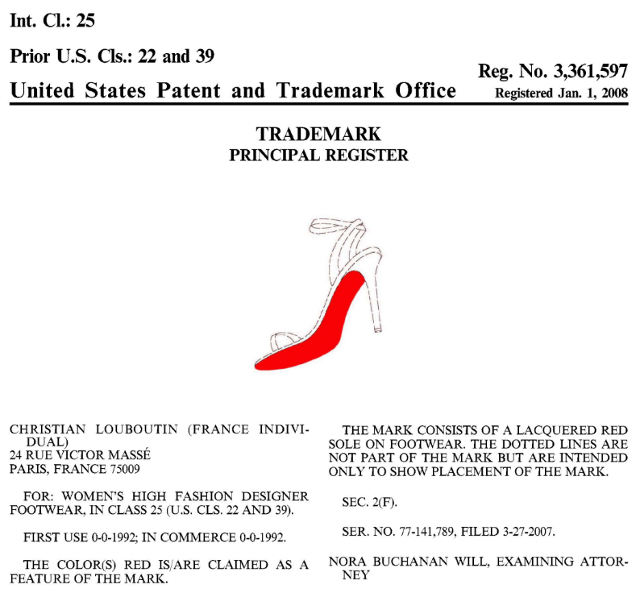
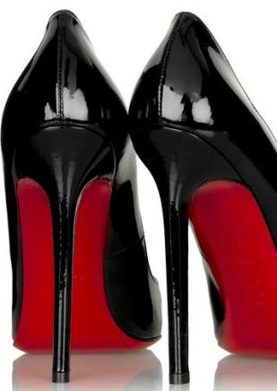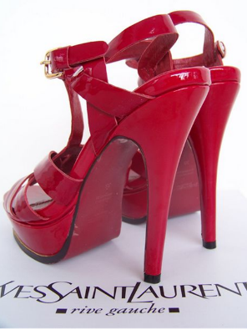

PER CURIAM:
. . . .
III. The “Functionality” Defense
As the Supreme Court observed in Qualitex, aspects of a product that are “functional” generally “cannot serve as a trademark.” Id. at 165. We have observed that “[t]he doctrine of functionality prevents trademark law from inhibiting legitimate competition by giving monopoly control to a producer over a useful product.” Nora Beverages, Inc., 269 F.3d at 120 n. 4; see Genesee Brewing Co., 124 F.3d at 145 n. 5 (it is a “fundamental principle of trademark law that a trademark . . . does not grant a monopoly of production”). This is so because functional features can be protected only through the patent system, which grants a limited monopoly over such features until they are released into general use (typically after either 14 or 20 years, depending on the type of patent). See Fabrication Enters., Inc., 64 F.3d at 58–59 & n. 4 (“The Lanham Act is not concerned with protecting innovation by giving the innovator a monopoly, which is the function of patent law.”) . . . .
As noted above, two forms of the functionality doctrine are relevant to us today: “traditional” or “utilitarian” functionality, and “aesthetic” functionality. Both forms serve as an affirmative defense to a trademark infringement claim.
A. “Traditional” or “Utilitarian” Functionality
According to our traditional understanding of functionality, a product feature is considered to be “functional” in a utilitarian sense11 if it is (1) “essential to the use or purpose of the article,” or if it (2) “affects the cost or quality of the article.” Inwood Labs., 456 U.S. at 850 n. 10, 102 S.Ct. 2182. A feature is essential “‘if [it] is dictated by the functions to be performed’” by the article. LeSportsac, Inc. v. K mart Corp., 754 F.2d 71, 76 (2d Cir. 1985) (quoting Warner Bros. Inc. v. Gay Toys Inc., 724 F.2d 327, 331 (2d Cir. 1983)).13 It affects the cost or quality of the article where it “‘permits the article to be manufactured at a lower cost’ or ‘constitutes an improvement in the operation of the goods.’”14 Id. (quoting Warner Bros., Inc., 724 F.2d at 331). A finding that a product feature is functional according to the Inwood test will ordinarily render the feature ineligible for trademark protection.
B. “Aesthetic Functionality”
Generally, “[w]here [a product’s] design is functional under the Inwood formulation there is no need to proceed further.” TrafFix Devices, Inc. v. Marketing Displays, Inc., 532 U.S. 23, 33 (2001) (“TrafFix “). Nevertheless, as the Supreme Court had held in 1995 in Qualitex, when the aesthetic design of a product is itself the mark for which protection is sought, we may also deem the mark functional if giving the markholder the right to use it exclusively “would put competitors at a significant non-reputation-related disadvantage,” Qualitex, 514 U.S. at 165. This remains true even if there is “no indication that [the mark has] any bearing on the use or purpose of the product or its cost or quality.” TrafFix, 532 U.S. at 33; see Landscape Forms, Inc. v. Colum. Cascade Co., 70 F.3d 251, 253 (2d Cir. 1995) (when evaluating design trademarks we consider whether “certain features of the design are essential to effective competition in [the] particular market”).
As set forth below, the test for aesthetic functionality is threefold: At the start, we address the two prongs of the Inwood test, asking whether the design feature is either “essential to the use or purpose” or “affects the cost or quality” of the product at issue. Next, if necessary, we turn to a third prong, which is the competition inquiry set forth in Qualitex. In other words, if a design feature would, from a traditional utilitarian perspective, be considered “essential to the use or purpose” of the article, or to affect its cost or quality, then the design feature is functional under Inwood and our inquiry ends.15 But if the design feature is not “functional” from a traditional perspective, it must still pass the fact-intensive Qualitex test and be shown not to have a significant effect on competition in order to receive trademark protection.
i. The Development of the Aesthetic Functionality Doctrine
Although the theory of aesthetic functionality was proposed as early as 1938,16 the first court to adopt the theory as the basis for denial of protection of a design was the United States Court of Appeals for the Ninth Circuit in Pagliero v. Wallace China Co., 198 F.2d 339 (9th Cir. 1952). . . .
Despite its apparent counterintuitiveness (how can the purely aesthetic be deemed functional, one might ask?), our Court has long accepted the doctrine of aesthetic functionality. See, e.g., Warner Bros., Inc., 724 F.2d at 329–32 (distinctive color and symbols on toy car were not functional, and so were protectable as trade dress).17 We have rejected, however, the circular “important ingredient” test formulated by the Pagliero court, which inevitably penalized markholders for their success in promoting their product.18 Instead, we have concluded that “Lanham Act protection does not extend to configurations of ornamental features which would significantly limit the range of competitive designs available.” Coach Leatherware Co. v. AnnTaylor, Inc., 933 F.2d 162, 171 (2d Cir. 1991) (emphasis added). Accordingly, we have held that the doctrine of aesthetic functionality bars protection of a mark that is “necessary to compete in the [relevant] market.” Villeroy & Boch Keramische Werke K.G. v. THC Sys., Inc., 999 F.2d 619, 622 (2d Cir. 1993).
ii. A Modern Formulation of the Aesthetic Functionality Doctrine
In 1995, the Supreme Court in Qualitex gave its imprimatur to the aesthetic functionality doctrine, holding that “[t]he ultimate test of aesthetic functionality . . . is whether the recognition of trademark rights [in an aesthetic design feature] would significantly hinder competition.” Qualitex, 514 U.S. at 170 (quoting Restatement (Third) of Unfair Competition § 17, cmt. c, at 176 (1993)) (internal quotation marks omitted). Six years later, reiterating its Qualitex analysis, the Supreme Court in TrafFix declared that where “[a]esthetic functionality [is] the central question,” courts must “inquire” as to whether recognizing the trademark “would put competitors at a significant non-reputation-related disadvantage.” TrafFix, 532 U.S. at 32–33.
Although we have not recently had occasion to apply the doctrine of aesthetic functionality thus enunciated by the Supreme Court, it is clear that the combined effect of Qualitex and TrafFix was to validate the aesthetic functionality doctrine as it had already been developed by this Court in cases including Wallace International Silversmiths, Stormy Clime, and LeSportsac. See Yurman Design, Inc., 262 F.3d at 116 (confirming, five months after the TrafFix decision, that a putative design trademark is “aesthetic[ally] functional[ ],” and therefore barred from trademark protection, if granting “the right to use [the mark] exclusively ‘would put competitors at a significant non-reputation-related disadvantage’” (quoting TrafFix, 532 U.S. at 32)).
On the one hand, “‘[w]here an ornamental feature is claimed as a trademark and trademark protection would significantly hinder competition by limiting the range of adequate alternative designs, the aesthetic functionality doctrine denies such protection.’” Forschner Grp., Inc. v. Arrow Trading Co., 124 F.3d 402, 409–10 (2d Cir. 1997) (quoting Wallace Int’l Silversmiths, Inc., 916 F.2d at 81). But on the other hand, “‘distinctive and arbitrary arrangements of predominantly ornamental features that do not hinder potential competitors from entering the same market with differently dressed versions of the product are non-functional[,] and [are] hence eligible for [trademark protection].’” Fabrication Enters., Inc., 64 F.3d at 59 (quoting Stormy Clime, 809 F.2d at 977) (emphasis added).
In short, a mark is aesthetically functional, and therefore ineligible for protection under the Lanham Act, where protection of the mark significantly undermines competitors’ ability to compete in the relevant market. See Knitwaves, Inc. v. Lollytogs Ltd., 71 F.3d 996, 1006 (2d Cir. 1995) (linking aesthetic functionality to availability of alternative designs for children’s fall-themed sweaters); Landscape Forms, Inc., 70 F.3d at 253 (holding that “in order for a court to find a product design functional, it must first find that certain features of the design are essential to effective competition in a particular market”). In making this determination, courts must carefully weigh “the competitive benefits of protecting the source-identifying aspects” of a mark against the “competitive costs of precluding competitors from using the feature.” Fabrication Enters., Inc., 64 F.3d at 59.
Finally, we note that a product feature’s successful source indication can sometimes be difficult to distinguish from the feature’s aesthetic function, if any. See, e.g., Jay Franco & Sons, Inc. v. Franek, 615 F.3d 855, 857 (7th Cir. 2010) (noting that “[f]iguring out which designs [produce a benefit other than source identification] can be tricky”). Therefore, in determining whether a mark has an aesthetic function so as to preclude trademark protection, we take care to ensure that the mark’s very success in denoting (and promoting) its source does not itself defeat the markholder’s right to protect that mark. See Wallace Int’l Silversmiths, Inc., 916 F.2d at 80 (rejecting argument that “the commercial success of an aesthetic feature automatically destroys all of the originator’s trademark interest in it, notwithstanding the feature’s secondary meaning and the lack of any evidence that competitors cannot develop non-infringing, attractive patterns”).
Because aesthetic function and branding success can sometimes be difficult to distinguish, the aesthetic functionality analysis is highly fact-specific. In conducting this inquiry, courts must consider both the markholder’s right to enjoy the benefits of its effort to distinguish its product and the public’s right to the “vigorously competitive market [ ]” protected by the Lanham Act, which an overly broad trademark might hinder. Yurman Design, Inc., 262 F.3d at 115 (internal quotation mark omitted). In sum, courts must avoid jumping to the conclusion that an aesthetic feature is functional merely because it denotes the product’s desirable source. Cf. Pagliero, 198 F.2d at 343.
iii. Aesthetic Functionality in the Fashion Industry
We now turn to the per se rule of functionality for color marks in the fashion industry adopted by the District Court—a rule that would effectively deny trademark protection to any deployment of a single color in an item of apparel. As noted above, the Qualitex Court expressly held that “sometimes [ ] a color will meet ordinary legal trademark requirements[, a]nd, when it does so, no special legal rule prevents color alone from serving as a trademark.” Qualitex, 514 U.S. at 161, 115 S.Ct. 1300. In other words, the Supreme Court specifically forbade the implementation of a per se rule that would deny protection for the use of a single color as a trademark in a particular industrial context. Qualitex requires an individualized, fact-based inquiry into the nature of the trademark, and cannot be read to sanction an industry-based per se rule. The District Court created just such a rule, on the theory that “there is something unique about the fashion world that militates against extending trademark protection to a single color.” Louboutin, 778 F.Supp.2d at 451.
Even if Qualitex could be read to permit an industry-specific per se rule of functionality (a reading we think doubtful), such a rule would be neither necessary nor appropriate here. We readily acknowledge that the fashion industry, like other industries, has special concerns in the operation of trademark law; it has been argued forcefully that United States law does not protect fashion design adequately.19 Indeed, the case on appeal is particularly difficult precisely because, as the District Court well noted, in the fashion industry, color can serve as a tool in the palette of a designer, rather than as mere ornamentation. Louboutin, 778 F.Supp.2d at 452–53.
Nevertheless, the functionality defense does not guarantee a competitor “the greatest range for [his] creative outlet,” id. at 452–53, but only the ability to fairly compete within a given market.20 See Wallace Int’l Silversmiths, Inc., 916 F.2d at 81 (“It is a first principle of trademark law that an owner may not use the mark as a means of excluding competitors from a . . . market.” (emphasis added)). The purpose of the functionality defense “is to prevent advances in functional design from being monopolized by the owner of [the mark] . . . in order to encourage competition and the broadest dissemination of useful design features.” Fabrication Enters., Inc., 64 F.3d at 58 (internal quotation marks omitted) (emphasis added).
In short, “[b]y focusing upon hindrances to legitimate competition, the [aesthetic] functionality test, carefully applied, can accommodate consumers’ somewhat conflicting interests in being assured enough product differentiation to avoid confusion as to source and in being afforded the benefits of competition among producers.” Stormy Clime, 809 F.2d at 978–79.
. . . .
IV. The Red Sole Mark
Having determined that no per se rule governs the protection of single-color marks in the fashion industry, any more than it can do so in any other industry, we turn our attention to the Red Sole Mark. As we have explained, Part II.A, ante, we analyze a trademark infringement claim in two stages, asking first whether the mark “merits protection” and, second, whether the allegedly infringing use of the mark (or a similar mark) is “likely to cause consumer confusion.” Louis Vuitton Malletier, 454 F.3d at 115. The functionality defense (including the tripartite aesthetic functionality test) is an affirmative defense that we consider at the second stage of this analysis. Stormy Clime, Ltd., 809 F.2d at 974.
. . . .
Although, as set forth below, we determine that the Mark as it currently stands is ineligible for protection insofar as it would preclude competitors’ use of red outsoles in all situations, including the monochromatic use now before us, we conclude that the Mark has acquired secondary meaning—and thus the requisite “distinctness” to merit protection—when used as a red outsole contrasting with the remainder of the shoe. Because in this case we determine that the Red Sole Mark merits protection only as modified, and because YSL’s use of a red outsole on monochromatic red shoes does not infringe on the Mark as modified, we need not, and do not, reach the issues of customer confusion and functionality at the second stage of the trademark infringement analysis described above.
A. Distinctiveness
. . . .
We further hold that the record fails to demonstrate that the secondary meaning of the Red Sole Mark extends to uses in which the sole does not contrast with the upper—in other words, when a red sole is used on a monochromatic red shoe. As the District Court observed, “[w]hen Hollywood starlets cross red carpets and high fashion models strut down runways, and heads turn and eyes drop to the celebrities’ feet, lacquered red outsoles on high-heeled, black shoes flaunt a glamorous statement that pops out at once.” Louboutin, 778 F.Supp.2d at 448 (emphasis added). As clearly suggested by the District Court, it is the contrast between the sole and the upper that causes the sole to “pop,” and to distinguish its creator.
The evidentiary record further demonstrates that the Louboutin mark is closely associated with contrast. For example, Pinault, the chief executive of YSL’s parent company, wrote that the “distinctive signature” of the Mark is in its “contrast with the general presentation of the [shoe], particularly its upper.” Joint App’x 529. Of the hundreds of pictures of Louboutin shoes submitted to the District Court, only four were monochrome red. Compare id. 19, 415, 438, 587 (depicting monochrome Louboutin shoes), with id. 415–27, 431–47, 593–653, 680–724 (photographs and news articles depicting Louboutin shoes). And Louboutin’s own consumer surveys show that when consumers were shown the YSL monochrome red shoe, of those consumers who misidentified the pictured shoes as Louboutin-made, nearly every one cited the red sole of the shoe, rather than its general red color. We conclude, based upon the record before us, that Louboutin has not established secondary meaning in an application of a red sole to a red shoe, but only where the red sole contrasts with the “upper” of the shoe. The use of a red lacquer on the outsole of a red shoe of the same color is not a use of the Red Sole Mark.
Because we conclude that the secondary meaning of the mark held by Louboutin extends only to the use of a lacquered red outsole that contrasts with the adjoining portion of the shoe, we modify the Red Sole Mark, pursuant to Section 37 of the Lanham Act, 15 U.S.C. § 1119,26 insofar as it is sought to be applied to any shoe bearing the same color “upper” as the outsole. We therefore instruct the Director of the Patent and Trade Office to limit the registration of the Red Sole Mark to only those situations in which the red lacquered outsole contrasts in color with the adjoining “upper” of the shoe. See id.
In sum, we hold that the Red Sole Mark is valid and enforceable as modified. This holding disposes of the Lanham Act claims brought by both Louboutin and YSL because the red sole on YSL’s monochrome shoes is neither a use of, nor confusingly similar to, the Red Sole Mark. We therefore affirm the denial of the preliminary injunction insofar as Louboutin could not have shown a likelihood of success on the merits in the absence of an infringing use of the Red Sole Mark by YSL.
B. Likelihood of Confusion and Functionality
Having limited the Red Sole Mark as described above, and having established that the red sole used by YSL is not a use of the Red Sole Mark, it is axiomatic that we need not—and should not—address either the likelihood of consumer confusion or whether the modified Mark is functional.
. . . .

11 See Wallace Int’l Silversmiths, Inc. v. Godinger Silver Art Co., 916 F.2d 76, 80 (2d Cir. 1990) (noting that the term “functionality” as commonly understood seems to imply “only utilitarian considerations”).
13 In LeSportsac, K Mart challenged the trade dress of a backpack composed of “parachute nylon and trimmed in cotton carpet tape with matching cotton-webbing straps. The zippers used to open and close the bags [we]re color coordinated with the bags themselves, and usually [we]re pulled with hollow rectangular metal sliders.” LeSportsac, 754 F.2d at 74.
14 In Warner Brothers, we cited as examples Kellogg Co. v. National Biscuit Co., 305 U.S. 111, 122, 59 S.Ct. 109, 83 L.Ed. 73 (1938), in which the pillow shape of a shredded wheat biscuit was deemed functional because the cost of the cereal would be increased and its quality lessened by any other form, and Fisher Stoves Inc. v. All Nighter Stove Works, Inc., 626 F.2d 193, 195 (1st Cir. 1980), in which a two-tier woodstove design was deemed functional because it improved the operation of the stove. See Warner Bros., Inc., 724 F.2d at 331.
15 See, e.g., Industria Arredamenti Fratelli Saporiti v. Charles Craig, Ltd., 725 F.2d 18, 19 (2d Cir. 1984) (interlocking design of couch cushions was a visual “label” but served a utilitarian purpose by keeping cushions in place and was therefore functional).
16 In 1938, the Restatement of Torts stated that “[a] feature of goods is functional . . . if it affects their purpose, action or performance, or the facility or economy of processing, handling or using them; it is non-functional if it does not have any of such effects.” Restatement of Torts § 742 (1938). In the official comment to that Section, the Restatement explained several ways in which goods or their features might be functional. With regard to “goods [that] are bought largely for their aesthetic value,” the Restatement suggested that “their features may be functional because they definitely contribute to that value and thus aid the performance of an object for which the goods are intended.” Id. § 742, cmt. a. This was the first time that a commentator had proposed that an aesthetic product feature might be functional. See 1 McCarthy on Trademarks § 7:79 (4th ed.).
17 The doctrine of aesthetic functionality remains controversial in our sister circuits, which have applied the doctrine in varying ways (and some not at all). For example, the Seventh Circuit has applied the doctrine of aesthetic functionality liberally, holding that “[f]ashion is a form of function.” See Jay Franco & Sons, Inc. v. Franek, 615 F.3d 855, 860 (7th Cir. 2010). The Sixth Circuit recently discussed the doctrine, but made clear that it has not yet decided whether or not to adopt it. See Maker’s Mark Distillery, Inc. v. Diageo N. Am., Inc., 679 F.3d 410, 417–19 (6th Cir. 2012). The Ninth Circuit has applied the doctrine inconsistently. See 1 McCarthy on Trademarks § 7:80 (4th ed.) (collecting cases). The Fifth Circuit rejects the doctrine of aesthetic functionality entirely. Bd. of Supervisors for La. State Univ. Agric. & Mech. Coll. v. Smack Apparel Co., 550 F.3d 465, 487–88 (5th Cir. 2008) (arguing that the Supreme Court has recognized the aesthetic functionality doctrine only in dicta, and that therefore the Fifth Circuit’s long-standing rejection of the doctrine was not abrogated by Qualitex and TrafFix).
18 See Wallace Int’l Silversmiths, 916 F.2d at 80 (“We rejected Pagliero[‘s ‘important ingredient’ formulation] in [Le]Sportsac and reiterate that rejection here.” (internal citation omitted)); Mark P. McKenna, (Dys)functionality, 48 Hous. L.Rev. 823, 851 (2011) (“Courts that apply the aesthetic functionality doctrine today overwhelmingly rely on the test the Supreme Court endorsed in TrafFix [rather than the Pagliero test], . . . asking whether exclusive use of the claimed feature put competitors at a significant non-reputation-related disadvantage.”).
19 The intellectual property protection of fashion design has been for years a subject of controversy among commentators. Some have proposed working within the confines of the current intellectual property system, while others have advocated that fashion design may be an appropriate area for sui generis statutory protection. See generally C. Scott Hemphill & Jeannie Suk, The Law, Culture, and Economics of Fashion, 61 Stan. L.Rev. 1147 (2009); see also id. at 1184–90. (Indeed, suggested legislation creating such protection has been considered several times by Congress, although not adopted. See, e.g., Design Piracy Prohibition Act, H.R. 2033, 110th Cong. § 2(c) (2007); Design Piracy Prohibition Act, S. 1957, 110th Cong. § 2(c) (2007).) Still other commentators have suggested that intellectual property protection of fashion design would be damaging to the industry and should be avoided. See Kal Raustiala & Christopher Sprigman, The Piracy Paradox: Innovation and Intellectual Property in Fashion Design, 92 Va. L.Rev. 1687, 1775–77 (2006). It is arguable that, in the particular circumstances of this case, the more appropriate vehicle for the protection of the Red Sole Mark would have been copyright rather than trademark. See generally Kieselstein–Cord v. Accessories by Pearl, Inc., 632 F.2d 989, 993–94 (2d Cir. 1980) (addressing the broad issue of aesthetically functional copyrights and holding that decorative belt buckles that were used principally for ornamentation could be copyrighted because the primary ornamental aspect of the buckles was conceptually separate from their subsidiary utilitarian function); Laura A. Heymann, The Trademark/Copyright Divide, 60 SMU L.Rev. 55 (2007). However, because Louboutin has chosen to rely on the law of trademarks to protect his intellectual property, we necessarily limit our review to that body of law and do not further address the broad and complex issue of fashion design protection.
20 The trademark system, in this way, stands in sharp contrast to the copyright system. Copyright, unlike trademark, rewards creativity and originality even if they interfere with the rights of an existing copyright holder. In the copyright system there is a defense to infringement known as “independent creation”: if a writer or musician, through the creative process, independently arrives at an arrangement of words or notes that is the subject of a copyright, he may market the result of his creativity despite the existing copyright. See Feist Publ’ns, Inc. v. Rural Tel. Serv. Co., 499 U.S. 340, 346, 111 S.Ct. 1282, 113 L.Ed.2d 358 (1991) (requesting that the reader “assume that two poets, each ignorant of the other, compose identical poems. Neither work is novel, yet both are original and, hence, copyrightable”); Procter & Gamble Co. v. Colgate–Palmolive Co., 199 F.3d 74, 77–78 (2d Cir. 1999). The trademark system, unlike the copyright system, aims to prevent consumer confusion even at the expense of a manufacturer’s creativity: in trademark, if a branding specialist produces a mark that is identical to one already trademarked by another individual or corporation, he must “go back to the drawing board.” See Blendco, Inc. v. Conagra Foods, Inc., 132 Fed.Appx. 520, 523 (5th Cir. 2005) (although defendant’s allegedly independent creation of infringing mark tended to show that infringement was not willful, defendant remained liable for damages); Tuccillo v. Geisha NYC, LLC, 635 F.Supp.2d 227 (E.D.N.Y. 2009) (same).
26 15 U.S.C. § 1119 provides that “[i]n any action involving a registered mark the court may determine the right to registration, order the cancellation of registrations, in whole or in part, restore canceled registrations, and otherwise rectify the register with respect to the registrations of any party to the action. Decrees and orders shall be certified by the court to the Director, who shall make appropriate entry upon the records of the Patent and Trademark Office, and shall be controlled thereby.” (emphasis added).

