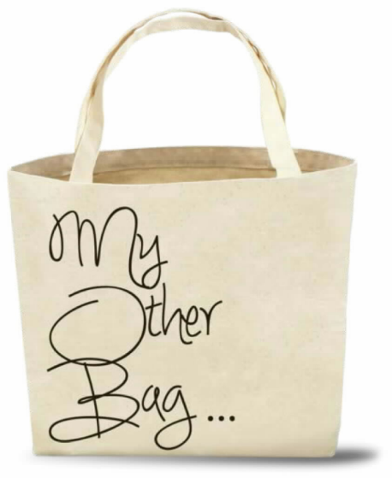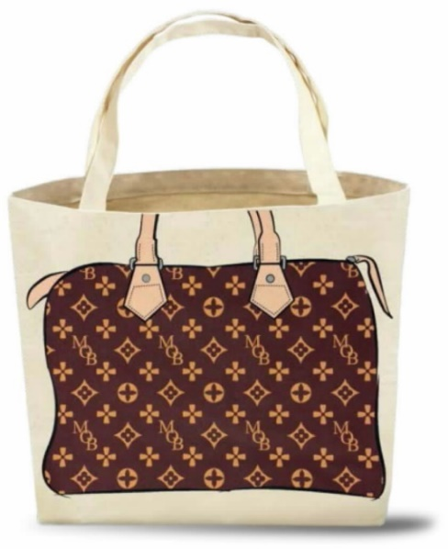
From the appendix to My Other Bag

Louis Vuitton Malletier v. My Other Bag, Inc.
156 F.Supp.3d 425 (SDNY 2016), aff’d, 674 F. App’x 16 (2d Cir. 2016)
JESSE M. FURMAN, United States District Judge:
Defendant My Other Bag, Inc. (“MOB”) sells simple canvas tote bags with the text “My Other Bag . . .” on one side and drawings meant to evoke iconic handbags by luxury designers, such as Louis Vuitton, Chanel, and Fendi, on the other. MOB’s totes—indeed, its very name—are a play on the classic “my other car . . . “ novelty bumper stickers, which can be seen on inexpensive, beat up cars across the country informing passersby—with tongue firmly in cheek—that the driver’s “other car” is a Mercedes (or some other luxury car brand). The “my other car” bumper stickers are, of course, a joke—a riff, if you will, on wealth, luxury brands, and the social expectations of who would be driving luxury and non-luxury cars. MOB’s totes are just as obviously a joke, and one does not necessarily need to be familiar with the “my other car” trope to get the joke or to get the fact that the totes are meant to be taken in jest.
Louis Vuitton Malletier, S.A. (“Louis Vuitton”), the maker of Louis Vuitton bags, is perhaps unfamiliar with the “my other car” trope. Or maybe it just cannot take a joke. In either case, it brings claims against MOB with respect to MOB totes that are concededly meant to evoke iconic Louis Vuitton bags. More specifically, Louis Vuitton brings claims against MOB for trademark dilution and infringement under the Lanham Act, 15 U.S.C. § 1125(c); a claim of trademark dilution under New York law; and a claim of copyright infringement. MOB now moves for summary judgment on all of Louis Vuitton’s claims; Louis Vuitton cross moves for summary judgment on its trademark dilution claims and its copyright infringement claim, and moves also to exclude the testimony of MOB’s expert and to strike the declarations (or portions thereof) of MOB’s expert and MOB’s founder and principal. For the reasons that follow, MOB’s motion for summary judgment is granted and Louis Vuitton’s motions are all denied.
BACKGROUND
The relevant facts, taken from the Complaint and admissible materials submitted in connection with the pending motions, are either undisputed or described in the light most favorable to Louis Vuitton. . . . Louis Vuitton is a world-renowned luxury fashion house known for its high-quality handbags and other luxury goods. . . . By all accounts, and as the discussion below will make clear, Louis Vuitton aggressively enforces its trademark rights.
MOB was founded by Tara Martin in 2011. As noted, the name “My Other Bag” was inspired by novelty bumper stickers, which can sometimes be seen on inexpensive cars claiming that the driver’s “other car” is an expensive, luxury car, such as a Mercedes. MOB produces and sells canvas tote bags bearing caricatures of iconic designer handbags on one side and the text “My Other Bag . . .” on the other. Several of MOB’s tote bags—one of which is depicted in the appendix to this Opinion—display images concededly designed to evoke classic Louis Vuitton bags. As the appendix illustrates, the drawings use simplified colors, graphic lines, and patterns that resemble Louis Vuitton’s famous Toile Monogram, Monogram Multicolore, and Damier designs, but replace the interlocking “LV” and “Louis Vuitton” with an interlocking “MOB” or “My Other Bag.” MOB markets its bags as “[e]co-friendly, sustainable tote bags playfully parodying the designer bags we love, but practical enough for everyday life.” While Louis Vuitton sells its handbags for hundreds, if not thousands, of dollars apiece, MOB’s totes sell at prices between thirty and fifty-five dollars. Its website and other marketing play up the idea that high-priced designer bags cannot be used to carry around, say, dirty gym clothes or messy groceries, while its casual canvas totes can. . . .
. . . .
DISCUSSION
. . . .
A. Trademark Dilution
. . . .
1. Fair Use
{T}he Court concludes as a matter of law that MOB’s bags are protected as fair use—in particular, that its use of Louis Vuitton’s marks constitutes “parody.” As noted, a successful parody communicates to a consumer that “an entity separate and distinct from the trademark owner is poking fun at a trademark or the policies of its owner.” 6 J. Thomas McCarthy, McCarthy on Trademarks and Unfair Competition § 31:153 (4th ed., updated Dec. 2015) (“McCarthy”). In other words, a parody clearly indicates to the ordinary observer “that the defendant is not connected in any way with the owner of the target trademark.” Id. That is precisely what MOB’s bags communicate. Indeed, the whole point is to play on the well-known “my other car . . .” joke by playfully suggesting that the carrier’s “other bag”—that is, not the bag that he or she is carrying—is a Louis Vuitton bag. That joke—combined with the stylized, almost cartoonish renderings of Louis Vuitton’s bags depicted on the totes—builds significant distance between MOB’s inexpensive workhorse totes and the expensive handbags they are meant to evoke, and invites an amusing comparison between MOB and the luxury status of Louis Vuitton. Further, the image of exclusivity and refinery that Louis Vuitton has so carefully cultivated is, at least in part, the brunt of the joke: Whereas a Louis Vuitton handbag is something wealthy women may handle with reverent care and display to communicate a certain status, MOB’s canvas totes are utilitarian bags “intended to be stuffed with produce at the supermarket, sweaty clothes at the gym, or towels at the beach.” (Mem. Law Def. My Other Bag, Inc. Supp. Mot. Summ. J (“MOB’s Mem.”) 24).
Louis Vuitton protests that, even if MOB’s totes are a parody of something, they are not a parody of its handbags and, relatedly, that MOB’s argument is a post hoc fabrication for purposes of this litigation. The company notes that MOB’s Chief Executive Officer, Tara Martin, has referred to its bags as “iconic” and stated that she never intended to disparage Louis Vuitton. (see Calhoun Decl., Ex. 25, MOB website describing its bags as “an ode to handbags women love”). Thus, Louis Vuitton argues, the “My Other Bag . . .” joke mocks only MOB itself or, to the extent it has a broader target, “any humor is merely part of a larger social commentary, not a parody directed towards Louis Vuitton or its products.” (Louis Vuitton’s Mem. at 19). In support of those arguments, Louis Vuitton relies heavily on its victory in an unpublished 2012 opinion from this District: Louis Vuitton Malletier, S.A. v. Hyundai Motor Am., No. 10–CV–1611 (PKC), 2012 WL 1022247 (S.D.N.Y. Mar. 22, 2012). In that case, {t}he Court rejected Hyundai’s parody defense based in large part on deposition testimony from Hyundai representatives that conclusively established that the car company had no intention for the commercial to make any statement about Louis Vuitton at all. See id. at *17–19 (excerpting deposition testimony establishing that Hyundai did not mean to “criticize” or “make fun of” Louis Vuitton, or even “compare the Hyundai with [Louis Vuitton]”). On the basis of that testimony, the Court concluded that Hyundai had “disclaimed any intention to parody, criticize or comment upon Louis Vuitton” and that the ad was only intended to make a “broader social comment” about “what it means for a product to be luxurious.” Id. at *17 (internal quotation marks omitted).
The Hyundai decision is not without its critics, see, e.g., 4 McCarthy § 24:120, but, in any event, this case is easily distinguished on its facts. Here, unlike in Hyundai, it is self-evident that MOB did mean to say something about Louis Vuitton specifically. That is, Louis Vuitton’s handbags are an integral part of the joke that gives MOB its name and features prominently on every tote bag that MOB sells. In arguing otherwise, Louis Vuitton takes too narrow a view of what can qualify as a parody. The quip “My Other Bag . . . is a Louis Vuitton,” printed on a workhorse canvas bag, derives its humor from a constellation of features—including the features of the canvas bag itself, society’s larger obsession with status symbols, and the meticulously promoted image of expensive taste (or showy status) that Louis Vuitton handbags have, to many, come to symbolize. The fact that MOB’s totes convey a message about more than just Louis Vuitton bags is not fatal to a successful parody defense. See Campbell v. Acuff–Rose Music, Inc., 510 U.S. 569, 580 (1994) (holding that a copyright parodist must show that his parody, “at least in part, comments on [the parodied] author’s work” (emphasis added)); Harley–Davidson, Inc. v. Grottanelli, 164 F.3d 806, 813 (2d Cir. 1999) (applying that standard to trademark parody). And the fact that Louis Vuitton at least does not find the comparison funny is immaterial; Louis Vuitton’s sense of humor (or lack thereof) does not delineate the parameters of its rights (or MOB’s rights) under trademark law. See, e.g., Cliffs Notes, 886 F.2d at 495–96 (“[T]he district court apparently thought that the parody here had to make an obvious joke out of the cover of the original in order to be regarded as a parody. We do not see why this is so. It is true that some of the covers of the parodies brought to our attention, unlike that of [the defendant], contain obvious visual gags. But parody may be sophisticated as well as slapstick; a literary work is a parody if, taken as a whole, it pokes fun at its subject.” (footnote omitted)); cf. Yankee Publ’g Inc. v. News Am. Publ’g Inc., 809 F.Supp. 267, 280 (S.D.N.Y. 1992) (“Although [the defendant’s] position would probably be stronger if its joke had been clearer, the obscurity of its joke does not deprive it of First Amendment support. First Amendment protections do not apply only to those who speak clearly, whose jokes are funny, and whose parodies succeed.”).4
In those regards, another decision from this District, Tommy Hilfiger Licensing, Inc. v. Nature Labs, LLC, 221 F.Supp.2d 410, 415 (S.D.N.Y. 2002), is more on point. That case involved a line of parody perfume products for use on pets. In particular, the defendant had created a pet perfume called Tommy Holedigger, which resembled a Tommy Hilfiger fragrance in name, scent, and packaging. See id. at 412–413. Hilfiger, like Louis Vuitton here, argued (albeit in connection with a claim of trademark infringement rather than dilution) that the defendant was not entitled to protection as a parody because “its product admittedly makes no comment about Hilfiger.” Id. at 415. In support of that argument, Hilfiger cited testimony from the defendant’s general partner that his product was not intended to make any comment about Hilfiger or its products. See id. Noting that the general partner had also testified that “he was intending to create a ‘parody . . . target[ing] . . . Tommy Hilfiger,’ ‘a fun play on words,’ or ‘spoof . . . [t]o create enjoyment, a lighter side,’ “ Judge Mukasey rejected Hilfiger’s argument as follows:
Although [the general partner] had difficulty expressing the parodic content of his communicative message, courts have explained that:
Trademark parodies . . . do convey a message. The message may be simply that business and product images need not always be taken too seriously; a trademark parody reminds us that we are free to laugh at the images and associations linked with the mark. The message also may be a simple form of entertainment conveyed by juxtaposing the irreverent representation of the trademark with the idealized image created by the mark’s owner.
Id. (quoting L.L. Bean, Inc. v. Drake Publishers, Inc., 811 F.2d 26, 34 (1st Cir. 1987)). He added, in a comment that applies equally well here: “One can readily see why high-end fashion brands would be ripe targets for such mockery.” Id.
Alternatively, relying principally on Dallas Cowboys Cheerleaders, Inc. v. Pussycat Cinema, Ltd., 604 F.2d 200 (2d Cir. 1979), Louis Vuitton argues that MOB’s totes cannot be a parody because they do not need to use Louis Vuitton’s trademarks for the parody to make sense. Strictly speaking, that is true—to the extent that MOB could use any well-known luxury handbag brand to make its points. But, whereas the defendant in Dallas Cowboys Cheerleaders, a purveyor of a “gross and revolting sex film,” 604 F.2d at 202, did not have to use anyone else’s trademark—let alone the plaintiff’s specific trademark—to make its point (allegedly, “comment[ing] on ‘sexuality in athletics,’ “ id. at 206), the same cannot be said here. MOB’s tote bags would not make their point, and certainly would not be funny, if the obverse of the tote merely depicted some generic handbag. Such a tote would confusingly communicate only that “my other bag . . . is some other bag.” In other words, Louis Vuitton’s argument distorts any “necessity” requirement beyond recognition, and myopically suggests that, where a parody must evoke at least one of a finite set of marks in order to make its point, it can evoke none of them because reference to any particular mark in the set is not absolutely necessary. The Court declines to create such an illogical rule.
. . . .

4 Even if Hyundai were not distinguishable, this Court would decline to follow it. In the Court’s view, the Hyundai Court blurred the distinction between association and dilution. As discussed in more detail below, association is a necessary, but not sufficient, condition for a finding of dilution by blurring. See, e.g., Moseley v. V Secret Catalogue, Inc., 537 U.S. 418, 433, 123 S.Ct. 1115, 155 L.Ed.2d 1 (2003) (“[T]he mere fact that consumers mentally associate the junior user’s mark with a famous mark is not sufficient to establish actionable dilution. . . . [S]uch mental association will not necessarily reduce the capacity of the famous mark to identify the goods of its owner.”).

