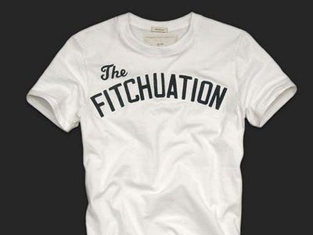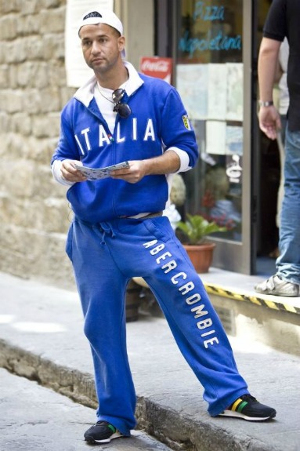

MPS Entm’t, LLC v. Abercrombie & Fitch Stores, Inc.
No. 11 Civ. 24110, 2013 WL 3288039 (S.D. Fla. June 28, 2013)
MPS Entm’t, LLC v. Abercrombie & Fitch Stores, Inc. offers a good, quick, and perhaps memorable example of an expressive use case where the court did not trouble itself with any extended analysis of whether the parody at issue was successful or of the First Amendment aspects of the case. Instead, the court simply applied the multifactor test for the likelihood of consumer confusion and found no likelihood of confusion.
In February 2010, the clothing store Abercrombie & Fitch began selling a t-shirt (shown above on the left) bearing the phrase “The Fitchuation”. The t-shirt referred to Michael Sorrentino, who starred as an antihero on the notorious reality television show of the time The Jersey Shore, whose nickname was “The Situation,”∗ and who wore without authorization Abercrombie & Fitch merchandise on the show (shown above on the right). Abercrombie & Fitch apparently feared that its brand would be tarnished by association with The Jersey Shore and Sorrentino. It had gone so far as to send a letter to MTV offering to pay up to $10,000 to cast members not to wear any clothing bearing its trademarks. The letter stated:
A & F obviously has not sought product placement on the show, and we believe that, since the character portrayed by Mr. Sorrentino is not brand appropriate, his display of A & F clothing could be misconstrued as an endorsement by him of our clothing or—worse—an endorsement by A & F of his wearing our clothing.
We have no interest at this point in pursuing any sort of legal action against MTV or the producers of “Jersey Shore.” In fact, we would be willing to pay MTV or Mr. Sorrentino or other characters up to $10,000 NOT to wear any clothing bearing the “ABERCROMBIE & FITCH,” “A & F,” “FITCH,” “MOOSE” or related trademarks. For additional episodes aired this season, we would appreciate it if you would ensure that our brands are pixilated or otherwise appropriately masked.
Id. at *2. Abercrombie & Fitch also issued a press release announcing its offer to the cast members of Jersey Shore and singled out Sorrentino by name: “We have therefore offered a substantial payment to Michael ‘The Situation’ Sorrentino and the producers of MTV’s The Jersey Shore to have the character wear an alternate brand.” Id. Apparently, Abercrombie & Fitch produced “The Fitchuation” t-shirt to mock and distance itself from Sorrentino. Meanwhile, Sorrentino, through the plaintiff, filed an application at the PTO to register the mark the situation for entertainment services and began selling t-shirts on his website displaying the words “The Situation” and “Official Situation Nation.”
Sorrentino sued Abercrombie & Fitch on the ground that “The Fitchuation” t-shirt and the press release violated his trademark rights. Granting Abercrombie & Fitch’s motion for summary judgment, the court applied the Eleventh Circuit’s multifactor test for the likelihood of consumer confusion to find that the t-shirt did not create a likelihood of confusion. As to the similarity of the marks factor,
The target of A & F’s parody is “The Situation.” The t-shirt expresses “The Fitchuation” visually and phonetically different than “The Situation.” There is no evidence of A & F “palming off” its t-shirt as that of the plaintiffs where, as here, the t-shirt has the A & F inside label and prominently uses A & F’s own famous trademark “Fitch” as part of the parody.
Id. at *7. On the proximity of the goods or services,
A & F’s apparel goods are dissimilar to the plaintiffs’ entertainment services. The plaintiffs concede that they did not offer apparel under a “Situation” mark until after A & F introduced “The Fitchuation” t-shirt. There is no evidence that the public attributes the parties’ respective goods and services to the same single source.
Id. The court found in favor of the defendant on the intent and actual confusion factors as well.
As to the press release, the court found nominative fair use:
The Court finds that the use of Michael Sorrentino’s name and nickname in the press release was a non-actionable fair use under trademark law. A & F used only so much of the plaintiff’s name as was reasonably necessary to respond to his wearing A & F’s brand on The Jersey Shore, and did not do anything that would suggest Sorrentino’s sponsorship or endorsement. A & F’s press release expressly disassociated Sorrentino from A & F, and the plaintiffs have conceded that no third party has expressed any confusion that the press release rejecting Sorrentino’s image somehow suggested sponsorship or endorsement by Sorrentino.
Id. at *13.
Do you think the court reached the right result in finding, on summary judgment, no likelihood of confusion?

∗ According to Wikipedia, “Sorrentino gained his nickname ‘The Situation’ when a girl complimented his abs while walking with her boyfriend on a beach in New Jersey. The girl’s boyfriend was angered by her complimenting another guy, and Sorrentino’s friend joked that his abs were causing a ‘situation’ between the couple.” https://en.wikipedia.org/wiki/Michael_Sorrentino.

