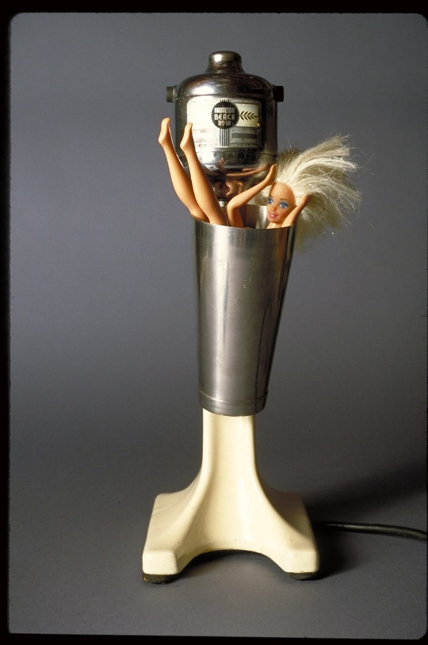
Tom Forsythe, Malted Barbie (1997)
See www.tomforsythe.com

Mattel, Inc. v. Walking Mountain Productions
353 F.3d 792 (9th Cir. 2003)
Pregerson, Judge:
In the action before us, Plaintiff Mattel Corporation asks us to prohibit Defendant artist Thomas Forsythe from producing and selling photographs containing Mattel’s “Barbie” doll. Most of Forsythe’s photos portray a nude Barbie in danger of being attacked by vintage household appliances. Mattel argues that his photos infringe on their copyrights, trademarks, and trade dress. We . . . affirm the district court’s grant of summary judgment to Forsythe.
{With respect to Mattel’s claim that Forsythe’s works infringed Mattel’s copyright rights in the design of the Barbie doll, the court applied the four copyright fair use factors established in 17 U.S.C. § 107 and found fair use. It then turned to the trademark claims.}
We now address whether the district court erred in granting summary judgment in favor of Forsythe on Mattel’s claims of trademark and trade dress infringement . . . .
A. Trademark
{The court applied the Rogers v. Grimaldi test, reviewed below in Section III.C, to find that Forsythe’s references to Barbie in the titles of his photographs were not infringing.}
B. Trade dress
Mattel also claims that Forsythe misappropriated its trade dress in Barbie’s appearance, in violation of the Lanham Act, 15 U.S.C. § 1125. Mattel claims that it possesses a trade dress in the Superstar Barbie head and the doll’s overall appearance. The district court concluded that there was no likelihood that the public would be misled into believing that Mattel endorsed Forsythe’s photographs despite Forsythe’s use of the Barbie figure.
Arguably, the Barbie trade dress also plays a role in our culture similar to the role played by the Barbie trademark—namely, symbolization of an unattainable ideal of femininity for some women. Forsythe’s use of the Barbie trade dress, therefore, presumably would present First Amendment concerns similar to those that made us reluctant to apply the Lanham Act as a bar to the artistic uses of Mattel’s Barbie trademark in both MCA and this case. But we need not decide how the MCA/Rogers First Amendment balancing might apply to Forsythe’s use of the Barbie trade dress because we find, on a narrower ground, that it qualifies as nominative fair use.
. . . .
Forsythe’s use of the Barbie trade dress is nominative. Forsythe used Mattel’s Barbie figure and head in his works to conjure up associations of Mattel, while at the same time to identify his own work, which is a criticism and parody of Barbie. See Cairns, 292 F.3d at 1151. Where use of the trade dress or mark is grounded in the defendant’s desire to refer to the plaintiff’s product as a point of reference for defendant’s own work, a use is nominative.
Fair use may be either nominative or classic. Id. at 1150. We recognize a fair use defense in claims brought under § 1125 where the use of the trademark “does not imply sponsorship or endorsement of the product because the mark is used only to describe the thing, rather than to identify its source.” New Kids on the Block, 971 F.2d at 306. . . .
Forsythe’s use easily satisfies the first element {of the New Kids test}; his use of the Barbie figure and head are reasonably necessary in order to conjure up the Barbie product in a photographic medium. See id. at 1153 (“[T]here is no substitute for Franklin Mint’s use of Princess Diana’s likeness on its Diana-related products . . . .”). It would have been extremely difficult for Forsythe to create a photographic parody of Barbie without actually using the doll.
Forsythe also satisfies the second element, which requires that a defendant only use so much of a trademark or trade dress as is reasonably necessary. As we recognized in Cairns, “[w]hat is ‘reasonably necessary to identify the plaintiff’s product’ differs from case to case.” Id. at 1154. Where identification “of the defendant’s product depends on the description [or identification] of the plaintiff’s product, more use of the plaintiff’s trademark” or trade dress is reasonably necessary. Id. Given the photographic medium and Forsythe’s goal of representing the social implications of Barbie, including issues of sexuality and body image, Forsythe’s use of the Barbie torso and head is both reasonable and necessary. It would be very difficult for him to represent and describe his photographic parodies of Barbie without using the Barbie likeness.
Though a “closer call than the first two elements” of the nominative fair use analysis, id. at 1155, the final element—that the user do nothing that would, in conjunction with use of the mark or dress, suggest sponsorship or endorsement by the trademark or trade dress holder—is satisfied here and weighs in Forsythe’s favor. This element does not require that the defendant make an affirmative statement that their product is not sponsored by the plaintiff. Id.
Mattel attempts to argue that Forsythe suggested sponsorship by asserting to potential consumers that one of his photographs “hangs on the wall of the office of Mattel’s President of Production,” to whom Forsythe referred as “Joe Mattel.”
One of the purchasers of Forsythe’s work apparently told Forsythe that he had given the work to this Mattel senior executive as a gift. Forsythe repeated this fact in certain letters to galleries and friends. Forsythe claims that he had no intention of suggesting sponsorship and that he meant the statement humorously. In virtually every promotional packet in which Forsythe mentioned “Joe Mattel,” he also included a copy of his biography in which he identified himself as “someone criticizing Mattel’s Barbie and the values for which it stands.” The letters in the packets asserted that Forsythe was attempting to “deglamourize[ ] Barbie,” “skewer[ ] the Barbie myth,” and expose an “undercurrent of dissatisfaction with consumer culture.” A similar mission statement was prominently featured on his website.
The rest of the materials in these promotional packets sent to galleries reduce the likelihood of any consumer confusion as to Mattel’s endorsement of Forsythe’s work. Any reasonable consumer would realize the critical nature of this work and its lack of affiliation with Mattel. Critical works are much less likely to have a perceived affiliation with the original work. New Kids on the Block, 971 F.2d at 309 (finding no suggested sponsorship in part because a poll in a magazine regarding the popularity of the New Kids asked if the New Kids had become a “turn off”). Moreover, even if “Joe Mattel” existed, we question whether possession by a third-party passive recipient of an allegedly infringing work can suggest sponsorship.
. . . .
{The district court eventually ordered Mattel to pay Forsythe’s legal fees in the amount of $1.9 million. See Mattel, Inc. v. Walking Mountain Productions, 2004 WL 1454100 (C.D.Cal., June 21, 2004). This was in addition to the Ninth Circuit’s determination that Mattel should pay the costs of the appeal. See Mattel, Inc. v. Walking Mountain Productions, 353 F.3d 792, 816 (9th Cir. 2003).}

