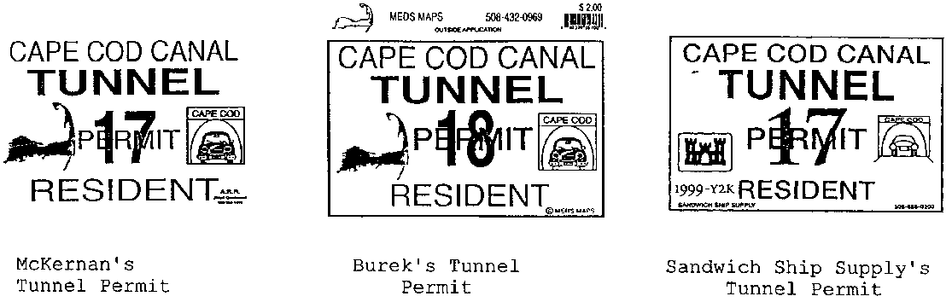

McKernan v. Burek
118 F. Supp. 2d 119 (D.Mass. 2000)
In McKernan, the plaintiff McKernan sold a novelty bumper sticker that purported to be a “Cape Cod Canal Tunnel Permit.” (This was meant to be hilarious. There is no tunnel to Cape Cod.) He brought a trademark infringement suit against Burek and others who were producing similar bumper stickers. McKernan conceded that his bumper sticker design had no secondary meaning. The parties filed cross-motions for summary judgment. Judge Lasker analyzed whether the bumper sticker was product packaging or product configuration as follows:
The Tunnel Permit presents one of the “hard cases at the margin” referred to by the Supreme Court {in Wal-Mart}. It is particularly difficult to try to distinguish between the packaging and the product when discussing an ornamental bumper sticker. The packaging and the product are so intertwined that distinguishing between them may be regarded as a scholastic endeavor.
Nevertheless, the Supreme Court’s opinion in Wal–Mart provides some guidance. The example given in Wal–Mart, of the classic Coca–Cola bottle is instructive: an item is the product if it is the essential commodity being purchased and consumed rather than the dress which presents the product.
Here, the essential commodity being purchased is a joke on a bumper sticker. All of the visual elements contained in the Tunnel Permit are a part of this joke and indispensable to it. What is being purchased and consumed is the novelty sticker, not dress identifying the prestige or standing of its source. Because McKernan is seeking protection for the product being consumed, the proper classification of what McKernan seeks to protect is product design. This view of the matter is strengthened by the Wal–Mart Court’s remarkably clear advice that in close cases trial courts should “err on the side of caution and classify ambiguous trade dress as product design.” Wal–Mart, 529 U.S. at 215.
Accordingly, because McKernan seeks to protect his product design which, by definition, cannot be “inherently distinctive,” his claim under § 43(a) fails.
118 F. Supp. 2d at 123-24. (McKernan did not bring a copyright claim, apparently because he falsely represented to the Copyright Office that he had drawn the image of Cape Cod appearing on the sticker when in fact he had copied it from a book. Id. at 122.).

