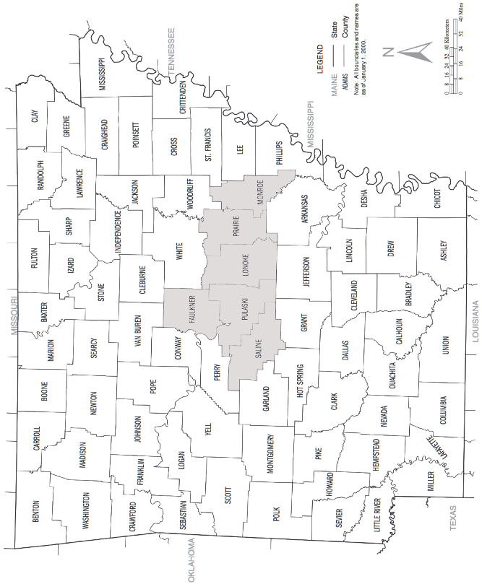
The six counties where Central Arkansas Area Agency on Aging, Inc. used its mark.

National Association for Healthcare Communications, Inc. v. Central Arkansas Area Agency on Aging, Inc.
257 F.3d 732 (8th Cir. 2001)
LOKEN, Circuit Judge.
This is an action under the Lanham Act and state law to determine which party has the superior right to use the service mark “CareLink” in Arkansas. The National Association for Healthcare Communications, Inc. (“Healthcom”) was the first to use the mark nationally. It has a federal service mark registration pending but must rely in this case on its common law trademark rights as enforced under the Lanham Act. See 15 U.S.C. § 1125(a). The Central Arkansas Area Agency on Aging, Inc. (“CA”) was the first to use the mark in six counties in central Arkansas and has registered its mark under the Arkansas trademark statutes. See Ark.Code Ann. Tit. 4, Ch. 71 (Michie Supp. 1999). The district court held that CA as first user prevailed in its six-county trade area and that CA’s state registration entitled it to statewide relief. Accordingly, the court enjoined Healthcom from using the CareLink mark anywhere in Arkansas. National Ass’n for Healthcare Commun., Inc. v. Central Ark. Area Agency on Aging, Inc., 119 F.Supp.2d 884 (E.D.Ark. 2000). Healthcom appeals. Agreeing that CA is entitled to injunctive relief, but limited to the six Arkansas counties where it has used the mark, we remand to the district court with instructions to modify the injunction.
I.
The Parties’ Use of the CareLink Mark. Healthcom is an Illinois corporation that provides remote electronic monitoring devices and emergency response services for at-home clients in twenty-five States, including Arkansas. Healthcom solicits local hospitals and home health care agencies to become members of Healthcom’s National Association for Emergency Response, Inc. Each member’s subscribers (individual clients or patients) are then offered a variety of CareLink at-home emergency response services. A CareLink program typically consists of monitoring equipment, usually leased by Healthcom to the member health care provider or directly to the subscriber, plus a round-the-clock support center operated by Healthcom, which responds to the subscriber’s emergency calls in a prearranged fashion and may monitor medical equipment in the subscriber’s home or monitor the whereabouts of an at-risk subscriber, such as one suffering from Alzheimer’s disease. Each provider-member markets CareLink programs and equipment to its patients, bills the patients, and pays Healthcom a monthly fee for each patient using CareLink services.
CA is a private, nonprofit Arkansas corporation organized in 1979 to provide a broad range of support services to elderly and disabled persons in a six-county region in central Arkansas. CA’s mission is to provide cost-effective, community-based alternatives to nursing home care. CA has 750 employees and 300 volunteers who assist some 10,000 elderly persons in the region. CA has never provided personal emergency response services, but it has occasionally paid for such services being provided to CA clients. In January 1995, CA adopted the trade name “CareLink” to use in lieu of its corporate name, which had proved awkward and hard to remember, and which created the mis-impression that CA is a government agency.
Facts relating to first usage. Healthcom began marketing emergency response services under the CareLink service mark in 1991 or early 1992. From 1992 to 1995, Healthcom spent an estimated $50,000 attempting to sell its services in Arkansas. Despite these efforts, during this period Healthcom made only one $385 sale in Arkansas, to an end user who stopped using its CareLink service in April 1994. Healthcom had no Arkansas customers from April 1994 to September 1995, when it entered into a contract with North Arkansas Regional Medical Center in Harrison. By July 1999, Healthcom had contracts with seven Arkansas health care providers and served 350 individual subscribers. Healthcom estimated that its total Arkansas revenues in 1999 would be just over $82,000. Healthcom has never had a customer for its CareLink services located within the six-county region served by CA. Healthcom applied for federal trademark registration on May 4, 1999, and its application is pending.
CA adopted the CareLink trade name and logo in early 1995 and has prominently displayed the logo on stationery, business cards, client information materials, and other publicity materials. CA registered its CareLink mark with the Arkansas Secretary of State on March 23, 1995, and has used the mark in promoting all of its services, except hospice care. CA’s annual revenues grew from $5,000,000 to $12,000,000 from early 1995 to mid–1999. Although CA derives most of its revenues from government grants, in 1999 it received approximately $138,000 in private donations and an estimated $250,000 from clients able to pay for its services. All of CA’s clients reside in its six-county region, but its activities are publicized beyond central Arkansas through news coverage, telephone listings, advertisements, and a monthly column in an Arkansas newspaper for the elderly.
CA did not know of Healthcom’s prior usage when it adopted the CareLink name and logo and received a state registration in early 1995. When CA learned that the North Arkansas Regional Medical Center was using Healthcom’s CareLink mark for emergency response services in northern Arkansas, CA sent a cease-and-desist letter to that provider. The parties were unable to resolve the resulting dispute. Healthcom then commenced this action, alleging common law trademark infringement and unfair competition in violation of the Lanham Act, 15 U.S.C. § 1125(a), and seeking an injunction barring CA from using the mark and cancellation of CA’s state registration. CA counterclaimed, alleging unfair competition under the Lanham Act and trademark infringement under Ark.Code Ann. § 4–71–212, and seeking an injunction prohibiting Healthcom from using its CareLink mark in Arkansas or, alternatively, in CA’s six-county region.
Deciding the case on cross motions for summary judgment, the district court dismissed Healthcom’s claims because its use of the CareLink mark in Arkansas prior to CA’s state registration was de minimis. The court granted CA a permanent injunction prohibiting Healthcom from using the mark anywhere in Arkansas because CA’s use of the mark has been substantial, because a statewide injunction is necessary “to prevent confusion among consumers and to prevent Healthcom from passing off its services as those of [CA],” and because CA’s state registration entitles it to a statewide injunction. Healthcom appeals, arguing that its common law trademark is entitled to priority because it first used the mark in Arkansas. Alternatively, Healthcare argues the district court abused its discretion in granting CA an overly broad injunction.
II.
Nearly a century ago, the Supreme Court established what is now called the Tea Rose/Rectanus doctrine—the first user of a common law trademark may not oust a later user’s good faith use of an infringing mark in a market where the first user’s products or services are not sold. See United Drug Co. v. Theodore Rectanus Co., 248 U.S. 90, 100–01 (1918); Hanover Star Milling Co. v. Metcalf, 240 U.S. 403, 415 (1916). The rationale is a core principle of trademark law: the owner of a mark may not “monopolize markets that his trade has never reached and where the mark signifies not his goods but those of another.” Hanover Star Milling, 240 U.S. at 416. That essential principle applies even when the first user has federally registered its mark under the Lanham Act, with one important modification: the owner of a registered mark has the right to expand its use into a new market unless an infringing user had penetrated that market prior to registration. See Natural Footwear Ltd. v. Hart, Schaffner & Marx, 760 F.2d 1383, 1395 (3d Cir.); 15 U.S.C. § 1072.
In this case we must apply the Tea Rose/Rectanus doctrine in resolving two distinct inquiries. First, we must determine whether Healthcom, as the first user of a CareLink common law mark elsewhere in the country, is entitled by reason of its own market penetration to oust CA from any area in Arkansas. Second, to the extent Healthcom failed to prove first use in Arkansas, we must determine whether CA, as owner of a state-registered mark used only in six counties, is entitled to statewide injunctive relief against Healthcom’s present use of its mark.
A.
It is undisputed that, in early 1995, CA adopted the CareLink mark in good faith, without knowledge of Healthcom’s prior use. To be entitled to injunctive relief against CA’s subsequent good faith use, Healthcom must prove that its prior use of the mark penetrated the geographic market in question. In determining whether Healthcom achieved the necessary market penetration, we apply the factors identified in our often-cited Sweetarts cases:
[Healthcom’s] dollar value of sales at the time [CA] entered the market, number of customers compared to the population of the state, relative and potential growth of sales, and length of time since significant sales. Though the market penetration need not be large to entitle [Healthcom] to protection, it must be significant enough to pose the real likelihood of confusion among the consumers in that area.
Sweetarts v. Sunline, Inc., 380 F.2d 923, 929 (8th Cir. 1967); Sweetarts v. Sunline, Inc., 436 F.2d 705, 708 (8th Cir. 1971) (citation omitted). Where the first user’s activities in a remote area are “so small, sporadic, and inconsequential” that its market penetration is de minimis, the first user is not entitled to protection against a later user’s good faith adoption of the mark in that area. Sweetarts, 380 F.2d at 929.
Healthcom argues that it penetrated the Arkansas market through its one sale to an end user in 1992, its seven provider-member contracts and 350 subscribers since the fall of 1995, and its continuous advertising and marketing efforts beginning in 1992. Healthcom errs in assuming without proof that the entire State of Arkansas is a single geographic market for these purposes. CA adopted its CareLink mark for use in six counties in central Arkansas, not the entire State. Healthcom has never made a sale in that area, nor has it even attempted to prove that CA’s use of the mark in its region is causing a likelihood of confusion elsewhere in the State. For this reason alone, Healthcom has not penetrated CA’s six-county trade area, and the district court properly denied Healthcom injunctive relief against CA’s use in that area.
This leaves the question whether Healthcom is entitled to injunctive relief as a prior user with market penetration in any other part of Arkansas. We agree with the district court that Healthcom’s one $385 sale long before CA’s adoption of its mark was de minimis market penetration. That leaves Healthcom’s reliance on later sales and continuous advertising. CA argues that sales in Arkansas after CA began using the mark are irrelevant, and that Healthcom’s prior advertising may not be used to satisfy the Sweetarts market penetration test. Those are strong arguments. The issue is whether they warrant summary judgment.
Sweetarts expressly recognized that the market penetration issue is focused on the time when the later user entered the market. However, subsequent sales by the first user may establish a trend of increased sales justifying a finding of market penetration. See Natural Footwear, 760 F.2d at 1401. Likewise, while “advertising alone is not sufficient to satisfy the significant market penetration test of Sweetarts,” Flavor Corp. of Am. v. Kemin Indus., Inc., 493 F.2d 275, 284 (8th Cir. 1974), we are not prepared to say as a matter of law that a first user’s highly focused local advertising, followed by initial sales shortly after a later user enters the market, may never satisfy the Sweetarts test. Compare Natural Footwear, 760 F.2d at 1402–03; Nutri/System, Inc. v. Con–Stan Indus., Inc., 809 F.2d 601, 604 (9th Cir. 1987). Nevertheless, we need not decide whether CA is entitled to summary judgment on the market penetration issue statewide because Healthcom presented no evidence that CA is presently likely to enter areas of Arkansas beyond its six-county region, and no evidence that any customers or potential customers of Healthcom are actually confused, or likely to be confused, by CA’s use of its CareLink mark in serving a six-county region where Healthcom does no business. In these circumstances, the district court properly dismissed all of Healthcom’s claims for relief. See generally Gaston’s White River Resort v. Rush, 701 F.Supp. 1431, 1435 (W.D.Ark. 1988).
B.
Having concluded that Healthcom is not entitled to injunctive relief, we turn to CA’s counterclaim for injunctive relief and the district court’s grant of a statewide injunction. As we have explained, CA has superior common law rights in its six-county region, and it is a state-registered user of the CareLink mark. Therefore, under both the Lanham Act and the Arkansas trademark statute, CA is entitled to an injunction against an infringing use that is likely to cause confusion as to origin. See 15 U.S.C. § 1125(a)(1)(A); Ark.Code Ann. § 4–71–212(1). . . .
. . . .
In summary, the absence of concrete evidence of likelihood of confusion outside of CA’s six-county region makes it improvident to grant a statewide injunction on this record. Healthcom is now enjoined from using its CareLink mark in CA’s trade area. If CA never expands beyond that area, this injunction may be all the judicial action that is required. If CA does decide to expand, its statewide registration puts Healthcom at risk of being ousted. But any future prayer by CA for a broader injunction may raise issues that would be better resolved on a fuller fact record, such as whether Healthcom was the first user in any local market; whether the CareLink mark is descriptive and, if so, whether CA’s mark has become incontestable or has acquired secondary meaning; precisely what services CA claims its registration covers; and whether there is likelihood of confusion between users of those services and users of Healthcom’s emergency response services. . . . Additional issues would be raised if Healthcom’s mark is granted federal registration. See Spartan Food Sys., Inc. v. HFS Corp., 813 F.2d 1279, 1284 (4th Cir. 1987); Burger King of Fla., Inc. v. Hoots, 403 F.2d 904, 906–07 (7th Cir. 1968).
We affirm the dismissal of Healthcom’s claims and the grant of a permanent injunction barring Healthcom’s use of its CareLink mark in CA’s six-county trade area. We reverse the grant of a statewide injunction and remand to the district court for an appropriate modification of its Judgment dated January 31, 2000.

