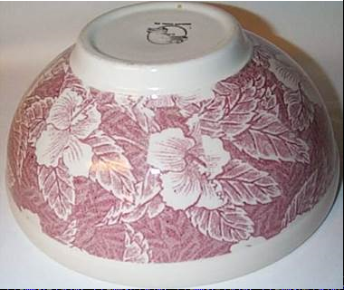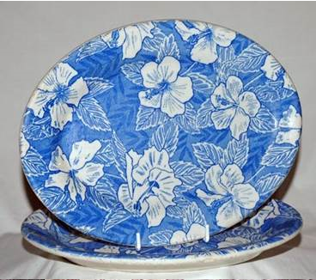
Wallace Hibiscus (L) and Tepco Hibiscus (R)

Pagliero v. Wallace China Co.
198 F.2d 339, 343-44 (9th Cir. 1952)
{Wallace China Co. (“Wallace”) produced hotel china imprinted with various designs. Wallace’s business model involved selling initial sets of hotel china at a relatively low price and making significant profits on selling replacement pieces (made necessary by breakage) bearing matching designs. Pagliero Brothers, doing business as Technical Porcelain and Chinaware Company (“Tepco”), produced low cost hotel china bearing designs substantially identical to Wallace’s. This undercut Wallace’s business model. Wallace brought federal trademark and other causes of action against Tepco for this and other conduct by Tepco. The district court found infringement and enjoined Tepco from producing china bearing designs similar to Wallace’s. Excerpted here is the Ninth Circuit’s discussion of the aesthetic functionality of Wallace’s designs.}
ORR, Circuit Judge
. . . .
Tepco’s use of the designs in question cannot be enjoined even though it be assumed that Wallace can establish secondary meaning for them. Imitation of the physical details and designs of a competitor’s product may be actionable, if the particular features imitated are ‘non-functional’ and have acquired a secondary meaning. Crescent Tool Co. v. Kilborn & Bishop Co., 2d Cir., 1917, 247 F. 299. But, where the features are ‘functional’ there is normally no right to relief. ‘Functional’ in this sense might be said to connote other than a trade-mark purpose. If the particular feature is an important ingredient in the commercial success of the product, the interest in free competition permits its imitation in the absence of a patent or copyright. On the other hand, where the feature or, more aptly, design, is a mere arbitrary embellishment, a form of dress for the goods primarily adopted for purposes of identification and individuality and, hence, unrelated to basic consumer demands in connection with the product, imitation may be forbidden where the requisite showing of secondary meaning is made. Under such circumstances, since effective competition may be undertaken without imitation, the law grants protection.
These criteria require the classification of the designs in question here as functional. Affidavits introduced by Wallace repeat over and over again that one of the essential selling features of hotel china, if, indeed, not the primary, is the design. The attractiveness and eye-appeal of the design sells the china. Moreover, from the standpoint of the purchaser china satisfies a demand for the aesthetic as well as for the utilitarian, and the design on china is, at least in part, the response to such demand. The granting of relief in this type of situation would render Wallace immune from the most direct and effective competition with regard to these lines of china. It seems clear that these designs are not merely indicia of source, as that one who copies them can have no real purpose other than to trade on his competitor’s reputation. On the contrary, to imitate is to compete in this type of situation. Of course, Tepco can also compete by developing designs even more aesthetically satisfying, but the possibility that an alternative product might be developed has never been considered a barrier to permitting imitation competition in other types of cases. The law encourages competition not only in creativeness but in economy of manufacture and distribution as well. Hence, the design being a functional feature of the china, we find it unnecessary to inquire into the adequacy of the showing made as to secondary meaning of the designs.
{The Ninth Circuit ordered the district court’s injunction to be modified to remove all reference to Tepco’s use of designs similar to Wallace’s.}

