Star Industries, Inc. v. Bacardi & Co. Ltd.
412 F.3d 373 (2d Cir. 2005)
{Star Industries, Inc. (“Star”) developed and registered the mark as shown and described below for orange-flavored georgi vodka. Bacardi & Co. Ltd. (“Bacardi”) then developed a similar mark for orange flavored rum. Star brought suit. Excerpted below is the court’s description of Star’s mark and its analysis of the inherent distinctiveness of that mark. Like the Seabrook plaintiff’s claim that the pointed loop alone was source distinctive, Star was claiming that the “O” alone was distinctive of source.}

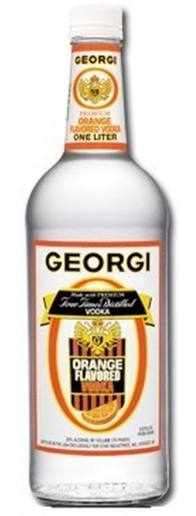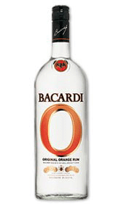

POOLER, Circuit Judge
. . . .
In June 1996, inspired by the success of flavored vodkas introduced by leading international companies such as Stolichnaya, Star’s president decided to develop an orange-flavored Georgi vodka. A new label was designed, consisting of the traditional Georgi label, which contains a coat of arms and a logo consisting of stylized capital letters spelling ‘Georgi’ on a white background, together with three new elements: an orange slice, the words “orange flavored,” and a large elliptical letter “O” appearing below the “Georgi” logo and surrounding all of the other elements. The “O” was rendered as a vertical oval, with the outline of the “O” slightly wider along the sides (about one quarter inch thick) and narrowing at the top and bottom (about one eighth inch thick); the outline of the “O” is colored orange and decorated with two thin gold lines, one bordering the inside and one bordering the outside of the outline. Star was apparently the first company to distribute an orange-flavored alcoholic beverage packaged in a bottle bearing a large elliptical orange letter “O.”
. . . .
The district court erred when it described the Star “O” as a basic geometric shape or letter, and therefore rejected inherent distinctiveness and required a showing of secondary meaning. The Star “O” is not a “common basic shape” or letter, and the district court’s holding to the contrary was premised on a misunderstanding of this trademark law concept. Unshaded linear representations of common shapes or letters are referred to as “basic.” They are not protectable as inherently distinctive, because to protect them as trademarks would be to deprive competitors of fundamental communicative devices essential to the dissemination of information to consumers. However, stylized letters or shapes are not “basic,” and are protectable when original within the relevant market. See Courtenay Communications Corp. v. Hall, 334 F.3d 210, 215 n.32 (2d Cir. 2003) (distinguishing case of mark consisting of word displayed with distinctive “typeface, color, and other design elements,” which was protectable, from cases holding generic words not protectable); compare W In re W.B. Roddenbery Co., 135 U.S.P.Q. 215, 216 (TTAB 1962) (holding design consisting of colored circle attached to differently colored rectangle protectable as inherently distinctive) with In re Hillerich & Bradsby Co., 40 C.C.P.A. 990, 204 F.2d 287, 288 (1953) (noting that applicant conceded that unshaded line oval was not inherently distinctive). Star’s “O” is sufficiently stylized to be inherently distinctive and therefore protectable as a trademark. It is stylized with respect to shading, border, and thickness, and each of these design elements distinguishes it from the simple or basic shapes and letters that have been held unprotectable.
The Star “O” design had sufficient shape and color stylization to render it slightly more than a simply linear representation of an ellipse or the letter “O.” It was, furthermore, a unique design in the alcoholic beverage industry at the time it was introduced. This suffices to establish its inherent distinctiveness and thus its protectability. Furthermore, the Star “O” design is protectable separately from the other design elements on the Georgi orange-flavored vodka label precisely because the “O” design is itself inherently distinctive. See In re E.J. Brach & Sons, 45 C.C.P.A. 998, 256 F.2d 325, 327 (1958); W.B. Roddenbery, 135 U.S.P.Q. at 216. However, the extent of stylization was marginal at best. The outline of the “O,” though not uniform, is ordinary in its slightly varying width, and the interior and exterior borders are also ordinary. The result is a “thin” or weak mark, which will be entitled to only limited protection. See Libman Co. v. Vining Indus., 69 F.3d 1360, 1363 (7th Cir. 1995).
{The court went on to find no likelihood of confusion.}

