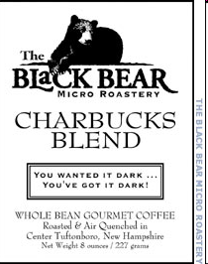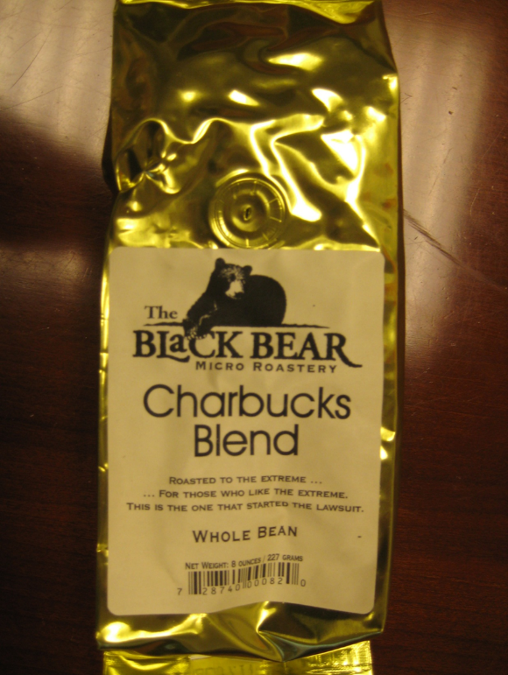

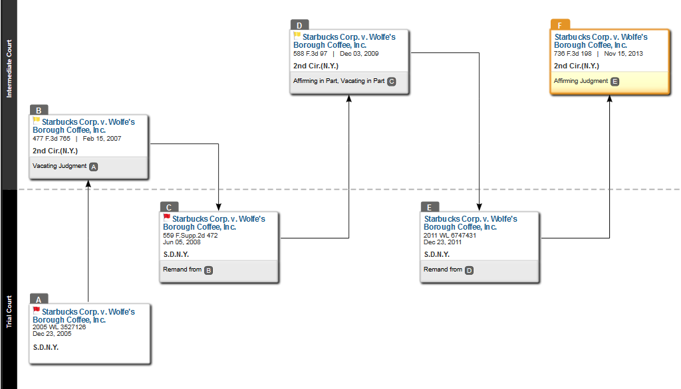

Starbucks Corp. v. Wolfe’s Borough Coffee, Inc.
736 F.3d 198 (2d Cir. 2013)
LOHIER, Circuit Judge:
Starbucks Corporation and Starbucks U.S. Brands LLC (together, “Starbucks”) appeal from a judgment of the United States District Court for the Southern District of New York (Swain, J.) denying Starbucks’ request for an injunction pursuant to the Federal Trademark Dilution Act of 1995 (“FTDA”), 15 U.S.C. § 1125(c), prohibiting Wolfe’s Borough Coffee, Inc., doing business as Black Bear Micro Roastery (“Black Bear”), from using Black Bear’s “Mister Charbucks,” “Mr. Charbucks,” and “Charbucks Blend” marks (the “Charbucks Marks”). After a bench trial followed by additional briefing from the parties upon remand from this Court, the District Court concluded that Starbucks failed to prove that the Charbucks Marks are likely to dilute Starbucks’ famous “Starbucks” marks (the “Starbucks Marks”) and denied Starbucks’ request for an injunction.
On appeal, Starbucks argues that the District Court erred in finding only minimal similarity and weak evidence of actual association between the Charbucks Marks and the Starbucks Marks. Starbucks also contends that the District Court erred in balancing the statutory dilution factors by giving no weight at all to three of the factors—the strong distinctiveness, exclusive use, and high degree of recognition of the Starbucks Marks—and placing undue weight on the minimal similarity between the marks.
For the following reasons, we conclude that the District Court did not err in its factual findings, and, balancing the statutory factors de novo, we agree with the District Court that Starbucks failed to prove a likelihood of dilution. We therefore affirm.
BACKGROUND
We assume familiarity with the underlying facts and long procedural history of the case, which are set forth in our previous opinions, Starbucks Corp. v. Wolfe’s Borough Coffee, Inc., 477 F.3d 765 (2d Cir. 2007) (“Starbucks II “), and Starbucks Corp. v. Wolfe’s Borough Coffee, Inc., 588 F.3d 97 (2d Cir. 2009) (“Starbucks IV “). We recount them here only as necessary to explain our disposition of this appeal.
As of 2005, when the bench trial occurred, Starbucks had grown from a single coffee shop in Seattle in 1971 to a singularly prominent global purveyor of specialty coffee and coffee products, with 8,700 retail locations worldwide and revenues of $5.3 billion for fiscal year 2004. Starbucks U.S. Brands is the owner, and Starbucks Corporation a licensee, of at least 56 valid United States trademark registrations that include the Starbucks Marks. The Starbucks Marks are displayed on signs and at multiple locations in each Starbucks store, as well as on the Starbucks website.
Starbucks has devoted substantial time, effort, and money to advertising and promoting the Starbucks Marks. From fiscal year 2000 to 2003, Starbucks spent over $136 million on advertising, promotion, and related marketing activities, essentially all of which featured the Starbucks Marks. Starbucks actively polices the Starbucks Marks, demanding that infringing uses be terminated and, where necessary, commencing litigation. Well before Black Bear used the term “Charbucks” as part of any product name, the Starbucks Marks were “famous” within the meaning of the FTDA. See 15 U.S.C. § 1125(c)(2)(A).
Black Bear manufactures and sells roasted coffee beans and related goods via mail and internet order, at a limited number of New England supermarkets, and at a single New Hampshire retail outlet. In 1997 Black Bear developed a coffee blend named “Charbucks Blend”; it now sells a dark-roast coffee called “Mister Charbucks” or “Mr. Charbucks.” When Black Bear began manufacturing coffee using the Charbucks Marks, it was aware of the Starbucks Marks. One of the reasons Black Bear used the term “Charbucks” was the public perception that Starbucks roasted its beans unusually darkly. Soon after Black Bear began to sell Charbucks Blend, Starbucks demanded that it cease using the Charbucks Marks. Black Bear nevertheless continued to sell coffee under the Charbucks Marks, and in 2001 Starbucks started this action claiming, among other things, trademark dilution in violation of 15 U.S.C. §§ 1125(c), 1127.3
The District Court held a two-day bench trial in March 2005. At trial, two matters of significance to this appeal occurred. First, Black Bear’s founder, James O. Clark III, testified that the name “Charbucks” had previously been used during “the coffee wars in Boston between Starbucks and the Coffee Connection,” a Boston-based company. Second, Starbucks introduced the testimony of Warren J. Mitofsky, a scientist in the field of consumer research and polling. Mitofsky explained the results of a telephone survey he had conducted of six hundred participants, designed to be representative of the United States population. The survey found that when asked, “What is the first thing that comes to your mind when you hear the name ‘Charbucks,’ spelled C–H–A–R–B–U–C–K–S?,” 30.5 percent of participants answered “Starbucks,” while 9 percent answered “coffee.”5 When the participants were asked, “Can you name any company or store that you think might offer a product called ‘Charbucks’?,” 3.1 percent responded “Starbucks,” and another 1.3 percent responded “coffee house.”6 Mitofsky concluded that “[t]he number one association of the name ‘Charbucks’ in the minds of consumers is with the brand ‘Starbucks.’” Commenting on the scope of his survey, Mitofsky also stated: “[I]f you want to know the reaction to the name Charbucks, then the telephone is perfectly adequate. If you want to measure the reaction or the familiarity with other visual cues, then it’s not the right method.” Starbucks IV, 588 F.3d at 104.
In December 2005 the District Court ruled in favor of Black Bear and dismissed Starbucks’ complaint. See Starbucks Corp. v. Wolfe’s Borough Coffee, Inc., No. 01 Civ. 5981, 2005 WL 3527126 (S.D.N.Y. Dec. 23, 2005) (“Starbucks I “). The District Court determined that there was neither actual dilution, which would establish a violation of federal trademark law,7 nor a likelihood of dilution, which would establish a violation of New York trademark law.
Starbucks appealed. While the appeal was pending, Congress passed the Trademark Dilution Revision Act of 2006 (“TDRA”), which amended the FTDA to clarify that the owner of a famous mark seeking an injunction need prove only that the defendant’s mark “is likely to cause dilution . . . of the famous mark, regardless of the presence or absence of actual or likely confusion, of competition, or of actual economic injury.” 15 U.S.C. § 1125(c)(1). The TDRA further redefined “dilution by blurring” as “association arising from the similarity between a mark or trade name and a famous mark that impairs the distinctiveness of the famous mark.” Id. § 1125(c)(2)(B). . . . In light of this change in the governing law, we vacated the judgment of the District Court and remanded for further proceedings. Starbucks II, 477 F.3d at 766.
On remand, after further briefing, the District Court again ruled in Black Bear’s favor for substantially the same reasons set forth in its earlier opinion, but it also analyzed the federal dilution claim in light of the TDRA. See Starbucks Corp. v. Wolfe’s Borough Coffee, Inc., 559 F.Supp.2d 472, 475–79 (S.D.N.Y. 2008) (“Starbucks III “). In particular, the District Court considered the six non-exclusive factors listed in the statute and made the following findings: (1) the marks were minimally similar, which the court deemed alone sufficient to defeat Starbucks’ claim; (2) (a) the distinctiveness of the Starbucks Marks, (b) the exclusivity of their use by Starbucks, and (c) their high degree of recognition, all weighed in favor of Starbucks; (3) the intent factor weighed in Black Bear’s favor because Black Bear’s intent to create an association with the Starbucks Marks did not constitute bad faith; and (4) evidence from Mitofsky’s survey was “insufficient to make the actual confusion factor weigh in [Starbucks’] favor to any significant degree.” Id. at 477–78 (quotation marks omitted). Balancing all six factors, the District Court held that the record was “insufficient to demonstrate the requisite likelihood that the association arising from the similarity of the core terms is likely to impair the distinctiveness of Starbucks’ mark, and Plaintiff is not entitled to injunctive relief under that statute.” Id. at 478.
Starbucks appealed again, arguing that the District Court erred in finding that the Charbucks Marks are not likely to dilute the Starbucks Marks. In Starbucks IV, we examined the District Court’s findings as to the first, fifth, and sixth factors, as well as its balancing of the statutory factors that bear on the likelihood of dilution by blurring. We held that “the District Court did not clearly err in finding that the Charbucks Marks were minimally similar to the Starbucks Marks,” 588 F.3d at 106, because the context of the Charbucks Marks (on Black Bear’s packaging, on its website, and in the phrases “Charbucks Blend” and “Mister Charbucks”) differentiated them from the famous marks. We concluded, however, that “the District Court erred to the extent it required ‘substantial’ similarity between the marks,” id. at 107, and we suggested that the District Court had overemphasized the similarity factor. In particular, we stated that the inclusion of “the degree of similarity” as only one of six factors in the revised statute indicates that even a low degree of similarity would not categorically bar a dilution-by-blurring claim. Id. at 108.
Turning to the fifth and sixth factors—intent to associate and actual association—we held that the District Court had erred by requiring “bad faith” to find that the intent to associate factor favored Starbucks. Id. at 109 (quotation marks omitted). Noting the survey results, which demonstrated some degree of association between “Charbucks” and “Starbucks,” we also held that the District Court erred by relying on evidence supporting the absence of “actual confusion “ to conclude that the actual association factor did not weigh in Starbucks’ favor “to any significant degree.” Id. (quotation marks omitted). The absence of actual or likely confusion, we reasoned, does not bear directly on whether dilution is likely. Id.
Emphasizing that the analysis of a dilution by blurring claim must ultimately focus on “whether an association, arising from the similarity between the subject marks, ‘impairs the distinctiveness of the famous mark,’” id. (quoting 15 U.S.C. § 1125(c)(2)(B)), we vacated the judgment of the District Court and remanded for reconsideration of the claim in light of our discussions of the first, fifth, and sixth statutory factors, id. at 109–10.
In its opinion and order following that remand, see Starbucks Corp. v. Wolfe’s Borough Coffee, Inc., No. 01 Civ. 5981, 2011 WL 6747431 (S.D.N.Y. Dec. 23, 2011) (“Starbucks V “), the District Court recognized that the second through fifth statutory factors8 favored Starbucks. Id. at *3 (citing Starbucks IV, 588 F.3d at 106–10). But the court again found that the first factor (the similarity of the marks) favored Black Bear because the marks were only minimally similar when presented in commerce—that is, when the Charbucks Marks are viewed on the packaging, which includes the phrases “Charbucks Blend” or “Mister Charbucks.” Id.
As for the sixth factor (actual association), the District Court acknowledged that the results of the Mitofsky survey “constitute evidence of actual association,” id. at *4, but it then significantly discounted those results on the ground that the survey inquired into associations only with the isolated word “Charbucks” and failed to present the Charbucks Marks in full context, id. The court also compared the survey results in this case with those in other cases. Here, it noted, only 30.5 percent of respondents associated “Charbucks” with “Starbucks,” while in other trade dilution cases 70 percent to 90 percent of survey respondents associated the relevant marks. Id. The District Court also compared the 3.1 percent of respondents who thought a product called “Charbucks” would be made by Starbucks to the 28 percent of respondents who made a similar origin association in a Ninth Circuit trademark dilution case. Id. (citing Jada Toys, Inc. v. Mattel, Inc., 518 F.3d 628, 636 (9th Cir. 2008)). With the benefit of these comparisons, the District Court found that the actual association factor weighs “no more than minimally” in Starbucks’ favor. Id.
In evaluating the likelihood of dilution, the District Court emphasized the “association” and “similarity” factors. Citing the TDRA’s definition of dilution by blurring as “association arising from the similarity between a mark or trade name and a famous mark that impairs the distinctiveness of the famous mark,” the District Court explained that “[t]he statutory language leaves no doubt” that these two factors are “obviously important.” Id. at *5 (quoting 15 U.S.C. § 1125(c)(2)(B)). 1 After balancing all six factors, the District Court held that Starbucks had failed to meet its burden of showing that it was entitled to injunctive relief:
[T]he Charbucks marks are only weakly associated with the minimally similar Starbucks marks and, thus, are not likely to impair the distinctiveness of the famous Starbucks marks. In other words, [Starbucks] has failed to carry its burden of proving that [Black Bear’s] use of its marks, as evidenced on the record before the Court, is likely to cause dilution by blurring.
Id. at *6.
On appeal, Starbucks challenges both the factual findings of minimal similarity and weak association and the conclusion that it failed to demonstrate a likelihood of dilution.
DISCUSSION
. . . .
B. Standard of Review
After a bench trial on a claim for trademark dilution by blurring, where the district court evaluates and balances the factors listed in the TDRA, we review the court’s determinations as to each factor for clear error and its balancing of those factors de novo. See Tiffany, 600 F.3d at 101; Starbucks IV, 588 F.3d at 105.10 . . . .
. . . .
We previously have declined to treat the factors pertinent to a trademark dilution analysis as an inflexible, mechanical test, suggesting instead that the importance of each factor will vary with the facts. Nabisco, Inc. v. PF Brands, Inc., 191 F.3d 208, 227–28 (2d Cir. 1999), abrogated on other grounds by Moseley, 537 U.S. at 433, 123 S.Ct. 1115. Accordingly, we need not consider all six statutory factors listed in 15 U.S.C. § 1125(c)(2)(B)(i)-(vi) if some are irrelevant to the ultimate question; nor are we limited to those six factors. See Louis Vuitton Malletier S.A. v. Haute Diggity Dog, LLC, 507 F.3d 252, 266 (4th Cir. 2007) (“Not every factor will be relevant in every case, and not every blurring claim will require extensive discussion of the factors.”). Instead, we employ a “cautious and gradual approach,” which favors the development of a nonexclusive list of trademark dilution factors over time. Nabisco, 191 F.3d at 217.
C. Factual Findings: The Statutory Factors
On appeal, Starbucks challenges two of the District Court’s findings: (1) that there is only a minimal degree of similarity between the Starbucks Marks and the Charbucks Marks; and (2) that Starbucks demonstrated only a weak association between the marks. The District Court did not clearly err with regard to either finding.
1. Degree of Similarity
In Starbucks IV we held that “[w]ith respect to the first factor—the degree of similarity between the marks—the District Court did not clearly err in finding that the Charbucks Marks were minimally similar to the Starbucks Marks.” 588 F.3d at 106. We highlighted the difference between the Starbucks Marks and Charbucks Marks when the latter are placed in the context of Black Bear’s packaging and the word “Charbucks” is incorporated into the phrases “Charbucks Blend” and “Mister Charbucks.” Id. “The law of the case ordinarily forecloses relitigation of issues expressly or impliedly decided by the appellate court.” United States v. Quintieri, 306 F.3d 1217, 1229 (2d Cir. 2002). Although not binding, the doctrine “counsels a court against revisiting its prior rulings in subsequent stages of the same case absent ‘cogent’ and ‘compelling’ reasons such as ‘an intervening change of controlling law, the availability of new evidence, or the need to correct a clear error or prevent manifest injustice.’” Ali v. Mukasey, 529 F.3d 478, 490 (2d Cir. 2008) (quoting United States v. Tenzer, 213 F.3d 34, 39 (2d Cir. 2000)). Starbucks advances no compelling reason for us to revisit our ruling on the issue of similarity. It urges that the holding in Starbucks IV applied only to our “likelihood of confusion” analysis, and that the District Court erred by considering the contexts in which consumers encounter the Charbucks Marks.11 We reject such a crabbed view of the holding and adhere to our prior ruling that the District Court did not clearly err in finding minimal similarity.
2. Actual Association
Starbucks next contends that the District Court’s finding that actual association “weighs no more than minimally” in Starbucks’ favor, Starbucks V, 2011 WL 6747431, at *4, was error for two reasons. First, Starbucks argues, Black Bear’s admitted intent to create an association—the fifth statutory factor—raises a “presumption of association,” or at least is strong evidence of actual association—the sixth statutory factor. Second, it argues that the District Court improperly discounted the Mitofsky survey evidence, which, in Starbucks’ view, proves a high degree of actual association. We reject both arguments.
a. Intent to Create an Association
As an initial matter, an intent to create an association is a separate factor under the TDRA and does not constitute per se evidence that the actual association factor weighs in favor of the owner of the famous mark. In support of its argument to the contrary, Starbucks quotes McCarthy’s treatise, which states, “If the junior [user] intended to create an association, the law may assume that it succeeded.” McCarthy § 24:119. Starbucks similarly relies on Federal Express Corp. v. Federal Espresso, Inc., 201 F.3d 168 (2d Cir. 2000), a dilution case in which we stated that the trier of fact “may well find that the marks are of sufficient similarity so that, in the mind of the consumer, the junior mark will conjure an association with the senior, especially in light of the testimony of [Federal Espresso’s founder] that she chose the name Federal Espresso, in part, precisely because it would call to mind Federal Express.” Id. at 177 (quotation marks omitted).
Both Federal Espresso and McCarthy’s treatise acknowledge the importance of the intent factor in determining likelihood of dilution. This makes sense, as district courts must evaluate whether a junior mark is “likely to cause” “association arising from the similarity” between the marks “that impairs the distinctiveness of the famous mark,” 15 U.S.C. §§ 1125(c)(1), (c)(2)(B), and the intent to associate may bear directly on the likelihood that the junior mark will cause such an association.
That said, “we interpret statutes to give effect, if possible, to every clause and word and to avoid statutory interpretations that render provisions superfluous.” United States v. Al Kassar, 660 F.3d 108, 124–25 (2d Cir. 2011) (quotation marks omitted). Adopting Starbucks’ presumption argument would effectively merge the intent to associate and the actual association factors, by making the former determinative of the latter, rather than treating them as distinct but related considerations. We therefore conclude that the District Court did not clearly err in finding that Clark’s testimony concerning the origin of the Charbucks Marks was not an “admission” of actual association and that his intentions were not definitive proof of an actual association between the marks.
b. Mitofsky Survey
Nor did the District Court err when it discounted the Mitofsky survey evidence because the survey measured only how respondents reacted to the isolated word “Charbucks,” rather than to the Charbucks Marks in context, and because the share of respondents who indicated an association between the marks was “relatively small.” Starbucks V, 2011 WL 6747431, at *4. We arrive at this conclusion for two reasons.
First, it coheres with our decision in Starbucks IV, in which we discerned no clear error in the District Court’s consideration of context—including the addition of “Mister” or “Blend” to “Charbucks” and Black Bear’s packaging—in assessing the marks’ similarity, as consumers are likely to experience the product only in the context of those full phrases and Black Bear’s packaging or website. Starbucks IV, 588 F.3d at 106. In our analysis of Starbucks’ infringement claim, we similarly determined that the District Court did not clearly err when it found (1) that the survey failed to demonstrate significant actual confusion, “[p]articularly in light of the fact that the survey was administered by telephone and did not present the term ‘Charbucks’ in the context in which Black Bear used it,” id. at 117, and (2) that the survey should have examined the effects of “a hypothetical coffee named either ‘Mister Charbucks’ or ‘Charbucks Blend’” on the respondents’ impressions of Starbucks coffee as a measure of dilution by tarnishment, id. at 110.
Second, our conclusion also comports with our prior precedents and other cases unrelated to Starbucks. In Playtex Products, Inc. v. Georgia–Pacific Corp., 390 F.3d 158 (2d Cir. 2004), a case interpreting the pre-revision FTDA, we held that the results of a consumer survey showing an association between the marks “Moist–Ones” and “Wet Ones” were inadmissible as evidence of actual dilution because the defendant’s product was “presented and packaged” as “Quilted Northern Moist–Ones.” Id. at 168 (emphasis added). District courts within our Circuit have applied the same reasoning in evaluating surveys in the infringement context. See, e.g., THOIP v. Walt Disney Co., 690 F.Supp.2d 218, 235–40 (S.D.N.Y. 2010); Juicy Couture, Inc. v. L’Oreal USA, Inc., No. 04 Civ. 7203, 2006 WL 1012939, at *25–27 (S.D.N.Y. Apr. 19,2006); WE Media, Inc. v. Gen. Elec. Co., 218 F.Supp.2d 463, 474 (S.D.N.Y. 2002) (“Germane survey evidence should make some effort to compare the impressions the marks have on potential customers under marketplace conditions.”). In the dilution context, the language of the FTDA, which requires a plaintiff to show the defendant’s “use of a mark . . . in commerce that is likely to cause dilution by blurring . . . ,” 15 U.S.C. § 1125(c)(1) (emphasis added), clarifies that the way the defendant’s mark is used in commerce is central to the dilution inquiry. As in Playtex, the District Court was within its rights to conclude that the Mitofsky survey had limited probative value because the defendant’s marks were not presented to survey respondents as they are actually “presented and packaged” in commerce.
Citing our decision in Nabisco, Starbucks nevertheless argues that consumers are likely to hear and view the term “Charbucks” outside the context of Black Bear’s packaging and without the full phrases “Mister Charbucks” and “Charbucks Blend.” Nabisco, 191 F.3d at 218 (rejecting an argument under the pre-revision FTDA that packaging made two marks dissimilar, because many consumers would see the marks outside of the packaging). But Starbucks presented no record evidence that “Charbucks” is ever read or heard in isolation,13 and in the absence of such evidence, we are not persuaded by the argument. To the contrary, as we noted in Starbucks IV, “it is unlikely that ‘Charbucks’ will appear to consumers outside the context of its normal use,” 588 F.3d at 106, and “it was not clearly erroneous for the District Court to find that the ‘Mister’ prefix or ‘Blend’ suffix lessened the similarity between the [marks],” id. at 107.
Starbucks also challenges the District Court’s finding that the association between “Charbucks” and Starbucks was “relatively small.” It contends that the Mitofsky survey in fact provided evidence of substantial actual association. We disagree.
It is true that in response to Mitofsky’s question most probative of actual association—”What is the FIRST THING that comes to your mind when you hear the name ‘Charbucks,’ spelled C–H–A–R–B–U–C–K–S?”—30.5 percent of respondents said “Starbucks,” and 9 percent said “coffee.” Both of these responses suggest an association between “Charbucks” and the Starbucks Marks. In Jada Toys, 518 F.3d at 636, for example, the Ninth Circuit held that a survey demonstrated actual association because it showed that 28 percent of respondents thought Jada’s product was made by Mattel when asked who they thought produced the item. Here, however, the equivalent question in Mitofsky’s survey was: “Can you name any company or store that you think might offer a product called ‘Charbucks’?”14 In response to that question concerning source on the Mitofsky survey, however, only 3.1 percent of respondents answered “Starbucks” and 1.3 percent answered “coffee house.” These percentages are far below that for the equivalent question in Jada Toys and fail to demonstrate anything more than minimal actual association.15 See Starbucks V, 2011 WL 6747431, at *4.
Ultimately, on this factor, we consider only whether the District Court clearly erred when it found that the Mitofsky survey tilts the “actual association” factor “no more than minimally in [Starbucks’] favor.” Id. Had the Mitofsky survey presented the Charbucks Marks as they appear in commerce, we might well conclude that the District Court erred. But the word “Charbucks” was presented outside of its marketplace context, and Starbucks, which bears the burden of proof, see Jada Toys, 518 F.3d at 634, failed to show that this flaw did not materially impact the survey results. We therefore conclude that the record supports the District Court’s decision to discount the survey and consider the actual association factor as weighing only minimally in Starbucks’ favor.
D. Balancing
We next balance the factors enumerated in § 1125(c)(2)(B), along with any other factors that bear on a likelihood of dilution, de novo. In balancing these factors, we are again mindful that the test is not an inflexible one, and that the ultimate question is whether the Charbucks Marks are likely to cause an association arising from their similarity to the Starbucks Marks, which impairs the Starbucks Marks’ tendency to identify the source of Starbucks products in a unique way.
We have already affirmed the District Court’s finding of minimal similarity between the Charbucks Marks and the Starbucks Marks. That finding weighs heavily in Black Bear’s favor. Certainly, a plaintiff may show a likelihood of dilution notwithstanding only minimal similarity. But here, minimal similarity strongly suggests a relatively low likelihood of an association diluting the senior mark . . . . {I}n Starbucks IV, we stated that “‘similarity’ is an integral element in the definition of ‘blurring’” under the TDRA and suggested that, without any similarity, there could be no dilution by blurring. 588 F.3d at 108–09.17
The next three factors—the degrees of distinctiveness, exclusive use, and recognition—are features of the senior mark itself that do not depend on the use of the junior mark . . . .
Although the three factors of distinctiveness, recognition, and exclusivity favor Starbucks and bear to some degree on our assessment of the likelihood of dilution by blurring, the more important factors in the context of this case are the similarity of the marks and actual association. We agree with the District Court that the distinctiveness, recognition, and exclusive use of the Starbucks Marks do not overcome the weak evidence of actual association between the Charbucks and Starbucks marks. To the contrary, viewed in light of Starbucks’ fame, both globally and among the Mitofsky survey participants more particularly, the fact that more survey participants did not think of “Starbucks” upon hearing “Charbucks” reinforces the District Court’s finding that the marks are only minimally similar, and therefore unlikely to prompt an association that impairs the Starbucks Marks. Likewise, although the distinctiveness and exclusive use of the Starbucks Marks help Starbucks prove susceptibility to dilution by association arising from similarity between the Charbucks and Starbucks marks, they do not demonstrate that such an association is likely to arise, as Starbucks needed to show to obtain an injunction. Accordingly, these factors weigh only weakly in Starbucks’ favor.
In this case, we attribute a moderate amount of significance to the fifth factor, intent to create an association . . . .
The final, disputed factor, actual association, is highly relevant to likelihood of association. In the analogous context of determining the “likelihood of confusion” for trademark infringement claims, we have noted that “[t]here can be no more positive or substantial proof of the likelihood of confusion than proof of actual confusion,” even though a showing of actual confusion is not necessary to prevail on such a claim. Savin Corp. v. Savin Grp., 391 F.3d 439, 459 (2d Cir. 2004). The same principle obtains with respect to proof of actual association in dilution claims. And as noted, the Mitofsky survey demonstrated weak actual association, at best.
Weighing the factors above de novo, we agree with the District Court that Starbucks did not demonstrate a likelihood of dilution by blurring. Ultimately what tips the balance in this case is that Starbucks bore the burden of showing that it was entitled to injunctive relief on this record. Because Starbucks’ principal evidence of association, the Mitofsky survey, was fundamentally flawed, and because there was minimal similarity between the marks at issue, we agree with the District Court that Starbucks failed to show that Black Bear’s use of its Charbucks Marks in commerce is likely to dilute the Starbucks Marks.
CONCLUSION
We have considered all of Starbucks’ contentions on this appeal and have concluded that they are without merit. For the foregoing reasons, we AFFIRM the judgment of the District Court.

3 Starbucks also asserted claims of trademark infringement in violation of 15 U.S.C. § 1114(1); unfair competition in violation of 15 U.S.C. § 1125(a); trademark dilution in violation of New York General Business Law § 360–l; deceptive acts and business practices and false advertising in violation of New York General Business Law §§ 349, 350; and unfair competition in violation of New York common law. All of these claims were dismissed during the course of this suit and are not the subject of this appeal.
5 Other common responses included “barbeque” or “charcoal” (7.9 percent); “restaurant” or “grill” (7.5 percent); “meat,” “steak,” or “hamburger” (4.6 percent); and “money” (3.9 percent).
6 More popular responses to this second question included: “grocery store” (18.3 percent); “discount store” (16.9 percent); “restaurant” (7.0 percent); “department store” (4.8 percent); and “hardware store” or “home improvement store” (3.7 percent).
7 At the time, federal law provided: “The owner of a famous mark shall be entitled . . . to an injunction against another person’s commercial use in commerce of a mark or trade name, if such use begins after the mark has become famous and causes dilution of the distinctive quality of the mark . . . .” 15 U.S.C. § 1125(c)(1) (1999) (amended 2006) (emphasis added).
8 For convenience, we repeat those factors here: (ii) the distinctiveness of the Starbucks Marks; (iii) the exclusivity of Starbucks’ use of its marks; (iv) the high degree of recognition of the Starbucks Marks; and (v) Black Bear’s intent to associate the Charbucks Marks with the Starbucks Marks.
10 We employ the same standard here that we use in the context of trademark infringement, where a district court evaluates and then balances the eight factors set forth in Polaroid Corp. v. Polarad Electronics Corp., 287 F.2d 492, 495 (2d Cir. 1961), to determine whether there is a likelihood of confusion. See, e.g., Star Indus. v. Bacardi & Co., 412 F.3d 373, 384 (2d Cir. 2005). The statutory factors enumerated in § 1125(c)(2)(B) are similar in kind to the Polaroid factors. For example, both lists include the “similarity between” the two marks; “strength” of the mark in Polaroid is akin to “distinctiveness” in § 1125; and “actual confusion” in Polaroid mirrors “actual association” in § 1125. See Polaroid, 287 F.2d at 495.
11 At oral argument, Starbucks’ counsel conceded that our earlier decision on minimal similarity is the law of the case.
13 Although the name “Mr. Charbucks” is presented in plain text on at least one page of Black Bear’s website, all other record uses of the Charbucks Marks situate them in Black Bear’s distinct color scheme, font, and layout.
14 Both that question and the question discussed in Jada Toys test not merely association but also source confusion. Source confusion may be probative of association, because to confuse Charbucks with Starbucks, the word “Charbucks” must call “Starbucks” to mind. See Nabisco, 191 F.3d at 221 (“Confusion lessens distinction.”).
15 Although some other respondents gave answers consistent with an association with Starbucks—18.3 percent answered “grocery store,” 16.9 percent answered “discount store,” 7 percent answered “restaurant,” and 4.8 percent answered “department store”—these responses are also consistent with other views of what “Charbucks” could be, including meat or a charcoal grilling product, as 38.5 percent of respondents suggested.
17 Of course, in Starbucks IV, we rejected a per se or threshold requirement of “substantial similarity” between the marks at issue in federal dilution actions. 588 F.3d at 108–09. In doing so, however, we did not suggest that a finding of minimal similarity could not be highly probative of the likelihood of dilution.

