Toho Co., Ltd. v. William Morrow & Co., Inc.
33 F. Supp. 2d 1206 (C.D. Cal. 1998)
In Toho Co., Ltd. v. William Morrow & Co., Inc., 33 F. Supp. 2d 1206 (C.D. Cal. 1998), Toho was the producer of and intellectual property rights holder in the Godzilla motion pictures. The defendant planned to release a 227-page Godzilla compendium book entitled “Godzilla!”, the title of which was “written in the distinctive lettering style used by Toho and its licensees in their merchandising activities.” Id. at 1209. Toho moved for a preliminary injunction.
Applying New Kids, the court found, on factor one, that “[t]he product (the Godzilla character) is one not readily identifiable without the use of the trademark. A ‘giant sized pre-historic dragon-like monster’ may be an adequate description of Plaintiff’s product, but use of the ‘Godzilla’ mark is required to readily identify Plaintiff’s product.” Id. at 1211. However, on factor two, “the cover of the Morrow Book contains Toho’s trademark in bold orange lettering prominently displayed. This prong of the test does not appear to be satisfied because Morrow’s use exceeds its legitimate referential purpose.” Id. On the third New Kids factor, the court proceeded through the Ninth Circuit’s Sleekcraft test for the likelihood of consumer confusion to find that “consumer confusion is likely.” Id. at 1215.
In a separate discussion (placed after its analysis of the first and second New Kids Factors but before its Sleekcraft analysis), the court found that the defendant’s disclaimers on the front and back of the book were ineffective. The court described the disclaimers:
On the front cover, the word “UNAUTHORIZED” appears at the very top of the page, in relatively small lettering, surrounded by an orange bordering. On the back cover the following disclaimer appears, highlighted by its appearance against a blue background: “THIS BOOK WAS NOT PREPARED, APPROVED, LICENSED OR ENDORSED BY ANY ENTITY INVOLVED IN CREATING OR PRODUCING ANY GODZILLA MOVIE, INCLUDING COLUMBIA/TRISTAR AND TOHO CO. LTD.”
Id. at 1212. The court concluded:
This Court finds that the disclaimers do not alleviate the potential for consumer confusion. The word “UNAUTHORIZED” on the front cover only conveys a limited amount of information. It is not necessarily clear that alerting the average consumer to the word “UNAUTHORIZED” would negate consumer confusion as to Toho’s sponsorship or endorsement of the Morrow Book. As the court in Twin Peaks Productions v. Publications Intern., 996 F.2d 1366, 1379 (2nd Cir. 1993) stated, the disclaimer would have been far more effective had it simply stated “that the publication has not been prepared, approved, or licensed by any entity that created or produced the” original Toho Godzilla films. That this information is conveyed on the back cover does not suffice. This Court is of the belief that most consumers look primarily at the front cover of a book prior to purchase. Moreover, the color of the disclaimer on the front cover does not effectively draw the attention of the average consumer as its bordering is in the same shade as the title. Further, the word is placed at the top of the page where most consumers’ eyes are not likely to dwell. Perhaps if the information contained on the back cover were placed on the front cover, consumer confusion could be negated. The disclaimer is also not placed on the spine of the Morrow Book, a place where many consumers are likely to view before seeing the cover. Toho also asserts that the advertisement for the Morrow Book placed on the Internet at sites such as “Amazon.com” does not even contain the disclaimer. In summary, this Court finds that the disclaimers are ineffective.
Id. at 1213.
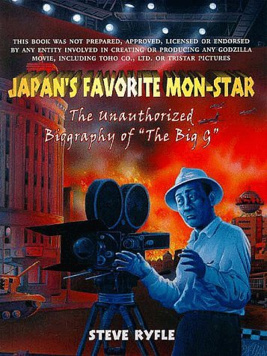
Consider, by contrast, the approach taken by the following book:

