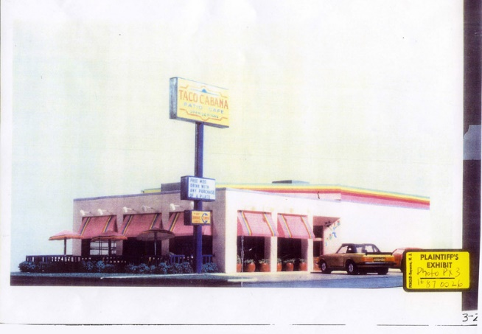



Two Pesos, Inc. v. Taco Cabana, Inc.
505 U.S. 763 (1992)
Two Pesos consists of an opinion for the Court by Justice White and three separate concurrences by Justice Scalia, Justice Stevens, and Justice Thomas. For purposes of brevity, discussed here are only the most essential aspects of the case.
Taco Cabana operated a chain of fast-food Tex-Mex restaurants in Texas. It claimed as its unregistered trade dress the following:
“a festive eating atmosphere having interior dining and patio areas decorated with artifacts, bright colors, paintings and murals. The patio includes interior and exterior areas with the interior patio capable of being sealed off from the outside patio by overhead garage doors. The stepped exterior of the building is a festive and vivid color scheme using top border paint and neon stripes. Bright awnings and umbrellas continue the theme.” 932 F.2d 1113, 1117 (CA5 1991).
Two Pesos, 505 U.S. at 765. The Court apparently accepted Taco Cabana’s broad definition of its trade dress. In a footnote, Justice White’s opinion for the Court explained:
The District Court instructed the jury: “‘[T]rade dress’ is the total image of the business. Taco Cabana’s trade dress may include the shape and general appearance of the exterior of the restaurant, the identifying sign, the interior kitchen floor plan, the decor, the menu, the equipment used to serve food, the servers’ uniforms and other features reflecting on the total image of the restaurant.” 1 App. 83–84. The Court of Appeals accepted this definition and quoted from Blue Bell Bio–Medical v. Cin–Bad, Inc., 864 F.2d 1253, 1256 (CA5 1989): “The ‘trade dress’ of a product is essentially its total image and overall appearance.” See 932 F.2d 1113, 1118 (CA5 1991). It “involves the total image of a product and may include features such as size, shape, color or color combinations, texture, graphics, or even particular sales techniques.” John H. Harland Co. v. Clarke Checks, Inc., 711 F.2d 966, 980 (CA11 1983). Restatement (Third) of Unfair Competition § 16, Comment a (Tent.Draft No. 2, Mar. 23, 1990).
Two Pesos, 505 U.S. at 764 n.1.
Two Pesos substantially copied Taco Cabana’s restaurant design, though with different colors. Taco Cabana sued under Lanham Act § 43(a) and the case went to a jury. The Texas jury found that Taco Cabana’s trade dress was inherently distinctive but that it “has not acquired a secondary meaning in the Texas market.” Id. at 766 (footnote omitted). These jury findings presented something of a paradox (or were simply nonsensical): how could a trademark that has for several years been used in the marketplace possess inherent distinctiveness of source but not yet have developed any additional acquired distinctiveness of source? The very fact that the mark over the years had not developed any additional acquired distinctiveness could be understood to indicate instead that the mark was not inherently distinctive in the first place.
On appeal to the Fifth Circuit, Two Pesos argued that “a finding of no secondary meaning contradicted a finding of inherent distinctiveness.” Id. at 767. The Fifth Circuit disagreed and affirmed the jury findings. Two Pesos then sought certiorari to reverse the Fifth Circuit and adopt instead Second Circuit doctrine of the time that 43(a) protects unregistered trade dress only if secondary meaning is shown. Id. Recognizing a circuit split on the issue, the Court “granted certiorari to resolve the conflict among the Courts of Appeals on the question whether trade dress that is inherently distinctive is protectible under § 43(a) without a showing that it has acquired secondary meaning.” Id.
In ruling in favor of Taco Cabana and the protectability of its trade dress, the Court stated that “[t]here is no persuasive reason to apply to trade dress a general requirement of secondary meaning which is at odds with the principles generally applicable to infringement suits under § 43(a).” The Court explained:
It would be a different matter if there were textual basis in § 43(a) for treating inherently distinctive verbal or symbolic trademarks differently from inherently distinctive trade dress. But there is none. The section does not mention trademarks or trade dress, whether they be called generic, descriptive, suggestive, arbitrary, fanciful, or functional. Nor does the concept of secondary meaning appear in the text of § 43(a). Where secondary meaning does appear in the statute, 15 U.S.C. § 1052 (1982 ed.), it is a requirement that applies only to merely descriptive marks and not to inherently distinctive ones. We see no basis for requiring secondary meaning for inherently distinctive trade dress protection under § 43(a) but not for other distinctive words, symbols, or devices capable of identifying a producer’s product.
Two Pesos, 505 U.S. at 775. The Court further explained:
[A]dding a secondary meaning requirement could have anticompetitive effects, creating particular burdens on the startup of small companies. It would present special difficulties for a business, such as respondent, that seeks to start a new product in a limited area and then expand into new markets. Denying protection for inherently distinctive nonfunctional trade dress until after secondary meaning has been established would allow a competitor, which has not adopted a distinctive trade dress of its own, to appropriate the originator’s dress in other markets and to deter the originator from expanding into and competing in these areas.
Id.

