An Open-Access Casebook

Version 12 (2025)
Digital Edition
www.tmcasebook.org

Barton Beebe
John M. Desmarais Professor of Intellectual Property Law
New York University School of Law

This work is licensed under a Creative Commons Attribution-NonCommercial-
ShareAlike 4.0 International License.

The Trademark Registration Process
Use, rather than registration, is the basis of federal trademark rights in the United States. See In re Int’l Flavors & Fragrances, Inc., 183 F.3d 1361, 1366 (Fed. Cir. 1999) (“The federal registration of a trademark does not create an exclusive property right in the mark. The owner of the mark already has the property right established by prior use․ However, those trademark owners who register their marks with the PTO are afforded additional protection not provided by the common law.”). As explained previously, the Lanham Act will protect a trademark owner’s exclusive rights in any trademark it is using in commerce regardless of whether the mark is registered provided that the unregistered mark meets the various substantive requirements for registration established by the Act. In other words, if the mark as used in commerce could be registered, it will be protected even if it is not registered. Conversely, the Lanham Act will not protect a trademark registrant’s exclusive rights in its registered mark if it no longer uses its mark in commerce and cannot prove an intent to resume use in the near future. On this basis, it is often said that the U.S. trademark system is a “use-based” system in contrast to the “registration-based” systems more common around the world. In the United States, registration merely records the preexistence of externally established rights.
The U.S. registration system is different in another significant respect. Unlike many foreign registration systems, which review applications only for compliance with formal requirements, the PTO reviews applications to ensure that they meet both formal requirements (which are largely set forth in Lanham Act § 1) and substantive requirements (largely found in Lanham Act § 2). These substantive requirements include both “absolute grounds” for refusal of registration, such as that the mark is deceptive, and “relative grounds” for refusal, such as that the mark is confusingly similar with a previously registered mark.
A trademark applicant at the PTO must claim at least one “filing basis” for its application among the five that are provided by the Lanham Act. These filing bases are:
- Lanham Act § 1(a): the applicant is already making actual use of the mark in commerce;
- Lanham Act § 1(b): the applicant has a bona fide intent to use the mark in commerce in the near future;
- Lanham Act § 44(d): the applicant filed a foreign application to register the mark within six months prior to its application to the PTO and claims the priority date of that prior foreign application;
- Lanham Act § 44(e): the applicant possesses a registration of the mark in the applicant’s country of origin;
- Lanham Act § 66(a): the applicant requests extension of protection of an international registration under the Madrid System for the international registration of trademarks.
The first four filing bases are not mutually exclusive; the § 66(a) filing basis, by contrast, may not be combined with other filing bases. While the §§ 1(a), 44(d), and 44(e) filing bases have been available since the effective date of the original Lanham Act on July 5, 1947, the § 1(b), or “ITU,” filing basis became available with the effective date of the Trademark Law Revision Act (TLRA) on November 16, 1989, and the § 66(a) filing basis became available with the effective date of the Madrid Protocol Implementation Act on November 2, 2003. Most trademark applications at the PTO are now filed under the Lanham Act § 1(b) intent to use basis.
Lanham Act §§ 44 & 66(a), 15 U.S.C. §§ 1126 & 1141f, set forth important though relatively obscure exceptions to the general rule that a trademark must be used in commerce for it to be federally registered. See, e.g., Lanham Act § 44(e), 15 U.S.C. § 1126(e) (“The application must state the applicant’s bona fide intention to use the mark in commerce, but use in commerce shall not be required prior to registration.”). As noted in In re Cyber-Blitz Trading Services, 47 U.S.P.Q.2d 1638 (Comm’r Pats. 1998),
[o]ne significant difference between Section 1(b) and 44 of the Trademark Act is that Applicants who rely on Section 1(b) as a filing basis must establish use of the mark prior to registration, or the application will become abandoned. In contrast, Applicants who rely solely on Section 44 are not required to demonstrate use in order to obtain registration. Crocker National Bank v. Canadian Imperial Bank of Commerce, 223 USPQ 909 (TTAB 1984). In fact, the first time evidence of use usually is required for Section 44 Applicants is upon the filing of an Affidavit of Continued Use under Section 8 of the Trademark Act, 15 U.S.C. § 1058. This does not occur until five to six years after registration.
Id. at 1639-40. See also TMEP § 1009. The reasoning of Cyber-Blitz also applies to § 66(a) applications. See also Lodestar Anstalt v. Bacardi & Co. Ltd., 31 F.4th 1228, 1245–51 (9th Cir. 2022).
For a sense of scale, the figure below shows the number of trademark applications at the PTO per year for each filing basis from 1981 through 2023. What might explain the spike in applications in the period 1999–2000? As for why Lanham Act § 1(a) use-based applications spiked so dramatically in 2020 and 2021, see USPTO, Trademarks and Patents in China: The Impact of Non-Market Factors on Filing Trends and IP Systems (January 2021) (discussing numerous Chinese-government subsidy measures encouraging Chinese nationals to procure foreign trademark registrations), and Barton Beebe & Jeanne Fromer, Fake Trademark Specimens: An Empirical Study, 121 Colum. L. Rev. Forum 217 (2020). See also Jeanne Fromer & Mark P. McKenna, Amazon’s Quiet Overhaul of the Trademark System, 113 Cal. L. Rev. __ (2025) (forthcoming) (describing Amazon’s Brand Registry as a “shadow trademark system” and analyzing its impact on trademark application practices at the PTO and branding practices more generally).
By the end of 2023, there were 3.1 million live trademark registrations on the PTO’s Principal Register. See USPTO Trademark Case Files Dataset 2023. Of these,
- 71.6% consisted only of “standard character” marks, meaning that the registrant was claiming a mark consisting only of text and was claiming that text in any font;
- 5.8% consisted of “stylized character” marks, meaning that the registrant was claiming a mark consisting only of text in a particular font;
- 3.7% consisted only of an image with no textual component;
- 18.9% consisting of text and image; and
- 0.01% (or 252 total registrations) consisted of “non-traditional marks” such as smells or textures.

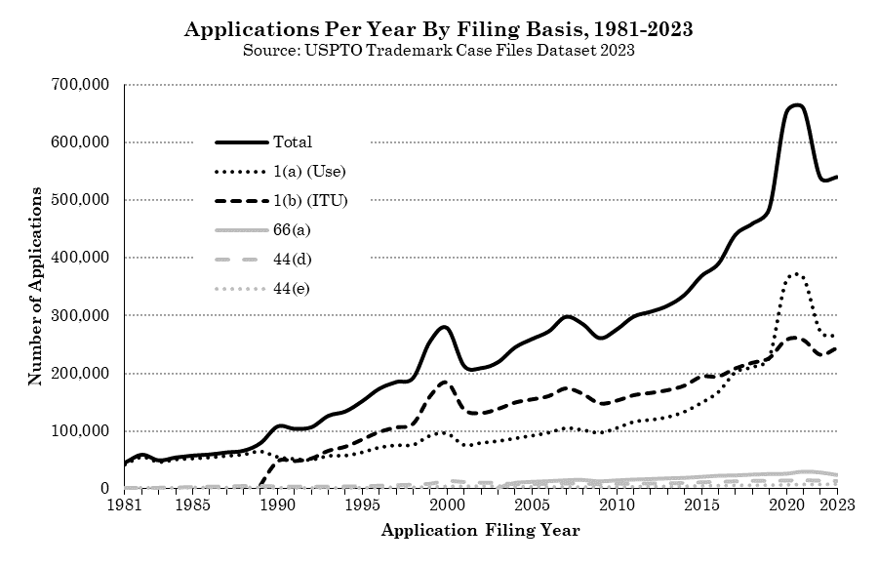
Comments and Questions
1. The phenomenon of “submarine trademarks.” Below is the registration certificate for the iPhone mark. Note the priority date claimed: “Priority claimed under Sec. 44(d) on Trinidad/Tobago Application No. 37090, filed 3-27-2006.” Rather than file an application for the mark at the USPTO on March 27, 2006, Apple instead filed on that date in Trinidad & Tobago through a shell company. As the registration certificate indicates, on September 26, 2006 (six months after March 27, 2006 minus a day), Apple then took advantage of Lanham Act § 44(d) to assert the priority date of their Trinidad & Tobago application in the U.S. Why would Apple, like many other consumer-oriented high-technology and fashion companies, engage in such a circuitous route to registration? Consider that at the time Apple filed its applications, Trinidad & Tobago did not provide a searchable online database of trademark applications filed at its Intellectual Property Office. See Carsten Fink, Andrea Fosfuri, Christian Helmers, & Amanda Myers, Submarine Trademarks, 31 J. Econ. & Management Strategy 818 (2022).
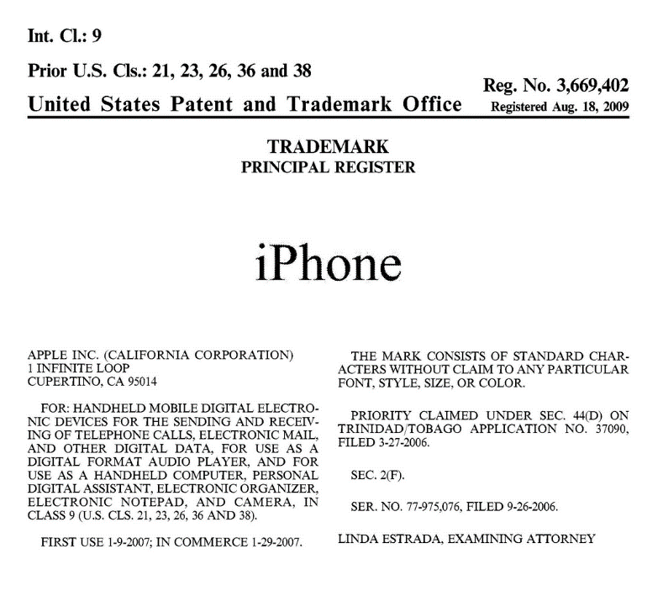

1. Benefits and Costs of Trademark Registration

a. Registration on the Principal Register
Registration on the Principal Register confers significant, substantive advantages on the registered mark. First and perhaps most importantly, under Lanham Act § 7(c), 15 U.S.C. § 1057, registration confers on the registrant nationwide priority in the mark as of the date of application. Section 7(c) reads as follows:
(c) Application to register mark considered constructive use. Contingent on the registration of a mark on the principal register provided by this Act, the filing of the application to register such mark shall constitute constructive use of the mark, conferring a right of priority, nationwide in effect, on or in connection with the goods or services specified in the registration against any other person except for a person whose mark has not been abandoned and who, prior to such filing–
(1) has used the mark;
(2) has filed an application to register the mark which is pending or has resulted in registration of the mark; or
(3) has filed a foreign application to register the mark on the basis of which he or she has acquired a right of priority, and timely files an application under section 44(d) [15 USC 1126(d)] to register the mark which is pending or has resulted in registration of the mark.
15 U.S.C § 1057. This right of priority extends nationwide even if, as is often the case, the registrant has not itself used the mark throughout the nation. And in the case of ITU applications, the intent to use applicant enjoys nationwide priority as of its ITU application date even if several years pass before the applicant finally makes an actual use of its mark and completes its registration. (We will address the geographic scope of trademark rights in more detail in Class 11).
Second, registration is prima facie evidence of the validity of the mark and of the registrant’s ownership of the mark. Lanham Act §§ 7(b) & 33(a), 15 U.S.C. §§ 1057(b) & 1115(a). The Circuits vary on whether these provisions shift the burden of persuasion to the defendant to disprove the validity of a registered mark or merely shift the burden of production to the defendant to come forward with evidence of invalidity. Compare, e.g., Christian Louboutin S.A. v. Yves Saint Laurent America Holdings, Inc., 696 F.3d 206, 216 n.10 (2d Cir. 2012) (“In order to rebut the presumption of validity, the allegedly infringing party must show, by a preponderance of the evidence, . . . that the mark is ineligible for protection.”) with OBX-Stock, Inc. v. Bicast, Inc., 558 F.3d 334, 342 (4th Cir. 2009) (“[E]ntry on the Principal Register does not shift the burden of persuasion on validity, merely the burden of production.”); Custom Vehicles, Inc. v. Forest River, Inc., 476 F.3d 481, 486 (7th Cir. 2007) (“[T]he presumption of validity that registration creates is easily rebuttable, since it merely shifts the burden of production to the alleged infringer.”); and Door Systems, Inc. v. Pro-Line Door Systems, Inc., 83 F.3d 169, 172 (7th Cir. 1996) (“The presumption of validity that federal registration confers evaporates as soon as evidence of invalidity is presented. Its only function is to incite such evidence and when the function has been performed the presumption drops out of the case.” See also Charles L. Cook & Theodore H. Davis, Jr., Litigating the Meaning of “Prima Facie Evidence” under the Lanham Act: The Fog and Art of War, 103 Trademark Rep. 437 (2013).
Third, only marks registered on the Principal Register may achieve incontestable status, which confers a significant benefit on descriptive marks. Lanham Act §§ 15 and 33, 15 U.S.C. §§ 1065 & 1115, set out the main requirements a registrant must meet to file a Declaration of Incontestability of a Mark Under Section 15: (1) the mark must have been in continuous use for any period of five consecutive years after the date of registration and must still be in use at the time of filing, (2) there has been no final decision adverse to the registrant’s ownership of or validity of the registration of the mark, and (3) there is no proceeding involving the registrant’s ownership of or validity of the registration of the mark pending at the PTO or in any court. Lanham Act § 15, 15 U.S.C. § 1065.
Incontestable status limits the grounds on which the registered mark’s validity may be contested for the remaining life of the registration (which may be renewed in perpetuity). Lanham Act §§ 15 and 33(b) explicitly list out these grounds; any that are not listed are foreclosed. One ground not listed is that the mark lacks secondary meaning. Thus, the validity of descriptive marks that have achieved incontestable status may not be challenged on the ground that they lack secondary meaning—though they may be challenged on the ground that they are generic. Another ground not listed is that the mark fails to function as a mark. See Lisa P. Ramsey, Using Failure to Function Doctrine to Protect Free Speech and Competition in Trademark Law, 104 Iowa L. Rev. Online 70 (2020) (advocating that § 14 and § 15 be amended to allow any mark to be cancelled at any time on the ground that it fails to function as a mark).
In the notorious case of Park ‘N Fly, Inc. v. Dollar Park and Fly, Inc., 469 U.S. 189 (1985), the Supreme Court confirmed the rule that incontestable marks may not be challenged on the ground that they lack secondary meaning. In Park ‘N Fly, the Court held that the incontestable—and clearly descriptive—mark Park ‘N Fly for airport parking services could not be challenged on the ground that it lacked secondary meaning, notwithstanding that the record below strongly suggested that the mark lacked secondary meaning at the time of registration in 1971 and still lacked secondary meaning when the case was being litigated in the early 1980s. See id. at 211 (Stevens, J., dissenting).
Registrants may also use incontestable status “defensively” in situations in which their registered mark is accused of infringing another mark. See McCarthy § 31:141. Together, Lanham Act §§ 15 and 33(b) establish that in the case of registrations granted incontestable status, the right of the registrant to use its registered mark in commerce on the goods specified in the registration is incontestable (even if the use causes confusion). For example, in Garcoa, Inc. v. Sierra Sage Herbs LLC, No. 21 Civ. 4672, 2022 WL 16548874 (C.D. Cal. October 4, 2022), the plaintiff used the registered mark blue goo for pain relief products and claimed that the defendant’s registered mark green goo, also for pain relief products, infringed. Wisely, the defendant had previously applied for and received incontestable status for its registration. The court granted the defendant’s motion for summary judgment purely on the basis that by operation of Lanham Act §§ 15 and 33(b), the defendant’s right to use its mark in commerce on the goods specified in the registration was incontestable. The court never reached the issue of likelihood of confusion.
Registration confers additional benefits on the trademark owner:
- Owners of registered marks may obtain statutory damages against counterfeiters. See Lanham Act § 35(c) (statutory damages available in “cases involving the use of a counterfeit mark”), 15 U.S.C. 1117(c), and Lanham Act § 34(d)(1)(B)(i) (defining “counterfeit mark” as “counterfeit of a mark that is registered on the principal register”), 15 U.S.C. § 1116(d)(1)(B)(i). Owners of registered marks may also benefit from criminal prosecution of trademark counterfeiters. See 18 U.S.C. § 2320.
- Owners of registered marks enjoy the right to request customs officials to bar the importation of goods bearing infringing trademarks under Lanham Act § 42, 15 U.S.C. § 1124.
- In the case of registered trade dress, owners do not bear the burden of establishing the non-functionality of their trade dress. Under Lanham Act § 43(a)(3), 15 U.S.C. § 1125(a)(3), owners of unregistered trade dress bear this burden.
- A mark’s registered status may serve a powerful rhetorical function in front of juries.
Note that it is often still said, incorrectly, that only owners of registered marks may seek treble damages and attorney fees in exceptional cases under Lanham Act § 35(a). In fact, the TLRA of 1988 amended Section § 35(a) to reference any “violation under section 43(a),” thus providing enhanced damages and attorney fees in exceptional cases to owners of unregistered marks.

b. Registration on the Supplemental Register
Non-inherently distinctive marks that fail to qualify for Principal Register registration because they are determined to lack acquired distinctiveness may nevertheless seek registration on the Supplemental Register. Specifically, Lanham Act Section 23(a), 15 U.S.C. § 1091(a), provides in part:
All marks capable of distinguishing applicant’s goods or services and not registerable on the principal register provided in this chapter, except those declared to be unregisterable under subsections (a), (b), (c), (d), and (e)(3) of section 1052 [Lanham Act § 2] of this title, which are in lawful use in commerce by the owner thereof, on or in connection with any goods or services may be registered on the supplemental register upon the payment of the prescribed fee and compliance with the provisions of subsections (a) and (e) of section 1051 [Lanham Act § 1] of this title so far as they are applicable.
Id. Principal Register applicants typically seek Supplemental Register registration (by amending their application) only after the PTO has refused registration on the Principal Register on the ground that the applied-for mark is descriptive and lacks secondary meaning. As the language of § 23(a) establishes (“which are in lawful use in commerce”), only use-based applications can be converted into supplemental registrations; intent to use applications do not have this option.
There are several benefits to Supplemental Register registration:
- Examiners may cite the supplemental registration against future applications for either Principal or Supplement Register registration where the future applied-for mark would be confusingly similar under § 2(d) with the supplemental registration mark. See Application of Clorox Co., 578 F.2d 305, 307 (C.C.P.A. 1978). See also McCarthy § 19:37 (calling the result in Clorox “strange and unsettling”); Anne Gilson LaLond & Jerome Gilson, The U.S. Supplemental Register: Solace, Substance or Just Extinct?, 103 Trademark Rep. 828, 892 (2013) (criticizing Clorox on ground that “from a public policy standpoint, these non-marks should not prevent registration of actual trademarks.”).
- Relatedly, the mark registered on the Supplemental Register is more likely to be detected in search reports prepared for others contemplating the registration of similar marks.
- Supplemental registration may form the basis for registration of certain marks (particularly those that are descriptive or take the form of product configuration or packaging) in certain foreign countries and regions. The Supplemental Register was originally established for this purpose. See Armstrong Paint & Varnish Works v. Nu-Enamel Corp., 305 U.S. 315, 334 n. 21 (1938); In re the Pepsi-Cola Co., 120 U.S.P.Q. 468 (T.T.A.B. Mar. 4, 1959).
Note, however, that supplemental registration does not provide any of the important advantages gained by principal registration. It has no evidentiary or remedial significance. It does not establish constructive use under § 7(c), 15 U.S.C. § 1057(c), or constructive notice of ownership under § 22, 15 U.S.C. § 1072, nor can a mark registered on the supplemental register gain incontestable status under § 15, 15 U.S.C. § 1065.

c. Costs of Trademark Registration
Current PTO fees for the registration of a trademark range begin at $350 per Nice class of goods or services (the Nice classification scheme is discussed below). Experienced trademark prosecutors will generally estimate that the cost to register a trademark at the PTO, including both filing fees and attorney’s fees, starts at approximately $2,000 for a simple use-based single-class word mark application, with the addition of perhaps $500 per additional Nice class. Attorney’s fees may vary by the quality of counsel. More complex applications, including those filed on an intent to use basis or for non-verbal marks, may cost considerably more.

2. Lanham Act § 1(b) Intent to Use Applications and the Bona Fide Intent to Use Requirement
As the figure above shows, by 1993, over half of all trademark applications filed annually at the PTO were filed on a § 1(b) intent to use filing basis. The ITU filing basis allows an applicant to begin the trademark registration process before it has used its mark in commerce provided that it has a “a bona fide intention, under circumstances showing the good faith of such person, to use [the] trademark in commerce.” Lanham Act § 1(b)(1), 15 U.S.C. § 1051(b)(1). The ITU filing basis greatly benefits firms that wish to establish the registrability of and priority rights in their marks before actually using their marks in commerce. However, the ITU system is also open to abuse from firms who have at the time of filing no real intention to use the mark, but rather wish merely to establish an option to use the mark sometime in the future. It is also open to abuse from “meme mark” filers who rush to file a § 1(b) application for the latest cultural catchphrase but have at the time of filing no reasonably well-developed plan to use that phrase on or in connection with goods or services. See Barton Beebe, Is the Trademark Office a Rubber Stamp?, 48 Houston L. Rev. 751, 757 (2011) (discussing “meme mark” filings associated with September 11 such as “Let’s Roll” and “Seal Team 6”).
The following opinion grew out of a priority battle between two claimants to the trademark WorkWire.

[The opinion in Kelly Services, Inc. v. Creative Harbor, LLC is available separately.]

3. Process of Registration
For marks already being used in commerce, a successful application proceeds though at least five basic stages: (1) application, (2) examination, (3) publication in the PTO’s Official Gazette, (4) opposition, and (5) registration.
Intent-to-use applications proceed through certain additional stages (shown in italics): (1) application, (2) examination, (3) publication in the PTO’s Official Gazette, (4) opposition, (5) the issuance by the PTO of a Notice of Allowance, (6) the filing by the applicant of a Statement of Use showing that the applicant has begun to make actual use of the mark in commerce; and (7) registration.
The PTO provides excellent annotated flowcharts of the registration process for each of the five filing bases on its website at: https://www.uspto.gov/trademark/trademark-timelines/trademark-application-and-post-registration-process-timelines. The reader is strongly encouraged to consult these flow charts while reviewing the following information.

a. Application
The application is relatively simple. See Lanham Act §§ 1(a) & 1(b) (setting out the required contents of use-based and intent-to-use applications, respectively). The following are the most important elements of the application:
- Filing Basis: As mentioned above, the applicant must specify at least one of the five filing bases provided for in the Lanham Act.
- Designation of Goods and Services: The applicant must identify the particular goods or services on or in connection with which it uses or intends to use the mark. The U.S. Acceptable Identification of Goods and Services Manual, available online, provides a listing of acceptable identifications of goods and services. The applicant should also identify the international class number(s) of the identified goods or services as established by the Nice International Classification of Goods and Services for the Purposes of the Registration of Trademarks. (“Nice” after the French city where the Nice Agreement was reached, and pronounced to rhyme with “peace”). The 45 classes of the Nice Classification are listed below. In principle, the identification of goods or services does not limit the breadth of the applicant’s registered exclusive rights. The sole purpose of the identification of goods and services is to aid the PTO in internal administration and review of applications. However, litigants sometimes cite a registered mark’s identification of goods and services to support their particular view of the scope of the registered rights at issue—and courts sometimes treat the identification as relevant, though not binding, on the question.
- Drawing: The applicant must submit a drawing of the trademark. As of 2003, if the mark consists of colors, the drawing must as well. For word marks, a typed representation of the mark is sufficient. For nonvisual marks, such as sound or scent marks, the applicant need not submit a drawing. The PTO relies instead on the applicant’s description of the mark given elsewhere in the application and on the applicant’s specimen of use. TMEP § 807.09.
- Specimen of Use: Applicants filing a “1(a)” use-based application must submit one specimen of use of the mark in commerce for each international class in which the applicant seeks registration. This specimen typically takes the form of digital photographs of the mark attached to goods or .pdf images of materials promoting services. Applicants filing a “1(b)” intent-to-use application need not (because they very likely cannot) submit a specimen of use with their application, but must do so instead when they file their Statement of Use. See Lanham Act § 1(d)(1) (15 U.S.C. 1051(d)(1)).
See Lanham Act § 1, 15 U.S.C. § 1051.
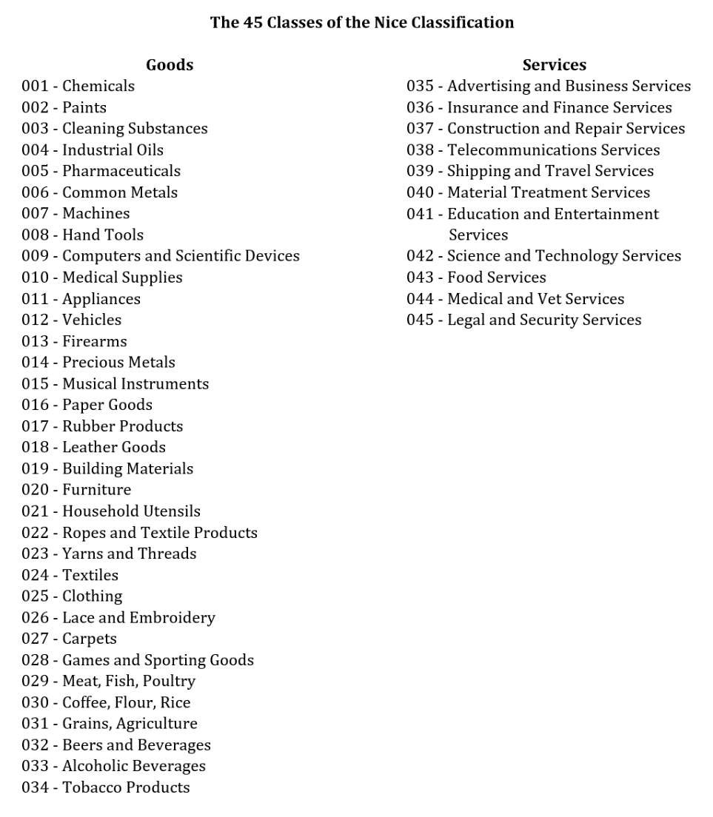
For applications filed under Lanham Act § 1 or § 44, the PTO will grant a filing date to the application according to the date on which all of the following “minimum requirements” are received at the PTO: (1) name of the applicant, (2) name and address for correspondence, (3) a clear drawing of the mark; (4) a listing of the goods or services; and (5) the filing fee for at least one class of goods or services. See TMEP §§ 201-02. For Madrid System applications filed under Lanham Act § 66(a), compliance with minimum filing requirements is established by the International Bureau at the World Intellectual Property Organization. (We will discuss the Madrid System in more detail below).
As of August 3, 2019, foreign-domiciled entities must file their applications through a U.S.-licensed attorney. U.S-domiciled entities may continue to file their applications without an attorney— though, as discussed in Comment 2 at the end of this section, applications filed by specialist trademark attorneys tend to do significantly better.
Over 99% of trademark applications are filed electronically at the PTO. Paper applications may be filed in limited circumstances and incur significantly higher filing fees. See TMEP § 301.01.

b. Examination
Typically within about eight to twelve months from the application’s filing date, an examining attorney will engage in a substantive examination of the application to determine if there are any absolute or relative grounds for refusal. See Lanham Act § 12(a), 15 U.S.C. § 1062(a). With respect to relative grounds for refusal, the examining attorney will search the PTO’s X-Search and Trademark Search databases (the latter of which is available online at no charge) to determine if any marks have already been filed that may be confusingly similar with the applied-for mark under Lanham Act §2(d), 15 U.S.C. § 1052(d). Estimates based on data from the mid-2010s indicate that almost half of applications receive such § 2(d) refusals. If the examining attorney finds no grounds for refusal, the attorney will approve the mark for publication in the PTO’s Official Gazette. One study suggests that only about 15% of use-based applications and 21% of ITU applications proceed directly from application to approval for publication without any grounds for refusal being identified by an examining attorney.
If the examining attorney finds grounds for refusal, the attorney will send an “office action” to the applicant to explain the grounds for refusal. Effective December 3, 2022, the applicant has a maximum of three months to respond (applicants previously had six months) and, if appropriate, to amend the application to satisfy the examiner’s objections. If the applicant fails to respond, the application will be deemed abandoned. See Lanham Act § 12(b), 15 U.S.C. § 1062(b). Correspondence between the office and the applicant will continue until either (1) the examining attorney approves the application for publication, (2) the examining attorney issues a final office action refusing registration of the mark, or (3) the applicant abandons the application. See id. The applicant may appeal the final office action to the Trademark Trial and Appeal Board.

c. Publication
Marks approved for publication are published in the PTO’s Official Gazette (OG), a weekly online publication. See Lanham Act § 12(a), 15 U.S.C. § 1062(a). Publication in the OG gives notice to the public that the PTO plans to register the mark. For a 30-day period following the date of the mark’s publication in the OG, any party that believes it would be harmed by the registration, including as a result of dilution, may file an opposition to the registration of the mark. See Lanham Act § 13, 15 U.S.C. § 1063.

d. Opposition and the Trademark Trial and Appeal Board
Oppositions are rare. See Barton Beebe & Jeanne Fromer, Are We Running Out of Trademarks? An Empirical Study of Trademark Depletion & Congestion, 131 Harv. L. Rev. 945, 971 n. 128 (2018) (reporting that “[f]or applications filed from 1985 through 2014, only 2.10% were opposed and only 0.90% were opposed successfully”). Those few oppositions that are filed are heard by the Trademark Trial and Appeal Board. The TTAB is an administrative board within the PTO that acts in the capacity of a trial court of first instance in opposition, cancellation, interference, and concurrent use proceedings and in the capacity of an appellate body in ex parte appeals from final office actions. Created in 1958, the TTAB consists of the Director of the PTO, the Commissioner for Patents, the Commissioner for Trademarks, and Administrative Judges appointed by the Secretary of Commerce in consultation with the Director. The Director and Commissioners rarely sit on TTAB panels. At this writing, there are 24 Administrative Judges on the TTAB, all of whom are highly experienced in trademark matters. The TTAB sits in panels of three judges. The Trademark Trial and Appeal Board Manual of Procedure, available online, details all aspects of TTAB procedure. Proceedings before the TTAB are conducted in writing (though counsel may request oral argument). There is no live testimony, though transcribed testimony, taken under oath and subject to cross-examination, may be submitted. Note that only those TTAB opinions that are explicitly labeled as “citable as precedent” should be cited to the TTAB in subsequent proceedings.
Under the terms of Lanham Act § 21, 15 U.S.C. § 1071, TTAB judgments may be appealed either to a federal district court or to the Court of Appeals for the Federal Circuit. There are two advantages of the district court route. First, the record in the case may be supplemented with additional evidence. Second, the district court’s rulings may be appealed to its reviewing appellate court, thus making it possible to avoid the Federal Circuit; for example, if the applicant appeals the PTO’s decision to the Eastern District of Virginia, Fourth Circuit case law would control.
The TTAB and Issue Preclusion. TTAB proceedings may gain substantially increased importance in certain situations in light of the Supreme Court opinion in B & B Hardware, Inc. v. Hargis Indus., Inc., 135 S. Ct. 1293 (2015). In 1993, B & B registered the mark sealtight in connection with metal fasteners for use in the aerospace industry. In 1996, Hargis sought to register the mark sealtite in connection with metal fasteners for use in building construction. B & B opposed on the ground that Hargis’s mark was confusingly similar to B & B’s mark. The TTAB found a likelihood of confusion and refused registration. Hargis did not appeal this decision. While the TTAB opposition proceeding was pending, B & B sued Hargis in federal district court, arguing that Hargis’s mark infringed B & B’s. Before the district court could rule, the TTAB announced its finding of a likelihood of confusion. B & B argued to the district court that the TTAB’s decision should be given preclusive effect. The district court disagreed and the jury ultimately found no likelihood of confusion. The Eight Circuit affirmed.
The Supreme Court reversed and remanded. It held: “So long as the other ordinary elements of issue preclusion are met, when the usages adjudicated by the TTAB are materially the same as those before the district court, issue preclusion should apply.” Id. at 1310. For an example of the effect of B & B outside of the likelihood of confusion context, see Ashe v. PNC Financial Services Group, Inc., 165 F. Supp. 3d 357 (D. Md. 2015) (holding that TTAB’s prior determination that defendant had priority of use of mark spendology collaterally estopped plaintiff from asserting that defendant’s use infringed on plaintiff’s identical mark).
Standing to Oppose. Lanham Act § 13, 15 U.S.C. § 1063, states that “[a]ny person who believes that he would be damaged by the registration of a mark upon the principal register” may file an opposition. In Ritchie v. Simpson, 170 F.3d 1092 (Fed. Cir. 1999), the Federal Circuit interpreted this language liberally: “an opposer must meet two judicially-created requirements in order to have standing—the opposer must have a ‘real interest’ in the proceedings and must have a ‘reasonable’ basis for his belief of damage.” Id. at 1095. “In no case has this court ever held that one must have a specific commercial interest, not shared by the general public, in order to have standing as an opposer . . . . The crux of the matter is not how many others share one’s belief that one will be damaged by the registration, but whether that belief is reasonable and reflects a real interest in the issue.” Id. at 1096-97. In Ritchie, the Federal Circuit held that Mr. Ritchie, who “described himself as a ‘family man’ who believes that the ‘sanctity of marriage requires a husband and wife who love and nurture one another,’” id. at 1097, had standing to oppose O.J. Simpson’s application to register the marks o.j. simpson, o.j., and the juice.
However, in Curtin v. United Trademark Holdings Inc., 137 F.4th 1359 (Fed. Cir. 2025), the Federal Circuit held that Professor Rebecca Curtin did not have standing to oppose the registration of rapunzel for dolls. Professor Curtin asserted standing on the basis of her status as a consumer and argued that the asserted mark failed to function as a mark, was generic, and would deny to consumers the benefit of healthy competition in the market for dolls depicting the public domain Rapunzel character. Citing Lexmark Int’l, Inc. v. Static Control Components, Inc., 572 U.S. 118 (2014), the Federal Circuit found, in essence, that standing under the opposition provisions of the Lanham Act is available only to those with “commercial interests” that could be damaged by the registration, such as competitors in the market for dolls. See Curtin, 137 F.4th at 1367 (“Under the Lexmark framework, a plaintiff may oppose registration of a mark when (1) her interests are within the zone of interests protected by the statute and (2) she has a reasonable belief in damage that would be proximately caused by registration of the mark in violation of the opposition statute.”). Curtin, following Lexmark, represents a repudiation of Ritchie and a substantial narrowing of standing under the Lanham Act (even if one of the leading justifications for trademark law is supposedly the protection of consumers).

e. Registration
With respect to use-based applications, if no opposition is filed within thirty days or if the opposition fails, then the PTO issues a certificate of registration and notice of the registration is published in the Official Gazette.
With respect to intent-to-use applications that are either unopposed or unsuccessfully opposed, the PTO issues a Notice of Allowance. The applicant then has six months (extendable for a total of three years) to file a Statement of Use showing that it is making use of the mark in commerce. See Lanham Act § 2(d), 15 U.S.C. § 1052(d); TMEP § 1106. Upon acceptance of the Statement of Use, the PTO issues a certificate of registration and notice of the registration is published in the Official Gazette.

4. Post-Registration Maintenance of the Registration
The term of registration is ten years. Lanham Act § 8, 15 U.S.C. § 1058. The registration may be renewed indefinitely provided that the registrant complies with the requirements of Lanham Act §§ 8 & 9, 15 U.S.C. §§ 1058 & 1059. Section 8 requires the registrant to file an Affidavit of Continuing Use “(1) on or after the fifth anniversary and no later than the sixth anniversary of the date of registration . . . and (2) within the year before the end of every ten-year period after the date of registration.” TMEP § 1604.04. Thus, the registrant must file a “Section 8 affidavit” in the sixth year of the registration, the tenth year, the twentieth year, the thirtieth year, etc. Section 8 adds a six-month grace period to this deadline. See Lanham Act § 8(c), 15 U.S.C. § 1058(c). See also TMEP § 1604.04 (“Example: For a registration issued on Nov. 1, 2005, a six-year affidavit or declaration may be filed as early as Nov. 1, 2010, and may be filed as late as Nov. 1, 2011, before entering the six-month grace period.”).
Section 9 requires the registrant to file a Renewal Application every tenth year following the date of registration. Registrants typically file the Section 8 Affidavit of Continuing Use and the Section 9 Renewal Application as a single document. Section 9 also adds a sixth-month grace period. See Lanham Act § 9(a), 15 U.S.C. § 1059(a). See also TMEP § 1606.03 (“Example: For a registration issued on November 5, 1998, an application for renewal may be filed as early as November 5, 2007, and as late as November 5, 2008, before entering the six-month grace period.”).
Registrants are also strongly advised to file an Affidavit of Incontestability under Lanham Act § 15 (15 U.S.C. § 1065) within one year after any five-year period of continuous use of the mark. In practice, sophisticated trademark owners typically combine their first § 8 Affidavit of Continuing Use (filed in the sixth year following registration) with a § 15 Affidavit of Incontestability. A § 15 affidavit may be filed at any time during the duration of the registration of the mark, however, provided that it is filed within the year following five years’ continuous use of the mark. See TMEP § 1605.03.

5. Notice of Federal Registration
Lanham Act § 29, 15 U.S.C. § 1111, provides:
Notwithstanding the provisions of section 22 hereof {15 USC § 1072}, a registrant of a mark registered in the Patent and Trademark Office, may give notice that his mark is registered by displaying with the mark the words “Registered in U.S. Patent and Trademark Office” or “Reg. U.S. Pat. & Tm. Off.” or the letter R enclosed within a circle, thus ®; and in any suit for infringement under this Act by such a registrant failing to give such notice of registration, no profits and no damages shall be recovered under the provisions of this Act unless the defendant had actual notice of the registration.
Id. The latter part of § 29 is generally understood to establish that in situations where the registrant has not provided statutory notice of the registration of its mark, that registrant may only win profits and damages from a period after the defendant had actual notice of the registration status of the mark. See McCarthy § 19:144.
The ® or “r in a circle” designation indicates that the mark is registered on either the Principal or Supplemental Register. A “TM” or “SM” designation indicates that the mark is unregistered, but that the owner is claiming property rights in the mark. Firms may sometimes use the “TM” or “SM” designations in an attempt to educate consumers that the mark at issue is a designation of source rather than simply a description, decoration, or feature of the product.

6. Cancellation of Registration
Lanham Act § 14, 15 U.S.C. § 1064, addresses the circumstances under which a third party may petition to cancel a registration. It provides, in essence, that for the five year period following the date of registration, a third party may petition to cancel the registration for any reason. See Lanham Act § 14(1), 15 U.S.C. § 1064(1). After five years have passed from the date of registration, a third party may petition to cancel a registration for only a limited number of reasons expressly enumerated in Lanham Act § 14(3), 15 U.S.C. § 1064(3). Here is the relevant statutory language:
A petition to cancel a registration of a mark, stating the grounds relied upon, may, upon payment of the prescribed fee, be filed as follows by any person who believes that he is or will be damaged, including as a result of a likelihood of dilution by blurring or dilution by tarnishment under section 1125(c) of this title, by the registration of a mark on the principal register established by this chapter, or under the Act of March 3, 1881, or the Act of February 20, 1905:
(1) Within five years from the date of the registration of the mark under this chapter.
. . . .
(3) At any time if the registered mark becomes the generic name for the goods or services, or a portion thereof, for which it is registered, or is functional, or has been abandoned, or its registration was obtained fraudulently or contrary to the provisions of section 1054 of this title or of subsection (a), (b), or (c) of section 1052 of this title for a registration under this chapter, or contrary to similar prohibitory provisions of such prior Acts for a registration under such Acts, or if the registered mark is being used by, or with the permission of, the registrant so as to misrepresent the source of the goods or services on or in connection with which the mark is used. If the registered mark becomes the generic name for less than all of the goods or services for which it is registered, a petition to cancel the registration for only those goods or services may be filed. A registered mark shall not be deemed to be the generic name of goods or services solely because such mark is also used as a name of or to identify a unique product or service. The primary significance of the registered mark to the relevant public rather than purchaser motivation shall be the test for determining whether the registered mark has become the generic name of goods or services on or in connection with which it has been used.
Lanham Act § 14, 15 U.S.C. § 1064. Note what is missing from § 14(3). Most significantly, after five years have passed since the date of registration, a third party cannot petition to cancel the registration on the ground that the mark is merely descriptive without secondary meaning (this ground is not included in § 14(3)) or on the ground that the registered mark is confusingly similar with a previously used mark (§ 2(d) is not included in § 14(3)). Nor can the registration be cancelled on the ground that the mark fails to function as a mark. This five-year time limit on grounds for cancellation petitions at the PTO applies even if the registrant has not applied for incontestable status.
Ex parte expungement and ex parte reexamination. In 2020, the Trademark Modernization Act (TMA) added Lanham Act § 16A, which provides that third parties (or the PTO itself) may seek ex parte expungement of a registration, in whole or part, for any goods or services listed in the registration in connection with which the registrant has never in fact made a use of the mark in commerce. The challenger may seek ex parte expungement at any time from the fourth year through the tenth year of the registration. The TMA also added Lanham Act § 16B, which provides that third parties (or the PTO itself) may seek ex parte reexamination of a registration to verify that the registered mark has been used on all the goods or services listed in the registration as of the filing date of a use-based application or the filing date of the Statement of Use following an ITU application. An ex parte reexamination request must be filed within the first five years of the challenged registration. For an assessment of how these provisions have operated in practice, see Jeremy N. Sheff, An Empirical Evaluation of the Trademark Modernization Act, 62 Hous. L. Rev. 339 (2024).
Lanham Act § 37. Lanham Act § 37, 15 U.S.C. § 1119, provides federal courts with broad powers over registrations:
In any action involving a registered mark the court may determine the right to registration, order the cancelation of registrations, in whole or in part, restore canceled registrations, and otherwise rectify the register with respect to the registrations of any party to the action. Decrees and orders shall be certified by the court to the Director, who shall make appropriate entry upon the records of the Patent and Trademark Office, and shall be controlled thereby.
Id. The Fourth Circuit has determined, however, that § 37 does not allow federal courts to override the time limits built in to § 14. See Shakespeare Co. v. Silstar Corp. of Am., 9 F.3d 1091 (4th Cir. 1993).

7. The Madrid System
The United States has been a member of the “Madrid System” for the international registration of trademarks since November 2, 2003, which was the effective date of the Madrid Protocol Implementation Act (“MPIA”), 116 Stat. 1758, 1913 Pub. L. 107-273. The Madrid System provides an efficient means by which trademark applicants or registrants may apply to register their marks at multiple foreign trademark offices through a single application filed at (and a single fee paid to) their home trademark office. For example, a trademark applicant or registrant at the PTO may file a single application and pay a single fee to register its trademark at any or all of the 131 countries within the Madrid Union; the fee increases with the number of countries. The PTO will forward any such application to the International Bureau administering the Madrid System (based in Geneva at the World Intellectual Property Organization (“WIPO”)), which will then forward the application in turn to all countries selected by the applicant. This can result in significant cost savings for the applicant because it need not hire foreign local counsel to prosecute its application unless the local trademark office rejects or otherwise demands some response relating to the application. Furthermore, the Madrid registrant need only file a single form and pay a single fee to renew its mark across multiple foreign countries.
For U.S. applicants, there are certain drawbacks to using Madrid. First, many foreign trademark offices permit relatively broad definitions of the goods or services with which the mark will be used. The PTO, however, does not. As a result, the U.S. applicant must file a narrow definition of the applied-for mark’s goods in order to satisfy the PTO but will then be required to use that definition when it seeks to extend its protection abroad. For this reason, some U.S. applicants seek to file in foreign countries locally rather than through Madrid.
A second disadvantage of Madrid is that all international trademark registrations filed through Madrid remain dependent on the applicant’s home (or “basic”) registration for five years from the date of that home registration. If the home registration fails during that five year period (as a result of a “central attack” from a third party opposer or for any other reason), then all international registrations will fail as well. However, within three months from the date of the cancellation of its home registration, the Madrid registrant may file to “transform” its international registrations into local registrations.
Comments and Questions
1. Trademark registration rates at the PTO. The PTO’s release of data concerning the registration process has made it possible to estimate the overall trademark registration rate at the PTO, i.e., the proportion of trademark applications that result in registration. For use-based applications filed at the PTO from 1981 through 2007, the overall registration rate was .75. See Barton Beebe, Is the Trademark Office a Rubber Stamp?, 48 Houston L. Rev. 751, 762 (2011). For ITU-based applications filed from November 16, 1989 through 2007, the registration rate was .37. Id. What might explain this significant difference in registration rates between use-based and ITU-based applications? Consider the publication rates of such applications, i.e., the proportion of applications that the PTO approved for publication. For use-based applications filed at the PTO from 1981 through 2007, the publication rate was .76. Id. at 770. For ITU-based applications filed from November 16, 1989 through 2007, the publication rate was also .76. Id. Recall that after an ITU-based application is approved for publication, the applicant must then submit a Statement of Use in order to complete the registration process.
The figure below shows trademark publication and registration rates at the PTO over time. What might explain the pronounced dip in registration rates in 1999-2000?
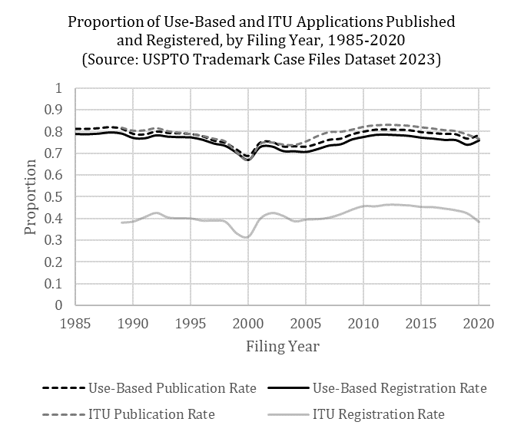

2. Do trademark lawyers matter? Deborah Gerhardt and John McClanahan have presented compelling evidence that trademark applications filed by attorneys do significantly better than applications filed by non-attorneys. See Deborah R. Gerhardt & Jon P. McClanahan, Do Trademark Lawyers Matter?, 16 Stan. Tech. L. Rev. 583 (2013). They note in particular that for the period 1984 through 2012, the publication rate for applications filed by attorneys was 82% while the publication rate for applications filed by non-attorneys was 60%. Id. at 606. They also reported significant differences in the publication rates of applications depending on the experience of the attorney filing the application. Id. at 610. See the article for a consideration of factors that may explain these differences.
3. Trademark registrations as an index of innovation? Scholarship has focused on the question of whether trademark registration data may be used to measure the rate of “non-technological” innovation, specifically, innovation in the service and marketing sectors (sectors about which patent data often has very little to say). See, e.g., Valentine Millot, Trademarks as an Indicator of Product and Marketing Innovations, OECD Science, Technology and Industry Working Papers 2009/06 (2009), http://dx.doi.org/10.1787/224428874418. See also Dev Saif Gangjee, Trade Marks and Innovation?, Trademark Law and Theory II (G.B. Dinwoodie & M.D. Janis eds., 2021).
4. Do state trademark registrations have any value? In general, no they do not. Scholars have even gone so far as to call for their abolition. See Lee Ann W. Lockridge, Abolishing State Trademark Registrations, 29 Cardozo Arts & Ent. L.J. 597 (2011). Lockridge reports:
Under the law of forty-five states, registrations provide registrants with no significant, enforceable substantive rights beyond those awarded under state common law or under the federal statute protecting unregistered common law trademarks. In five states certain substantive rights can accrue to an owner through state registration, although those rights are limited by competing rights held by certain common law owners or federal registrants.
Id. at 598-99. Lockridge observes that in five states (Massachusetts, Minnesota, Rhode Island, Texas, and Washington), state law provides that a state trademark registration will create constructive notice of the registrant’s claim of ownership as of the date of state registration, which impairs the ability of a common law adopter of the mark to claim good faith adoption of the mark after that date (or good faith geographic expansion within the state of its prior continuing use). Id. at 624. This benefit arises only under state law, however, and has no bearing on claims brought under federal law. Id. In the face of a subsequent third party federal registration, a state trademark registrant is typically treated no better than a § 7(c) prior “common law” user.
McCarthy proposes one way in which state registration may provide a slight advantage in federal litigation:
State registrations in most states have little legal significance other than serving as proof that on a certain date the registrant filed a claim that it was using a certain mark. This gives a slight procedural advantage of proving priority compared to merely relying upon a trademark owner’s inherent common-law right of priority as proven by business records.
McCarthy at § 22:1 (footnote omitted). Note, however, that before the TTAB, state trademark registrations are not competent evidence of use by the state registrant of the mark. See, e.g., Visa International Service Ass’n v. Visa Realtors, 208 U.S.P.Q. 462 (TTAB 1980).
For a broader historical discussion of the relation between state trademark law and federal trademark law, see Mark P. McKenna, Trademark Law’s Faux Federalism, in Intellectual Property and the Common Law 288 (Shyamkrishna Balganesh ed. 2013). McKenna argues that “the persistent sense that federal and state law regulate concurrently has masked a significant federalization of trademark and unfair competition law over the last forty to fifty years.” Id. at 289. McKenna goes so far as to call for the explicit federal preemption of state trademark and unfair competition law. Id. at 298.

See, e.g., Graeme B. Dinwoodie, (National) Trademark Laws and the (Non-National) Domain Name System, 21 U. Pa. J. Int’l Econ. L. 495, 496 (2000) (“[F]or over a century the United States has steadfastly resisted adoption of a registration-based system of trademark priority and has adhered instead to a use-based philosophy.”); see also William M. Landes & Richard A. Posner, Trademark Law: An Economic Perspective, 30 J.L. & Econ. 265, 282 (1987) (comparing the American use-based system to other nations’ registration-based systems and concluding that the former is more economically efficient).
See, e.g., Keebler Co. v. Rovira Biscuit Corp., 624 F.2d 366, 372 (1st Cir. 1980) (“[F]ederal registration . . . does not create the underlying right in a trademark. That right, which accrues from the use of a particular name or symbol, is essentially a common law property right . . . .”).
Trademark Law Revision Act of 1988, Pub. L. No. 100-667, 102 Stat. 3935 (codified as amended in scattered sections of the U.S.C.).
Madrid Protocol Implementation Act, Pub. L. No. 107-273, 116 Stat. 1913 (2002) (codified as amended at 15 U.S.C. §§ 1141–1141 (2006)).
However, as is suggested by Dragon Bleu (SARL) v. VENM, LLC, 112 U.S.P.Q.2d 1925 (TTAB 2014), which dealt with § 66(a) registrations, if the § 44 or § 66(a) registrant is accused of having abandoned its mark in the U.S., the registrant may be required to present evidence of use sooner than five years after the date of registration. On the issue of trademark abandonment, see Part III.D.
Furthermore, even if the statute forces the court to find that the incontestable mark possesses secondary meaning, a court may nevertheless find that the mark’s secondary meaning is so weak that as a practical matter no consumers would be confused by a similar mark. See Rebecca Tushnet, Registering Disagreement: Registration in Modern American Trademark Law, 130 Harv. L. Rev. 867, 903-04 (2017).
In his lengthy dissent, Justice Stevens expressed his dismay that the decision of a single trademark examiner in an ex parte proceeding a decade earlier, followed by the registrant’s perfunctory filing of a declaration of incontestability, could somehow prevent the Court from striking from the Principal Register an “inherently unregistrable” mark. See Park ‘N Fly, 469 U.S. at 206–07 (Stevens, J., dissenting). He also added his own opinion of trademark quality at the PTO for good measure. See id. at 212 (“No matter how dedicated and how competent administrators may be, the possibility of error is always present, especially in nonadversary proceedings.”). In a footnote to this statement, Justice Stevens quoted a PTO official who testified to Congress that “at any one time, about 7 percent of our 25 million documents are either missing or misfiled.” Id. at 212 n.12 (quoting Hearing Before the Subcomm. on Patents, Copyrights & Trademarks of the S. Comm. on the Judiciary, 98th Cong. 5 (1983) (statement of Gerald J. Mossinghoff, Assistant Secretary and Comm’r of Patents and Trademarks)).
At the examination stage, an examiner may not refuse registration on the ground that the applied-for mark will dilute another mark. See Lanham Act § 2(f), 15 U.S.C. § 1052(f) (“A mark which when used would cause dilution under section 43(c) may be refused registration only pursuant to a[n opposition] proceeding brought under section 13.”).
See Barton Beebe & Jeanne Fromer, Are We Running Out of Trademarks? An Empirical Study of Trademark Depletion & Congestion, 131 Harv. L. Rev. 945, 1005 (2018)
See Barton Beebe, Is the Trademark Office a Rubber Stamp?: Trademark Registration Rates at the PTO, 1981-2010, 48 Houston L. Rev. 752 (2012).
Applicants whose filing basis is §66(a) under the Madrid Protocol continue to have six months to respond to an office action.
Formerly, a disadvantage of the district court route was that the applicant was required to pay the government’s expenses in defending any ex parte PTO decision before the district court, including prorated salaries of the government attorneys, regardless of whether the applicant prevailed. This rule was based on Lanham Act § 21(b)(3), 15 U.S.C. § 1071(b)(3): “[U]nless the court finds the expenses to be unreasonable, all the expenses of the proceeding shall be paid by the [appealing] party bringing the case, whether the final decision is in favor of such party or not.” However, in Peter v. NantKwest, 140 S.Ct. 365 (2019), the Supreme Court determined that similar language from the Patent Act did not override “the bedrock principle known as the ‘“American Rule”‘: Each litigant pays his own attorney’s fees, win or lose, unless a statute or contract provides otherwise.” Id. at 370. Thus, applicants challenging ex parte PTO decisions at a district court need not pay the government’s attorney’s fees.
May registrants take advantage of their rights under Lanham Act § 43(a), dealing with unregistered marks, to claim profits and damages even where the registrant did not provide statutory notice? McCarthy suggests that the answer is no: The more problematic question is whether a registrant who proves infringement under both § 32(1) (registered mark) and § 43(a) (unregistered mark) can avoid the notice limitation imposed by § 29 by claiming all of its damages fall under the § 43(a) count. A strict reading of the statutory language of § 29 would, in the author’s opinion, lead to the conclusion that such a registrant cannot avoid the § 29 damage limitation by using § 43(a). Section 29 does not distinguish between the kind of statutory infringement that a registrant proves. Rather, § 29 simply states that no profits and damages shall be recovered “under the provisions of this Act” unless statutory or actual notice was given. McCarthy § 19:144.
Note that Lanham Act § 14 can be read only to apply to cancellation petitions brought before the PTO. If the registrant has not obtained incontestable status for the mark, challengers in federal court are arguably not limited by Lanham Act § 14 in the grounds on which they can challenge the validity—or at least the enforceability—of the mark. But see McCarthy § 30:112 (arguing that § 14’s five-year limit on grounds for cancellation applies to federal courts as well).
The Madrid System functions under two international instruments, the Madrid Agreement Concerning the International Registration of Marks of 1891, which the U.S. has never joined, and the 1989 Protocol Relating to the Madrid Agreement Concerning the International Registration of Marks (generally referred to as the “Madrid Protocol”), which was developed primarily to bring the U.S. and other major economies (such as the U.K. and Japan), into the Madrid System. Both the Agreement and the Protocol are filing treaties rather than substantive harmonization treaties.
As of May 2025. See http://www.wipo.int/madrid/en/members/. Canada became a party to the Madrid Protocol in June 2019, and Brazil did so in October 2019.

