An Open-Access Casebook

Version 12 (2025)
Digital Edition
www.tmcasebook.org

Barton Beebe
John M. Desmarais Professor of Intellectual Property Law
New York University School of Law

This work is licensed under a Creative Commons Attribution-NonCommercial-
ShareAlike 4.0 International License.

The Geographic Extent of Trademark Rights
We consider in this section the geographical extent of trademark rights within the territorial borders of the United States. Under the common law, priority of usage has long been the basis of the geographic extent of a claimant’s rights; first in time is first in right. The Lanham Act provides registered marks with the benefit of very important exceptions to this common law principle. We begin first with the geographic extent of rights in unregistered, common law marks. We then turn to the geographic extent of rights in federally registered marks.

1. The Geographic Extent of Rights in Unregistered Marks
A classic hypothetical in American trademark law involves the question of whether the owner of an unregistered mark used in, say, Anchorage, Alaska, can assert exclusive rights in that mark beyond the borders of Anchorage. Can the proprietor of the unregistered mark arctic coffee for a cafe in Anchorage, Alaska prevent someone in Miami, Florida from later opening a cafe under the same name? And should it make a difference if the proprietor of the Miami coffee shop knew of the existence of the arctic coffee cafe in Anchorage when she opened her cafe in Miami?
In the cases Hanover Star Milling Co. v. Metcalf, 240 U.S. 403 (1916) (commonly known as the Tea Rose case), and United Drug Co. v. Theodore Rectanus, 248 U.S. 90 (1918), the Supreme Court established the so-called “Tea Rose-Rectanus rule,” which holds that:
(1) The territorial scope of an unregistered mark is limited to the territory in which the mark is known and recognized by relevant consumers in that territory.
(2) The senior user of an unregistered mark cannot stop the use of a territorially remote good faith junior user who was first to use the mark in that remote territory.
McCarthy § 26.2. The result of the Tea Rose-Rectanus rule is that, for unregistered marks, the first person to adopt the mark in the United States and subsequent good faith remote junior users may end up coexisting in the national marketplace, with each entity claiming exclusive rights in the mark in the geographic area in which each was the first to use the mark. Thus, the Anchorage and Miami cafes both using the mark arctic coffee may coexist, provided that the Miami cafe adopted its mark in good faith (the standard for which we will consider below). Furthermore, barring federal registration by either the Anchorage or the Miami cafe, the two firms’ exclusive rights will expand across the country only in those areas in which each firm is the first to use the mark in good faith.
The case below, Nat’l Ass’n for Healthcare Commc’ns, Inc. v. Cent. Arkansas Area Agency on Aging, Inc., 257 F.3d 732, 734 (8th Cir. 2001), offers a relatively straightforward example of the application of the Tea Rose-Rectanus doctrine.

a. The Tea Rose-Rectanus Doctrine Applied

[The opinion in National Association for Healthcare Communications, Inc. v. Central Arkansas Area Agency on Aging, Inc. is available separately.]
Comments and Questions
1. The geographic scope of rights in unregistered descriptive marks. If the senior user’s unregistered mark is a non-inherently distinctive mark, then the geographic scope of the senior’s rights are limited to the area in which the mark possesses secondary meaning. A junior user will be enjoined from using the mark in areas in which the senior user has already established secondary meaning. See, e.g., Katz Drug Co. v. Katz, 188 F.2d 696 (8th Cir. 1951). More generally, competitors using unregistered confusingly-similar descriptive marks may end up in a “race to secondary meaning,” McCarthy § 26:25, in which each competitor seeks to be the first to establish secondary meaning—and thus exclusive rights—in the descriptive term in any particular area where the competitors are competing.
2. What about internet use of the mark? Does the commercial use of a mark on an internet website accessible anywhere in the country establish national geographic common law rights for the mark? Courts have reasoned that common law rights based only on internet use should extend geographically only so far as the mark owner can show actual market penetration. The owner can do so through evidence consisting of the internet protocol addresses of website visitors, the geographic location of online buyers of goods or services bearing the mark, and other evidence that the website is not merely accessible, but has been accessed by consumers in any geographic areas at issue. See, e.g., Optimal Pets, Inc. v. Nutri-Vet, LLC, 877 F. Supp. 2d 953, 962 (C.D. Cal. 2012) (“In considering the adequacy of {the plaintiff’s} proof of sufficient market penetration, evidence regarding internet sales and internet advertising will be considered together with the evidence of sales and advertising in geographic areas. Thus, a sale to a customer through the internet will be considered a sale in the geographical area in which the customer is located.”); id. at 964 (granting judgment as a matter of law to defendant on ground that “[t]here could be no reasonable finding that [the plaintiff] has proven legally sufficient market penetration to establish a common law trademark as to the entire United States or any geographical area”).
3. Tacking. Can a trademark owner modify the mark over time without loss of priority? If a newly modified mark continues to create the “same, continuing commercial impression” as the previous mark (be it registered or unregistered) such that “consumers generally would regard them as essentially the same,” then the mark owner may claim the priority date of the previous mark. Brookfield Communications, Inc. v. West Coast Entertainment Corp., 174 F.3d 1036, 1048 (9th Cir. 1999). In such a situation, the priority date of the previous mark is “tacked” on to the new mark. The standard for tacking is “exceedingly strict.” Id. See also Quiksilver, Inc. v. Kymsta Corp., 466 F.3d 749, 760 (9th Cir. 2006) (holding that the plaintiff cannot tack earlier use of quiksilver roxy onto later use of roxy because the marks did not create the same continuing commercial impression). In Hana Financial, Inc. v. Hana Bank, 135 S. Ct. 907 (2015), the Supreme Court held that the question of whether an earlier mark may be tacked on to a later mark is an issue of fact to be determined by the jury.

b. The Good Faith Standard in the Tea Rose-Rectanus Doctrine
When a mark is being used on an unregistered basis by a common law senior user, what constitutes good faith adoption of the same mark (for the same or confusingly-similar goods) by a junior user? All courts agree that if, as in the Central Arkansas case above, the junior user of an unregistered mark had no knowledge of the senior user’s use at the time that the junior user adopted its mark, then the junior user adopted its mark in good faith. But what if the junior user did have knowledge of the senior user’s use? As discussed below in Stone Creek, Inc. v. Omnia Italian Design, Inc., 875 F.3d 426 (9th Cir. 2017), the circuits are split on this question.

[The opinion in Stone Creek, Inc. v. Omnia Italian Design, Inc. is available separately.]
Comments and Questions
1. Is Stone Creek bad policy in the age of internet search? Consider the following oft-quoted language from the Supreme Court’s Rectanus opinion:
There is no such thing as property in a trade-mark except as a right appurtenant to an established business or trade in connection with which the mark is employed. The law of trade-marks is but a part of the broader law of unfair competition; the right to a particular mark grows out of its use, not its mere adoption; its function is simply to designate the goods as the product of a particular trader and to protect his good will against the sale of another’s product as his; and it is not the subject of property except in connection with an existing business. Hanover Milling Co. v. Metcalf, 240 U. S. 403, 412-414.
The owner of a trade-mark may not, like the proprietor of a patented invention, make a negative and merely prohibitive use of it as a monopoly. See United States v. Bell Telephone Co., 167 U. S. 224, 250; Bement v. National Harrow Co., 186 U. S. 70, 90; Paper Bag Patent Case, 210 U. S. 405, 424.
. . . .
It results that the adoption of a trade-mark does not, at least in the absence of some valid legislation enacted for the purpose, project the right of protection in advance of the extension of the trade, or operate as a claim of territorial rights over areas into which it thereafter may be deemed desirable to extend the trade. And the expression, sometimes met with, that a trade-mark right is not limited in its enjoyment by territorial bounds, is true only in the sense that wherever the trade goes, attended by the use of the mark, the right of the trader to be protected against the sale by others of their wares in the place of his wares will be sustained.
United Drug Co. v. Theodore Rectanus, 248 U.S. 90, 97-98 (1918). In effect, under Stone Creek, the senior user of an unregistered mark enjoys exclusive rights in the mark against any other person in the nation who is aware of the senior user’s use, even if the senior user has not yet used the mark in that person’s particular remote location. Is this outcome consistent with the principles articulated in Rectanus? Imagine you wish to open a cafe in New York City under the service mark arctic coffee. You google the term and discover that a cafe in Anchorage, Alaska is already using the mark. You then search the mark on the PTO’s Trademark Electronic Search System and learn that the Anchorage cafe has not applied to register the mark. Under Stone Creek, you cannot adopt the mark in good faith, and if the Anchorage cafe eventually expands into New York City, it may assert priority over your use. Is this sound policy?

2. The Geographic Extent of Rights in Registered Marks
Unless the Lanham Act states otherwise, the common law norms of Tea Rose-Rectanus apply as much to registered marks as they do to unregistered marks. But crucially, the Lanham Act states otherwise extensively, primarily through the operation of Lanham Act §§ 7(c), 15, 22, and 33 (15 U.S.C. §§ 1057(c), 1065, 1072, & 1115). Indeed, these sections depart so dramatically from the common law norms that it is easy to forget that at least in theory they form merely an overlay on those underlying norms. The statutory sections grant registered marks important privileges in the form of exceptions to the Tea Rose-Rectanus doctrine. We consider these exceptions here.
In what follows, for the sake of explication, we will assume priority conflicts between parties using the identical mark on identical goods or services. But the principles also apply in situations where there is no such “double identity” but there is consumer confusion, that is, in situations where the parties are using confusingly-similar (but non-identical) marks on confusingly-similar (but non-identical) goods or services.

a. Applications Filed on or after November 16, 1989: Constructive Use Priority as of Date of Application
The Trademark Law Revision Act of 1988 (TLRA) created Lanham Act § 7(c), 15 U.S.C. § 1057(c), which applies to all applications filed on or after the November 16, 1989 effective date of the TLRA. Section 7(c) reads as follows:
(c) Application to register mark considered constructive use. Contingent on the registration of a mark on the principal register provided by this Act, the filing of the application to register such mark shall constitute constructive use of the mark, conferring a right of priority, nationwide in effect, on or in connection with the goods or services specified in the registration against any other person except for a person whose mark has not been abandoned and who, prior to such filing–
(1) has used the mark;
(2) has filed an application to register the mark which is pending or has resulted in registration of the mark; or
(3) has filed a foreign application to register the mark on the basis of which he or she has acquired a right of priority, and timely files an application under section 44(d), 15 USC § 1126(d), to register the mark which is pending or has resulted in registration of the mark.
Id. Section 7(c) thus confers on the successful registrant nationwide “constructive use” priority in the registered mark as of the date of application, and does so regardless of whether the registrant has in fact made or is in fact making actual nationwide use of the mark. See Humanoids Group v. Rogan, 375 F.3d 301, 305 n.3 (4th Cir. 2004) (“Constructive use establishes a priority date with the same legal effect as the earliest actual use of a trademark at common law.” (citation omitted)). Note that until the registration issues, this priority is merely “contingent” nationwide priority. The applicant may not use § 7(c) to enjoin others’ conduct until the registration issues, at which time the registrants’ constructive use priority is the date of application.
To appreciate the practical significance of § 7(c), imagine the following course of events:
Time 1: A files a § 1(b) intent-to-use application for registration of the mark.
Time 2: B subsequently begins to make actual use of the mark throughout the U.S. (on goods or services confusingly similar to A’s).
Time 3: A begins to make actual use of the mark throughout the U.S. and files a Statement of Use.
Time 4: A’s application matures into registration.
Under the terms of § 7(c), registration confers on A nationwide priority as of Time 1 even though A did not make actual use of the mark until Time 3. At Time 4, A may enjoin B’s use. Meanwhile, even though B was the first to make actual use of the mark, B cannot on that basis enjoin A from making its own actual use and thereby completing the ITU process. See WarnerVision Entertainment Inc. v. Empire of Carolina Inc., 101 F.3d 259, 262 (2d Cir. 1996) (“The ITU provisions permit the holder of an ITU application to use the mark in commerce, obtain registration, and thereby secure priority retroactive to the date of filing of the ITU application. Of course, this right or privilege is not indefinite; it endures only for the time allotted by the statute. But as long as an ITU applicant’s privilege has not expired, a court may not enjoin it from making the use necessary for registration on the grounds that another party has used the mark subsequent to the filing of the ITU application. To permit such an injunction would eviscerate the ITU provisions and defeat their very purpose.”).

i. The Senior Common Law User Scenario
As the statutory language makes clear, § 7(c) nationwide constructive use priority is subject to certain important limitations. Most significantly, constructive use priority does not apply to any entity that began use of the mark at issue somewhere in the United States prior to the registrant’s own use and date of application. For example:
Time 1: A begins actual use of the mark in Area A.
Time 2: B begins actual use of the mark in Area B (on goods or services confusingly similar to A’s).
Time 3: B applies to register the mark.
Time 4: B’s registration issues.
On these simple facts, A qualifies as a “senior common law user” of the mark, because its unregistered use preceded B’s unregistered use and date of application for registration. Once B has registered its mark, A may continue to use its mark, but this raises a difficult question: exactly where may A continue to do so?
The answer is that A may continue to use its mark anywhere it was using the mark at the date of B’s registration (not the date of B’s application). In the senior common law user scenario, the statutory basis for A’s frozen area of use is not § 7(c) and its provision of nationwide constructive use at the date of application, because by the clear terms of the section, nationwide constructive use priority does not apply to senior common law users. So what provision does apply to such users? It is Lanham Act § 22, 15 U.S.C. § 1072, that freezes the senior common law user. Section 22 provides that “Registration of a mark on the principal register provided by this chapter or under the Act of March 3, 1881, or the Act of February 20, 1905, shall be constructive notice of the registrant’s claim of ownership thereof.” See also Lanham Act § 15, 15 U.S.C. § 1065 (providing incontestable marks with incontestable rights “except to the extent, if any, to which the use of a mark registered on the principal register infringes a valid right acquired under the law of any State or Territory by use of a mark or trade name continuing from a date prior to the date of registration under this chapter of such registered mark”). Section 22’s constructive notice at the date of registration is understood to be nationwide in effect and strips the senior common law user of any claim to good faith expansion in the use of its mark after that date. See Allard Enterprises v. Advanced Programming Res., Inc. 249 F.3d 564 (6th Cir. 2001). See also Geisha LLC v. Tuccillo, No. 05 Civ. 5529, 2009 U.S. Dist. LEXIS 20300 (N.D. Ill. March 13, 2009) (citing Allard) (stating that rights are frozen at registration but finding that the senior user had actual notice of junior’s federal trademark application before expansion, which prevented the senior user’s rights from expanding).

ii. The Intermediate Junior User Scenario
Lanham Act § 33(b)(5), 15 U.S.C. § 1115(b)(5), establishes a so-called “intermediate junior user” defense against registered marks that are incontestable and, through § 33(a), registered marks that are contestable. Section 33(b)(5) provides that the registrant’s rights are subject to the defense
(5) That the mark whose use by a party is charged as an infringement was adopted without knowledge of the registrant’s prior use and has been continuously used by such party or those in privity with him from a date prior to (A) the date of constructive use of the mark established pursuant to section 7(c) {15 USC § 1057(c)}, (B) the registration of the mark under this Act if the application for registration is filed before the effective date of the Trademark Law Revision Act of 1988, or (C) publication of the registered mark under subsection (c) of section 12 of this Act {15 USC § 1062(c)}: Provided, however, That this defense or defect shall apply only for the area in which such continuous prior use is proved.
15 U.S.C. § 1115(b)(5).
The practical significance of § 33(b)(5) may be demonstrated with the following set of facts:
Time 1: A begins actual use of the mark in Area A.
Time 2: B begins actual use of the mark in Area B (on goods or services confusingly similar to A’s) without knowledge of A’s use.
Time 3: A applies to register the mark.
Time 4: A’s registration issues.
In this set of facts, A is the senior user (i.e., the first user within the United States) and B is the junior user (somewhere in the United States) who began its use at a time intermediate between A’s first use and A’s application to register. Registrant A may enjoin B’s use anywhere in the United States except where B was using the mark at Time 3 (in other words, if B has been expanding its use, B is frozen to the extent of its expansion at the date of A’s application). See § 33(b)(5), 15 U.S.C. § 1115(b)(5) (“from a date prior to (A) the date of constructive use of the mark established pursuant to section 7(c) . . . . [T]his defense or defect shall apply only for the area in which such continuous prior use is proved.”). For an example of a straightforward application of Lanham Act § 33(b)(5) to this timeline, see Ledo Pizza System, Inc. v. Ledo’s Inc., 20 Civ. 7350, 2024 WL 1013897 (N.D. Ill. March 7, 2024). See also Gilson on Trademarks § 11.08. Note that A may seek an injunction only once its registration has issued.
But what if the intermediate junior user adopted the mark at issue with knowledge of the registrant’s senior common law use? Section 33(b)(5) would not apply (because it explicitly requires adoption “without knowledge”), but is § 7(c) any help? In contrast with § 33(b)(5), § 7(c) makes no mention of knowledge, nor does it explicitly limit itself only to senior common law users or exclude intermediate junior users. Instead, § 7(c) simply refers to any person who “prior to such filing . . . has used the mark.” Can an intermediate junior user who adopted with knowledge before the registrant’s application date thus retreat back to § 7(c) and claim the same right as a senior common law user to continue to use its mark in an area frozen as of the date of the registrant’s registration?
The law is not clear on this question, and it was never raised in the Stone Creek case above, but experience has shown that especially attentive students tend to ask it. The answer is almost certainly that the intermediate junior user with knowledge cannot work around § 33(b)(5) by resorting to § 7(c). For prior common law users of the registrant’s mark, be they senior common law users or intermediate junior (common law) users, Section 7(c) provides no independent basis for freezing any such user’s prior rights. It states only that the registrant’s nationwide constructive use as of the date of application does not apply to anyone who used the mark before the registrant’s date of application. Instead, in general, § 22 would freeze the rights of all such prior users at the latest at the date of the registrant’s registration, with the exception that under the more specific provisions of § 33(b)(5), the rights of good faith intermediate junior users in particular are frozen earlier at the registrant’s date of application. What then of intermediate junior users who did not adopt in good faith (i.e., who adopted with knowledge of the registrant’s prior use)? It would be at odds with the purposes of the Lanham Act (among them, to promote good faith conduct) to leave bad faith intermediate junior users better off than good faith intermediate junior users by treating the former as if they were senior common law users under § 7(c) and § 22. Instead, once the registrant’s registration issues, the intermediate junior user who adopted with knowledge of the registrant’s prior use would almost certainly be required to cease all use of its mark (subject to the Dawn Donut rule, discussed below).

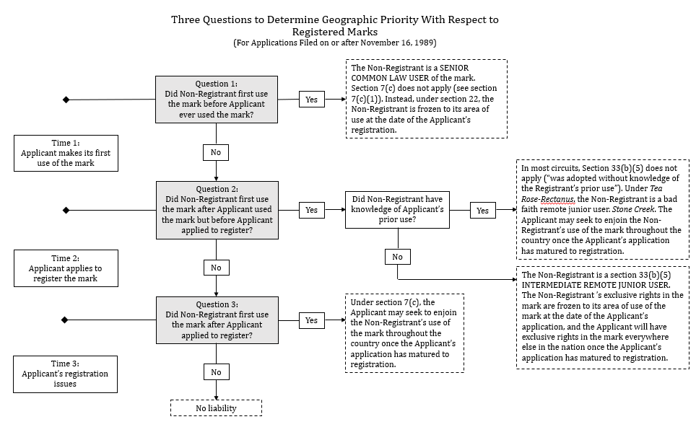

b. Applications Filed before November 16, 1989: Constructive Notice Priority as of Date of Registration
Applications filed before November 16, 1989 must rely on § 22, 15 U.S.C. § 1072:
Registration of a mark on the principal register provided by this Act or under the Act of March 3, 1981, or the Act of February 20, 1905, shall be constructive notice of the registrant’s claim of ownership thereof.
This “constructive notice” disables any person who adopts the mark after the registrant’s date of registration from claiming that it did so in good faith. See McCarthy § 26:32.
With respect to applications filed before November 16, 1989, senior common law users (those who adopted the mark before the registrant began actual use of the mark) are frozen to their area of use as of the date of registration. See Lanham Act §§ 15 & 22, 15 U.S.C. §§ 1065 & 1072. Section 33(b)(5) applies to intermediate junior users. See, e.g., Burger King of Fla., Inc. v. Hoots, 403 F.2d 904 (7th Cir. 1968) (limiting intermediate junior user of burger king for restaurant services to 25-mile radius around Mattoon, Illinois).

c. Concurrent Use and Registration
Lanham Act § 2(d), 15 U.S.C. § 1052(d), provides that two or more parties may use or register similar or identical marks for similar or identical goods provided that their respective uses of the marks will be sufficiently geographically distinct as not to cause consumer confusion. The text of § 2(d) provides as follows:
No trademark by which the goods of the applicant may be distinguished from the goods of others shall be refused registration on the principal register on account of its nature unless it—
. . . .
(d) Consists of or comprises a mark which so resembles a mark registered in the Patent and Trademark Office, or a mark or trade name previously used in the United States by another and not abandoned, as to be likely, when used on or in connection with the goods of the applicant, to cause confusion, or to cause mistake, or to deceive: Provided, That if the Director determines that confusion, mistake, or deception is not likely to result from the continued use by more than one person of the same or similar marks under conditions and limitations as to the mode or place of use of the marks or the goods on or in connection with which such marks are used, concurrent registrations may be issued to such persons when they have become entitled to use such marks as a result of their concurrent lawful use in commerce prior to (1) the earliest of the filing dates of the applications pending or of any registration issued under this chapter; (2) July 5, 1947, in the case of registrations previously issued under the Act of March 3, 1881, or February 20, 1905, and continuing in full force and effect on that date; or (3) July 5, 1947, in the case of applications filed under the Act of February 20, 1905, and registered after July 5, 1947. Use prior to the filing date of any pending application or a registration shall not be required when the owner of such application or registration consents to the grant of a concurrent registration to the applicant. Concurrent registrations may also be issued by the Director when a court of competent jurisdiction has finally determined that more than one person is entitled to use the same or similar marks in commerce. In issuing concurrent registrations, the Director shall prescribe conditions and limitations as to the mode or place of use of the mark or the goods on or in connection with which such mark is registered to the respective persons.
15 U.S.C. § 1052(d). See also TMEP § 1207.
Thus, the first applicant for a mark may be granted a registration covering the entirety of the United States except for the limited area in which an intermediate junior user or senior common law user is entitled to use the mark. See, e.g., Terrific Promotions, Inc. v. Vanlex, Inc., 36 U.S.P.Q.2d 1349 (TTAB 1995) (“TPI is entitled to a concurrent use registration for the mark DOLLAR BILLS and design for discount variety goods store services for the area comprising the entire United States except for the counties of Essex, Bergen, Hudson, Union and Middlesex in New Jersey, the five Boroughs of New York City and the counties of Suffolk, Nassau, Westchester, Rockland and Putnam in New York, the county of Fairfield in Connecticut and the county of Allegheny in Pennsylvania.” (see registration certificate below)); Weiner King, Inc. v. Wiener King Corp., 615 F.2d 512 (C.C.P.A. 1980) (limiting junior user-registrant’s registration to the entirety of the U.S. except for certain areas of New Jersey in which senior user had been using its mark). Meanwhile, the intermediate junior user or senior common law user may seek to register the mark for the limited area in which it is allowed still to use the mark. See, e.g., Ole’ Taco, Inc. v. Tacos Ole, Inc., 221 U.S.P.Q. 912 (TTAB 1984) (limiting senior user’s registration to entirety of U.S. except for area consisting of 180-mile radius around Grand Rapids, Michigan; limiting junior user’s registration to Grand Rapids, Michigan (see registration certificates below)).
Though concurrent registrations are an interesting phenomenon, they are exceedingly rare. The PTO’s data indicate that among all 2.65 million live trademark registrations on the Principal Register in 2020, only 332 consisted of registrations subject to concurrent use. See USPTO, Case Files Dataset, https://www.uspto.gov/ip-policy/economic-research/research-datasets/trademark-case-files-dataset (concur_use_in).

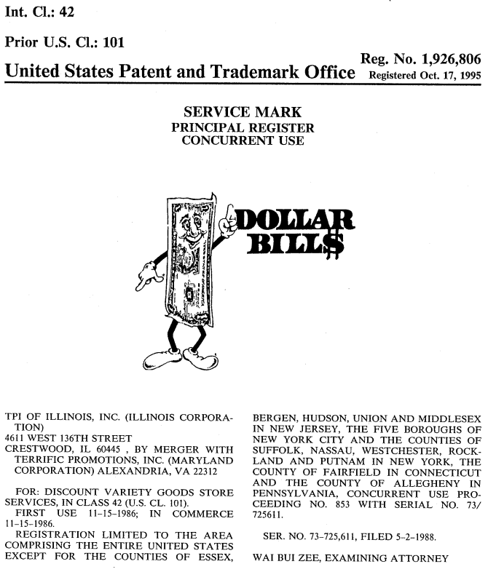

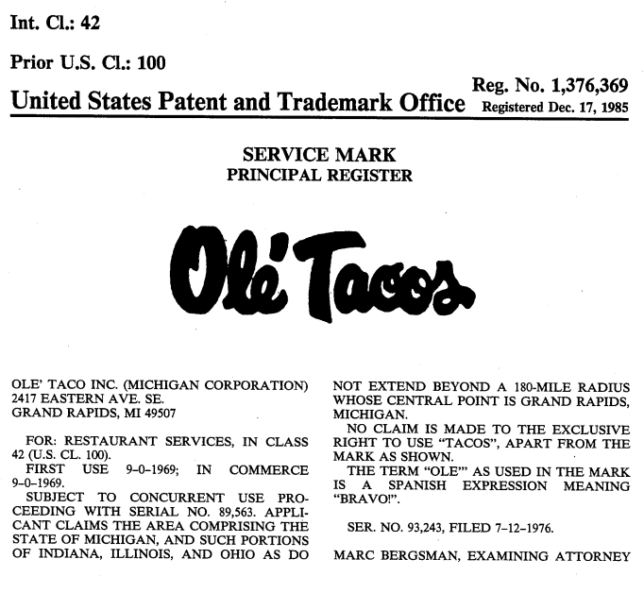
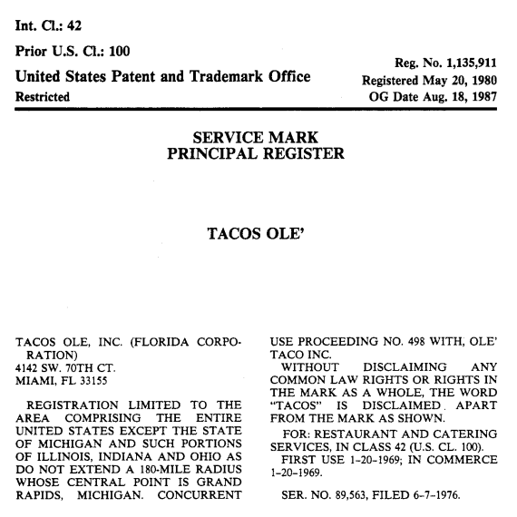

d. The Dawn Donut Rule
In Dawn Donut Co. v. Hart’s Food Stores, Inc., 267 F.2d 358 (2d Cir. 1959), the Second Circuit established a significant geographic limitation on a federal registrant’s ability to enjoin confusingly-similar uses by those over whom the registrant has priority. The Dawn Donut court held that though registration confers on the registrant nationwide priority, mere registration without more does not entitle the registrant to nationwide injunctive relief. Instead, the registrant must show that it is likely to make (or is already making) an actual use of the mark in any post-registration junior user’s area of trade before the registrant will be entitled to enjoin the junior use. The Dawn Donut rule does not present a problem for a registrant making nationwide use of its mark. But for a registrant making only a local or regional use of its mark, the registrant cannot enjoin uses in different geographic areas until it can show that it is actually using or is likely imminently to use its mark in those areas or its reputation has spread to those areas.
In the Dawn Donut case itself, the plaintiff was the senior user and registrant of the mark dawn for doughnuts, which it had registered in 1927 and renewed under the Lanham Act in 1947. In 1951, the defendant began to use the same mark for doughnuts in Rochester, New York. At the time of the suit, the plaintiff was not using or advertising its mark in the Rochester area. The Second Circuit held that there was thus no likelihood of confusion that could form the basis of injunctive relief:
[I]f the use of the marks by the registrant and the unauthorized user are confined to geographically separate markets, with no likelihood that the registrant will expand his use into the defendant’s market, so that no public confusion is possible, then the registrant is not entitled to enjoin the junior user’s use of the mark.
Dawn Donut, 267 F. 2d at 364. The plaintiff could seek relief at a later date if it could show an intent to expand into the defendant’s area of use:
[B]ecause of the effect we have attributed to the constructive notice provision of the Lanham Act, the plaintiff may later, upon a proper showing of an intent to use the mark at the retail level in defendant’s market area, be entitled to enjoin defendant’s use of the mark.
Id. at 365. To emphasize, the strange effect of the Dawn Donut rule is that even though a registrant may have nationwide priority in its registered mark, the registrant may not be able to prevent others from using that mark in regions in which the registrant is not yet itself using the mark or has established a reputation. Those others are, however, living on “borrowed time.” McCarthy, § 26.33. The junior user’s “use of the mark can continue only so long as the federal registrant remains outside the market area. But once the federal registrant shows a likelihood of entry, the junior user must stop use of the mark.” Id.
Dawn Donut remains good law. In the remarkable case of What-A-Burger of Virginia, Inc. v. Whataburger, Inc. of Corpus Christi, Texas, 357 F.3d 441 (4th Cir. 2004), the declaratory defendant Whataburger-Texas registered the mark whataburger for restaurant services in September, 1957. By the time of the suit, Whataburger-Texas was using the mark in connection with over 500 locations in various southern states but not in Virginia. The declaratory plaintiff What-A-Burger-Virginia began to use the mark What-A-Burger in Newport News, Virginia in August, 1957, and subsequently expanded its use to various other locations in Virginia in the following years. In 1970, Whataburger-Texas became aware of What-A-Burger-Virginia’s use in Virginia and proposed a licensing arrangement. There was no further communication between the parties until 2002, when Whataburger-Texas contacted What-A-Burger-Virginia to determine if What-A-Burger-Virginia’s use was infringing on Whataburger-Texas’s registered mark. What-A-Burger-Virginia asserted, among other things, that Whataburger-Texas was barred by the doctrine of laches from asserting infringement because it had waited nearly thirty years to do so. Whataburger-Texas successfully argued that laches could not apply because, under the principles established in Dawn Donut, Whataburger-Texas could not have sought during that thirty year period to enjoin What-A-Burger-Virginia’s use of the mark in Virginia. The Fourth Circuit explained: “There is nothing in this case to indicate a likelihood of entry into the local Virginia market by {Whataburger-Texas} (in fact, {Whataburger-Texas} specifically disavows any such intention) or that the likelihood of confusion otherwise looms large, triggering the obligation for {Whataburger-Texas} to initiate an action for trademark infringement.” Id. at 451.
Courts are growing increasingly wary of Dawn Donut however. For example, in Westmont Living, Inc. v. Ret. Unlimited, Inc., 132 F.4th 288 (4th Cir. 2025), the plaintiff operated numerous retirement communities in California and Oregon under the registered mark westmont living. The defendant then opened a retirement community in Virginia named “Westmont at Short Pump.” On cross-motions for summary judgment, the district court considered only the Dawn Donut rule to find that the parties “operate in entirely distinct geographic markets and therefore there is no likelihood of consumer confusion.” Westmont Living, Inc. v. Ret. Unlimited, Inc., No. 22 Civ. 811, 2023 WL 7285420, at *12 (E.D. Va. Nov. 3, 2023). The Fourth Circuit remanded. It emphasized that both parties advertised nationally:
While Westmont Living operates facilities on the West Coast and RUI operates facilities on the East Coast, they both advertise nationally, and with good success. Westmont Living's online advertising has produced tens of thousands of affirmative responses, including inquiries from every State, which have yielded numerous customers and contributed millions of dollars to Westmont Living's gross revenue. RUI likewise advertises nationally on the Internet, and presumably also with good results. Thus, when a person searches the Internet for “Westmont,” he or she will encounter both Westmont Living's site and RUI's site for The Westmont at Short Pump.
Westmont Living, Inc. v. Ret. Unlimited, Inc., 132 F.4th at 298. The Fourth Circuit explained more generally:
{B}oth Dawn Donut and What-A-Burger recognize the commonsense proposition that when two local businesses operate with the same mark in entirely distinct geographical markets, including their advertising and marketing, a likelihood of confusion will not arise. But those circumstances are present far less frequently today, in light of increased mobility, the Internet, and the reduced influence of local radio and newspaper advertising. See Cir. City Stores, Inc. v. CarMax, Inc., 165 F.3d 1047, 1057 (6th Cir. 1999) (Jones, J., concurring) (observing that “[t]he Dawn Donut Rule was enunciated in 1959” and that “our society is far more mobile than it was four decades ago,” with “the Internet . . . increasingly deconstructing geographical barriers for marketing purposes”).
Westmont Living, Inc. v. Ret. Unlimited, Inc., 132 F.4th at 298. See also Guthrie Healthcare Sys. v. ContextMedia, Inc., 826 F.3d 27, 48 (2d Cir. 2016) (aggressively distinguishing away Dawn Donut on the basis that “Dawn Donuts {sic} did not present the problem, like this case, of a plaintiff who has shown entitlement to an injunction in one geographic area and seeks to have the injunction extend beyond as well. It therefore has no pertinence to the question at issue here.”).
For an excellent (and brief) practical overview of the Dawn Donut rule, see Christopher P. Bussert, Trademark Enforcement in Distinct Geographic Territories: Is the Infringement Case “Ripe”?, Franchise Lawyer, Summer 2019, at 3.
Comments and Questions
1. Consent to use agreements. Two users of similar marks may reach an agreement in which they promise not to sue each other for trademark infringement provided that each complies with the limitations on use set forth in the agreement. These limitations may limit use to, among other things, specific geographical areas, specific goods or services, or specific mark formats. See Brennan’s Inc. v. Dickie Brennan & Co. Inc., 376 F.3d 356, 364 (5th Cir. 2004) (discussing consent to use agreements); McCarthy § 18:79 (same). See also Eric Pfanner, British Judge Allows Apple to Keep Logo on iTunes, NY Times, May 9, 2006, https://www.nytimes.com/2006/05/09/technology/09apple.html (discussing litigation between Apple Computer and Apple Corps, the Beatles’ corporate entity, concerning the former’s alleged breach of the 1991 consent to use agreement between the two firms). Courts (and examiners) typically give great weight to consent to use agreements, but they sometimes nevertheless find a likelihood of confusion. See, for example, In Re 8-Bit Brewing LLC, Serial No. 86760527, 2017 WL 5885609, (Oct. 30, 2017), in which the TTAB affirmed the examiner’s section 2(d) refusal to register the applied-for mark 8-bit aleworks in light of the registered mark 8 bit brewing company:
Ultimately, in view of the identity of the involved goods, beer, and their trade channels, as well as the overall strong similarity of the marks, we conclude there is a likelihood of confusion between Applicant’s applied-for mark 8-Bit Aleworks and the registered marks, 8 bit Brewing Company (with and without design). We make this conclusion bearing in mind that “consent agreements are frequently entitled to great weight.” Bay State Brewing Co., 117 USPQ2d at 1967. In this case, however, Registrant’s consent is ambiguous and outweighed by the several other relevant du Pont factors. In other words, the shortcomings in the consent agreement are such that consumer confusion remains likely.
In Re 8-Bit Brewing LLC, 2017 WL 5885609, at *8. But see In re American Cruise Lines, Inc., 128 U.S.P.Q.2d 1157 (TTAB 2018) (reversing examiner’s Lanham Act § 2(d) refusal even though consent agreement between constellation and american constellation for cruise ships contained no provisions requiring parties to seek to avoid confusion, reasoning that “[w]hile the inclusion of provisions to avoid any potential confusion are preferred and probative in consent agreements, they are not mandatory.”).
2. Secondary meaning in only one part of the United States. To register a non-inherently distinctive mark, the mark owner need only show that the mark has secondary meaning in some part of the United States. But see McCarthy 15:72 (citing a 1963 TTAB opinion for the proposition that “the law is unclear [on this issue], with a hint that proving secondary meaning in only a small part of the United States might not be sufficient.”). Yet the priority rights that stem from registration are nationwide in scope. Does this make sense as a policy matter? Cf. Société des produits Nestlé v. Mondelez UK Holdings & Services, C‑84/17 P, C‑85/17 P and C‑95/17 P, ECLI:EU:C:2018:596, ¶ 83 (CJEU, July 25, 2018) (holding that for purposes of registering an EU trademark that is not inherently distinctive anywhere in the European Union, the applicant must show that the mark has acquired secondary meaning throughout the European Union).

3. National Borders and Trademark Rights
We have focused so far on trademark uses within the territorial borders of the U.S. and the geographical extent of rights established by such uses. We turn now to trademark uses outside the territorial borders of the U.S. and to the question of whether such uses can form the basis for exclusive rights within the U.S.
As exemplified in Person’s Co., Ltd. v. Christman, 900 F.2d 1565 (Fed. Cir. 1990), the traditional view has long been that trademark rights are generally limited to national borders and that foreign uses of trademarks generally do not confer exclusive rights within the U.S. However, the “well-known marks doctrine” holds that foreign uses of trademarks that become very well-known in the U.S. may form the basis for exclusive rights within the U.S. even when the foreign user is not making any actual use of the mark within the U.S. Finally, a more recent opinion from the Fourth Circuit, Belmora LLC v. Bayer Consumer Care AG, 819 F.3d 697 (4th Cir. 2016), cert. denied, 137 S. Ct. 1202 (U.S. 2017), has the potential profoundly to change our traditional understanding of the national limits of trademark rights (and of the relation between Lanham Act §§ 32 and 43(a)). Belmora was denied certiorari review. If its reasoning is adopted by other circuits, it may significantly lessen the importance of much of the doctrine discussed in Person’s and in the Well-Known Marks cases.

a. National-Border Limits on Trademark Rights
The opinion below, Person’s Co., Ltd. v. Christman, 900 F.2d 1565 (Fed. Cir. 1990), is frequently cited as standing for the proposition that foreign uses do not establish exclusive rights within the U.S. In reading through the opinion, consider the following questions:
- Does the outcome in Person’s strike you as fair?
- Alternatively, has the Federal Circuit chosen the economically efficient outcome? If not, what would that outcome be?
- Is the Person’s holding still viable in a globalized, internet-based economy?

[The opinion in Person’s Co., Ltd. v. Christman is available separately.]

b. The Well-Known Marks Doctrine
Though it is rarely invoked, the well-known marks doctrine constitutes an important exception to—or variation on—the territoriality principle in trademark law. It is also the source of a basic split between the Ninth and Second Circuits on whether U.S. federal trademark law incorporates well-known marks protection. As you read through the opinions below, consider the following questions:
- As a policy matter, for a foreign mark not used in the U.S., how well-known should such a mark be in the U.S. for it to qualify for protection in the U.S.? Should mere secondary meaning in a particular geographic location be sufficient? “Secondary meaning plus”? Nationwide fame?
- What is the particular statutory or common law basis for the Ninth Circuit’s application of the well-known marks doctrine?
- Is the New York Court of Appeals approach to the issue persuasive?
- Is the well-known marks doctrine simply a transnational extension of the Tea Rose-Rectanus doctrine? Is there any way in which the well-known marks doctrine is different?

i. The Well-Known Marks Doctrine in the Ninth Circuit

[The opinion in Grupo Gigante SA De CV v. Dallo & Co., Inc. is available separately.]

ii. The Well-Known Marks Doctrine in the Second Circuit

[The opinion in ITC Ltd. v. Punchgini, Inc. is available separately.]
Comments and Questions
1. The final disposition of ITC v. Punchgini. The case returned to the Second Circuit, which affirmed the district court’s initial grant of summary judgment to the defendant on the ground, among others, that bukara for restaurant services had no secondary meaning in New York. ITC Ltd. v. Punchgini, Inc., 518 F.3d 159 (2d Cir. 2008), aff’g 373 F.Supp.2d 275 (S.D.N.Y. 2005).
2. “Well-known marks doctrine” or “famous marks doctrine”? In a footnote in a portion of the New York Court of Appeals opinion not included in the excerpt above, the court addressed the terminological ambiguity over the correct name of the doctrine at issue:
There is some ambiguity regarding the proper name for what has been variously called the “famous marks doctrine,” the “well-known marks doctrine” and the “famous mark doctrine” (see e.g. 5 McCarthy on Trademarks and Unfair Competition § 29:4 [4th ed 2007] [using the above names interchangeably]). Apparently, the use of “well-known” in place of “famous” took hold after the Lanham Act was amended by passage of the Federal Trademark Anti-Dilution Act of 2006, which uses “famous” as a term of art (see 15 USC § 1125 [c]). At any rate, “famous” and “well-known,” “mark” and “marks,” have been used interchangeably to describe the putative doctrine, and no distinction is intended by our choice of words here.
ITC Ltd. v. Punchgini, Inc., 880 N.E.2d 852, 856 n.1 (N.Y. 2007).

c. Belmora and the End of Territorial Limits on Trademark Rights?
As stated above, the Fourth Circuit’s opinion in Belmora LLC v. Bayer Consumer Care AG, 819 F.3d 697 (4th Cir. 2016), cert. denied, 137 S. Ct. 1202, (U.S. 2017), represents a significant break with much of our traditional understanding of the national limits of trademark rights and with the requirement that a plaintiff use a mark in commerce in the U.S. (or otherwise own a mark that qualifies as a well-known mark in the U.S.) in order to assert exclusive rights in the mark.
Two noteworthy cases form the basis of Belmora. The first is International Bancorp, LLC v. Societe des Bains de Mer et du Cercle des Estrangers a Monaco, 329 F.3d 359 (4th Cir. 2003). The mark at issue was casino de monte carlo. The declaratory plaintiffs operated various websites whose domain names and content incorporated at least “some portion”, id. at 361, of the term casino de monte carlo and various images of the declaratory defendant’s casino in Monte Carlo, which has operated under the casino de monte carlo mark since 1863. The defendant advertised its casino in the U.S. but rendered its services only abroad. In a controversial opinion, the Fourth Circuit found infringement. Judge Luttig reasoned, in short, that the defendant had shown “use in commerce” because (1) U.S. consumers’ purchase of casino services from the defendant constituted trade with a foreign nation that Congress was empowered to regulate, and (2) the defendant’s advertising of its mark in the U.S. had made the mark distinctive as a designation of source in the U.S. In a thorough and well-reasoned opinion, Judge Motz dissented. Id. at 383-398 (Motz, J., dissenting).
The second is Lexmark International, Inc. v. Static Control Components, Inc., 134 S. Ct. 1377 (2014). Static Control Components (SCC) produced components that various companies employed in the remanufacture and refurbishing of used toner cartridges for Lexmark printers. Such remanufacturers were significantly disrupting Lexmark’s own sales of replacement toner cartridges for its printers. SCC alleged that Lexmark engaged in false advertising (1) by informing certain Lexmark toner cartridge end-users that they were contractually required to return used cartridges to Lexmark and (2) by informing remanufacturing companies that it was illegal to refurbish certain Lexmark toner cartridges and to use SCC’s components in doing so. Id. at 1384-85. The district court granted Lexmark’s motion to dismiss on the ground that SCC lacked standing. Id. at 1385. The Sixth Circuit reversed. Id. As explained in Belmora, the Supreme Court clarified in Lexmark what the plaintiff must show to have standing to sue for false advertising.
Two final notes: First, the Belmora opinion makes no reference whatsoever to the well-known marks doctrine. As you will see, Belmora’s facts cry out for application of the doctrine. But early on in the litigation, the TTAB determined that Article 6bis of the Paris Convention “do[es] not afford an independent cause of action for parties in Board proceedings,” nor does any section of the Lanham Act establish such a cause of action. Bayer Consumer Care AG v. Belmora LLC, 90 U.S.P.Q.2d 1587, 2009 WL 962811, *5 (TTAB 2009).
Second, Meenaxi Enterprise, Inc. v. Coca-Cola Company, 38 F.4th 1067 (Fed. Cir. 2022) engages facts and arguments comparable to those in Belmora. Students wishing to dig deeper into the implications—and limits—of the Belmora decision should begin with Meenaxi.

[The opinion in Belmora LLC v. Bayer Consumer Care AG is available separately.]
Comments and Questions
1. Belmora’s implications for trademark prosecution and litigation strategy. For a comprehensive account of Belmora’s practical implications for trademark prosecution and litigation strategy, see Christine Haight Farley, No Trademark, No Problem, 23 B.U. J. Sci. & Tech. L. 304 (2017). See also Martin B. Schwimmer & John L. Welch, U.S. Law Inches Towards Protecting Trademark Reputation Without Use, World Trademark Rev., Oct. 1, 2019. For a subsequent application of Belmora, see The Coca-Cola Company v. Meenaxi Enterprises, Inc., Cancellation Nos. 92063353 & 92064398, 2021 WL 2681898 (TTAB June 28, 2021) [precedential].
2. The ongoing saga of Belmora. After the Supreme Court denied certiorari review of the 2016 Fourth Circuit opinion in Belmora, the case returned to the Eastern District of Virginia. In September, 2016, the district court affirmed the PTO’s cancellation of Belmora’s registration but granted Belmora’s motion for summary judgment on Bayer’s unfair competition claim on the ground that Bayer had waited too long to file suit. See Belmora, LLC v. Bayer Consumer Care AG, 338 F. Supp. 3d 477, 484 (E.D. Va. 2018) (“Whether a three or four-year statute of limitations is applied in this case is immaterial. That is because Bayer’s filing of this action misses the statute of limitations by almost a decade.”). In May, 2021, the Fourth Circuit reversed the district court’s grant of summary judgment to Belmora on Bayer’s unfair competition claim, holding that the district court should have applied laches rather than any state-law statute of limitations. See Belmora LLC v. Bayer Consumer Care AG, 987 F.3d 284 (4th Cir. 2021). The Fourth Circuit once again remanded the case back to the district court. Id.

The Lanham Act does not explicitly state that the benefits of § 7(c) should be available only to applications filed on or after the effective date of the TLRA. However, as McCarthy notes, “Lanham Act § 33(b)(5), 15 U.S.C. § 1115(b)(5) distinguishes between the application date creating constructive use on the one hand and the registration date creating constructive notice [under § 22] on the other hand, limiting the later to a case where “the application for registration is filed before the effective date of the Trademark Law Revision Act of 1988.” This indicates a legislative intent to restrict the benefits of § 7(c) constructive use to registrations resulting from applications filed after the effective date of the revision.” McCarthy § 26.38 fn 1.10.

