An Open-Access Casebook

Version 12 (2025)
Digital Edition
www.tmcasebook.org

Barton Beebe
John M. Desmarais Professor of Intellectual Property Law
New York University School of Law

This work is licensed under a Creative Commons Attribution-NonCommercial-
ShareAlike 4.0 International License.

Trademark Infringement
In this Part, we consider the infringement of trademark rights under certain sections of the Lanham Act:
- § 32, 15 U.S.C. § 1114 (likelihood of confusion with respect to registered marks)
- § 43(a), 15 U.S.C. § 1125(a) (likelihood of confusion with respect to registered or unregistered marks)
- § 43(c), 15 U.S.C. § 1125(c) (likelihood of dilution with respect to registered or unregistered marks)
- § 43(d), 15 U.S.C. § 1125(d) (“cybersquatting” of registered or unregistered marks)
The test for likelihood of confusion under § 32 is now essentially the same as the test for likelihood of confusion under § 43(a), and courts often cite to case law under one section interchangeably with case law under the other. When owners of registered marks plead likelihood of confusion, they typically do so under both § 32 and § 43(a) in the event that some defect is discovered in their registration. Such plaintiffs may also plead under both sections in order to avail themselves of the slightly broader language of § 43(a), though, again, courts have come to treat § 32 and § 43(a) as essentially interchangeable.
Courts have set forth the elements of a trademark infringement claim in a variety of ways. For example, with respect to a claim based on a likelihood of confusion under either or both of § 32 and § 43(a), courts have stated:
- “[T]o succeed in a Lanham Act suit for trademark infringement, a plaintiff has two obstacles to overcome: the plaintiff must prove that its mark is entitled to protection and, even more important, that the defendant’s use of its own mark will likely cause confusion with plaintiff’s mark.” Gruner + Jahr USA Publ’g v. Meredith Corp., 991 F.2d 1072, 1074 (2d Cir. 1993).
- “To prevail on a claim of trademark infringement under the Lanham Act, 15 U.S.C. § 1114, a party must prove: (1) that it has a protectible ownership interest in the mark; and (2) that the defendant’s use of the mark is likely to cause consumer confusion.” Network Automation, Inc. v. Advanced Systems Concepts, Inc., 638 F.3d 1137, 1144 (9th Cir. 2011) (citations omitted).
- “To establish trademark infringement under the Lanham Act, a plaintiff must prove: (1) that it owns a valid mark; (2) that the defendant used the mark ‘in commerce’ and without plaintiff’s authorization; (3) that the defendant used the mark (or an imitation of it) ‘in connection with the sale, offering for sale, distribution, or advertising’ of goods or services; and (4) that the defendant’s use of the mark is likely to confuse consumers.” Rosetta Stone Ltd. v. Google, Inc., 676 F.3d 144, 152 (4th Cir. 2012) (citations omitted).
- “Both infringement and false designation of origin have five elements. To prevail under either cause of action, the trademark holder must prove: (1) that it possesses a mark; (2) that the [opposing party] used the mark; (3) that the [opposing party’s] use of the mark occurred ‘in commerce’; (4) that the [opposing party] used the mark ‘in connection with the sale, offering for sale, distribution, or advertising’ of goods or services; and (5) that the [opposing party] used the mark in a manner likely to confuse consumers.” Lamparello v. Falwell, 420 F.3d 309, 313 (4th Cir. 2005) (citations omitted).
Though the enumerations vary in their level of detail, these statements of the elements of a likelihood of confusion claim are all essentially the same. The plaintiff must prove that (1) it possesses exclusive rights in a mark and (2) the defendant has infringed those exclusive rights. Our focus to this point has been on the first of these two basic elements—whether there is a property right. Our focus here is on the second of these elements—whether that right has been infringed.
We begin by reviewing the requirement that, in order to be liable for trademark infringement, a defendant must “use in commerce” the plaintiff’s mark “in connection with the sale . . . of any goods or services.” We then turn, in later Classes, to forms of infringement that are based on the likelihood of consumer confusion as to the source or sponsorship of the defendant’s goods. In Classes 19, 20, and 21, we consider forms of infringement that are not based on consumer confusion at the point of sale, most notably trademark dilution.
Comments and Questions
1. Do individual consumers or groups of consumers have standing to sue under the Lanham Act’s infringement sections? In short, no. Lanham Act § 32(1), 15 U.S.C. § 1114(1), which applies to registered marks, provides that an infringing party “shall be liable in a civil action by the registrant for the remedies hereafter provided” (emphasis added). Lanham Act § 43(a), 15 U.S.C. § 1125(a), which applies to both registered and unregistered marks, provides that an infringing party “shall be liable in a civil action by any person who believes that he or she is or is likely to be damaged by such act” (emphasis added). Though broad, this language has been construed to exclude consumers. See Lexmark Int’l, Inc. v. Static Control Components, Inc., 572 U.S. 118, 132 (2014) (“A consumer who is hoodwinked into purchasing a disappointing product may well have an injury-in-fact cognizable under Article III, but he cannot invoke the protection of the Lanham Act—a conclusion reached by every Circuit to consider the question . . . . Even a business misled by a supplier into purchasing an inferior product is, like consumers generally, not under the Act’s aegis.”). See also id. at 140 (“To invoke the Lanham Act’s cause of action for false advertising, a plaintiff must plead (and ultimately prove) an injury to a commercial interest in sales or business reputation proximately caused by the defendant’s misrepresentations.”). Does this make sense as a matter of sound policy? See also Curtin v. United Trademark Holdings Inc., 137 F.4th 1359 (Fed. Cir. 2025).

Confusion-Based Infringement
The overriding question in most federal trademark infringement litigation is a simple one: is the defendant’s trademark, because of its similarity to the plaintiff’s trademark, causing or likely to cause consumer confusion as to the source or sponsorship of the defendant’s goods? Each of the circuits requires that, in answering this question, the district court conduct a multifactor analysis of the likelihood of consumer confusion according to the factors set out by that circuit. As the Seventh Circuit has explained, the multifactor test operates “as a heuristic device to assist in determining whether confusion exists.” Sullivan v. CBS Corp., 385 F.3d 772, 778 (7th Cir. 2004). In Section II.B.1, we will briefly review the peculiar history of the multifactor test approach to the likelihood of confusion (or “LOC”) question. In Section II.B.2, we will focus on a particularly rich application of the multifactor test in Virgin Enterprises Ltd. v. Nawab, 335 F.3d 141 (2d Cir. 2003). Section II.B.4 will address the use of survey evidence in the LOC context. Sections II.B.5 through II.B.9 will address various modes of consumer confusion such as “sponsorship or affiliation” confusion, “initial interest” confusion, “post-sale” confusion, and “reverse” confusion. Section II.B.10 will return briefly to the Lanham Act § 2(d) bar to registration of a mark that is confusingly-similar to a previously registered mark.

1. The History of the Confusion-Based Cause of Action for Trademark Infringement

a. The Early-Twentieth Century Approach to the Likelihood of Confusion
In the following opinion, Borden Ice Cream Co. v. Borden’s Condensed Milk Co., 201 F. 510 (7th Cir. 1912), the appellee Borden Condensed Milk Co. was the well-known manufacturer of, among other things, milk products under the trademark borden. However, the only ice cream appellee had ever made was a specialized product made from malted milk and sold only to hospitals. The appellant Borden Ice Cream Co. commenced use of the borden mark for ice cream – after finding someone named Borden to join its application for a corporate charter in Illinois. Under current trademark law, this would be a clear case of trademark infringement. As you will see, the Borden Ice Cream court saw things differently at the time.

[The opinion in Borden Ice Cream Co. v. Borden’s Condensed Milk Co. is available separately.]

b. The Development of the Modern Multifactor Test
The idiosyncrasies of tradition rather than of reason drove the development of the multifactor tests across the circuits. Each of the circuits’ current multifactor tests originated either directly or indirectly from the 1938 Restatement (First) of the Law of Torts. The Restatement (First) failed to set forth a single, unified multifactor test for trademark infringement. Instead, it proposed four factors that courts should consider in all cases and nine more factors that courts should additionally consider only when the parties goods were noncompeting with each other, i.e., not substitutable for each other. Section 729 of the Restatement (First) set out the four factors courts should always consider:
In determining whether the actor’s designation is confusingly similar to the other’s trade-mark or trade name, the following factors are important:
(a) the degree of similarity between the designation and the trade-mark or trade name in
(i) appearance;
(ii) pronunciation of the words used;
(iii) verbal translation of the pictures or designs involved;
(iv) suggestion;
(b) the intent of the actor in adopting the designation;
(c) the relation in use and manner of marketing between the goods or services marketed by the actor and those marketed by the other;
(d) the degree of care likely to be exercised by purchasers.
Restatement First of Torts § 729 (1939). Section 731 set out the additional nine factors that courts should additionally consider only in cases involving noncompetitive goods:
In determining whether one’s interest in a trade-mark or trade name is protected, under the rules stated in §§ 717 and 730, with reference to the goods, services or business in connection with which the actor uses his designation, the following factors are important:
(a) the likelihood that the actor’s goods, services or business will be mistaken for those of the other;
(b) the likelihood that the other may expand his business so as to compete with the actor;
(c) the extent to which the goods or services of the actor and those of the other have common purchasers or users;
(d) the extent to which the goods or services of the actor and those of the other are marketed through the same channels;
(e) the relation between the functions of the goods or services of the actor and those of the other;
(f) the degree of distinctiveness of the trademark or trade name;
(g) the degree of attention usually given to trade symbols in the purchase of goods or services of the actor and those of the other;
(h) the length of time during which the actor has used the designation;
(i) the intent of the actor in adopting and using the designation.
Id. at § 731.
Through the course of the mid-twentieth century, the federal courts lost track of the distinction between the two sets of factors, and the circuits each began to use a single, unified multifactor test regardless of whether the parties’ goods were competing. Each circuit developed its own test, and for the most part, the peculiarities of the particular cases in which the circuit’s multifactor test first coalesced determined which factors are still considered in that circuit today. A good example of this is found in the following opinion, Polaroid Corp. v. Polarad Electronics Corp., 287 F.2d 402 (2d Cir. 1961), which is the origin of the Second Circuit’s “Polaroid Factors.” Despite Judge Friendly’s clear statement that his test was meant for situations “[w]here the products are different,” id. at 495, Second Circuit courts routinely apply the Polaroid factors in competing goods cases. The opinion is presented here primarily for its historical significance as one of the most influential opinions in U.S. trademark law, but also to show, in the final paragraph of the opinion excerpt, how much trademark infringement doctrine had evolved since Borden’s Ice Cream.

[The opinion in Polaroid Corp. v. Polarad Electronics Corp. is available separately.]

Questions and Comments
1. Laches in federal trademark law. There is no statute of limitations provision in the Lanham Act. Instead, the analogous state statute of limitations period in the forum state will typically apply in order to fill the gap in federal law. Tandy Corp. v. Malone & Hyde, Inc., 769 F.2d 362 (6th Cir. 1985). “The limitations period is often used to shift the initial burden of proof for the laches defense. If the case was filed within the relevant statute of limitations, the burden will be on the defendant to show that laches applies, but if the case was filed after the limitations period expired, then the burden will be on the plaintiff to show why it would be inequitable to apply laches.” 3 Gilson on Trademarks § 13.21 (2019). Different state’s limitations periods can run anywhere from about two to six years. See 6 McCarthy on Trademarks and Unfair Competition § 31:33 (5th ed. 2019).
For an impressive application of the laches defense, see Dropbox, Inc. v. Thru Inc., No. 15 Civ. 01741, 2016 WL 6696042 (N.D. Cal. Nov. 15, 2016), supplemented, 15 Civ. 01741, 2016 WL 7116717 (N.D. Cal. Dec. 7, 2016), aff’d, 728 F. App’x 717 (9th Cir. 2018), and aff’d, 728 F. App’x 717 (9th Cir. 2018). The case involved litigation between the Dropbox file hosting service and a company that probably had a reasonable claim of seniority in the dropbox mark. Dropbox’s laches defense was so strong and Thru’s litigation conduct so abusive (it waited until Dropbox’s IPO announcement to file suit) that Dropbox eventually won attorney’s fees and costs in the total amount of $2.3 million.
2. “His Mark is His Authentic Seal.” In Yale Elec. Corp. v. Robertson, 26 F.2d 972 (2d Cir. 1928), which Judge Friendly cites in the final paragraph of Polaroid, Judge Hand set forth his oft-quoted description of the plaintiff’s interest in preventing the use of its mark on noncompeting goods:
However, it has of recent years been recognized that a merchant may have a sufficient economic interest in the use of his mark outside the field of his own exploitation to justify interposition by a court. His mark is his authentic seal; by it he vouches for the goods which bear it; it carries his name for good or ill. If another uses it, he borrows the owner’s reputation, whose quality no longer lies within his own control. This is an injury, even though the borrower does not tarnish it, or divert any sales by its use; for a reputation, like a face, is the symbol of its possessor and creator, and another can use it only as a mask. And so it has come to be recognized that, unless the borrower’s use is so foreign to the owner’s as to insure against any identification of the two, it is unlawful.
Id. at 974. If the defendant’s conduct “does not tarnish [the plaintiff’s reputation], or divert any sales by its use,” then what exactly is the harm to the plaintiff?

2. Contemporary Applications of the Multifactor Test for the Likelihood of Consumer Confusion
Each circuit has developed its own multifactor test for the likelihood of consumer confusion. Here are the multifactor tests from certain leading circuits. As you will see, they are roughly similar:
- The Second Circuit’s “Polaroid Factors”: Polaroid Corp. v. Polarad Elecs. Corp., 287 F.2d 492, 495 (2d Cir. 1961) (“Where the products are different, the prior owner’s chance of success is a function of many variables: the strength of his mark, the degree of similarity between the two marks, the proximity of the products, the likelihood that the prior owner will bridge the gap, actual confusion, and the reciprocal of defendant’s good faith in adopting its own mark, the quality of defendant’s product, and the sophistication of the buyers. Even this extensive catalogue does not exhaust the possibilities—the court may have to take still other variables into account. American Law Institute, Restatement of Torts, §§ 729, 730, 731.”).
- The Seventh Circuit’s “Helene Curtis Factors”: Helene Curtis Indus., Inc. v. Church & Dwight Co., 560 F.2d 1325, 1330 (7th Cir. 1977) (In determining ‘likelihood of confusion’ several factors are important: ‘the degree of similarity between the marks in appearance and suggestion; the similarity of the products for which the name is used; the area and manner of concurrent use; the degree of care likely to be exercised by consumers; the strength of the complainant’s mark; actual confusion; and an intent on the part of the alleged infringer to palm off his products as those of another’. Carl Zeiss Stiftung v. VEB Carl Zeiss Jena, 433 F.2d 686, 705 (2d Cir. 1970).”)
- The Ninth Circuit’s “Sleekcraft Factors”: AMF Inc. v. Sleekcraft Boats, 599 F.2d 341, 348–49 (9th Cir. 1979) (“In determining whether confusion between related goods is likely, the following factors are relevant: 1. strength of the mark; 2. proximity of the goods; 3. similarity of the marks; 4. evidence of actual confusion; 5. marketing channels used; 6. type of goods and the degree of care likely to be exercised by the purchaser; 7. defendant’s intent in selecting the mark; and 8. likelihood of expansion of the product lines. See, e.g., Sleeper Lounge Co. v. Bell Manufacturing Co., 253 F.2d at 722; Restatement of Torts s 731 (1938).”).
In Virgin Enterprises Ltd. v. Nawab, 335 F.3d 141 (2d Cir. 2003), the Second Circuit applied its Polaroid test to determine if consumers would likely mistake the goods and services of the defendant, operating under the mark virgin wireless, for the those of the plaintiff, the owner of the virgin mark for a wide variety of goods and services. The opinion is exceptional for its thorough analysis of the factors. In reading through Virgin Enterprises, consider the following questions:
- Which of the Polaroid factors are likely the most important to courts’ adjudication of the likelihood of confusion question?
- In practice, is intent likely as unimportant to courts’ determinations as the Virgin Enterprises opinion suggests?
- Why should strong marks receive a wider scope of protection than weak marks?
- Why should inherent strength be more important to the multifactor inquiry than acquired strength? Relatedly, why should fanciful marks receive a wider scope of protection that arbitrary or suggestive marks?
- Does the court make any basic mistakes of doctrine in its discussion of the Abercrombie spectrum?

[The opinion in Virgin Enterprises Ltd. v. Nawab is available separately.]

Questions and Comments
1. The Abercrombie spectrum. In its discussion of inherent distinctiveness, the court divides the Abercrombie spectrum into inherently and non-inherently distinctive marks: “This inquiry distinguishes between, on the one hand, inherently distinctive marks—marks that are arbitrary or fanciful in relation to the products (or services) on which they are used—and, on the other hand, marks that are generic, descriptive or suggestive as to those goods.” Do you detect an error in this division?
Later in the opinion, the court refers to the Virgin mark as “arbitrary and fanciful.” Should we treat these two Abercrombie categories as indistinguishable for purposes of the inherent distinctiveness analysis? Why might we seek to accord a greater scope of protection to fanciful marks than to arbitrary marks?
2. Are all factors equally important? In order to prevail in the overall likelihood of confusion multifactor test, must a plaintiff win all of the factors, a majority of them, some of them? Is the outcome of any particular factor necessary or sufficient to trigger a particular overall test outcome?
Empirical work offers some insight into these questions. See Barton Beebe, An Empirical Study of the Multifactor Tests for Trademark Infringement, 94 Calif. L. Rev. 1581 (2006). The author’s evidence suggests that the plaintiff must win the similarity factor in order to win the overall test. Of the 192 preliminary injunction and bench trial opinions studied, 65 opinions found that the marks were not similar, and each of these 65 opinions found in favor of the defendant in the overall likelihood of confusion test. Notwithstanding the Virgin court’s assertion that the intent factor is not “of high relevance” and may only “tip the balance where the questions are close,” the study also suggests that the outcome of the intent factor correlates very strongly with the outcome of the overall test. Sixty-seven of the 192 preliminary injunction and bench trial opinions found that the intent factor favored the plaintiff. Of these 67 opinions, 65 found in favor of the plaintiff in the overall test (and in the two outlying opinions, the court found that the similarity factor favored the defendant). Overall, across the circuits, five core factors appear to drive the outcome of the likelihood of confusion test. In order of importance, these factors are the similarity of the marks, the defendant’s intent, the proximity of the goods, evidence of actual confusion, and the strength of the plaintiff’s mark. The remaining factors appear, in practice, to be largely irrelevant to the outcome of the test. See also Daryl Lim, Trademark Confusion Revealed: An Empirical Analysis, 71 Am. U. L. Rev. 1285 (2022).
3. Why should strong marks receive more protection? The conventional rationale for according a greater scope of protection to strong marks is that, due to their notoriety, they are more easily called to mind by similar marks. See Jacob Jacoby, The Psychological Foundations of Trademark Law: Secondary Meaning, Genericism, Fame, Confusion and Dilution, 91 Trademark Rep. 1013, 1038-42 (2001). But shouldn’t strong marks actually require less protection? Consider the example of coke. Having been exposed to the coke mark countless times throughout their lives, are American consumers more or less likely to detect slight differences between the coke mark and other similar marks? Some foreign courts have had the temerity to suggest that exceptionally strong marks are less likely to be confused with other marks. See, e.g., Baywatch Production Co. Inc. v The Home Video Channel, High Court of Justice, Chancery Division, 31 July 1996 (Crystal J.) (citing BASF Plc v CEP (UK) Plc (Knox J.), 16 October 1995)); Uprise Product Yugen Kaisha v. Commissioner of Japan Patent Office, Heisei 22 (gyo-ke) 10274 Intellectual Property High Court of Japan (2010). Australian courts have been particularly receptive to this line of argument. See Robert Burrell & Michael Handler, Australian Trademark Law 253-55, 403-06 (2d ed. 2016). See generally Barton Beebe & C. Scott Hemphill, The Scope of Strong Marks: Should Trademark Law Protect the Strong More than the Weak?, 92 NYU L. Rev. 1339 (2017).
4. Sophistication of the relevant consumers. Courts assess the likelihood of confusion by the “reasonably prudent” consumer of the goods or services at issue. Consumers of more expensive or more technically sophisticated goods are understood to exercise greater care in their purchasing decisions, and thus to be comparatively less likely to be confused. See, e.g., Florida Int’l Univ. Bd. of Trustees v. Florida Nat’l Univ., Inc., 830 F.3d 1242, 1256 (11th Cir. 2016) (in finding no likelihood of confusion between florida international university and florida national university, observing that “students looking for a college to attend are likely to be relatively sophisticated and knowledgeable because of the nature, importance, and size of the investment in a college education”); Heartsprings, Inc. v. Heartspring, Inc., 143 F.3d 550, 557 (10th Cir. 1998) (finding that consumers would not likely confuse defendant’s mark heartspring for a residential school for physically disabled children with plaintiff’s mark heartsprings for printed materials teaching children to resolve conflicts non-violently where tuition for defendant’s school ranged from $90,000 to $150,000 per year). See also M Welles & Assocs., Inc. v. Edwell, Inc., 69 F.4th 723, 736 (10th Cir. 2023) (citing Heartsprings in support of and affirming magistrate judge’s bench trial ruling that edwell for nonprofit organization dedicated to improving schoolteachers’ mental health was not confusingly similar with edwel for provider of classes and certification workshops for project management professionals); but see id. at 737 (Thmokovich, J., dissenting) (“The majority . . . overlooks the likelihood of confusion as to affiliation between the two.”).
A Canadian case captured this aspect of consumer sophistication doctrine quite memorably. In Atomic Energy of Canada Limited v. Areva NP Canada Ltd., 2009 FC 980 (2009), the plaintiff used a stylized “A” (shown below on the left) as its trademark for services relating to the design and construction of nuclear reactors while the defendant also used a stylized “A” (shown below on the right) in connection with the sale of nuclear reactor parts and components. The court noted: “All of [the plaintiff’s] experts acknowledged in cross-examination that the relevant consumers would not be confused into purchasing the wrong nuclear reactor.” Id. at ¶19. Citing English case law, the court recognized that “[I]t is not sufficient that the only confusion would be to a very small, unobservant section of society; or as Foster J. put it recently, if the only person who would be misled was a ‘moron in a hurry.’” Id. at ¶28. Mr. Justice Zinn added: “In this industry, the fact that Homer Simpson may be confused is insufficient to find confusion.” Id.


Are relatively poor individuals less sophisticated consumers and thus more easily confused? One S.D.N.Y. judge seemed to think so. See Schieffelin & Co. v. The Jack Co., 1994 WL 144884 at *55 (S.D.N.Y. 1994) (“Even if some of the prospective purchasers of Dom Perignon are from low income groups, and are therefore less sophisticated shoppers than wealthier purchasers, . . .”). A later court took exception to the Shieffelin Court’s assumption. See Reebok Intern. Ltd. v. K-Mart Corp., 849 F.Supp. 252, 268 (S.D.N.Y. 1994) (“[T]he court expressly disagrees with this statement’s implication that there is a direct relationship between income and consumer intelligence. Careless shopping habits are not a necessary by-product of a low income.”). Indeed, couldn’t an argument be made that low income groups would give more care to their purchases?
5. What about the interests of consumers who are not confused? In Michael Grynberg, Trademark Litigation as Consumer Conflict, 83 N.Y.U. L. Rev. 60 (2008), Grynberg argues:
Trademark litigation typically unfolds as a battle between competing sellers who argue over whether the defendant’s conduct is likely to confuse consumers. This is an unfair fight. In the traditional narrative, the plaintiff defends her trademark while simultaneously protecting consumers at risk for confusion. The defendant, relatively speaking, stands alone. The resulting “two-against-one” storyline gives short shrift to the interests of nonconfused consumers who may have a stake in the defendant’s conduct. As a result, courts are too receptive to nontraditional trademark claims where the case for consumer harm is questionable. Better outcomes are available by appreciating trademark litigation’s parallel status as a conflict between consumers. This view treats junior and senior trademark users as proxies for different consumer classes and recognizes that remedying likely confusion among one group of consumers may cause harm to others. Focusing on the interests of benefited and harmed consumers also minimizes the excessive weight given to moral rhetoric in adjudicating trademark cases. Consideration of trademark’s consumer-conflict dimension is therefore a useful device for critiquing trademark’s expansion and assessing future doctrinal developments.
Id. at 60. Should courts be more solicitous of the interests of sophisticated consumers who are in fact not confused and may benefit from the information provided by the defendant’s conduct?
6. Is it necessary for courts explicitly to consider each factor? District courts are generally required explicitly to address each of the factors listed in their circuit’s multifactor test. If a factor is irrelevant, the court must explain why. Failure to do so can result in remand. See, for example, Sabinsa Corp. v. Creative Compounds, 609 F.3d 175 (3d Cir. 2010), which reviewed a district court opinion that addressed only three of the ten Lapp factors used by the Third Circuit. The Third Circuit explained: “[W]hile it is true that a district court may find that certain of the Lapp factors are inapplicable or unhelpful in a particular case, the court must still explain its choice not to employ those factors. Here, the District Court failed to explain whether it viewed these remaining factors as neutral or irrelevant or how it weighed and balanced the combined factors.” Id. at 183. Finding that the facts were “largely undisputed,” id., the Third Circuit declined to remand. Instead, it considered each of the ten Lapp factors and reversed.
7. A two-dimensional model of trademark scope. Trademark lawyers typically speak of trademarks in two dimensions, as in the trademark “ford for cars” or the trademark “ace for hardware, but not for bandages.” From this we can derive a simple two-dimensional model of trademark infringement, as in the figure below. See Barton Beebe, The Semiotic Analysis of Trademark Law, 51 UCLA L. Rev. 621, 654-655 (2004). This model conceives of any given trademark as forming a point in a two-dimensional features space consisting of a trademark dimension and a goods/services dimension. The trademark dimension consists of a collapsed, one-dimensional continuum of all possible marks arranged according to similarities of “sound, sight, and meaning.” The goods/services dimension similarly consists of a one-dimensional continuum of all possible goods and services arranged according to their degree of similarity.

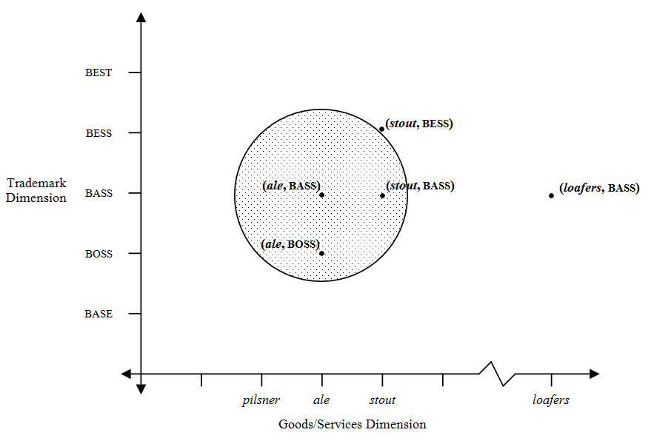
Distance in this features space is a measure of two concepts. First, distance is a measure of difference. The distance between any two points represents the degree of difference between them. Second, and related, distance is a measure of the likelihood of consumer confusion. The closer two points are in features space, the greater the proportion of consumers in the relevant consumer population who will likely confuse them.
As we have seen, in order to prevent consumer confusion as to source, trademark law invests a trademark-product combination with some broader scope of protection extending out from the point the combination forms in this features space. Otherwise, a competitor could come very near to that point, as in (stout, bass) or (ale, boss) in the above figure and, by confusing some proportion of consumers as to source, unfairly appropriate as to those consumers the goodwill of the bass ale brand. The closer a junior user’s trademark-product combination comes to the trademark-product combination of a senior user, the greater the proportion of consumers who will confuse the junior’s with the senior’s use. At some proximity to the senior’s use, trademark law declares that too high a proportion of consumers are or will be confused, and establishes a border, a property line, inside of which no competitor may come. This border, enveloping any given trademark, describes the scope of that trademark’s protection and the extent of the producer’s property right.
For exceptionally well-known marks, what might be the shape of the mark’s scope in this features space? Would it matter where the mark falls on the Abercrombie spectrum? What would be the shape of the scope of protection for coca-cola? Can any other firm reasonably use that mark on any other good or service? What would be the shape of the scope of ford for automobiles or apple for high technology goods and services?

3. Further Examples of the Application of the Multifactor Test for the Likelihood of Consumer Confusion Test
The application of the multifactor test for the likelihood of confusion is often highly fact-specific. String citations of cases finding confusion and other seemingly similar cases finding no confusion may give the impression that the test is unpredictable. See, e.g., Bank of Texas v. Commerce Southwest, Inc., 741 F.2d 785, 223 U.S.P.Q. 1174 (Fed. Cir. 1984) (bank of texas and banc texas found not confusing); Laurel Capital Group, Inc. v. BT Fin. Corp., 45 F. Supp. 2d 469 (W.D. Pa. 1999) (laurel savings bank and laurel bank found confusing); Popular Bank of Fla. v. Banco Popular de Puerto Rico, 9 F. Supp. 2d 1347 (S.D. Fla. 1998) (popular bank and banco popular found confusing); Wachovia Bank and Trust Co. v. Crown National Bancorp., 27 U.S.P.Q.2d 1698 (W.D.N.C. 1993) (wachovia crown account and crown account found not confusing). However, close attention to the facts of each case would show no significant inconsistencies in the courts’ rulings.
Adding to the difficulty is that there are no clear rules for when marks are too similar or not similar enough to trigger liability. Good trademark lawyers tend to build up over time a feel for what courts will likely find infringing in light of all the facts of the case. Provided below are brief summaries of a few more cases in which courts found or did not find confusion to try to impart to those new to trademark law some further sense of the diverse variety of considerations that can enter into a court’s application of the multifactor test.
1. In Hero Nutritionals LLC v. Nutraceutical Corp., No. 11 Civ. 1195, 2013 WL 4480674 (C.D. Cal. Aug. 16, 2013), the plaintiff produced nutritional supplements for children under the registered marks yummi and yummi bears. The defendant began to produce vitamin supplements labelled “Vitamin C-Rex Yummy Gummy.” The trade dresses of the competing products are shown below.

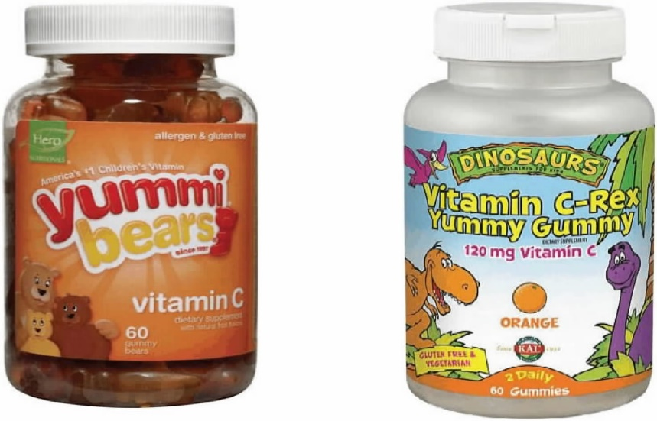
In finding no confusion after a bench trial, the court summarized its multifactor analysis:
The balance of the Sleekcraft factors does not demonstrate a likelihood of confusion between Hero’s marks and Nutraceutical’s use of “Yummy Gummy.” Hero’s marks are weak and entitled only to a narrow scope of protection. Although the words “Yummy” and “yummi” are similar, the overall impression of the marks, including the packaging, labeling, designs, and house marks, are dissimilar. Consumers of children’s vitamins at health food stores tend to be more careful and discriminating than the average shopper. Despite years of coexistence in the market, there was no showing of actual confusion, nor has Hero offered a survey to show actual confusion. Other than knowledge of the YUMMI BEARS mark, Hero has made no showing that Nutraceutical’s use of “Yummy Gummy” was done in bad faith with an intent to trade off of Hero’s good will. Although the products at issue are competitive and are generally sold in the same trade channel, these factors do not outweigh the other considerations leading to the ultimate conclusion that there is no likelihood of confusion.
Id. at *8.
2. In Spangler Candy Co. v. Tootsie Roll Indus., LLC, 2019 WL 1170749, 372 F. Supp. 3d 588 (N.D. Ohio 2019), the defendant Tootsie Roll developed a new, red trade dress for its Charms Mini Pops lollipops product, shown immediately below on the right. This new trade dress was suspiciously similar to the red trade dress of the plaintiff Spangler’s Dum Dums, which had been gaining market share, shown immediately below on the left. The defendant Tootsie Roll’s previous trade dress was yellow, shown below. The court found a likelihood of confusion and summarized its reasoning as follows:
The Dum Dums trade dress is not strong and there is no evidence of actual confusion. But the two companies used the same marketing channels to sell the same product. While the Charms Mini Pops trade dress is distinguishable when seen alone, Tootsie intends the product to be sold side-by-side on the shelf with Dum Dums, which would increase the likelihood of confusion due to the low degree of purchaser care. This intent along with other evidence also supports a conclusion that Tootsie acted with the intent to deceive. Therefore, considering all the factors, I find the evidence suggests the red Charms Mini Pops packaging is confusingly similar to the Dum Dums trade dress.
Id. at *12.
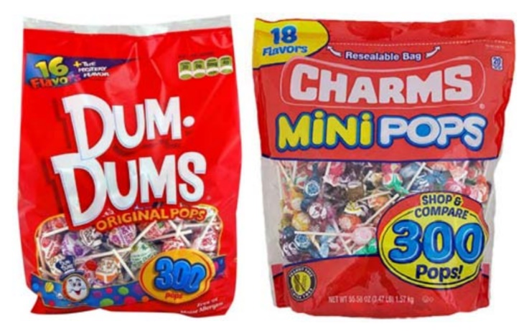
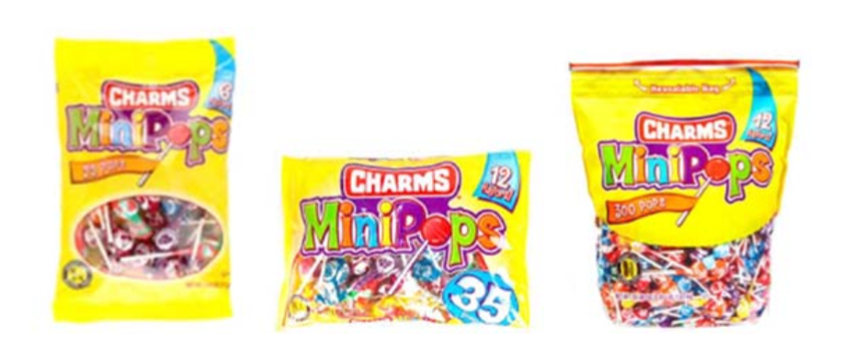
3. In Eli Lilly & Co. v. Nat. Answers, Inc., 86 F. Supp. 2d 834 (S.D. Ind.), aff’d, 233 F.3d 456 (7th Cir. 2000), the plaintiff produced an antidepressant under the registered mark prozac. The defendant produced an herbal drug under the name herbrozac that it claimed promoted “mood elevation.” In finding a likelihood of confusion and granting the plaintiff’s motion for a preliminary injunction, the district court summarized its multifactor analysis:
Considering all the factors as set forth above, the court concludes that Lilly has shown an unusually strong case on the issue of likelihood of confusion. Most important here are the unusual strength of Lilly’s PROZAC® mark, the strong similarity between PROZAC® and HERBROZAC, and defendant’s intentional selection of the HERBROZAC name precisely because of its similarity to PROZAC® for the purpose of suggesting an association or affiliation between the products. Add to this mixture the fairly close “competitive proximity” of the two products, especially as pharmaceutical companies expand into the herbal and dietary supplement business, and Lilly has made a powerful showing of likelihood of success on its claim for trademark infringement.
Id. at 846.
4. In Kate Spade LLC v. Saturdays Surf LLC, 950 F. Supp. 2d 639 (S.D.N.Y. 2013), the plaintiff produced primarily men’s apparel under the mark saturdays surf nyc. The defendant launched a line of women’s apparel under the mark kate spade saturday. Examples of the parties’ respective uses of their marks are shown below.
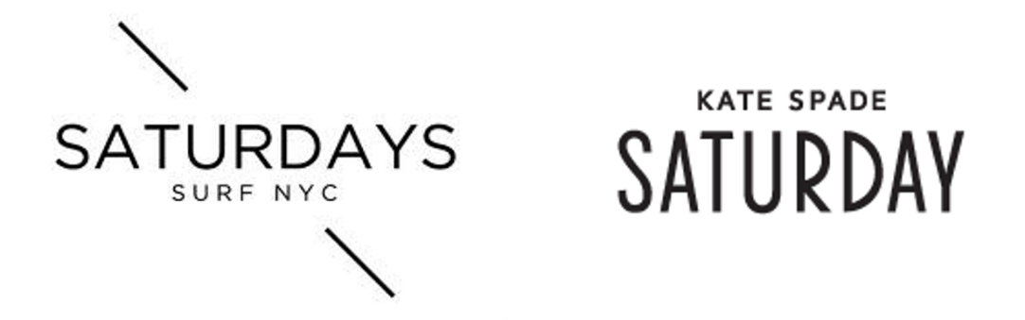
In finding no likelihood of confusion after a bench trial, the court summarized its multifactor analysis:
After considering and weighing each of the Polaroid factors, I conclude that Saturdays Surf NYC has not shown a likelihood of confusion by a preponderance of the credible evidence. I am particularly persuaded by the relative weakness of the word that the two marks share, the significant distance between the men’s and women’s products, and the consistent inclusion of the famous house mark, Kate Spade, in its Kate Spade Saturday mark.
Id. at 648
5. In the relatively straightforward case of Nikon, Inc. v. Ikon Corp., 987 F.2d 91 (2d Cir. 1993), the plaintiff was a world-famous producer of high-quality cameras under the mark nikon. The defendant was a lesser known seller of low-cost cameras under the mark ikon. The court found confusion: “Applying the facts found by the court, each factor, with the exception of actual confusion, weighs heavily in favor of Nikon. And there was some evidence of actual confusion.” Id. at 96.
6. In Alliance for Good Gov’t v. Coalition for Better Gov’t, 901 F.3d 498 (5th Cir. 2018), the plaintiff had been using the mark below on the left since the 1960s to promote political candidates in Louisiana. The defendant organization subsequently developed its own logo, below on the right, in the early 1980s or 1990s to promote political candidates in New Orleans. The district court found a likelihood of confusion and the Fifth Circuit affirmed.

Of special interest is the Fifth Circuit’s analysis of the similarity of the marks, and in particular its reference to the defendant’s attorney’s ignoble attempt (basically a failed con) to distinguish the marks:
Finally, we observe that Coalition attempted to distinguish the two logos—not by appearance, design, color, or font—but by the birds’ species:
DISTRICT COURT: They look exactly alike to me, the two birds.
COUNSEL: [. . .] [N]o, they really aren’t, your Honor, if you look at the wing span. The wing span of the eagle is different from the hawk. It’s much larger and it fans out, and that’s just the way the hawk looks.
COURT: I’ll tell you, unless my eyes are deceiving me, . . . those two look exactly alike. They even look like the same feathers, same number of feathers, same arrangement, head is facing the same way, the same beak. I don’t know if you call them—I don’t know technically what kind of bird it is, but whatever they are, they look exactly alike to me.
COUNSEL: Well, they’re both birds of prey; one is an eagle and one is a hawk.
COURT: Okay.
COUNSEL: And when we filed with the Secretary of State to get our font, we said it was a hawk. We were represented by a hawk, not an eagle.
We agree with the district court: the birds are identical. Whether that bird is a haliaeetus leucocephalus (bald eagle), a buteo jamaicensis (red-tailed hawk), or some other bird, we need not determine.
Id. at 511–12. The plaintiff was subsequently awarded attorney’s fees in the dispute. See Alliance for Good Gov’t v. Coalition for Better Gov’t, 919 F.3d 291 (5th Cir. 2019).

4. Survey Evidence and the Likelihood of Confusion
It is often said that survey evidence is routinely submitted in trademark litigation, particularly on the issue of consumer confusion. In a statement before Congress, the American Bar Association offered a typical expression of this view: “survey evidence is traditionally one of the most classic and most persuasive and most informative forms of trial evidence that trademark lawyers utilize in both prosecuting and defending against trademark claims of various sorts.” Committee Print to Amend the Federal Trademark Dilution Act: Hearing Before the Subcomm. on Courts, the Internet, and Intellectual Property of the Comm. on the Judiciary, 108th Cong. 14 (2004) (statement of Robert W. Sacoff, Chair, Section of Intellectual Property Law, American Bar Association). In fact, empirical work suggests that survey evidence plays a surprisingly small role in deciding most trademark cases. See Barton Beebe, An Empirical Study of the Multifactor Tests for Trademark Infringement, 94 Calif. L. Rev. 1581, 1641-42 (2006). The author studied all federal court opinions applying a likelihood of confusion multifactor test over a five-year period from 2000 through 2004 and found that only 65 (20%) of the 331 opinions addressed survey evidence, 34 (10%) credited the survey evidence, and 24 (7%) ultimately ruled in favor of the outcome that the credited survey evidence itself favored. Eleven (24%) of the 46 bench trial opinions addressed survey evidence (with eight crediting it), while 24 (16%) of the 146 preliminary injunction opinions addressed survey evidence (with 12 crediting it). Id. See also Robert C. Bird & Joel H. Steckel, The Role of Consumer Surveys in Trademark Infringement: Empirical Evidence from the Federal Courts, 14 Penn. J. Bus. L. 1013 (2012) (finding that survey evidence is infrequently used in trademark litigation and suggesting that “the mere submission of a survey by a defendant appears to help its case, while a plaintiff-submitted survey can potentially hurt its case if the court deems it flawed”). But see Dan Sarel & Howard Marmorstein, The Effect of Consumer Surveys and Actual Confusion Evidence in Trademark Litigation: An Empirical Assessment, 99 Trademark Rep. 1416 (2009) (finding survey evidence presented in one-third of the opinions studied and that survey evidence had a substantial impact in cases involving dissimilar goods). Cf. Shari Seidman Diamond & David Franklyn, Trademark Surveys: An Undulating Path, 92 Texas L. Rev. 2029 (2014) (concluding based on a survey of trademark practitioners that surveys can perform a significant role in settlement negotiations).
Nevertheless, in the small subset of trademark cases involving high-stakes litigation or one or more well-funded parties, survey evidence is customary, so much so that courts will sometimes draw an “adverse inference” against a party for failing to present it. See, e.g., Eagle Snacks, Inc. v. Nabisco Brands, Inc., 625 F. Supp. 571, 583 (D.N.J. 1985) (“Failure of a trademark owner to run a survey to support its claims of brand significance and/or likelihood of confusion, where it has the financial means of doing so, may give rise to the inference that the contents of the survey would be unfavorable, and may result in the court denying relief.”); but see, e.g., Tools USA and Equipment Co. v. Champ Frame Straightening Equipment Inc., 87 F.3d 654, 661 (4th Cir. 1996) (“Actual confusion can be demonstrated by survey evidence, but contrary to [defendant’s] suggestion, survey evidence is not necessarily the best evidence of actual confusion and surveys are not required to prove likelihood of confusion.”).
When litigants do present survey evidence, courts’ analysis of this evidence can be painstaking, especially when the litigants present dueling survey experts. In the following opinion, Smith v. Wal-Mart Stores, Inc., 537 F.Supp.2d 1302 (N.D.Ga. 2008), the declaratory plaintiff Charles Smith sought to criticize Wal-Mart’s effect on American communities and workers by likening the retailer to the Nazi regime and, after Wal-Mart sent Smith two cease and desist letters, to Al Qaeda. Smith created and sold online through CafePress.com t-shirts and other merchandise incorporating the term “Walocaust” and various Nazi insignia (shown below) or the term “Wal-Qaeda” and various slogans and images (shown below). Wal-Mart produced survey evidence to support the proposition that American consumers would believe that Wal-Mart was selling the t-shirts or had otherwise authorized their sale, or that in any case, Smith’s conduct tarnished Wal-Mart’s trademark. Both parties moved for summary judgment. Excerpted below is Judge Timothy Batten, Sr.’s extraordinarily fine analysis of the surveys before him, which he conducted under the “actual confusion” factor of the multifactor test for the likelihood of consumer confusion. The analysis is lengthy and very detailed, but it addresses a variety of survey-related issues with which a serious student of trademark litigation should be familiar. (For another exemplary judicial analysis of survey evidence, see Snap Inc. v. Vidal, 750 F. Supp. 3d 1120 (C.D. Cal. 2024) (Magistrate Judge Steve Kim)).
A few additional preliminary comments. First, the surveys at issue in Smith v. Wal-Mart are modified forms of the “Eveready format” for likelihood of confusion surveys, based on the case Union Carbide Corp. v. Ever-Ready, Inc., 531 F.2d 366 (7th Cir. 1976), in which the Seventh Circuit credited two surveys as strong evidence of the likelihood of confusion. (Despite the spelling of “Ever-Ready” in the caption of the case, most commentators, including McCarthy, refer to the survey format as the “Eveready format.”) Second, the excerpt below addresses, in addition to the likelihood of confusion issue, a cause of action for dilution by tarnishment of Wal-Mart’s mark.
In reading through the excerpt, consider the following question:
- Do you find the Eveready format persuasive? How else might you design a likelihood of confusion survey?
- The “third set of questions” in the surveys, “aimed at testing for confusion as to authorization or sponsorship, asked whether the company that ‘put out’ the shirt needed permission from another company to do so, and if so, which company.” Is this an appropriate survey question to ask consumers?

[The opinion in Smith v. Wal-Mart Stores, Inc. is available separately.]

Questions and Comments
1. The authorization or permission question. You will recall that the third group of questions in the surveys at issue in Smith v. Wal-Mart asked respondents if they thought the company that “put out” the defendant’s products needed permission from another company to do so, and if so, which company. Isn’t this the very question that the judge is trying to decide in the case? Why should we ask survey respondents for their view on what is in essence a legal question?
2. Confusion by whom? What is the appropriate consumer population to survey, the defendant’s and/or the plaintiff’s? McCarthy sets forth the conventional wisdom: “In a traditional case claiming ‘forward’ confusion, not ‘reverse’ confusion, the proper universe to survey is composed of the potential buyers of the junior user’s goods or services. However, in a ‘reverse confusion’ case, the relevant group to be surveyed is the senior user’s customer base.” McCarthy, at § 32:159 (citations omitted).
3. Alternative survey formats. Two other methods of surveying for the likelihood of consumer confusion are of particular interest.
- The “Squirt format”. In Squirt Co. v. Seven-Up Co., 628 F.2d 1086 (8th Cir. 1980), survey respondents were played radio advertisements for squirt and quirst soft drinks and two other products. The respondents were then asked: (1) “Do you think squirt and quirst are put out by the same company or by different companies?”, and (2) “What makes you think that?” This method, consisting of either seriatim or simultaneous exposure to the plaintiff’s and defendant’s marks, is especially beneficial for a plaintiff whose mark may not be well-known to the survey respondents. However, some courts have rejected this survey method on the ground that it makes the respondents “artificially aware” of the plaintiff’s mark and does not approximate market conditions. See, e.g., Kargo Global, Inc. v. Advance Magazine Publishers, Inc., No. 06 Civ. 550, 2007 WL 2258688, at *8 (S.D. N.Y. 2007).
- The “Exxon format”. In Exxon Corp. v. Texas Motor Exchange of Houston, Inc., 628 F2d 500 (5th Cir. 1980), survey respondents were shown a photograph of one of the defendant’s signs bearing its texon trademark. The respondents were then asked: “What is the first thing that comes to mind when looking at this sign?”, and “What was there about the sign that made you say that?” If the respondents did not name a company in response to the first set of questions, they were then asked: “What is the first company that comes to mind when you look at this sign?” (emphasis in original survey script) and “What was there about the sign that made you mention (COMPANY)?” Courts have proven to be less receptive to this “word association” method of surveying for consumer confusion. See, e.g., Major League Baseball Properties v. Sed Non Olet Denarius, Ltd., 817 F. Supp. 1103, 1122 (S.D.N.Y. 1993) (“[T]he issue here is not whether defendants’ name brings to mind any other name . . . . Rather, the issue here is one of actual confusion. Plaintiff’s survey questions regarding association are irrelevant to the issue of actual confusion.”).
In Itamar Simonson, The Effect of Survey Method on Likelihood of Confusion Estimates: Conceptual Analyses and Empirical Test, 83 Trademark Rep. 364 (1993), Simonson compared the results of five methods of surveying for the likelihood of confusion, including a simple form of the Eveready format, the Squirt format, and the Exxon format. He found that the Exxon format “tends to overestimate the likelihood of confusion, often by a significant amount,” id. at 385, and that the Squirt format, as expected, “can have a significant effect on confusion estimates when the awareness level of the senior mark is low.” Id. at 386.
4. What percentage of confusion is enough? “Figures in the range of 25% to 50% have been viewed as solid support for a finding of a likelihood of confusion.” McCarthy § 32:188. Still often cited by plaintiffs with especially weak cases, Jockey International, Inc. v. Burkard, No 74 Civ. 123, 1975 WL 21128 (S.D. Cal. 1975), found that survey evidence of 11.4 percent supported a likelihood of confusion. But see Georgia-Pacific Consumer Product LP v. Myers Supply, Inc., No. 08 Civ. 6086, 2009 WL 2192721 (W.D. Ark. 2009) (survey evidence of 11.4 percent confusion does not support a likelihood of confusion).
5. Outside of the world of trademark law, should survey evidence be used to interpret contractual terms? See Omri Ben-Shahar & Lior Jacob Strahilevitz, Interpreting Contracts via Surveys and Experiments, 92 NYU L. Rev. 1753 (2017) (proposing and testing a “survey interpretation method” of contractual interpretation in which “interpretation disputes are resolved through large surveys of representative respondents, by choosing the meaning that a majority supports”).

Lanham Act § 2(d) Confusion
Recall that a registration application at the PTO may be rejected on the basis that the applied-for mark will create a likelihood of confusion with an already registered mark. The PTO’s test for determining whether Lanham Act § 2(d) bars a registration is essentially the same as the multifactor test for the likelihood of confusion in the federal court litigation context. See B&B Hardware, Inc. v. Hargis Industries, Inc., 135 S.Ct. 1293 (2015). Excerpted below is the discussion of the § 2(d) bar in the Trademark Manual of Examining Procedure.

TMEP § 1207.01 Likelihood of Confusion
[1] In the ex parte examination of a trademark application, a refusal under § 2(d) is normally based on the examining attorney’s conclusion that the applicant’s mark, as used on or in connection with the specified goods or services, so resembles a registered mark as to be likely to cause confusion. See TMEP § 1207.02 concerning application of the § 2(d) provision relating to marks that so resemble another mark as to be likely to deceive, and TMEP § 1207.03 concerning § 2(d) refusals based on unregistered marks (which generally are not issued in ex parte examination).
[2] The examining attorney must conduct a search of USPTO records to determine whether the applicant’s mark so resembles any registered mark(s) as to be likely to cause confusion or mistake, when used on or in connection with the goods or services identified in the application. The examining attorney also searches pending applications for conflicting marks with earlier effective filing dates . . . . The examining attorney must place a copy of the search strategy in the record.
[3] If the examining attorney determines that there is a likelihood of confusion between applicant’s mark and a previously registered mark or marks, the examining attorney refuses registration of the applicant’s mark under § 2(d). Before citing a registration, the examining attorney must check the automated records of the USPTO to confirm that any registration that is the basis for a § 2(d) refusal is an active registration . . . .
[4] In the seminal case involving § 2(d), In re E. I. du Pont de Nemours & Co., the U.S. Court of Customs and Patent Appeals discussed the factors relevant to a determination of likelihood of confusion. 476 F.2d 1357, 177 USPQ 563 (C.C.P.A. 1973) . . . .
[5] Although the weight given to the relevant du Pont factors may vary, the following two factors are key considerations in any likelihood of confusion determination:
- The similarity or dissimilarity of the marks in their entireties as to appearance, sound, connotation and commercial impression.
- The relatedness of the goods or services as described in the application and registration(s).
See, e.g., Federated Foods, Inc. v. Fort Howard Paper Co., 544 F.2d 1098, 1103, 192 USPQ 24, 29 (C.C.P.A. 1976); In re Iolo Techs., LLC, 95 USPQ2d 1498, 1499 (TTAB 2010); In re Max Capital Grp. Ltd., 93 USPQ2d 1243, 1244 (TTAB 2010); In re Thor Tech, Inc., 90 USPQ2d 1634, 1635 (TTAB 2009).
[6] The following factors may also be relevant in an ex parte likelihood-of-confusion determination and must be considered if there is pertinent evidence in the record:
- The similarity or dissimilarity of established, likely-to-continue trade channels.
- The conditions under which and buyers to whom sales are made, i.e., “impulse” vs. careful, sophisticated purchasing (see TMEP § 1207.01(d)(vii)).
- The number and nature of similar marks in use on similar goods (see TMEP § 1207.01(d)(iii)).
- The existence of a valid consent agreement between the applicant and the owner of the previously registered mark (see TMEP § 1207.01(d)(viii)).
See, e.g., du Pont, 476 F.2d at 1362-63, 177 USPQ at 568-69; In re Davey Prods. Pty Ltd., 92 USPQ2d 1198, 1203-04 (TTAB 2009); In re Toshiba Med. Sys. Corp., 91 USPQ2d 1266, 1272-74 (TTAB 2009); Ass’n of the U.S. Army, 85 USPQ2d at 1271-73.
[7] As should be clear from the foregoing, there is no mechanical test for determining likelihood of confusion and “each case must be decided on its own facts.” Du Pont, 476 F.2d at 1361, 177 USPQ at 567. In some cases, a determination that there is no likelihood of confusion may be appropriate, even where the marks are similar and the goods/services are related, because these factors are outweighed by other factors, such as differences in the relevant trade channels of the goods/services, the presence in the marketplace of a significant number of similar marks in use on similar goods/services, the existence of a valid consent agreement between the parties, or another established fact probative of the effect of use. For example, in In re Strategic Partners, Inc., 102 USPQ2d 1397 (TTAB 2012), the Board reversed a refusal to register the mark ANYWEAR (in stylized text), for “footwear,” finding no likelihood of confusion with the registered mark ANYWEAR BY JOSIE NATORI (and design), for “jackets, shirts, pants, stretch T-tops and stoles.” Given the similarity in the marks and the relatedness of the goods, the Board stated that “under usual circumstances” it would conclude that confusion is likely to occur; however, an “unusual situation” compelled the Board “to balance the similarities between the marks and goods against the facts that applicant already owns a registration for a substantially similar mark for the identical goods, and that applicant’s registration and the cited registration have coexisted for over five years.” Id. at 1399. Applicant’s prior registration of ANYWEARS for goods including footwear was substantially similar to the applied-for mark ANYWEAR for the same goods, and the registration had achieved incontestable status. Id. Basing its decision on the thirteenth du Pont factor, which “relates to ‘any other established fact probative of the effect of use,’” the Board determined that this factor outweighed the others and confusion was unlikely. Id. at 1399-1400 (quoting du Pont, 476 F.2d at 1361, 177 USPQ at 567).
[8] The decision in Strategic Partners may be applied and weighed against a § 2(d) refusal in the limited situation where: (1) an applicant owns a prior registration for the same mark or a mark with no meaningful difference from the applied-for-mark; (2) the identifications of goods/services in the application and applicant’s prior registration are identical or identical in relevant part; and (3) the applicant’s prior registration has co-existed for at least five years with the registration being considered as the basis for the Section 2(d) refusal. See Id. at 1400.
[9] The determination of likelihood of confusion under § 2(d) in an intent-to-use application under § 1(b) of the Trademark Act does not differ from the determination in any other type of application.
TMEP § 1207.03 Marks Previously Used in United States but Not Registered
As a basis for refusal, § 2(d) refers not only to registered marks but also to “a mark or trade name previously used in the United States by another and not abandoned.” Refusal on the basis of an unregistered mark or trade name has sometimes been referred to as refusal on the basis of a “known mark.” This provision is not applied in ex parte examination because of the practical difficulties with which an examining attorney is faced in locating “previously used” marks, and determining whether anyone has rights in them and whether they are “not abandoned.”
Comments and Questions
1. Lanham Act § 2(d) and unregistered marks. Note that § 2(d) not only prohibits the registration of a mark that is confusingly similar with any previously registered mark, but also prohibits the registration of a mark that is confusingly similar with an unregistered “mark or tradename previously used in the United States by another and not abandoned.” Lanham Act § 2(d), 15 U.S.C. § 1052 (d). In practice, “[t]his provision is not applied in ex parte examination because of the practical difficulties with which an examining attorney is faced in locating ‘previously used’ marks, and determining whether anyone has rights in them and whether they are ‘not abandoned.’” TMEP § 1207.03 (Jan. 2015).

