An Open-Access Casebook

Version 12 (2025)
Digital Edition
www.tmcasebook.org

Barton Beebe
John M. Desmarais Professor of Intellectual Property Law
New York University School of Law

This work is licensed under a Creative Commons Attribution-NonCommercial-
ShareAlike 4.0 International License.

Reverse Confusion
Consider a quick example of a claim of “reverse confusion.” In Dreamwerks Production, Inc. v. SKG Studio, 142 F.3d 1127 (9th Cir. 1998), the plaintiff had been using the mark dreamwerks since 1984 in connection with services for organizing science fiction conventions in the Northeast and Midwest of the U.S. In 1994, Steven Spielberg, Jeffrey Katzenberg and David Geffen established the massive Hollywood studio known as DreamWorks SKG. The plaintiff sued for “reverse confusion.” It argued that consumers would now believe that the plaintiff’s services somehow originated in the defendant. In the Dreamwerks case, the Ninth Circuit reversed the district court’s summary judgment in favor of the defendant and held that the matter should go to trial. The court observed: “Dreamwerks notes that whatever goodwill it has built now rests in the hands of DreamWorks; if the latter should take a major misstep and tarnish its reputation with the public, Dreamwerks too would be pulled down.” Id. at 1130. The case eventually settled.
In many typical “forward confusion” cases, such as in the Virgin Wireless case above, the senior user of the mark is a much larger company than the junior user of the mark. Thus, the senior Goliath claims that the junior David’s use of the mark will likely confuse consumers into believing that the junior’s goods are coming from the senior user, the company with which consumers are much more familiar.
By contrast, reverse confusion typically involves a situation in which the senior user of the mark is a small company and the junior user is an enormous company with the resources to extensively advertise its use of the mark. The risk is that the meaning of the senior David’s mark will be overwhelmed by the junior Goliath, so that consumers will believe that the senior users goods are coming from the junior user. This was exactly the claim the plaintiff made in the following opinion, Wreal, LLC v. Amazon.com, Inc.
Note, importantly, how certain of the factors in the multifactor test for the likelihood of consumer confusion change in a reverse confusion analysis. (And incidentally, do you agree with the court’s treatment of the plaintiff’s evidence of actual confusion?)

[The opinion in Wreal, LLC v. Amazon.com, Inc. is available separately.]

Comments and Questions
1. Did Wreal ever go before a jury? As expected, after the Eleventh Circuit decision, the parties settled on confidential terms. John Woolley, Amazon Settles With Porn Company In ‘Fire TV’ Trademark Lawsuit, Bloomberg Law, Aug. 16, 2023.
2. Trademark strength and reverse confusion. In A & H Sportswear, Inc. v. Victoria’s Secret Stores, Inc., 237 F.3d 198, 231-32 (3d Cir. 2000), the Third Circuit discussed the relation between commercial and conceptual strength in the context of a reverse confusion claim. This discussion is excerpted below. Is the court’s reasoning persuasive?
a. Commercial Strength
Where the greater advertising originates from the senior user, we are more likely to see a case of direct confusion; if the greater advertising originates from the junior user, reverse confusion is more likely . . . .
Logically, then, in a direct confusion claim, a plaintiff with a commercially strong mark is more likely to prevail than a plaintiff with a commercially weak mark. Conversely, in a reverse confusion claim, a plaintiff with a commercially weak mark is more likely to prevail than a plaintiff with a stronger mark, and this is particularly true when the plaintiff’s weaker mark is pitted against a defendant with a far stronger mark . . . . “[T]he lack of commercial strength of the smaller senior user’s mark is to be given less weight in the analysis because it is the strength of the larger, junior user’s mark which results in reverse confusion.” Commerce Nat’l Ins. Servs., Inc. v. Commerce Ins. Agency, Inc., 214 F.3d 432, 444 (3d Cir. 2000) . . . .
Therefore, in a reverse confusion claim, a court should analyze the “commercial strength” factor in terms of (1) the commercial strength of the junior user as compared to the senior user; and (2) any advertising or marketing campaign by the junior user that has resulted in a saturation in the public awareness of the junior user’s mark.
b. Distinctiveness or Conceptual Strength
. . . .
As stated above, in the paradigmatic reverse confusion case, the senior user has a commercially weak mark when compared with the junior user’s commercially strong mark. When it comes to conceptual strength, however, we believe that, just as in direct confusion cases, a strong mark should weigh in favor of a senior user . . . .
In H. Lubovsky, Inc. v. Esprit de Corp., 627 F.Supp. 483 (S.D.N.Y. 1986), the court explained that conceptual distinctiveness was relevant in the same way for a reverse confusion claim because “if a customer saw a doll in a toy store bearing a strong familiar trademark like ‘Exxon,’ he might well assume that the oil company had gone into the toy business; if, on the other hand, he saw a doll bearing a familiar but weak laudatory trademark like Merit, he would be unlikely to assume that it is connected with the similarly named gasoline or cigarettes.” Id. at 487; see also Long & Marks, supra, at 22.
The H. Lubovsky logic resonates, for it makes more sense to hold that conceptual strength, unlike commercial strength, works in the plaintiff’s favor. That is, if we were to apply the rule stated above for commercial strength, i.e., weighing weakness in the plaintiff’s favor, we would bring about the perverse result that less imaginative marks would be more likely to win reverse confusion claims than arbitrary or fanciful ones. We therefore hold that, as in direct confusion claims, a district court should weigh a conceptually strong mark in the plaintiff’s favor, particularly when the mark is of such a distinctive character that, coupled with the relative similarity of the plaintiff’s and defendant’s marks, a consumer viewing the plaintiff’s product is likely to assume that such a mark would only have been adopted by a single source—i.e., the defendant.
3. Other Examples of Reverse Confusion Found. See, e.g., Fleet Feet, Inc. v. Nike Inc., 419 F.Supp.3d 919 (M.D.N.C. 2019), appeal dismissed and remanded, 986 F.3d 458 (4th Cir. 2021), and vacated, No. 19 Civ. 885, 2021 WL 4067544 (M.D.N.C. Apr. 6, 2021) (finding that defendant’s use of the phrase “Sport Changes Everything” would cause reverse confusion with plaintiff, seller of running and fitness merchandise, in light of plaintiff’s prior use of the phrases “Change Everything” and “Running Changes Everything”); H. Lubovsky, Inc. v. Esprit De Corp., 627 F. Supp. 483, 228 U.S.P.Q. (BNA) 814 (S.D.N.Y. 1986) (defendant’s extension of esprit brand to women’s shoes created reverse confusion with plaintiff’s prior use of same mark for same products); Tanel Corp. v. Reebok Intern., Ltd., 774 F. Supp. 49 (D. Mass. 1990) (defendant’s junior use of 360 degrees for shoes created reverse confusion with small company’s senior use of same mark for same products).
4. Examples of Reverse Confusion Not Found. See, e.g, Surfvivor Media, Inc. v. Survivor Productions, 406 F.3d 625 (9th Cir. 2005) (survivor television show did not create reverse confusion with surfvivor for beach-themed products); Harlem Wizards Entertainment Basketball, Inc. v. NBA Properties, Inc., 952 F. Supp. 1084 (D.N.J. 1997) (NBA team’s adoption of name washington wizards would not create reverse confusion with harlem wizards trick basketball team); Pump, Inc. v. Collins Management, Inc., 746 F. Supp. 1159 (D. Mass. 1990) (Rock band Aerosmith’s album entitled “Pump” did not create confusion with little-known rock band by same name where visual displays of marks and contexts in which they were used were different); Lobo Enterprises, Inc. v. Tunnel, Inc., 693 F. Supp. 71 (S.D.N.Y. 1988) (large nightclub tunnel did not create reverse confusion with small gay bar tunnel bar where clienteles of club and bar were sufficiently different to preclude reverse confusion); Andy Warhol Enterprises, Inc. v. Time Inc., 700 F. Supp. 760 (S.D.N.Y. 1988) (People Magazine’s use of “Interview” as the descriptive heading of its interview section did not create reverse confusion with magazine of same name where consumers would not believe that defendant published plaintiff’s magazine).

Reverse Passing Off
“Reverse passing off” generally involves situations in which a “defendant falsely takes credit for another’s goods or services,” McCarthy § 25.6. More specifically, reverse passing off occurs when the defendant unauthorizedly passes off as its own product (or service) what was in fact made (or performed) by the plaintiff, perhaps to gain the goodwill that the plaintiff’s product might generate for the defendant, perhaps to charge a higher price to unsuspecting consumers, or perhaps simply to meet a production deadline. For example, a defendant who unauthorizedly rebottles (or simply relabels) a plaintiff’s shampoo under a new brand name could be liable for reverse passing off. Who does this sort of thing? See, for a recent example, DJ Direct, Inc. v. Margaliot, 512 F. Supp. 3d 396 (E.D.N.Y. 2021), in which the defendant hot glued a metallic “Amasing” label directly over the plaintiff’s KaraoKing mark on karaoke machines and then listed those rebranded machines on Amazon:
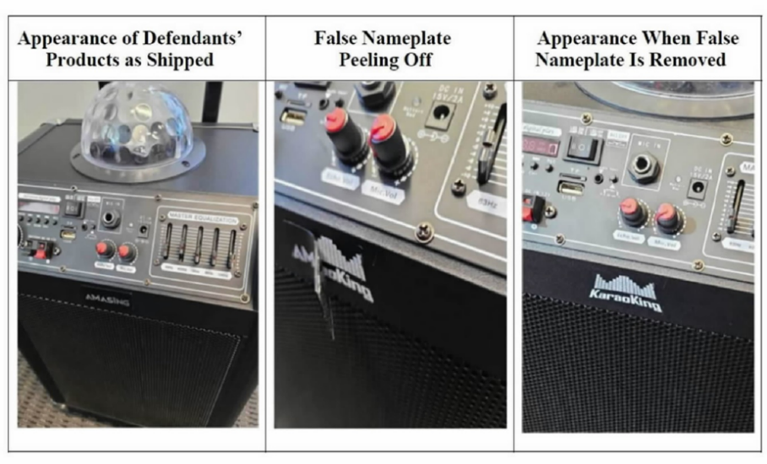
The court found reverse passing off and granted the plaintiff’s motion for a preliminary injunction. Id. at 414–417. Cf. id. at 415 (“Although, as Defendants argue, Plaintiff’s supplier manufactured the tangible goods offered for sale in this case, the fact that Plaintiff ordered the machines in question to be built to its specifications and to bear the KaraoKing mark, and that it provided customer service and support through its website, www.karaoking.net, supports the conclusion that Plaintiff commissioned the machines and stood behind their production.”). For another example, see Industria de Diseo Textil SA. v. Thiliko LLC, No. 23 Civ. 47 (S.D.N.Y.) (complaint filed Jan. 4, 2023), in which the global fast-fashion retailer Zara sued the defendant Thilikó for, among other things, purchasing Zara’s goods, replacing all Zara labelling with defendant’s own labelling, and reselling those goods as its own (at significantly higher prices). The defendant also used on its webpage Zara’s copyrighted images, as shown below. The court eventually issued a default judgment against the defendant.
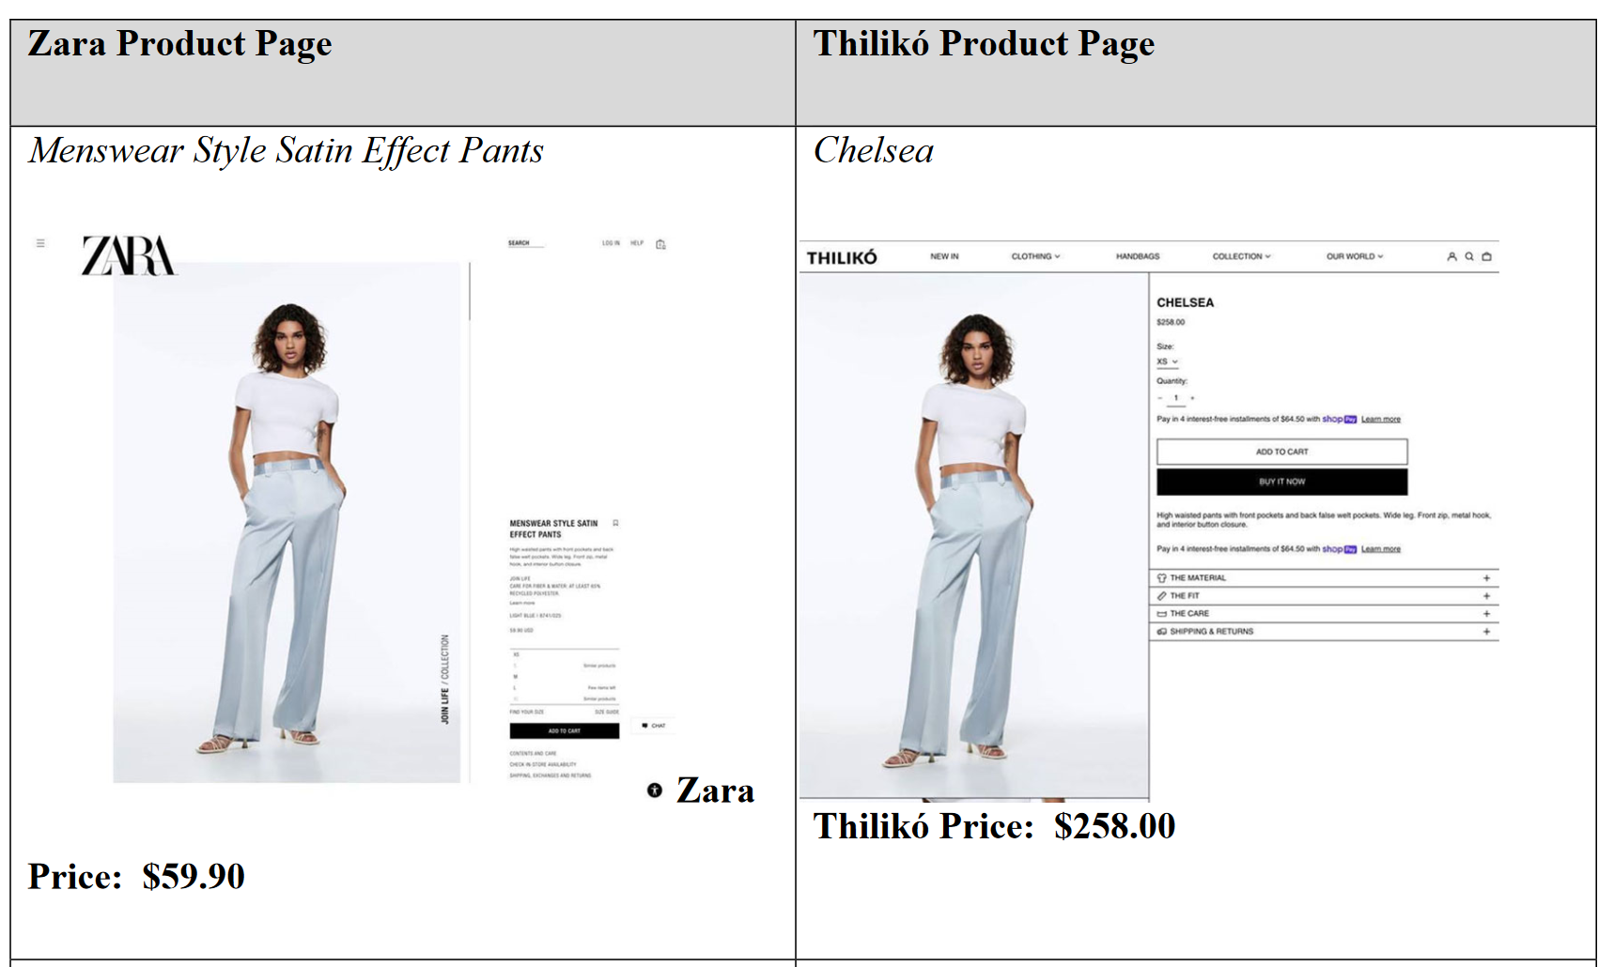
Reverse passing off is a very rare cause of action, even more so after the case below, Dastar Corp. v. Twentieth Century Fox Film Corp., 539 U.S. 23 (2003). We consider reverse passing off and the Dastar case because of the profound policy questions implicated by the cause of action and the facts of the Dastar case. It is one thing to provide a reverse passing off cause of action when someone unauthorizedly rebottles or relabels someone else’s shampoo without attribution, but what about when someone unauthorizedly restates someone else’s ideas or expression without attribution? Should trademark law and specifically the concept of “reverse passing off” provide a cause of action for plagiarism? If not, why should we treat ideas and expression differently?
Consider a related problem. One advantage that trademark protection enjoys over copyright or patent protection is that trademark protection is unlimited in time, provided that the trademark owner continue to use the mark in commerce. Thus, when patent or copyright protection of a product feature expires, the patent or copyright owner may continue to exert control over that feature through trademark law (if the feature satisfies the various requirements of trademark protection). This raises significant concerns. For example, Disney owns the Mickey Mouse image mark, whose registration is shown below:
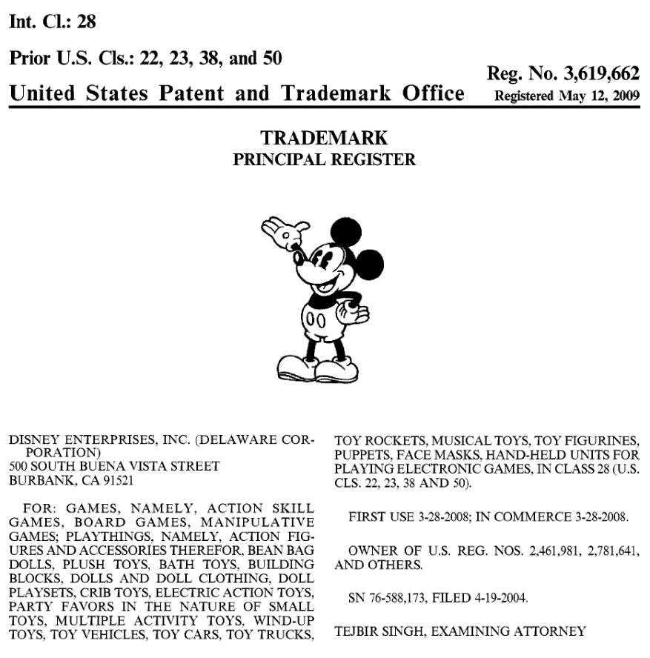
At some point, Disney’s copyright rights in the countless cartoons in which Mickey Mouse is depicted will begin to expire. See Brooks Barnes, Mickey’s Copyright Adventure: Early Disney Creation Will Soon Be Public Property, N.Y. Times, Dec. 27, 2022 (discussing the legal aspects of the expiration beginning in 2024 of Disney’s copyright rights in Steamboat Willie and subsequent incarnations of Mickey Mouse). But can Disney then use its trademark rights in the image of the character to prevent others from reproducing these cartoons? With copyright law, the public agrees to grant short-term exclusive rights to the author of a work in order to incentivize authorship, but an exceedingly important part of that bargain is that these rights will eventually expire and the work will be dedicated to the public domain, free for anyone to use in any way. Should trademark rights be allowed to trump this basic bargain? For an analysis of this question with respect to the Disney-owned intellectual property Winnie the Pooh, the earliest publications of which have already begun to join the public domain, see Jennifer Jenkins, This Bear’s For You! (Or, Is It?): Can Companies Use Copyright and Trademark To Claim Rights to Public Domain Works?, Duke Center for the Study of the Public Domain, Jan. 1, 2022, https://web.law.duke.edu/cspd/publicdomainday/ 2022/bcvpd/#fn6ref (https://perma.cc/W48P-3UK2).
As you read through the Dastar opinion, consider whether it resolves the question of whether Disney may continue to assert exclusive rights through trademark law after its copyright rights have expired.

[The opinion in Dastar Corp. v. Twentieth Century Fox Film Corp. is available separately.]

Comments and Questions
1. Dastar on remand. On remand back to the Central District of California, the district court dismissed with prejudice Twentieth Century Fox’s § 43(a) and state law unfair competition claims, and with that the litigation apparently ended. See Twentieth Century Fox Film Corp. v. Dastar Corp., No. 98 Civ. 07189, 2003 WL 22669587 (C.D. Cal. Oct. 14, 2003).


2. Dastar and the reverse passing off of “any idea, concept, or communication”. In the wake of Dastar, courts have uniformly held that the “origin of goods” provision of Lanham Act § 43(a) cannot prevent the unattributed use of someone else’s ideas or expression. Consider, for example, LaPine v. Seinfeld, 92 U.S.P.Q.2d 1428, 2009 WL 2902584 (S.D.N.Y. 2009), judgment aff’d, 375 Fed. Appx. 81, 96 U.S.P.Q.2d 1130 (2d Cir. 2010). The plaintiff Missy Chase Lapine, a trained chef, wrote a cook book entitled The Sneaky Chef: Simple Strategies for Hiding Healthy Food in Kids’ Favorite Meals, which was published in April 2007 to mild success. The defendant Jessica Seinfeld, wife of Jerry Seinfeld, subsequently authored—or was credited as the author of—the book Deceptively Delicious: Simple Secrets to Get Your Kids Eating Good Food, which was published in October 2007 and reached number one on the New York Times bestseller list.

Lapine sued for, among other things, copyright infringement and reverse passing off. The court found no copyright infringement on the ground that the “total concept and feel” of the two cookbooks was dissimilar. Id. at *12. On the reverse passing off claim, the court explained:
Plaintiffs’ third claim for relief alleges unfair competition in violation of section 43(a) of the Lanham Act. Section 43(a)(1) prohibits any “misleading representation of fact which (A) is likely to cause confusion . . . as to the origin . . . of . . . goods . . . or (B) in commercial advertising or promotion, misrepresents the nature, characteristics, [or] qualities . . . of his or her or another person’s goods.” 15 U.S.C.A. § 1125(a)(1) (West 1998). This claim, too, fails as a matter of law.
In Dastar Corp. v. Twentieth Century Fox Film Corp., 539 U.S. 23, 123 S.Ct. 2041, 156 L.Ed.2d 18 (2003), the Supreme Court defined the “origin of goods” for section 43(a) purposes, holding that the phrase “refers to the producer of the tangible goods that are offered for sale, and not to the author of any idea, concept, or communication embodied in those goods.” Id. at 37.9 To do otherwise would place the Lanham Act in conflict with the copyright [and patent] law and “be akin to finding that § 43(a) created a species of perpetual patent and copyright, which Congress may not do.” Id. The Court recognized that the Lanham Act was not intended to protect originality or creativity. Id.
Following Dastar, a plaintiff may be able to bring a section 43(a) violation based on a defendant’s repackaging of plaintiff’s material as its own. Id. at 31 (the claim “would undoubtedly be sustained if Dastar had bought some of New Line’s Crusade videotapes and merely repackaged them as its own”); see also Flaherty v. Filardi, No. 03 Civ. 2167, 2009 WL 749570, at *9 (S.D.N.Y. Mar. 20, 2009) (“Had [Defendant] merely changed the cover page of the script to list himself as author and provide a new title, Plaintiff might have had a Lanham Act claim.”). However, “the mere act of publishing a written work without proper attribution to its creative source is not actionable under the Lanham Act.” Wellnx Life Sciences Inc. v. Iovate Health Sciences Research Inc., 516 F.Supp.2d 270, 285 (S.D.N.Y. 2007). Plaintiffs have not alleged that Defendants took Plaintiffs’ cookbook and repackaged it as their own, nor could the evidentiary record sustain such a claim because, as explained above, the works are not substantially similar.
Although Plaintiffs did not identify in the Complaint the Section 43 subdivision under which they assert their Lanham Act unfair competition claim, Plaintiffs argue that they are asserting a claim under Section 43(a)(1)(B), the false advertising subsection, and that Dastar does not foreclose that claim. This argument is unavailing. Plaintiffs’ Lanham Act unfair competition claim is, at its core, the same as Plaintiffs’ copyright claim—that Defendants took Plaintiff Lapine’s ideas and used them in Deceptively Delicious without Plaintiffs’ permission and without any attribution as to the source of the ideas and the work.
Plaintiffs’ Section 43(a) claim is premised on their allegations that Seinfeld misappropriated Lapine’s work in preparing Deceptively Delicious and that, consequently, Seinfeld’s statements that Deceptively Delicious is the product of her own work and Defendants’ claim of a copyright in that work constitute falsities because they “assign the entire credit for [Deceptively Delicious] and Lapine’s property contained therein, to themselves, and fail to credit Lapine or her Book.” (Compl.¶¶ 73–75.) Plaintiffs assert that the alleged misrepresentations that are likely to cause confusion or deception “as to the origin of [Deceptively Delicious] and Lapine’s property contained therein.” (Id. ¶ 76 (emphasis supplied).) This is precisely the type of claim that is precluded by Dastar, and the Court finds persuasive those decisions holding that “a failure to attribute authorship to Plaintiff does not amount to misrepresentation of the nature, characteristics, qualities, or geographic origin of . . . [Defendant’s] goods.” Thomas Publishing Company, LLC v. Technology Evaluation Centers, Inc., No. 06 Civ.14212, 2007 WL 2193964, at * 3 (S.D.N.Y. July 27, 2007) (alteration in original); see also Wellnx Life Sciences Inc. v. Iovate Health Sciences Research Inc., 516 F.Supp.2d 270, 286 (S.D.N.Y. 2007) (“[A] Lanham Act claim cannot be based on false designation of authorship in [Defendant’s] publications.”); Antidote International Films v. Bloomsbury Publishing, PLC, 467 F.Supp.2d 394, 399–400 (S.D.N.Y. 2006) (“the holding in Dastar that the word ‘origin’ in § 43(a)(1)(A) refers to producers, rather than authors, necessarily implies that the words ‘nature, characteristics, [and] qualities’ in § 43(a)(1)(B) cannot be read to refer to authorship. If authorship were a ‘characteristic[ ]’ or ‘qualit[y]’ of a work, then the very claim Dastar rejected under § 43(a)(1)(A) would have been available under § 43(a)(1)(B)” (alterations in original)). Thus, Plaintiffs’ claims of unfair competition under the Lanham Act are dismissed.
Id. at *14-15.
3. Dastar and products other than “communicative products”. Courts have similarly held that short of the mere “repackaging” of another’s products as one’s own, the “origin of goods” provision of Lanham Act § 43(a) will not prevent the unattributed use of someone else’s products as components in one’s own products. Consider, for example, Bretford Mfg., Inc. v. Smith System Mfg. Corp., 419 F.3d 576 (7th Cir. 2005). The plaintiff and defendant were competing table manufacturers. When one of its suppliers failed to produce satisfactory parts, the defendant incorporated some of the plaintiff’s hardware in its sample table that it showed to purchasing officials from a school district, who placed an order. The tables the defendant ultimately delivered to the school district contained none of the plaintiff’s hardware. Judge Easterbrook held for the defendant:
Passing off or palming off occurs when a firm puts someone else’s trademark on its own (usually inferior) goods; reverse passing off or misappropriation is selling someone else’s goods under your own mark. See Roho, Inc. v. Marquis, 902 F.2d 356, 359 (5th Cir. 1990). It is not clear what’s wrong with reselling someone else’s goods, if you first buy them at retail. If every automobile sold by DeLorean includes the chassis and engine of a Peugeot, with DeLorean supplying only the body shell, Peugeot has received its asking price for each car sold and does not suffer any harm. Still, the Supreme Court said in Dastar that “reverse passing off” can violate the Lanham Act if a misdescription of goods’ origin causes commercial injury. Our opinion in Peaceable Planet, Inc. v. Ty, Inc., 362 F.3d 986 (7th Cir. 2004), shows how this could occur.
Dastar added that the injury must be a trademark loss—which is to say, it must come from a misrepresentation of the goods’ origin. Dastar thus had the right (so far as the Lanham Act is concerned) to incorporate into its videos footage taken and edited by others, provided that it manufactured the finished product and did not mislead anyone about who should be held responsible for shortcomings. No one makes a product from scratch, with trees and iron ore entering one end of the plant and a finished consumer product emerging at the other. Ford’s cars include Fram oil filters, Goodyear tires, Owens-Corning glass, Bose radios, Pennzoil lubricants, and many other constituents; buyers can see some of the other producers’ marks (those on the radio and tires for example) but not others, such as the oil and transmission fluid. Smith System builds tables using wood from one supplier, grommets (including Teflon from du Pont) from another, and vinyl molding and paint and bolts from any of a hundred more sources—the list is extensive even for a simple product such as a table. If Smith System does not tell du Pont how the Teflon is used, and does not inform its consumers which firm supplied the wood, has it violated the Lanham Act? Surely not; the statute does not condemn the way in which all products are made.
Legs are a larger fraction of a table’s total value than grommets and screws, but nothing in the statute establishes one rule for “major” components and another for less costly inputs. The right question, Dastar holds, is whether the consumer knows who has produced the finished product. In the Dastar case that was Dastar itself, even though most of the product’s economic value came from elsewhere; just so when Smith System includes components manufactured by others but stands behind the finished product. The portion of § 43(a) that addresses reverse passing off is the one that condemns false designations of origin. “Origin” means, Dastar holds, “the producer of the tangible product sold in the marketplace”. 539 U.S. at 31. As far as Dallas was concerned, the table’s “origin” was Smith System, no matter who made any component or subassembly.
Much of Bretford’s argument takes the form that it is just “unfair” for Smith System to proceed as it did, making a sale before its subcontractor could turn out acceptable leg assemblies. Businesses often think competition unfair, but federal law encourages wholesale copying, the better to drive down prices. Consumers rather than producers are the objects of the law’s solicitude. If Smith System misled Dallas into thinking that it could supply high-quality tables, when its subcontractor could not match Bretford’s welds and other attributes of Bretford’s V-shaped leg assemblies, then the victim would be the Dallas school system. (As far as we are aware, however, Dallas is happy with the quality of the tables it received; it has not complained about a bait and switch.) As the Court observed in Dastar, creators of certain artistic works are entitled (along the lines of the European approach to moral rights) to control how their work is presented or altered by others. See 539 U.S. at 34-35, citing 17 U.S.C. § 106A. See also Lee v. A.R.T. Co., 125 F.3d 580 (7th Cir. 1997). Bretford’s table is not a “work of visual art” under § 106A (and the definition in 17 U.S.C. § 101). Once Bretford sold its goods, it had no control over how customers used their components: the Lanham Act does not include any version of the “derivative work” right in copyright law. See 17 U.S.C. § 106(2).
Id. at 580-81.
4. Non-attribution versus misattribution. In Gilliam v. American Broadcasting Companies, Inc., 538 F.2d 14 (2d Cir. 1976), the plaintiffs were a highly successful British comedy group known as “Monty Python.” They sought to enjoin the ABC television network from broadcasting edited versions of three 30-minute Monty Python programs. Though ABC had validly obtained the rights to broadcast the programs, ABC replaced approximately 24 minutes of the total of 90 minutes of Monty Python material with television commercials. Some of ABC’s edits destroyed the comedic content of the work. The plaintiffs argued among other things that, in essence, their Monty Python trademark was being placed on work that should no longer be attributed to them. The Ninth Circuit explained:
{T}he appellants claim that the editing done for ABC mutilated the original work and that consequently the broadcast of those programs as the creation of Monty Python violated the Lanham Act § 43(a), 15 U.S.C. § 1125(a). This statute, the federal counterpart to state unfair competition laws, has been invoked to prevent misrepresentations that may injure plaintiff’s business or personal reputation, even where no registered trademark is concerned. It is sufficient to violate the Act that a representation of a product, although technically true, creates a false impression of the product’s origin . . . . We find that the truncated version at times omitted the climax of the skits to which appellants’ rare brand of humor was leading and at other times deleted essential elements in the schematic development of a story line. We therefore agree with {the district court’s} conclusion that the edited version broadcast by ABC impaired the integrity of appellants’ work and represented to the public as the product of appellants what was actually a mere caricature of their talents.
Id. at 24-25 (citations and footnotes omitted).
Is a claim akin to the plaintiffs’ claim in Gilliam still viable after Dastar? (To be clear, Gilliam was not a reverse passing off case, but what about its facts makes it at least problematic in light of Dastar?)
5. Do data or computer software qualify as protectable tangible goods or unprotectable intangible “communicative products” under Dastar? The answer to this question appears to be highly fact-specific. See, for example, Laura Laaman & Assocs., LLC v. Davis, No. 16 Civ. 00594, 2017 U.S. Dist. LEXIS 194175 (D. Conn. Nov. 27, 2017), in which the court reviewed recent case law:
The question of where to draw the line between protected goods and unprotected ideas, however, has divided courts in the aftermath of Dastar. Compare Cvent, Inc. v. Eventbrite, Inc., 739 F. Supp. 2d 927, 935-936 (E.D. Va. 2010) (holding that defendant’s repackaging and sale of information stripped from plaintiff’s computer database provided basis for cognizable reverse passing off claim); Experian Marketing Solutions, Inc. v. U.S. Data Corp., No. 8:09CV24, 2009 U.S. Dist. LEXIS 82075, 2009 WL 2902957, at *10 (D. Neb. Sept. 9, 2009) (holding that defendant’s unauthorized acquisition of and sale of plaintiff’s consumer data files gave rise to viable reverse passing off claim) with Smartix Intern. Corp. v. MasterCard Intern. LLC, No. 06 CV 5174 (GBD), 2008 U.S. Dist. LEXIS 108548, 2008 WL 4444554, at *6-7 (S.D.N.Y. Sept. 30, 2008) (dismissing reverse passing off claim alleging defendant had stolen and reproduced plaintiff’s software); Bob Creeden & Associates, LTD. v. Infosoft, Inc., 326 F. Supp. 2d 876, 879-80 (N.D. Ill. 2004) (dismissing reverse passing off claim based on defendant’s purported theft and distribution of plaintiff’s software to its competitors).
Laura Laaman & Assocs., 2017 U.S. Dist. LEXIS 194175 at *13-14. For a full consideration of the problems that intangible digital goods present for trademark law, see Mark P. McKenna & Lucas Osborn, Trademarks and Digital Goods, 92 Notre Dame L. Rev. 1425 (2017).
6. What about “forward passing off”? Dastar may be read to establish the proposition that there is no liability for reverse passing off under the Lanham Act when a defendant reproduces the plaintiff’s “communicative products” and relabels those non-physical products as originating in the defendant. But does Dastar go too far? Does it further establish the proposition that there is no liability when a defendant places on its own “communicative products” a trademark confusingly similar with the plaintiff’s mark (the standard “forward passing off” scenario)? For example, if an entity creates non-fungible tokens that explicitly reference a famous trademark and then sells those NFTs, is the entity liable for trademark infringement? Aren’t the NFTs (and any images they may link to) non-physical “comunicative products” akin to those at issue in Dastar, the origin of which “are typically of no consequence to purchasers”? Apparently not, at least according to Hermès Int’l v. Rothschild, 590 F. Supp. 3d 647, 654 (S.D.N.Y. 2022) (finding that “Dastar said nothing at all about the general applicability of the Lanham Act to intangible goods”). See also Yuga Labs, Inc. v. Ripps, No. 22 Civ. 4355, 2023 WL 3316748, at *5 (C.D. Cal. Apr. 21, 2023) (agreeing with Hermès and concluding that “although NFTs are virtual goods, they are, in fact, goods for purposes of the Lanham Act”).

9 Although Dastar involved copying of uncopyrighted work, subsequent decisions have recognized its applicability to copyrighted work as well. See, e.g., Atrium Group De Ediciones Y Publicaciones, S.L. v. Harry N. Abrams, Inc., 565 F.Supp.2d 505, 512–13 (S.D.N.Y. 2008) (discussing cases).
The specifics of the injunctive relief granted to the plaintiffs are more complicated. The plaintiffs filed their complaint on December 15, 1976, seeking to prevent the airing of the episodes eleven days later on December 26. For various reasons, the district court ordered ABC only to broadcast a disclaimer during the December 26 broadcast stating that the plaintiffs disassociated themselves form the program because of their editing. By the time it heard the appeal of the case in April, 1977, the Ninth Circuit was left to preliminarily enjoin ABC from any further airing of the episodes in their mutilated form.

