An Open-Access Casebook

Version 12 (2025)
Digital Edition
www.tmcasebook.org

Barton Beebe
John M. Desmarais Professor of Intellectual Property Law
New York University School of Law

This work is licensed under a Creative Commons Attribution-NonCommercial-
ShareAlike 4.0 International License.

Initial Interest Confusion
Virgin Enterprises focused on “point of sale” confusion, i.e., consumer confusion as to source at the moment when the consumer purchases the defendant’s goods or services. We turn now to other modes of confusion. We consider first “initial interest confusion,” which “occurs when a customer is lured to a product by the similarity of the mark, even if the customer realizes the true source of the goods before the sale is consummated.” Promatek Indus., Ltd. v. Equitrac Corp., 300 F.3d 808, 812 (7th Cir. 2002), as amended (Oct. 18, 2002) (citation omitted). See also Grotrian, Helfferich, Schulz, Th. Steinweg Nachf. v. Steinway & Sons, 523 F.2d 1331, 1342 (2d Cir. 1975) (finding “initial confusion” when the declaratory plaintiff used the mark grotrian-steinweg for pianos even if no consumers ultimately purchased the plaintiff’s pianos believing them to be steinway pianos).

[The opinion in Select Comfort Corporation v. Baxter is available separately.]

[The opinion in Jim S. Adler, P.C. v. McNeil Consultants, L.L.C. is available separately.]

Questions and Comments
1. Cases similar to Adler. For students wishing to learn more about how courts have treated keyword advertising conduct under trademark law, see Lerner & Rowe PC v. Brown Engstrand & Shely LLC, 119 F.4th 711 (9th Cir. 2024) (affirming finding of no confusion); 1-800 Contacts, Inc. v. JAND, Inc., 119 F.4th 234 (2d Cir. 2024) (same).
2. Initial interest confusion and trade dress. In Gibson Guitar Corp. v. Paul Reed Smith Guitars, LP, 423 F.3d 539 (6th Cir. 2005), Gibson and Paul Reed Smith both manufactured single cutaway guitars, the shape of which is shown below in Gibson’s trademark registration for its product configuration. Gibson conceded that there was no likelihood of point-of-sale confusion due to Paul Reed Smith’s prominent labelling, but argued that there was a likelihood of initial interest confusion in that consumers would see a PRS single cutaway guitar from across a store and believe it to be a Gibson guitar. The Sixth Circuit declined to apply initial interest confusion to trade dress. It reasoned:
The potential ramifications of applying this judicially created doctrine to product-shape trademarks are different from the ramifications of applying the doctrine to trademarks on a product’s name, a company’s name, or a company’s logo. Cf. Versa Prods. Co. v. Bifold Co., 50 F.3d 189, 201–03, 207, 209, 212–13, 215 (3rd Cir. 1995) (discussing the related context of product-configuration trade dress). Specifically, there are only a limited number of shapes in which many products can be made. A product may have a shape which is neither functional nor generic (and hence which can be trademarked) but nonetheless is still likely to resemble a competing product when viewed from the far end of a store aisle. Thus, many legitimately competing product shapes are likely to create some initial interest in the competing product due to the competing product’s resemblance to the better-known product when viewed from afar. In other words, application of the initial-interest-confusion doctrine to product shapes would allow trademark holders to protect not only the actual product shapes they have trademarked, but also a “penumbra” of more or less similar shapes that would not otherwise qualify for trademark protection.
Id. at 551.
(In ruling in favor of Paul Reed Smith on all surviving claims brought against it, the court ruled that Paul Reed Smith’s functionality objection to the validity of Gibson’s mark was moot).
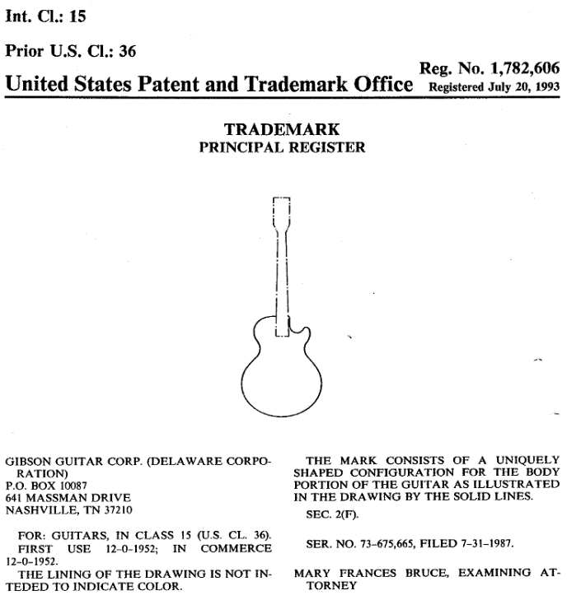

2. When do courts find initial interest confusion? Initial interest confusion remains a highly controversial basis for a finding of infringement, one which courts typically resort to only in a limited set of contexts. Courts appear to be more likely to find initial interest confusion if the defendant has engaged in patently bad faith “bait and switch” sales practices or in conduct akin to intentional cybersquatting, if the relevant consumers are unsophisticated, or if the defendant competes directly with the plaintiff. See, e.g., Epic Sys. Corp. v. YourCareUniverse, Inc., 244 F. Supp. 3d 878, 902 (W.D. Wisc. 2017) (“Courts are most likely to apply the doctrine of initial interest confusion doctrine in circumstances involving directly competing products, particularly when the potential purchasers are lay consumers making decisions in a relatively short amount of time with limited information.”). But see Multi Time Mach., Inc. v. Amazon.com, Inc., 804 F.3d 930 (9th Cir. 2015). In Multi Time Machine, when consumers entered the plaintiff’s trademark in Amazon’s search box, they were not shown the plaintiff’s products, which Amazon did not carry, but were instead shown competing products. The Ninth Circuit found no likelihood of initial interest confusion, reasoning that “[t]he search results page makes clear to anyone who can read English that Amazon carries only the brands that are clearly and explicitly listed on the web page. The search results page is unambiguous—not unlike when someone walks into a diner, asks for a Coke, and is told ‘No Coke. Pepsi.’” Id. at 938.
Furthermore, in reviewing the initial interest confusion case law, Gilson concludes that to prevail on an initial interest confusion basis, the plaintiff must show that it has been economically damaged by the defendant’s conduct. See Gilson § 5.14[01][1][a]. See also Lamparello v. Falwell, 420 F.3d 309, 317 (4th Cir. 2005) (“The few appellate courts that have . . . imposed liability under [the initial interest confusion] theory for using marks on the Internet have done so only in cases involving . . . one business’s use of another’s mark for its own financial gain. . . . Profiting financially from initial interest confusion is . . . a key element for imposition of liability under this theory.”).
In general, it appears that courts have developed initial interest confusion doctrine to provide them with some degree of flexibility to reach what they deem to be the right result as a matter of equity in situations where there is no consumer confusion at the point of sale.
3. Critiquing initial interest confusion. For a thorough critique of initial interest confusion doctrine, see Jennifer E. Rothman, Initial Interest Confusion: Standing at the Crossroads of Trademark Law, 27 Cardozo L. Rev. 105 (2005). Rothman observes: “The courts’ initial motivation for adopting initial interest confusion was a legitimate effort to prevent baiting and switching practices. However, since then courts have unreasonably stretched the doctrine to cover many circumstances which should be considered fair competition or which are better addressed by other existing statutes.” Id. at 113.

Post-Sale Confusion

Mastercrafters’ clock (left) and LeCoultre’s clock (right)*

While initial interest confusion addresses the likelihood of confusion before the point of sale, post-sale confusion, as its name suggests, addresses confusion after the point of sale. One of the first cases to recognize some form of post-sale confusion was Mastercrafters Clock & Radio Co. v. Vacheron & Constantin-LeCoultre Watches, Inc., 221 F.2d 464 (2d Cir. 1955). In Mastercrafters, the declaratory plaintiff Mastercrafters produced an electric clock made to look like the declaratory defendant’s expensive and prestigious Atmos table clock, a non-electric clock that wound itself from changes in atmospheric pressure. Mastercrafters sold its clock for about $30; LeCoultre sold the Atmos clock for not less than $175 (about $2,000 in today’s money). Mastercrafters sought a declaration that its conduct did not constitute unfair competition. Judge Frank held in favor of LeCoultre. Though there was no point-of-sale confusion, there was nevertheless unfair competition:
True, a customer examining plaintiff’s clock would see from the electric cord, that it was not an ‘atmospheric’ clock. But, as the {district} judge found, plaintiff copied the design of the Atmos clock because plaintiff intended to, and did, attract purchasers who wanted a “luxury design” clock. This goes to show at least that some customers would buy plaintiff’s cheaper clock for the purpose of acquiring the prestige gained by displaying what many visitors at the customers’ homes would regard as a prestigious article. Plaintiff’s wrong thus consisted of the fact that such a visitor would be likely to assume that the clock was an Atmos clock. Neither the electric cord attached to, nor the plaintiff’s name on, its clock would be likely to come to the attention of such a visitor; the likelihood of such confusion suffices to render plaintiff’s conduct actionable.
Id. at 464.
The post-sale confusion theory has been controversial, as the dissent in the following case suggests. In reading through Ferrari S.P.A. v. Roberts, 944 F.2d 1235 (6th Cir. 1991), which involves the unauthorized production of “Fauxrraris”, consider the following questions:
- Should courts take into account the confusion as to source of consumers who would never actually purchase the plaintiff’s goods (or the defendant’s goods for that matter)?
- Should trademark law be used to protect the exclusivity of status goods? If it should not be so used, how can we make sure we do not throw out the baby with the bathwater? In other words, how can we design trademark law so that it will not protect the exclusivity of status goods but will nevertheless continue to protect the traditional source-denoting function of trademarks for non-status goods?
- Who decides which goods are status goods? Is a pickup truck a status good?

[The opinion in Ferrari S.P.A. v. Roberts is available separately.]
Questions and Comments
1. Are the Ferrari exterior designs functional? The district court found that they were not and the Sixth Circuit affirmed:
The district court found that Ferrari proved, by a preponderance of the evidence, that the exterior shapes and features of the Daytona Spyder and Testarossa were nonfunctional. The court based this conclusion on the uncontroverted testimony of Angelo Bellei, who developed Ferrari’s grand touring cars from 1964-75, that the company chose the exterior designs for beauty and distinctiveness, not utility.
Ferrari S.P.A., 944 F.2d at 1246. Does this strike you as an adequate consideration of the issue?

* Courtesy of Rebecca Tushnet & Georgetown Law Library, Intellectual Property Teaching Resources (2020).

