An Open-Access Casebook

Version 12 (2025)
Digital Edition
www.tmcasebook.org

Barton Beebe
John M. Desmarais Professor of Intellectual Property Law
New York University School of Law

This work is licensed under a Creative Commons Attribution-NonCommercial-
ShareAlike 4.0 International License.

Nominative Fair Use

1. The Three-Step Test for Nominative Fair Use

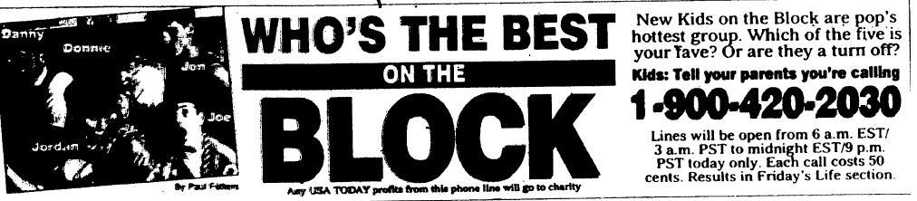

In New Kids on the Block v. News Am. Publ’g, Inc., 971 F.2d 302 (9th Cir. 1992), the Ninth Circuit first developed the concept of nominative fair use. The defendants, two newspapers, conducted separate polls asking readers to call a 900 number to vote for their favorite member of the boy band New Kids on the Block. As The Star politely put it: “Which of the New Kids on the Block would you most like to move next door?” Id. at 305. The band sued for, among other things, trademark infringement. Affirming the district court’s grant of summary judgment to the defendants, Judge Kozinski held that a “nominative use of a mark—where the only word reasonably available to describe a particular thing is pressed into service—lies outside the strictures of trademark law,” id. at 308 (emphasis in original), and set out three “requirements” that a defendant’s use must meet to qualify as nominative fair use:
First, the product or service in question must be one not readily identifiable without use of the trademark; second, only so much of the mark or marks may be used as is reasonably necessary to identify the product or service;7 and third, the user must do nothing that would, in conjunction with the mark, suggest sponsorship or endorsement by the trademark holder.
Id. at 307. The Lanham Act did not at the time explicitly include any basis for nominative fair use and even now it arguably only references nominative fair use in connection with dilution, see § 43(c)(3)(A), 15 U.S.C. § 1125(c)(3)(A). On the issue of confusion, nominative fair use remains essentially judge-made law.
Note the conceptual distinction between descriptive (or “classic”) fair use and nominative fair use:
The nominative fair use analysis is appropriate where a defendant has used the plaintiff’s mark to describe the plaintiff’s product, even if the defendant’s ultimate goal is to describe his own product. Conversely, the classic fair use analysis is appropriate where a defendant has used the plaintiff’s mark only to describe his own product, and not at all to describe the plaintiff’s product.
Cairns v. Franklin Mint Co., 292 F.3d 1139, 1151 (9th Cir. 2002).
In the opinion below, Judge Kozinski returned to the concept of nominative fair use, this time in connection with domain names—and in light of KP Permanent. In reading through the opinion, consider the following questions:
- Why should the New Kids factors replace the Sleekcraft multifactor test for the likelihood of consumer confusion? Why shouldn’t a court first work through the Sleekcraft test to determine if plaintiff has even made out its case and, if it has, then turn to the question of nominative fair use?
- What sense do you make of the final excerpted paragraphs of Judge Kozinski’s opinion? How exactly should a Ninth Circuit court now proceed to evaluate a nominative fair use “defense”?
- Do you find the concurrence’s concerns valid?

[The opinion in Toyota Motor Sales, U.S.A., Inc. v. Tabari is available separately.]
Questions and Comments
1. The Third Circuit’s hybrid approach in Century 21. In Century 21 Real Estate Corp. v. Lendingtree, Inc., 425 F.3d 211 (3d Cir. 2005), the Third Circuit rejected the Ninth Circuit’s approach in which the New Kids factors replace the multifactor test for the likelihood of consumer confusion. Instead, seeking properly to cast the nominative fair use “defense” as a true affirmative defense, the Century 21 court set forth four factors Third Circuit courts should consider in the nominative fair use context to determine if there was a likelihood of confusion: “(1) the price of the goods and other factors indicative of the care and attention expected of consumers when making a purchase; (2) the length of time the defendant has used the mark without evidence of actual confusion; (3) the intent of the defendant in adopting the mark; and (4) the evidence of actual confusion.” Id. at 225-26. If the plaintiff meets its burden of proving a likelihood of confusion under these factors, then the defendant bears the burden of winning each of the following factors to make out the defense of nominative fair use: “1. Is the use of plaintiff’s mark necessary to describe (1) plaintiff’s product or service and (2) defendant’s product or service? 2. Is only so much of the plaintiff’s mark used as is necessary to describe plaintiff’s products or services? 3. Does the defendant’s conduct or language reflect the true and accurate relationship between plaintiff and defendant’s products or services?” Id. at 228. In his dissent, Judge Fisher was highly critical of this new approach. See id. at 232 (Fisher, J., dissenting).
______________________________________________________________________________
We had long awaited some statement from the Second Circuit as to whether the circuit recognizes nominative fair use, and if it does, how courts should analyze the issue. That statement finally came in the following opinion. Does Judge Pooler’s approach in the Second Circuit strike you as more sensible than Judge Kozinski’s in the Ninth?

[The opinion in Int’l Info. Sys. Sec. Certification Consortium, Inc. v. Sec. Univ., LLC is available separately.]

2. Further Examples of Nominative Fair Use Analyses

[The opinion in Liquid Glass Enterprises, Inc. v. Dr. Ing. h.c.F. Porsche AG is available separately.]

[The opinion in Toho Co., Ltd. v. William Morrow & Co., Inc. is available separately.]

[The opinion in Mattel, Inc. v. Walking Mountain Productions is available separately.]

[The opinion in Board of Supervisors for Louisiana State University Agricultural & Mechanical College v. Smack Apparel Co. is available separately.]

7 Thus, a soft drink competitor would be entitled to compare its product to Coca–Cola or Coke, but would not be entitled to use Coca–Cola’s distinctive lettering. See Volkswagenwerk Aktiengesellschaft v. Church, 411 F.2d 350, 352 (9th Cir. 1969) (“{In advertising that he specialized in Volkswagen repair,} Church did not use Volkswagen’s distinctive lettering style or color scheme, nor did he display the encircled ‘VW’ emblem” {and was therefore not infringing}). . . .

