An Open-Access Casebook

Version 12 (2025)
Digital Edition
www.tmcasebook.org

Barton Beebe
John M. Desmarais Professor of Intellectual Property Law
New York University School of Law

This work is licensed under a Creative Commons Attribution-NonCommercial-
ShareAlike 4.0 International License.

The Distinctiveness Analysis of Nonverbal Marks
We have so far discussed the concept of trademark distinctiveness only in reference to word marks. But as we have seen already, contemporary trademark law offers protection to far more than words and phrases. It protects image marks, sound marks, scent marks, and perhaps someday it will protect flavor or taste marks. See In re N.V. Organon, 79 U.S.P.Q.2d 1639, 2006 WL 1723556 (TTAB 2006) (denying registration to a mark consisting of “an orange flavor” for “pharmaceuticals for human use, namely, antidepressants in quick-dissolving tablets and pills” on the grounds that the mark lacked distinctiveness and was functional). Trademark law also protects “trade dress,” which may consist of a product’s packaging or configuration as well as nearly any other aspect of the product or service.
Over the past two decades, courts have struggled with how to analyze the distinctiveness of nonverbal marks, none more so than the Supreme Court. We first consider here the relevant Supreme Court case law on the issue. We then turn to lower court attempts to apply the doctrine developed in that case law.

a. Supreme Court Approaches to the Distinctiveness Analysis of Nonverbal Marks
The Supreme Court has engaged the distinctiveness analysis of nonverbal marks in a series of three opinions:
- Two Pesos, Inc. v. Taco Cabana, Inc., 505 U.S. 763 (1992) (analyzing the source-distinctiveness of a restaurant interior),
- Qualitex Co. v. Jacobson Products Co., Inc., 514 U.S. 159 (1995) (analyzing the source-distinctiveness of a single color), and
- Wal-Mart Stores, Inc. v. Samara Bros., Inc., 529 U.S. 205 (2000) (analyzing the source-distinctiveness of an apparel design).
In Two Pesos, the Court held that inherently distinctive trade dress could be protected without a showing of secondary meaning. In other words, and contrary to lower court case law primarily from the Second Circuit, the Court held that there was no special rule requiring that trade dress always show secondary meaning. In Qualitex, the Court held that a single color could qualify for trademark protection (provided that it possessed acquired distinctiveness of source). Finally, in Samara Bros. (or Wal-Mart, as some courts prefer), the Court arguably rewrote Two Pesos. It described the universe of trade dress as consisting of at least two categories: product packaging trade dress and product configuration trade dress. Product packaging trade dress was deemed capable of being inherently distinctive and when it was, it did not require a showing of secondary meaning to receive protection. Product configuration trade dress, however, could never be inherently distinctive and must always be shown to have acquired distinctiveness in order to qualify for protection.
One area of distinctiveness doctrine that the Court has not explicitly addressed is how to analyze the inherent distinctiveness of product packaging. Should courts use the Abercrombie spectrum or some other scheme of classification? As we will see below, there appears to be a circuit split on this issue.
______________________________________________________________________________

[The opinion in Two Pesos, Inc. v. Taco Cabana, Inc. is available separately.]

Comments and Questions
1. Taco Cabana eventually purchased Two Pesos. After winning the $3.7 million jury award in the above case, Taco Cabana again sued Two Pesos for failing to make court-ordered changes in its trade dress. As part of the settlement of this dispute, Taco Cabana eventually purchased Two Pesos. See http://en.wikipedia.org/wiki/Taco_Cabana. See also Ron Ruggless, Taco Cabana Buys Rival Two Pesos, Nation’s Restaurant News, Jan. 25, 1993.
2. The advantages and disadvantages of defining trade dress broadly and narrowly. Courts commonly claim that trade dress constitutes the “total image and overall appearance” of a product, Blue Bell Bio-Medical v. Cin-Bad, Inc., 864 F.2d 1253, 1256 (5th Cir. 1989). See also Chun King Sales, Inc. v. Oriental Foods, Inc., 136 F. Supp. 659, 664 (D. Cal. 1955) (analyzing “the tout ensemble of the article as it appears to the average buyer”). Yet courts also typically require that the plaintiff specify and even enumerate the combination of elements it is claiming as protectable trade dress. See, e.g., Sports Traveler, Inc. v. Advance Magazine Publishers, Inc., 25 F. Supp. 2d 154, 162 (S.D.N.Y. 1998) (“Despite this mandate to focus on the overall appearance of the product, a plaintiff must still articulate the specific elements of the trade dress that render the trade dress unique or novel, that is, capable of being an identifier for the product’s source.”); Abercrombie & Fitch Stores, Inc. v. American Eagle Outfitters, Inc., 280 F.3d 619, 635 (6th Cir. 2002) (stating that a plaintiff is “expected to list the elements of the designs and the unique combinations it [seeks] to protect . . . .”). Cf. General Motors Corp. v. Lanard Toys, Inc., 468 F.3d 405, 415 (6th Cir. 2006) (finding sufficient plaintiff’s definition of the trade dress of its hummer and humvee vehicles as “the exterior appearance and styling of the vehicle design which includes the grille, slanted and raised hood, split windshield, rectangular doors, squared edges, etc.”).
What strategic considerations may come into play in how a plaintiff defines its trade dress? What are the costs and benefits of defining it too broadly or too narrowly?
______________________________________________________________________________
In reading Qualitex, consider the following questions:
- It is often remarked that the Court’s holding in Qualitex is in significant tension with its previous holding in Two Pesos. Do you detect any tension between the holdings of the two cases?
- Does Justice Breyer’s analysis apply as well to a combination of two or more colors?
- In light of Qualitex, how do you predict courts will treat smells, textures, and tastes? Are such marks capable of inherent distinctiveness?

[The opinion in Qualitex Co. v. Jacobson Products Co., Inc. is available separately.]

Comments and Questions
1. Why did Qualitex bother seeking certiorari review of its single-color claim if it had already won its case against Jacobsen on its broader trade dress claim? Both the district court and the Ninth Circuit ruled that Jacobsen had infringed Qualitex’s overall trade dress, consisting of “[t]he total impression of the Qualitex green-gold pad and its ‘Sun Glow’ name . . . or overall appearance[ ] of the Qualitex product.” Qualitex Co. v. Jacobson Prod. Co., 13 F.3d 1297, 1304 (9th Cir. 1994). But this judgment would likely not have enabled Qualitex to prevent competitors, including Jacobsen, from selling press pads in a green-gold color that prominently carried a different brand name or other distinguishing feature. Qualitex sought at the Supreme Court a more abstract and much more powerful property right: the exclusive right to use the green-gold color on press pads regardless of brand name or any other distinguishing feature.
2. Color Marks and Non-English-Speaking and Illiterate Consumers. Perhaps it makes sense that a company like Tiffany & Co. would assert exclusive rights in the distinctive robin’s-egg blue color of its packaging, see U.S. Reg. No. 2,359,351 (June 20, 2000) (“The mark consists of a shade of blue often referred to as robin’s-egg blue which is used on boxes.”), or even that 3M Corp. would assert exclusive rights in the canary yellow color of its Post-It Pads, see U.S. Reg. No. 2,390,667 (Oct. 3, 2000) (“The mark consists of the color canary yellow used over the entire surface of the goods.”), but why would a manufacturer of dry cleaning press pad covers claim rights in the color of its press pad covers? Professor Laura Heymann points to one possible explanation. See Laura A. Heymann, The Reasonable Person in Trademark Law, 52 St. Louis. L.J. 781, 792 (2008). Though the Supreme Court opinion makes no mention of the issue, the Qualitex district court opinion noted that “many [dry cleaning businesses] are foreign speaking with limited skills in reading or speaking English.” Qualitex Co. v. Jacobson Prods. Co., Inc., No. 90 Civ. 1183, 1991 WL 318798, at *1 (C.D. Cal. Sep. 5,1991), aff’d in part and rev’d in part, 13 F.3d 1297 (9th Cir. 1994), rev’d, 514 U.S. 159 (1995).
______________________________________________________________________________
Between Two Pesos in 1992 and Samara Bros. in 2000, lower courts struggled to establish a workable test by which to determine whether a particular instance of trade dress was inherently distinctive. Courts had particular difficulty establishing a test to determine whether trade dress in the form of product configuration—i.e., in the form of design features of the product itself—was inherently distinctive. As we will see, in Samara Bros. the Supreme Court solved this problem of product configuration rather abruptly.
In reading through Samara Bros., consider the following questions:
- In Samara Bros., the Supreme Court accepted certiorari on the following question: “What must be shown to establish that a product’s design is inherently distinctive for purposes of Lanham Act trade-dress protection?” Wal-Mart Stores, Inc. v. Samara Brothers, Inc., 528 U.S. 808 (1999). How did the Court answer this question?
- Is the court’s holding in Samara Bros. consistent with its holding in Two Pesos?

[The opinion in Wal-Mart Stores, Inc. v. Samara Bros. Inc. is available separately.]

Comments and Questions
1. What about copyright infringement in Samara Bros.? At the district court, “[t]he jury found that Wal–Mart had wilfully infringed Samara’s rights, awarding Samara $912,856.77 on the copyright claims, $240,458.53 for the Lanham Act violation and $50 for the state law violations.” Samara Bros. v. Wal-Mart Stores, Inc., 165 F.3d 120, 123 (2d Cir. 1998). Decades later, Judge Denny Chin, who was the district court judge in Samara Bros. (and is now on the Second Circuit), reflected on the case:
Ironically, the Supreme Court latched on to a very small part of the case. This was principally a copyright case—the copying of Samara’s copyrighted designs. But Samara had included a trade dress claim, and the jury awarded some damages for the trade dress claim, although far less than for the copyright claims. The jury’s award on the copyright claims remained intact, and, ultimately, the Supreme Court’s reversal had little practical impact on the case, even as it made new law. Apparently, the Supreme Court saw this case as an opportunity to clarify the law in the trade dress area, and it did so.
Hon. Denny Chin, Litigating Copyright Cases: A View from the Bench, 59 J. Copyright Soc’y U.S.A. 185, 194–95 (2012).

b. Distinguishing Product Packaging from Product Configuration after Wal-Mart v. Samara Bros.
The Supreme Court’s holding in Samara Bros. eliminated one problem—how to analyze the inherent distinctiveness of product configuration trade dress—but created another: how to determine whether a particular product feature or combination of product features qualifies as product packaging trade dress, product configuration trade dress, or perhaps some other kind of trade dress. The opinion excerpts that follow offer examples of how courts have sought to determine where along the packaging/configuration divide particular forms of trade dress fall. In reading the opinions, consider the following question: How should a court treat various forms of decoration applied to the surface of the product (e.g., stripes on the side of an athletic shoe)? Is such decoration product packaging, production configuration, or something else?

[The opinion in In re Slokevage is available separately.]
[The opinion in LVL XIII Brands, Inc. v. Louis Vuitton Malletier S.A. is available separately.]

[The opinion in McKernan v. Burek is available separately.]

[The opinion in Best Cellars, Inc. v. Wine Made Simple, Inc. is available separately.]

[The opinion in Fedders Corp. v. Elite Classics is available separately.]

[The opinion in In re SnoWizard, Inc. is available separately.]

[The opinion in In re Frankish Enterprises Ltd. is available separately.]

Comments and Questions
1. Is the three stripes design for the surface of athletic shoes shown in the registration below product configuration, product packaging, or some “tertium quid”? (The dotted lines do not constitute part of the claimed mark. The registration includes them only to show placement of the mark).
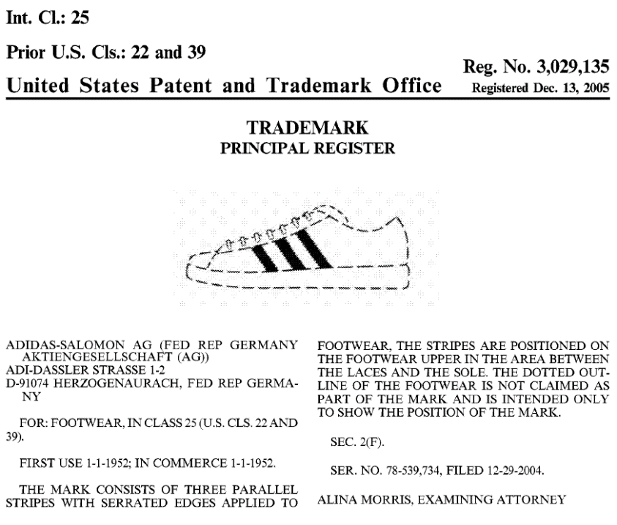

c. Analyzing the Inherent Distinctiveness of Product Packaging Trade Dress
Product configuration trade dress and single colors (whether applied to the packaging of the product or the product itself) are per se incapable of inherent distinctiveness, and it is likely that courts would also find smells, tastes, and textures also to be incapable of inherent distinctiveness. But this leaves a wide array of nonverbal marks, including product packaging trade dress, that remain capable of inherent distinctiveness. The question, then, is how to determine whether a particular mark that falls into one of these categories is in fact inherently distinctive. While the Abercrombie spectrum works reasonably well for verbal marks, it is not well suited to the inherent distinctiveness analysis of nonverbal marks. Instead, as we will see below, most courts outside of the Second Circuit have adopted the so-called Seabrook factors, from Seabrook Foods, Inc. v. Bar–Well Foods Ltd., 568 F.2d 1342 (CCPA 1977), to analyze the inherent distinctiveness of nonverbal marks.
We first consider an example of the Second Circuit’s attempt to adapt its Abercombie spectrum to the question of whether a product packaging feature is inherently distinctive. We then turn to an example of the (probably far more sensible) Seabrook factors approach to the question.

i. Using the Abercrombie Spectrum to Analyze Whether Product Packaging Is Inherently Distinctive

[The opinion in Fun-Damental Too, Ltd. v. Gemmy Industries Corp. is available separately.]

ii. Using the Seabrook Factors to Analyze Whether Product Packaging is Inherently Distinctive
In Seabrook, the plaintiff Seabrook had registered, for frozen vegetables, a mark consisting in part of a pointed loop (or “stylized leaf design”, as Seabrook called it) as shown below. Seabrook opposed the registration of Bar-Well’s mark, also for frozen foods, that incorporated a similar pointed loop design on the ground that Bar-Well’s use of the mark would confuse consumers. The Court of Customs & Patent Appeals (the predecessor court to the Court of Appeals for the Federal Circuit) set forth various factors relevant to the question of whether consumers would perceive the pointed loop design (absent the words and image of a farm) as inherently distinctive of source:
In determining whether a design is arbitrary or distinctive this court has looked to whether it was a ‘common’ basic shape or design, whether it was unique or unusual in a particular field, whether it was a mere refinement of a commonly-adopted and well-known form of ornamentation for a particular class of goods viewed by the public as a dress or ornamentation for the goods, or whether it was capable of creating a commercial impression distinct from the accompanying words.
Id. at 1344. The CCPA ultimately determined that the pointed loop design on its own would be perceived merely as decoration. Id. These factors soon came to inform most courts analysis of the inherent distinctiveness of all nonverbal trademarks (including, before Samara Bros., product configuration trade dress).

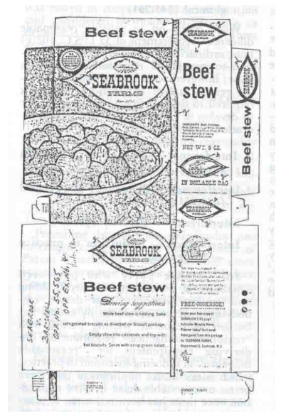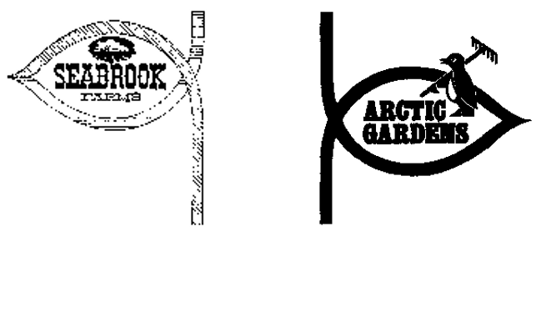

Note that the two leading treatises on trademark law disagree on whether the Abercrombie spectrum or the Seabrook factors work better for assessing the inherent distinctiveness of product packaging trade dress. McCarthy strongly endorses Seabrook:
In the author’s view, the Seabrook test is by far the preferable test to classify inherently distinctive trade dress in packaging and containers. Necessarily focusing upon the probable reaction of the ordinary consumer, it focuses upon the key issue in these cases: is the design so different in this market that it will immediately be perceived as a source identifier, not merely or solely as an attractive decoration or embellishment. The Abercrombie spectrum was developed specifically for word marks and does not translate into the world of shapes and designs.
McCarthy § 8:13. The Gilson treatise remains loyal to Abercrombie:
The Abercrombie classifications are not an ideal fit for product packaging trade dress cases; is a squeeze bottle with a top that squirts liquid suggestive of dish soap or spring water or is it generic for those products because it is so widely used? Nevertheless, pending further clarification from the Supreme Court, lower courts should continue to use the Abercrombie spectrum in classifying product packaging trade dress.
Gilson § 2A.03[1][a][ii].
Note further that if a court finds a feature of product packaging to lack both inherent and acquired distinctiveness or a feature of product configuration to lack acquired distinctiveness, then the court will often (but not always) deem the feature to be “mere ornamentation.”
As you read through the following opinion, consider the following questions:
- Which test is better: Abercrombie or Seabrook? On what grounds should courts prefer one or the other? Which test tends to be more plaintiff-friendly, i.e., more prone to find the trade dress at issue to be inherently distinctive?
- Could Seabrook be successfully modified to apply to the inherent distinctiveness analysis of verbal marks as well?

[The opinion in Amazing Spaces, Inc. v. Metro Mini Storage is available separately.]

[The opinion in Fiji Water Co., LLC v. Fiji Mineral Water USA, LLC is available separately.]

[The opinion in In re Frankish Enterprises Ltd. is available separately.]
______________________________________________________________________________
Though the Second Circuit apparently still subscribes to the use of Abercrombie in the analysis of the inherent distinctiveness of non-configuration trade dress, consider whether Seabrook-like factors inform the Second Circuit’s analysis in the Star Industries case below.

[The opinion in Star Industries, Inc. v. Bacardi & Co. Ltd. is available separately.]

d. Analyzing the Acquired Distinctiveness of Nonverbal Marks
The secondary meaning analysis of nonverbal marks is largely the same as that of verbal marks. Courts tend to use essentially the same factors and considerations for both. See, e.g., Herman Miller, Inc. v. Palazzetti Imports and Exports, Inc., 270 F.3d 298 (6th Cir. 2001) (reviewing seven factors to determine that Herman Miller had raised an issue of fact as to the secondary meaning of the design of its Eames chair); Yankee Candle Co. v. Bridgewater Candle Co., 259 F.3d 25, 43–45, (1st Cir. 2001) (finding insufficient evidence of secondary meaning in plaintiff’s label designs for scented candles).
Courts may treat one factor differently, however, in the context of product configuration. Evidence that the defendant deliberately copied from the plaintiff may not carry as much weight when the defendant copied product configuration. See, e.g., Kaufman & Fisher Wish Co. v. F.A.O. Schwarz, 184 F. Supp. 2d 311, 319 (S.D.N.Y. 2001) (in case involving defendant’s alleged trademark infringement of plaintiff’s toy doll and packaging, stating that “[t]he probative value of evidence of intentional copying is particularly limited in cases involving product design, since ‘the copier may very well be exploiting a particularly desirable feature, rather than seeking to confuse consumers as to the source of the product.’ Duraco Products, Inc. v. Joy Plastic Enterprises, Ltd., 40 F.3d 1431, 1453 (3d Cir. 1994)”).
The concept of “limping trademarks” is also relevant to determining whether nonverbal marks (and indeed some verbal marks) have developed sufficient acquired distinctiveness to merit protection. This concept comes to American trademark law from English trademark law, and in particular from the opinion of Mr. Justice Jacobs (as he then was, before becoming a Lord Justice) in Philips Elecs. BV v. Remington Consumer Prods., [1998] RPC 283 (U.K.). There, Philips had claimed trademark rights in the mark philishave and separate trademark rights in the particular configuration of the three rotating heads on its electric shaver. As to the latter, product configuration mark, Jacobs memorably explained that the three-headed configuration “has never been used by Philips as the sole means of identification of trade source. It has never been trusted by Philips to do this job on its own, a matter plainly relevant in considering acquired distinctiveness. It is at best a ‘limping trade mark’, needing the crutch of ‘Philishave’ in use.” Id. at 290. In other words, standing on its own, the three-headed configuration fails to indicate source; it only does so when appearing with the philishave mark. For more on the concept of limping marks, see Rebecca Tushnet, Registering Disagreement: Registration in Modern American Trademark Law, 130 Harv. L. Rev. 867, 922-25 (2017) (urging American trademark law to recognize the phenomenon of limping marks).

