Problem Set #1

[adapted in part from James Boyle & Jennifer Jenkins, Open Intellectual Property Casebook. Boyle & Jenkins is distributed under a Creative Commons Attribution, Non Commercial, Share-Alike license. This adaption is distributed under the same terms.]

One (comparatively easy)

You are a lawyer advising a client seeking to enforce a trademark against a business operating in a different (non-competing) market. Given public policy tensions between the “unfair competition” roots of trademark law and the theory that trademarks are intended to facilitate efficient producer-consumer information flow, how should you proceed?

Two (harder)

Do you agree that genericide best explains the loss of rights to a novel, invented term, such as “Escalator,” “Thermos,” “Aspirin”? What other explanations might be better? As a trademark lawyer who both represents trademark owners and defends the occasional trademark infringement lawyer, which explanation best serves you and your clients? Why and how?

Three (harder)

Unlike patents and copyrights, trademarks can (so long as continually used and renewed) last for an unlimited period of time. Why? If your answer is that the Constitution requires that copyright and patent be for limited times, why do we also find that difference in other countries not bound by the U.S. Constitution?

Four (harder still)

Critics of “brand fetishism,” such as Naomi Klein, author of No Logo, argue that we define ourselves in terms of brands (both those we accept and those we reject), that we obsess about the messages that come with these symbols, and that the public space for debate, self-definition and meaning is increasingly privatized via trademark law (and contract, and copyright, and other legal systems). The social harms attributed to this process range from thefts or crimes of violence to acquire favored status-symbols such as branded jackets or shoes, to the claim that in turning over our visions of self to private logoed creations, we impoverish our culture and ourselves. The private harms include the fact that we (collectively) spend enormous amounts of money to acquire branded items as status symbols. We pay out of our own pockets to be “us.”

One central thesis of this argument is that trademarks have long since left behind the rationale of efficient consumer information flow. The logo does not tell us something about the producer of the good. The logo is the good. The person who purchases a plain white T-shirt or the pair of shoes with a Nike swoosh (or the jacket with the logo of an NFL team, and so on) is not buying the shirt, or the shoes. The shirt is merely the transport mechanism for the logo.

Is this right? Not? How? What implications does this argument (let us call it the “brand fetishism critique”) have for trademark law? Imagine that you represent a client accused of producing and selling knock-off fashion clothing. How could you use this argument to help your client? Then imagine that you represent a (different) client accused of using a reference to the name and logo of a well-known fashion brand in a music video or episode of a streamed video entertainment, without the prior permission of the brand. How could you use this argument to help your client? Finally, imagine that you represent Nike. How do you avoid this argument – and maximize the strength of its trademark portfolio?

Five (hardest; this is the hypothetical that was “Assignment One” for the Fall 2021 version of this course)

Our client Warner Bros. produces Ted Lasso, which as I’m sure you know, is an unexpectedly successful hit on streaming, via Apple.

Ted Lasso-themed merchandise is already available not only via the authorized Warner Bros. online store but also via Etsy and other unauthorized online sites. To secure Warner Bros. trademark rights and maximize its power to deal with unauthorized merchandise, the client wants us to explore registering relevant trademarks in connection with merchandise that appears on the show and/or that is sold to fans of the show.

For now, we’ve been asked to look into the potential registrability of the following marks. I need you to briefly explain potential roadblocks and speed bumps in the registration process, so that I can brief the client.

“AFC Richmond”

(In Ted Lasso, AFC Richmond is the name of the fictional soccer club that hires Ted Lasso and is the setting for most of the show. Richmond is a real location in England. “AFC” is a common acronym in English soccer; it stands for “Athletic Football Club.”)

“Greyhounds”

(A greyhound is the mascot of the fictional AFC Richmond. As I understand the show, the name of the team is not the “Richmond Greyhounds” or “AFC Richmond Greyhounds.” But, as with many organized soccer clubs in the UK (both professional and semi-professional), in the show the club and its supporters collectively have adopted and refer to a mascot. For Richmond, that’s the greyhound.)

This logo:
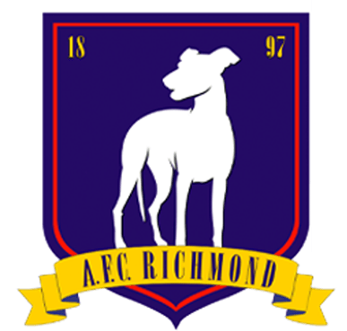

(In the show, this logo – a “badge,” in soccer terms – appears on the team’s uniforms, training outfits, and on graphics associated with the team: websites, social media, printed matter, and so on.)

